Additional file
Additional file 1: Table S1: Melanoma cohort characteristics.
 |  | Total | Primary | Mets | p-value
n (% total) |  | 123 | 71 (57.72%) | 52 (42.28%)
Age (years) | Median | 71 | 71 | 68.5 | 0.375
Age (years) | Range | 21-98 | 21-98 | 28-88 | 0.375
Sex | F (%) | 42 (34.15%) | 23 (32.39%) | 19 (36.54 %) | 0.702
Sex | M (%) | 81 (65.59%) | 48 (67.61%) | 33 (63.46 %) | 0.702
Stage | 1 (%) | 3 (2.44%) | 3 (4.23%) | 0 | N/A
Stage | 2 (%) | 2 (1.63%) | 2 (2.82%) | 0 | N/A
Stage | 3 (%) | 13 (10.57%) | 9 (12.68%) | 4 (7.69%) | N/A
Stage | 4 (%) | 11 (8.94%) | 11 (15.49%) | 0 | N/A
Stage | Missing (%) | 94 (76.42%) | 46 (64.79%) | 48 (92.31%) | N/A
BRAF Mutation | WT (%) | 39 (31.71%) | 25 (35.21%) | 14 (26.92%) | 0.464
BRAF Mutation | Mutant (%) | 10 (8.13%) | 8 (11.27%) | 2 (3.85%) | 0.464
BRAF Mutation | Missing (%) | 74 (60.16%) | 38 (53.52%) | 36 (69.23%) | 0.464
Breslow Thickness (mm) | Median |  | 6.23
Breslow Thickness (mm) | Range |  | 0.4-65
Breslow Thickness (mm) | Missing |  | 13 (18.31%)
Clarke's Microanatomical Level | 1 |  | 1 (1.41%)
Clarke's Microanatomical Level | 2 |  | 2 (2.82%)
Clarke's Microanatomical Level | 3 |  | 10 (14.08%)
Clarke's Microanatomical Level | 4 |  | 24 (33.80%)
Clarke's Microanatomical Level | 5 |  | 17 (23.94%)
Clarke's Microanatomical Level | Missing |  | 17 (23.94%)
Development of Metastasis | Yes |  | 28 (39.44%)
Development of Metastasis | No |  | 19 (26.76%)
Development of Metastasis | Unknown |  | 24 (33.80%)
p-values (primary vs mets): Age – Whitney U Test; Sex & BRAF mutation – Fisher’s exact test. Mets: metastasis; BRAF: B-Raf Proto-Oncogene; WT – wild-type.
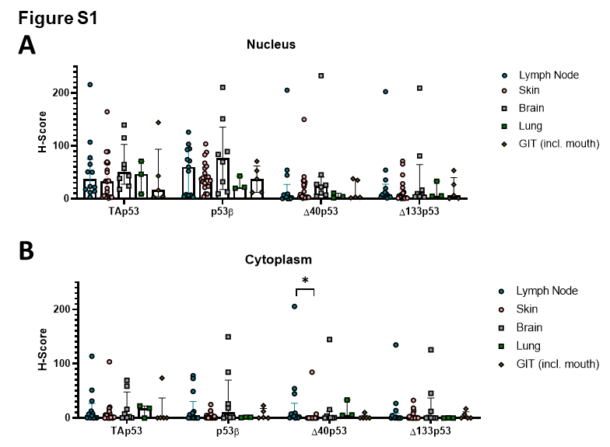
Additional file 1: Figure S1: Expression of p53 isoforms in metastatic samples by metastatic site. A. Nuclear and B. cytoplasmic expression of p53 isoforms in metastatic melanoma samples obtained from lymph nodes (n = 13), the skin (n = 21), the brain (n = 8), the lungs (n = 3) and the gastrointestinal tract (incl. the mouth (n = 5). Two metastatic samples, one from the liver and one from the abdomen, were not included. Significance was determined by Kruskal-Wallis test corrected for multiple comparisons with Dunn’s multiple comparisons test. GIT – gastrointestinal tract; * - p < 0.05.
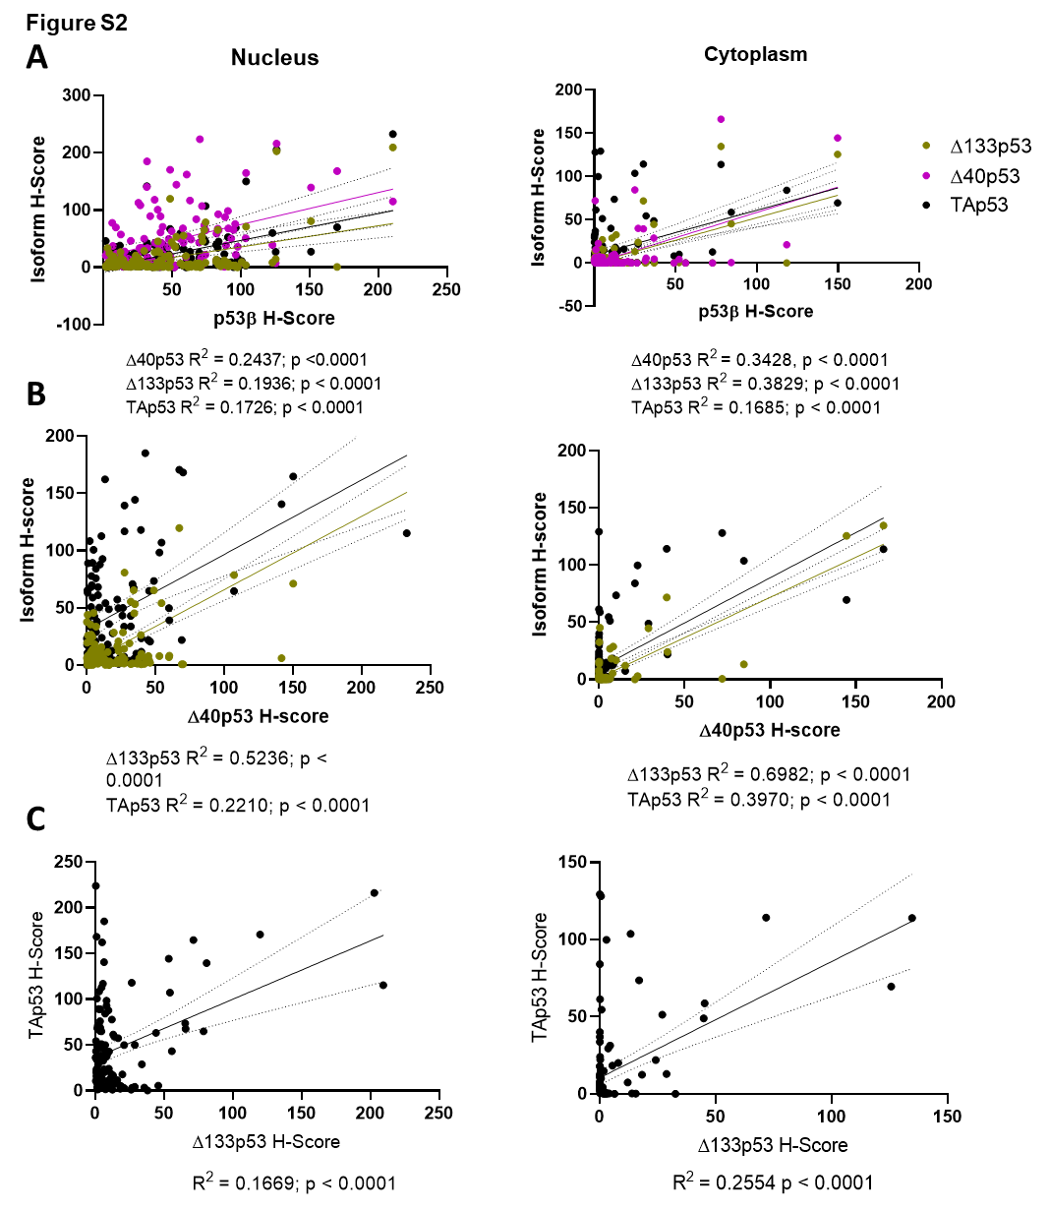
Additional file 1: Figure S2: Correlation between the expression of different p53 isoforms in the nucleus and cytoplasm. A. Correlations between p53β and other p53 isoform H-scores, B. correlations between Δ40p53 and other N-terminal p53 isoform H-scores, and C. correlation between Δ133p53 and TAp53 H-scores in the nucleus (left) and cytoplasm (right). R² of the linear regressions and associated p-values are shown under each graph.
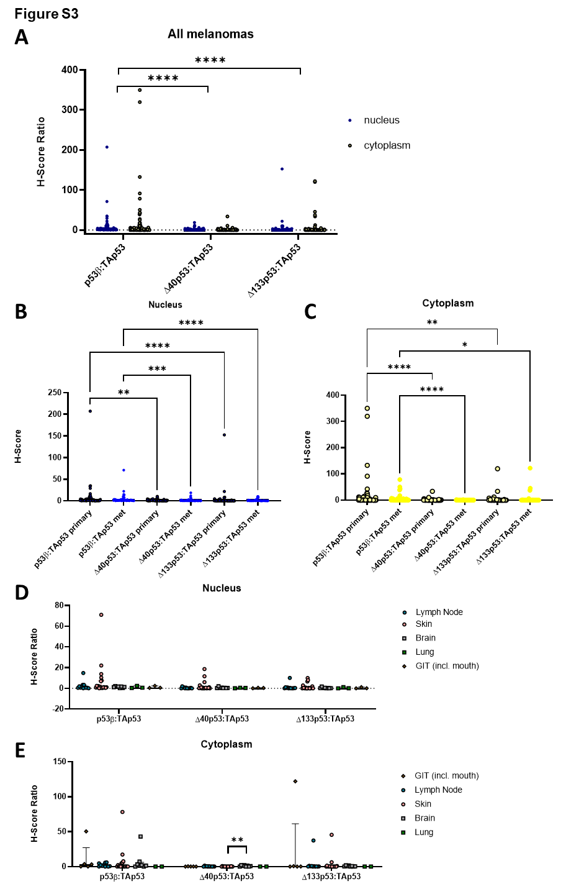
Additional file 1: Figure S3: Relative expression of truncated p53 isoforms. A. Relative expression of p53β, Δ40p53, and Δ133p53 to TAp53 of all melanomas in the nucleus (n = 119) and cytoplasm (n = 110). Relative B. nuclear and C. cytoplasmic expression of truncated p53 isoforms to TAp53 in primary (nucleus n = 69; cytoplasm n = 64) and metastatic melanomas (nucleus n = 50, cytoplasm n = 46). D. Relative nuclear and E. cytoplasmic expression of p53 isoforms in metastatic melanoma samples obtained from lymph nodes (nucleus n = 12, cytoplasm n = 11), the skin (nucleus n = 20, cytoplasm n = 18), the brain (nucleus n= 8, cytoplasm n = 8), the lungs (nucleus n = 3, cytoplasm n = 2) and the gastrointestinal tract (incl. the mouth (nucleus n = 3, cytoplasm n = 5). Two metastatic samples, one from the liver and one from the abdomen, are not included. Significance was determined through Friedman test (matched samples A) or Kruskal-Wallis test (unmatched samples B-E), corrected for multiple comparisons with Dunn’s multiple comparisons test. GIT – gastrointestinal tract; * - p < 0.05;** - p < 0.01; *** - p <0.001; **** - p <0.0001.
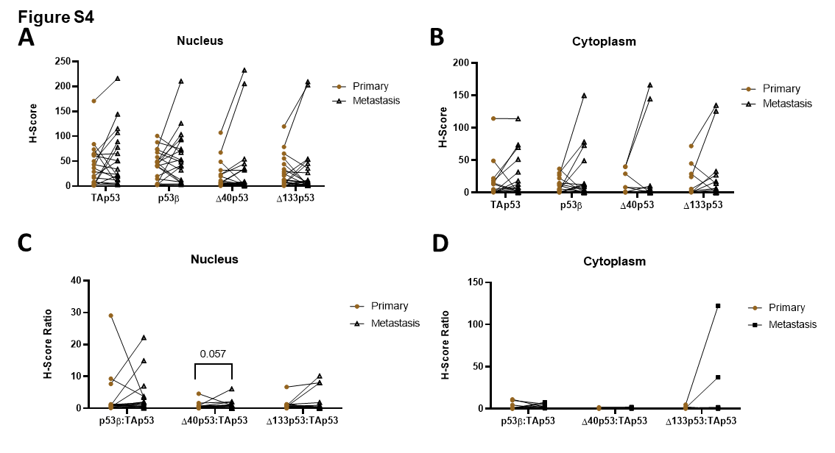
Additional file 1: Figure S4: p53 isoform expression in matched primary and metastatic melanomas. A. Nuclear and B. cytoplasmic p53 isoform H-scores in matched primary and metastatic melanoma samples (n=21). C. Relative nuclear and D. cytoplasmic p53 isoform expression in matched primary and metastatic melanoma samples (n=17). p-values of comparisons nearing statistical significance are shown.
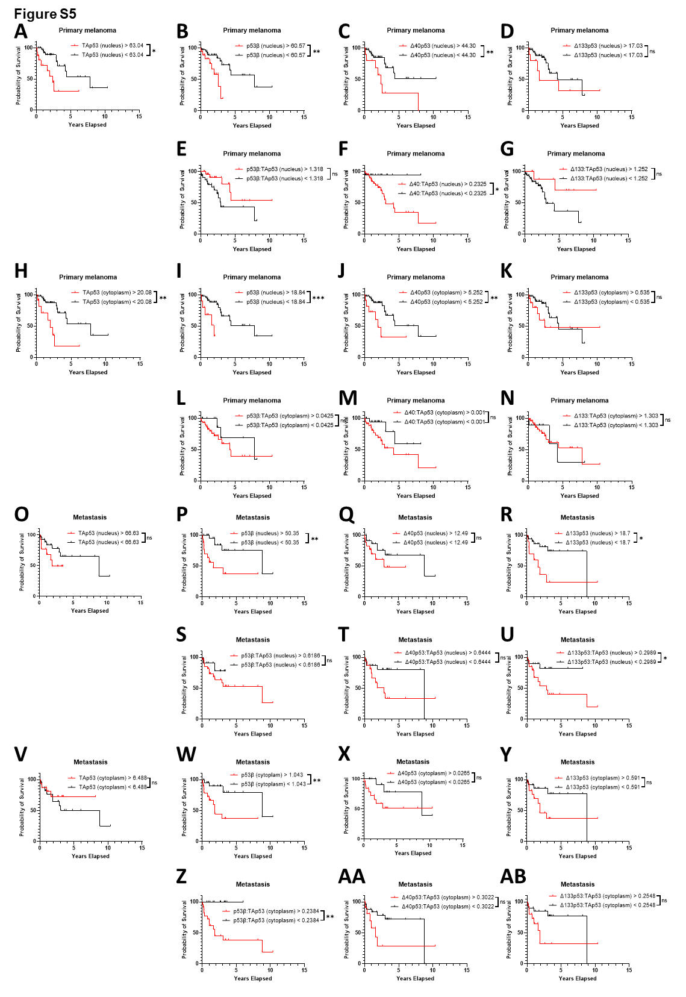
Additional file 1: Figure S5: Probability of survival based on p53 isoform expression in primary and metastatic melanoma. Kaplan-Meier plots of probability of melanoma-specific survival in primary melanomas (n = 59) based on A. nuclear TAp53 H-scores > 63.04 (n = 16) or < 63.04 (n = 42), B. nuclear p53β H-scores > 60.57 (n = 19) or < 60.57 (n = 40), C. nuclear Δ40p53 H-scores > 44.30 (n = 10) or < 44.30 (n = 49), D. nuclear Δ133p53 H-scores > 17.03 (n = 10) or < 17.03 (n = 49), E. relative nuclear p53β expression >1.318 (n =26) or < 1.318 (n = 32), F. relative nuclear Δ40p53 > 0.2325(n =40) or < 0.2325 (n = 18), G. relative nuclear Δ133p53 expression >1.252 (n = 10) or < 1.252 (n = 48), H. cytoplasmic TAp53 H-scores > 20.08 (n = 12) or < 20.08 (n = 46), I. cytoplasmic p53β H-scores > 18.84 (n = 10) or < 18.84 (n = 49), J. cytoplasmic Δ40p53 H-scores > 5.252 (n = 11) or < 5.252 (n = 48), K. cytoplasmic Δ133p53 H-scores > 0.535 (n = 16) or < 0.535 (n = 43), L. relative cytoplasmic p53β expression > 0.0425 (n = 42) or < 0.0425 (n = 13), M. relative cytoplasmic Δ40p53 expression > 0.001 (n = 34) or < 0.001 (n = 21), N. relative cytoplasmic Δ133p53 > 1.303 (n = 46) or < 1.303 (n = 9), and in metastatic melanomas (n = 42) based on O. nuclear TAp53 H-scores > 66.63 (n = 13) or < 66.63 (n = 28), P. nuclear p53β H-scores > 50.35 (n = 18) or < 50.35 (n = 24), Q. nuclear Δ40p53 H-scores > 12.49 (n = 18) or < 12.49 (n = 24), R. nuclear Δ133p53 H-scores > 18.70 (n = 10) or < 18.70 (n = 32), S. relative nuclear p53β expression > 0.6186 (n = 30) or < 0.6186 (n = 11), T. relative nuclear Δ40p53 > 0.6444 (n =16) or < 0.6444 (n = 25), U. relative nuclear Δ133p53 expression > 0.2982 (n = 20) or < 0.2989 (n = 21), V. cytoplasmic TAp53 H-scores > 6.488 (n = 16) or < 6.488 (n = 25), W. cytoplasmic p53β H-scores > 1.043 (n = 20) or < 1.043 (n = 22), X. cytoplasmic Δ40p53 H-scores > 0.0265 (n = 26) or < 0.0265 (n = 16), Y. cytoplasmic Δ133p53 H-scores > 0.591 (n = 17) or < 0.591 (n = 25), Z. relative cytoplasmic p53β expression > 0.2384 (n = 24) or < 0.2384 (n = 14), AA. relative cytoplasmic Δ40p53 expression > 0.3022 (n = 12) or < 0.3022 (n = 26), AB. relative cytoplasmic Δ133p53 > 0.2548 (n = 16) or < 0.2548 (n = 22). Significance was determined by Log-rank (Mantel-Cox) tests. ns – not significant; * - p < 0.05; ** - p < 0.01; *** - p < 0001; **** - p < 0.0001.
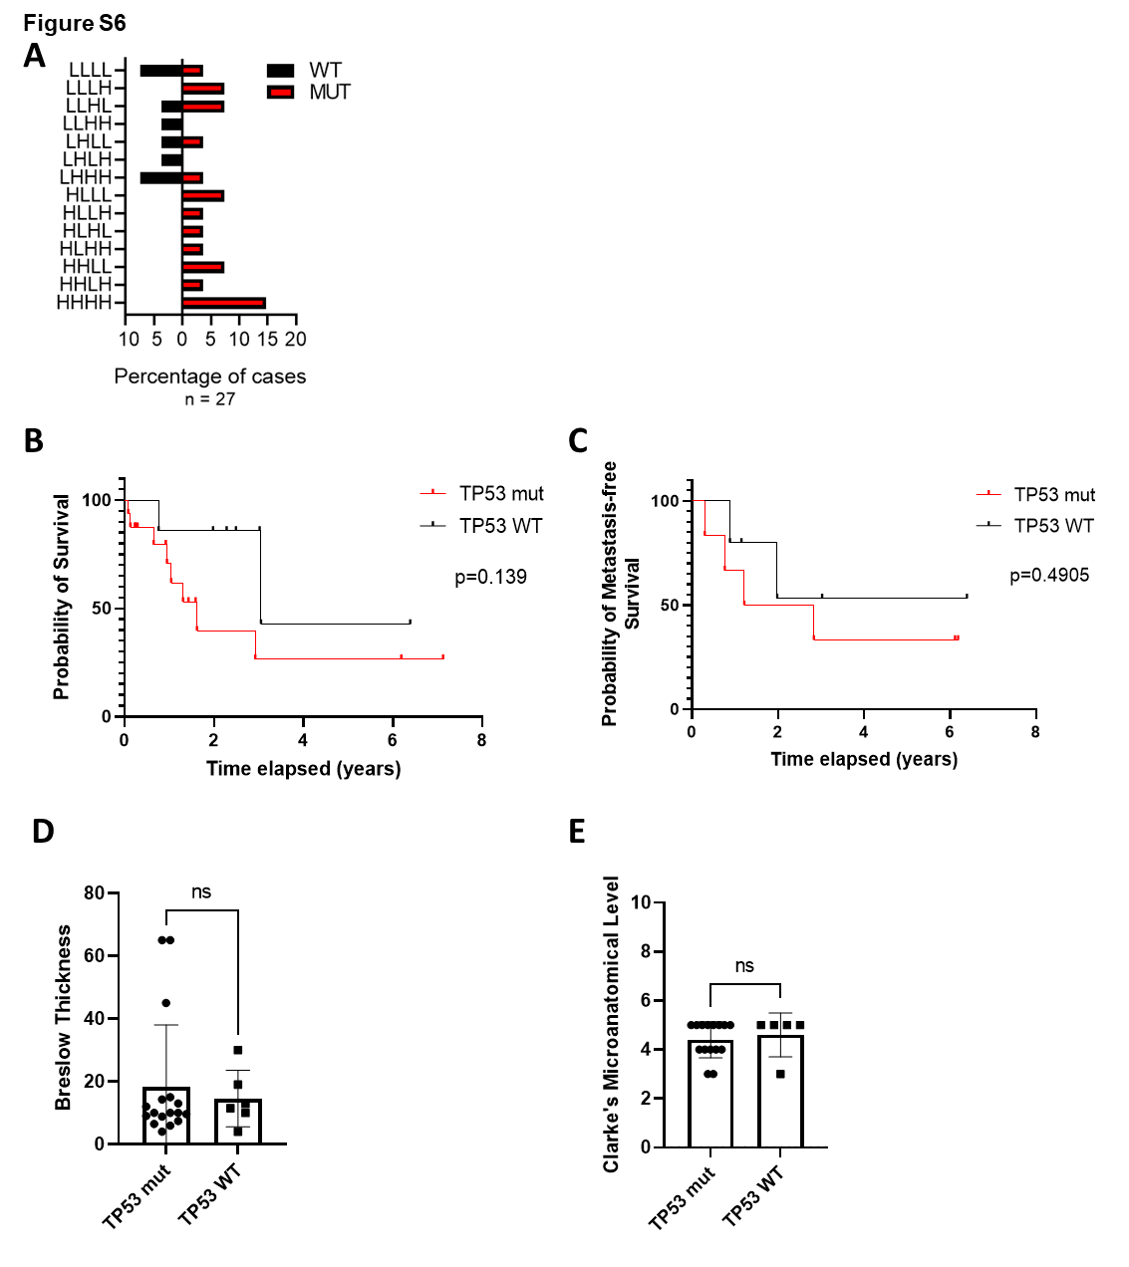
Additional file 1: Figure S6: Association of TP53 mutation status with clinical parameters. A. Percentage of melanoma cases with wild-type (n = 8) or mutated (n = 19) TP53 divided according to the p53 isoform composite biomarker classes. B. Kaplan-Meier plots of probability of melanoma-specific survival in primary melanomas (n = 27) based on TP53 mutation status. C. Kaplan-Meier plots of probability of metastasis-free survival in primary melanomas (n = 27) based on TP53 mutation status. D. Breslow thickness and E. Clarke’s microanatomical level in samples with mutant and wild-type TP53. In A and B Significance was determined by Log-rank (Mantel-Cox) tests. p-values as indicated. In C and D significance was determined by Kruskal-Wallis test. ns – not significant; mut – mutant; WT – wild-type.

