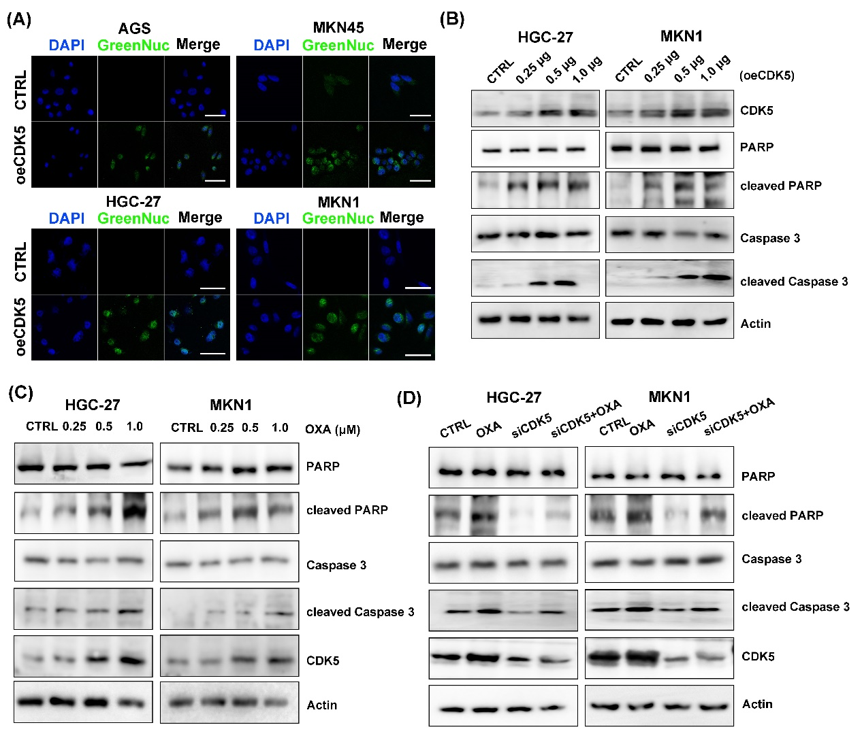
Additional file 9: Figure S5. CDK5 promotes apoptosis in gastric cancer
(A) Staining (scale bars = 50 μm) for apoptosis assessed caspase 3 activities in the four gastric cancer cell lines after overexpression of CDK5. Green staining indicates caspase 3 activity. (B–D) Western blotting of CDK5, total/cleaved PARP, and total/cleaved caspase 3 in HGC-27 and MKN1 cells. Panel B shows that cells were transfected with the indicated amounts (0.25, 0.5 or 1.0 μg) of pLV-CDK5 expression plasmid (oeCDK5) or empty vector (CTRL). Panel C shows that cells were treated with the indicated amounts (0.25, 0.5 or 1.0 μM) of oxaliplatin (OXA) or DMSO (CTRL). Panel D shows that cells were treated with 0.5 μM OXA or siRNA targeting CDK5.

