Supplementary materials
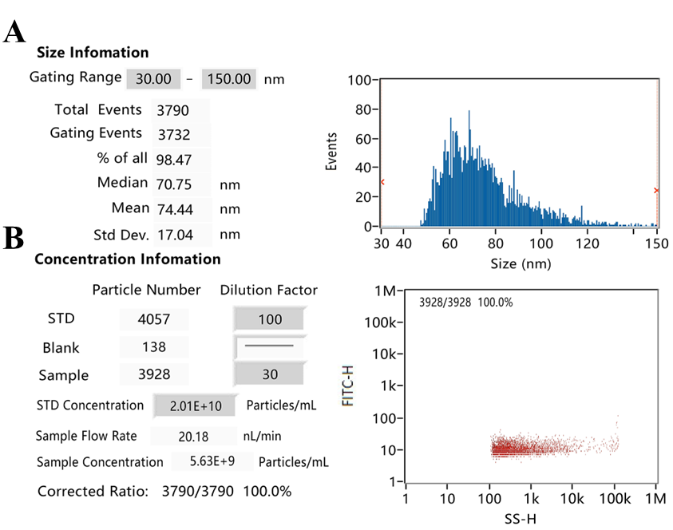
Figure S1. NTA analysis of purified exosomes from H. pylori infected GES-1 cells. (A) The particle diameter and (B) concentration of exosomes were determined with NTA.
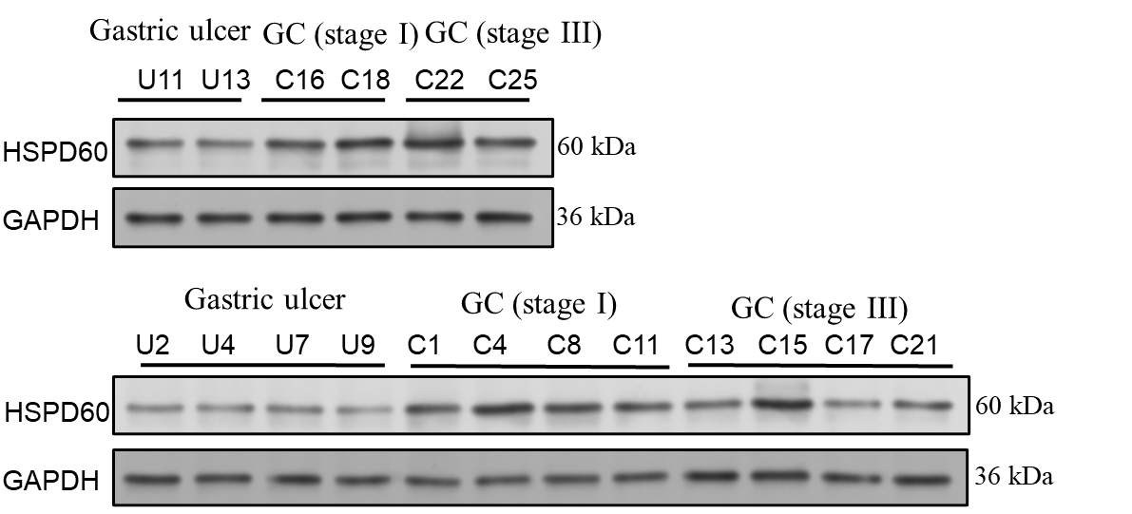
Figure S2. The infection of H. pylori regulates the expression of HSP60 in GC. The expression of HSP60 in gastric ulcer, and stage I and III GC mucosal tissues was determined by western blot.

