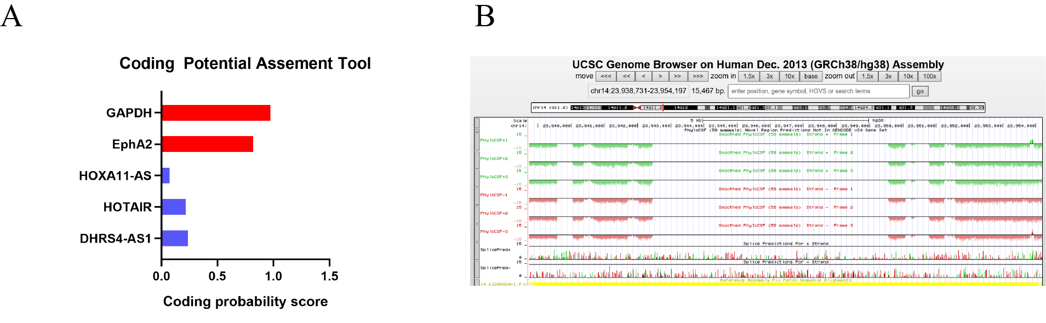

Fig. S1: The prediction of protein-coding potential of lncRNA DHRS4-AS1.
- CPAT analyses of the protein-coding potential of DHRS4-AS1. B) The ORF of lncRNA DHRS4-AS1 in txCdsPredict.

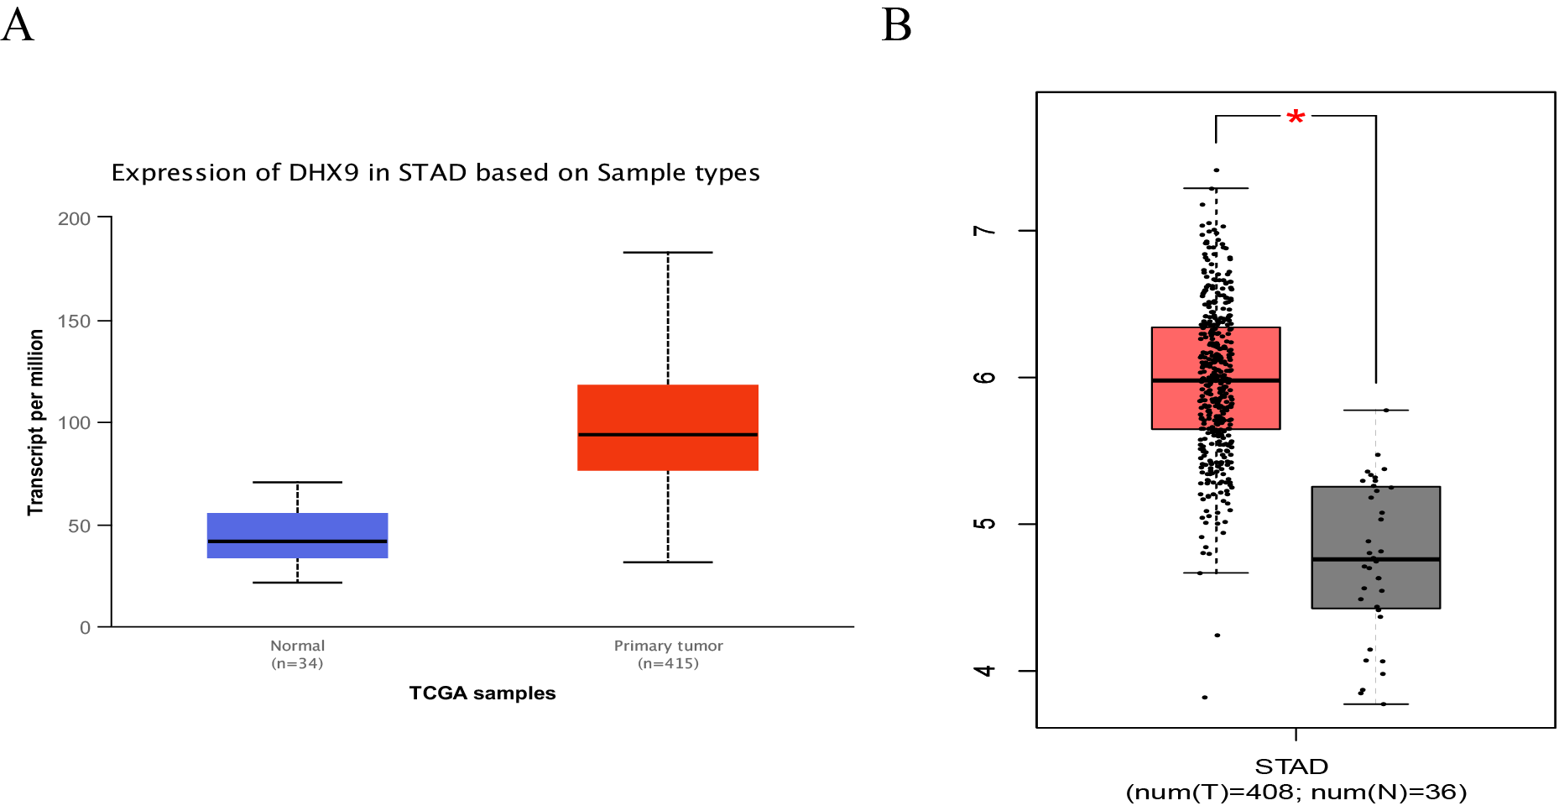

Fig. S2: The expression profile of DHX9 in TCGA and GEPIA databases.
- DHX9 expression in gastric cancer was searched in the TCGA database. B）The expression of DHX9 in GEPIA database.

Supplementary Table 1. Sequences of shRNAs and siRNAs
Name | shRNA Sequence
Sh-NC | CCGGTAGTCGCATACGGAACATTCGCTCGAGCGAATGTTCCGTATGCGACTATTTTTG
Sh-DHRS4-AS1 #1 | GAACTGTACTCTTACTCGAGTAAGAGTACAGTTCTGTCCTTTT
Sh-DHRS4-AS1 #2 | GCAGAGACCUUCCUGAAATTUUUCAGGAAGGUUCUCUGCTT
Sh-DHX9-NC | TTCTCCGAACGTGTCACGT
Sh-DHX9-1 | GGGCTATATCCATCGAAATTT
Sh-DHX9-2 | ACGACAATGGAAGCGGATATA
Si-ILF3 | CCUGUGUGAGAAAUCCAUU

Supplementary Table 2. Primers for RT-qPCR
Name | Primer Sequence
DHRS4-AS1-F | ATCTACCTTCCGCCTGACTGG
DHRS4-AS1-R | TCCAGAACTCGATGTGCTCCA
DHX9-F | GCCAATTTCTGGCCAAAGCA
DHX9-R | CGAGGCTCAATGGGGAGTTT
GAPDH-F | GGAAGCTTGCATCAATGGAAATC
GAPDH-R | TGATGACCCTTTTGGCTCCC

Supplementary Table 3. Antibodies used in the study
Name | Company | Catalog Number | Antibody solubility
Bcl-2 (Rabbit) | Abcam | Ab32124 | 1:1000
Bax (Mouse) | Proteintech | 60267-1-Ig | 1:5000
GAPDH (Mouse) | Proteintech | 60004-1-Ig | 1:5000
DHX9 (Rabbit) | Proteintech | 67153-1-Ig | 1:5000
DHX9 (Rabbit) | Abcam | Ab183731 | 1:5000
Ubiquitin (Mouse) | CST | #3936 | 1:1000
Normal Rabbit IgG (Mouse) | CST | #2729 | 1-5ug for IP
Mouse IgG (Mouse) | CST | #3420 | 1:20 for IP
MDM2 (Rabbit) | Abcam | Ab259265 | 1:1000
MDM2 (Mouse) | Abcam | Ab16895 | 1:1000
ILF3 (Rabbit) | Proteintech | 19887-1-AP | 1:5000
Flag (Rat) | Abcam | Ab213519 | 1:1000
Myc （Rabbit） | Abcam | Ab289980 | 1:5000
NF-κB(P65) (Rabbit) | CST | #8242S | 1:1000
p-P65 (Rabbit) | CST | #3033S | 1:1000
IκBα (Mouse) | Proteintech | 10268-1-AP | 1:5000
p-IκBα (Ser32) | CST | #2859S | 1:1000
β-Actin | CST | #3700S | 1:1000

Supplementary Table 4. Mass spectrometry of proteins pulled-down by lncRNA DHRS4-AS1 in AGS nucleus extracts
No. | Protein names | Gene names | LFQ intensity Antisense (Nuclear protein) | LFQ intensity Sense (Nuclear protein)
1 | Polyadenylate-binding protein 2 | PABPN2 | 0 | 61565000
2 | Polyadenylate-binding protein 1 | PABPC1 | 0 | 33842000
3 | GTP-binding nuclear protein Ran | RAN | 0 | 22228000
4 | ATP-dependent RNA helicase A | DHX9 | 0 | 18028000
5 | Interleukin enhancer-binding factor 3 | ILF3 | 0 | 12526000
6 | Protein MAL2 | MAL2 | 0 | 11381000
7 | Heterogeneous nuclear ribonucleoprotein Q | SYNCRIP | 0 | 8458800
8 | Interleukin enhancer-binding factor 2 | ILF2 | 0 | 8107800
9 | AMP deaminase 2 | AMPD2 | 0 | 8026300
10 | Elongation factor 1-beta | EEF1B2 | 0 | 7901300

Supplementary Table 5 The top 20 potential ubiquitin E3 ligase that target to DHX9
E3 | E3GENE | SUB | SUBGENE | HOMO | PFAM | GO | NET | MOTIF | SCORE
Q86TM6 | SYVN1 | Q08211 | DHX9 | 1 | 1.73 | 1.25 | 1.77 | 6.61 | 0.803
O60315 | ZEB2 | Q08211 | DHX9 | 1 | 3.18 | 2.88 | 1.77 | 1 | 0.77
Q9C035 | TRIM5 | Q08211 | DHX9 | 1 | 3.17 | 3.77 | 1 | 1 | 0.746
P22681 | CBL | Q08211 | DHX9 | 1 | 1 | 2.88 | 1.87 | 2.8 | 0.744
Q9Y252 | RNF6 | Q08211 | DHX9 | 1 | 1.73 | 1 | 1 | 6.61 | 0.742
Q00987 | MDM2 | Q08211 | DHX9 | 1 | 1 | 2.93 | 1.7 | 2.8 | 0.737
P19474 | TRIM21 | Q08211 | DHX9 | 1 | 2.47 | 3.77 | 1 | 1 | 0.725
Q86Y01 | DTX1 | Q08211 | DHX9 | 1 | 1.73 | 2.88 | 1.84 | 1 | 0.724
Q14258 | TRIM25 | Q08211 | DHX9 | 1 | 3.17 | 1.25 | 1 | 2.12 | 0.716
P14373 | TRIM27 | Q08211 | DHX9 | 1 | 2.47 | 1.78 | 1.69 | 1 | 0.705
Q9HCE7 | SMURF1 | Q08211 | DHX9 | 1 | 1 | 4.05 | 1.69 | 1.06 | 0.703
Q9UM11 | FZR1 | Q08211 | DHX9 | 1 | 1 | 1.78 | 1.77 | 2.12 | 0.695
Q99973 | TEP1 | Q08211 | DHX9 | 1 | 1 | 3.77 | 1.77 | 1 | 0.695
Q96Q27 | ASB2 | Q08211 | DHX9 | 1 | 1 | 1 | 1 | 6.61 | 0.694
Q96PU5 | NEDD4L | Q08211 | DHX9 | 1 | 1 | 2.33 | 1.29 | 2.12 | 0.691
Q9NZS9 | BFAR | Q08211 | DHX9 | 1 | 3.17 | 1.51 | 1.29 | 1 | 0.688
Q9UNE7 | STUB1 | Q08211 | DHX9 | 1 | 1 | 3.77 | 1.87 | 1 | 0.676
Q15751 | HERC1 | Q08211 | DHX9 | 1 | 2.47 | 1.25 | 1.77 | 1 | 0.676
Q8TEQ6 | GEMIN5 | Q08211 | DHX9 | 1 | 1 | 3.77 | 1.7 | 1 | 0.676

