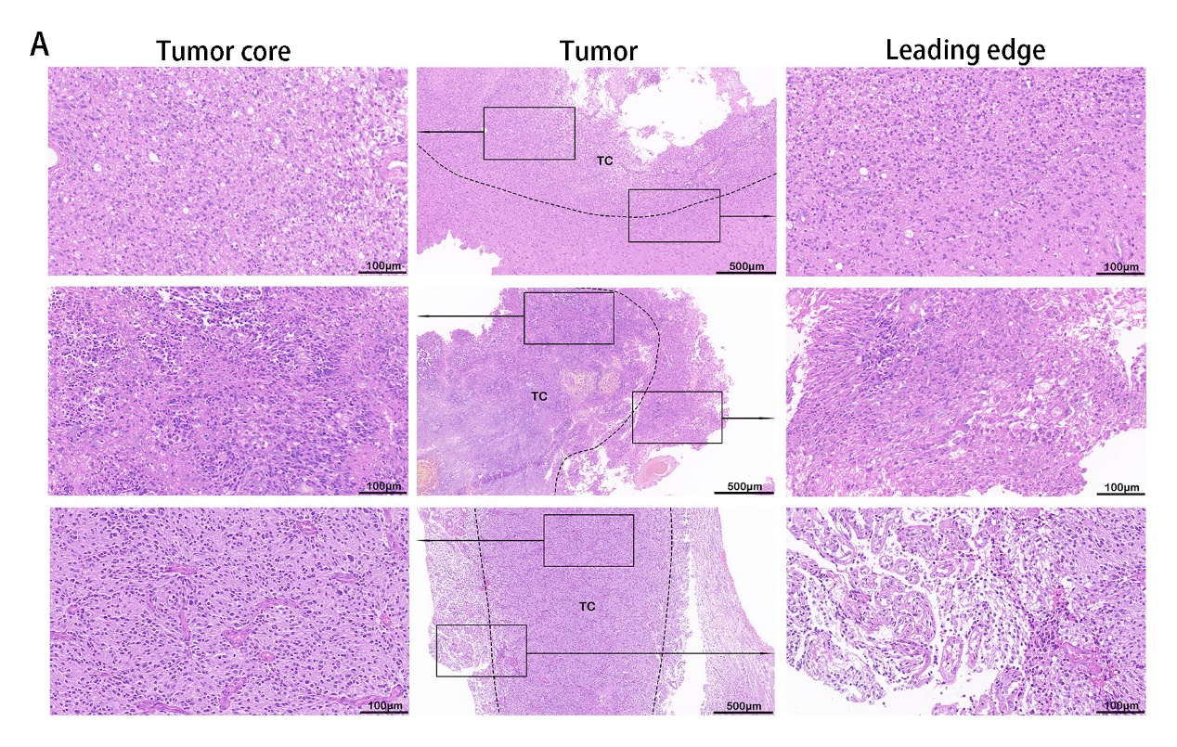
Fig. S1 H&E staining of GBM tissue. (A) H&E staining of GBM tissue (the middle and rest scale bar are 500 μm and 100 μm, respectively)

