Additional Figure 1 Total Ion Chromatogram peak of the top 10 metabolites from negative ion model.
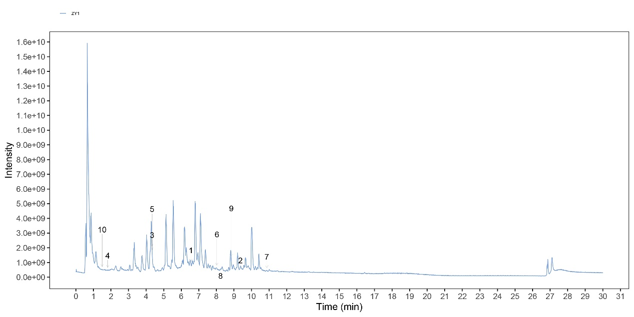
Additional Figure 2 Total Ion Chromatogram peak of the top 10 metabolites from positive ion model.
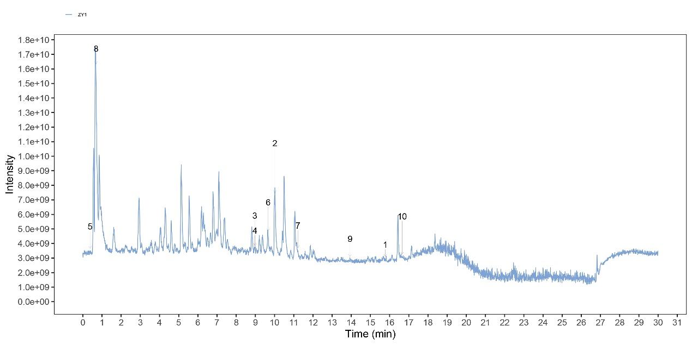

Additional Figure 3 Analysis of marker species of intestinal flora. A. MetagenomeSeq test results in the Model and the Higher Dose group. B. The log2 values of the top five ASV/OUT and ASV/OTU multiples that were significantly up- and down-regulated. Positive values represent upregulation in M group compared with H or L group. C. Histogram of distribution of LDA values for significantly different species. D. Taxonomic branching diagram showing taxonomic hierarchy relationships from phylum to genus in each taxon sample.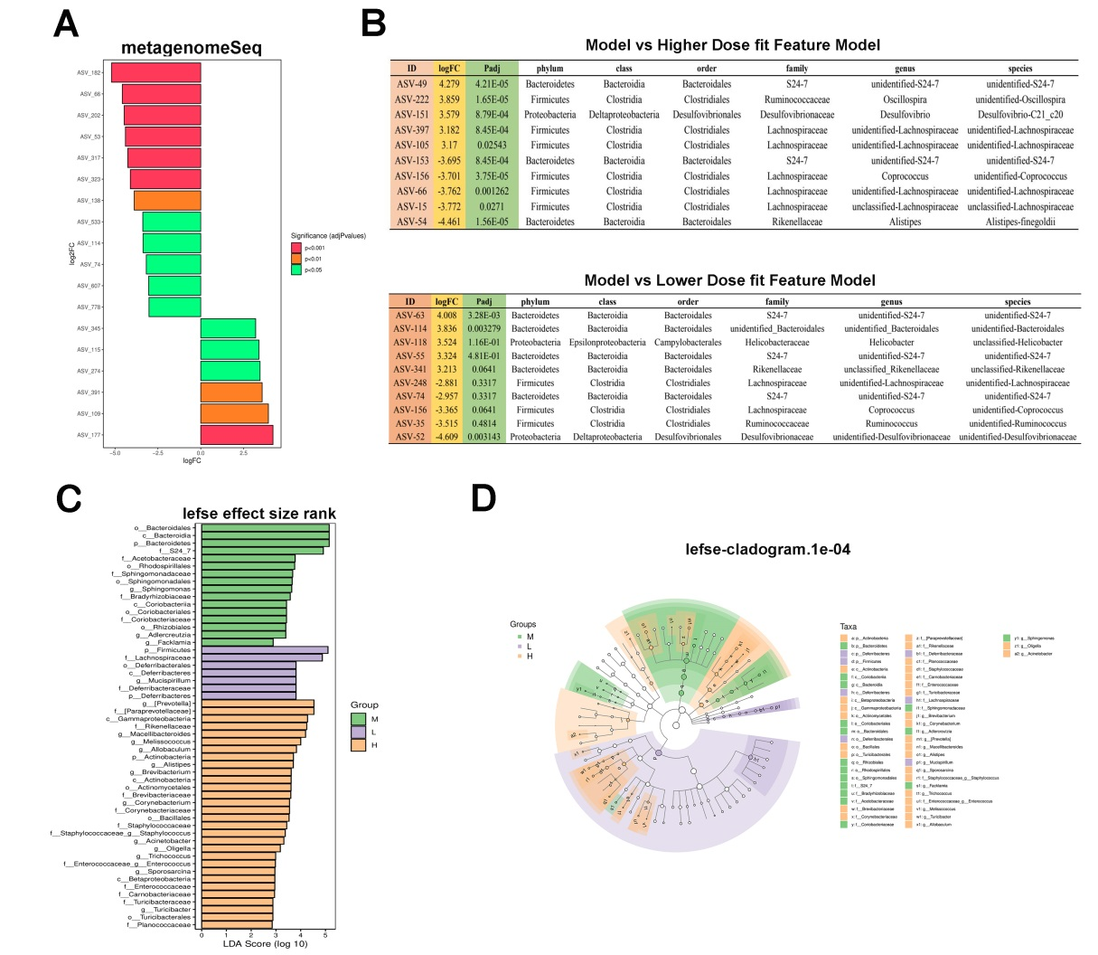

Additional Figure 4. PCA and OPLS-DA analysis of differential species. A. Two-dimensional sorting diagram of samples for PCA analysis. B. Sorting diagram of samples for OPLS-DA discriminant analysis.
