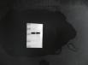
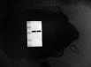
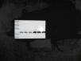
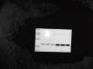
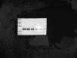
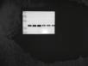
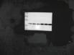
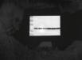
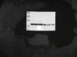
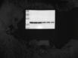
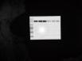
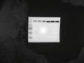
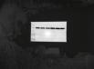
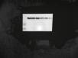
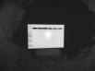
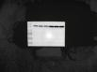
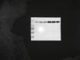
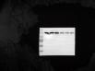
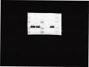
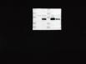
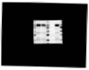
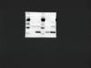
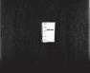
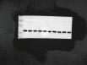
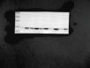
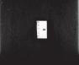
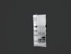
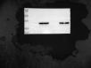
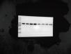
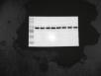
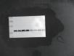
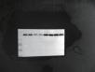
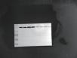
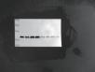
Figure 2
HepG2-OE
Figure 1 F
A Huh7-OE


Figure 2
D Huh7 overexpression proliferative marker
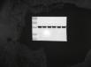
HepG2-SH
E Huh7-SH
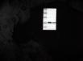
H Huh7 knockdown proliferation marker assay
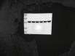

HepG2 overexpression proliferative marker
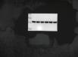

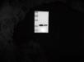
HepG2 knockdown proliferation marker assay
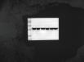

Figure 3
DHepG2 overexpression migration marker detection
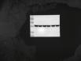
I HepG2-shSTX6-migration marker detection
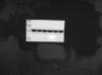

EHuh7 overexpression migration marker detection
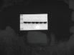
J Huh7-shSTX6-migration marker detection
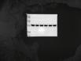

Figure 4
B
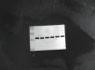

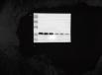

G
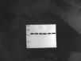

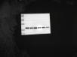

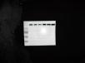

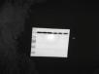

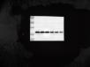

Figure 5
G

IP-HA

(right）IN-H-HA-AM

IP-FLAG

(left)IN-F-FLAG-AM
H
IP-HA

(right）IN-H-HA-AM
IP-FLAG

(left)IN-F-FLAG-AM
I

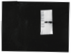
IN-H-FLAG-AM
(left)IN-F-HA-AM
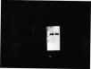
IN-H-FLAG-AM
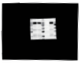
(left)IN-F-HA-AM
J

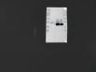
IP-H-FLAG-AM
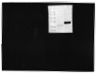
IP-F-FLAG-AM
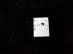
IP-H-FLAG-AM
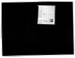
IP-F-FLAG-AM

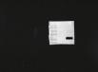
IP-H-HA-AM
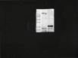
IP-F-HA-AM
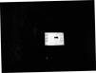
IP-H-HA-AM
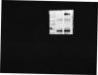
IP-F-HA-AM

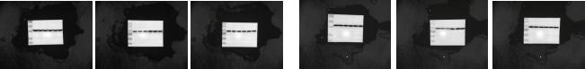

K
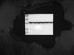
M
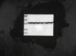

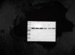

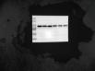

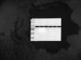

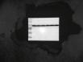

L


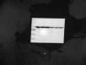

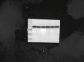

Figure 6
A
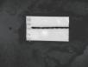
D
