Supplementary Information

Chrysophanol inhibits of colorectal cancer cell motility and energy metabolism by targeting the KITENIN/ErbB4 oncogenic complex

Mücahit Varlı ¹, Eunae Kim ², Songjin Oh ¹, Sultan Pulat ¹, Rui Zhou ¹, Chathurika D.B. Gamage ¹, Barış Gökalsın ³, Nüzhet Cenk Sesal ³, Kyung Keun Kim ⁴, Man-Jeong Paik ¹, Hangun Kim ¹, *

¹College of Pharmacy, Sunchon National University, Sunchon, Republic of Korea; mucahitvarli@s.scnu.ac.kr (M.V.), osj7797@naver.com (S.O.); sultanpulat@s.scnu.ac.kr (S.P); zhourui274@gmail.com (R.Z.); chathurika.gamage@gmail.com (C.D.B.G.); paik815@sunchon.ac.kr (M.-J.P.).
²College of Pharmacy, Chosun University, 146 Chosundae-gil, Gwangju 61452, Republic of Korea; eunaekim@chosun.ac.kr (E.K.).
³ Faculty of Arts and Sciences, Department of Biology, Marmara University, Istanbul, Türkiye; baris.gokalsin@marmara.edu.tr (B.G.); cses-al@marmara.edu.tr (N.C.S.).
4 Department of Pharmacology, Chonnam National University Medical School, 160 Baekseoro, Gwangju 61469, Republic of Korea; kimkk@chonnam.ac.kr (K.K.K.).
* Correspondence: hangunkim@scnu.ac.kr (H.K.)

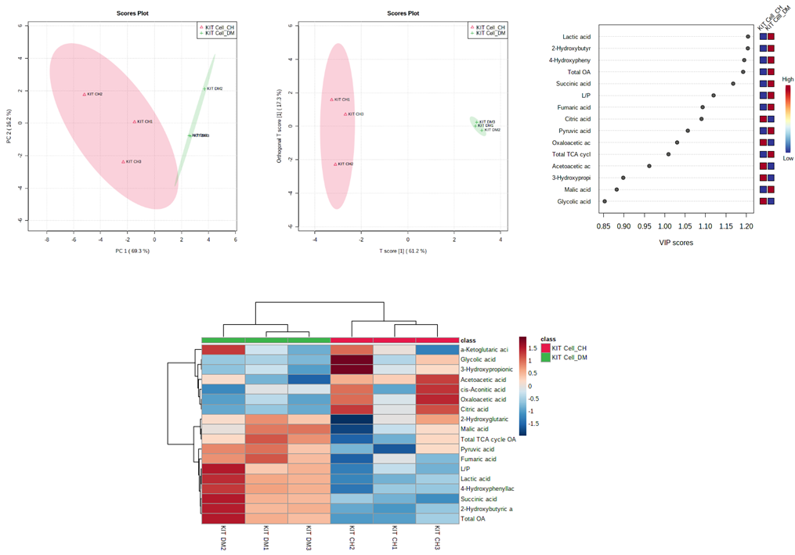
Supplementary Figure 1. PCA, OPLS-DA, VIP score, and heatmap analysis for CaCo2/KITENIN cell with DMSO and chrysophanol treatment.

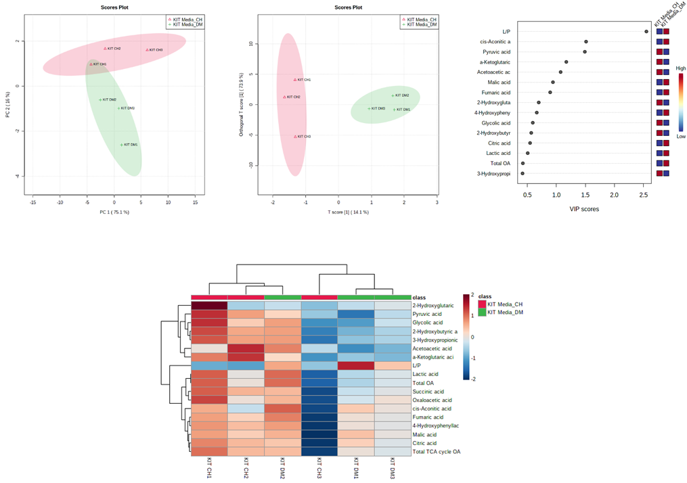

Supplementary Figure 2. PCA, OPLS-DA, VIP score, and heatmap analysis for CaCo2/KITENIN media samples treatment by DMSO and chrysophanol treatment.

Supplementary Table 1. qRT-PCR primers
Primers sequences
Gene symbol | For (5'-3') | Rev (5'-3')
GLUT1 | CTTTGTGGCCTTCTTTGAAGT | CCACACAGTTGCTCCACAT
HK2 | AAGGCTTCAAGGCATCTG | CCACAGGTCATCATAGTTCC
PKM1 | CGAGCCTCAAGTCACTCCAC | GTGAGCAGACCTGCCAGACT
PKM2 | ATTATTTGAGGAACTCCGCCGCCT | ATTCCGGGTCACAGCAATGATGG
LDHA | TGGCCTGTGCCATCAGTATC | TTCCAAGCCACGTAGGTCAA
β-catenin | AAAATGGCAGTGCGTTTAG | TTTGAAGGCAGTCTGTCGTA
c-Myc | AATGAAAAGGCCCCCAAGGTAGTTATCC | GTCGTTTCCGCAACAAGTCCTCTTC
Cyclin D1 | CCGTCCATGCGGAAGATC | GAAGACCTCCTCCTCGCACT
hnRNPI (PTBP1) | TCAGGCCTTCATCGAGATGCACA | TCTTGAGCTCCTTGTGGTTGGA
hnRNPA1 | GCTCACGGACTGTGTGGTAA | GGCCTTGCATTCATAGCTGC
hnRNPA2 | GGAGTGGAAGAGGAGGCAAC | CAGGTCCTCCTCCATACCCA
β-actin | ATTGTGAACTTTGGGGGATG | GATGAGATTGGCATGGCTTT

Supplementary Table 2. Antibody information
Antibodies
Alpha tubulin (11h101) Rabbit mAb | Cell signaling | #2125
GAPDH (D16H11) XP Rabbit mAb | Cell signaling | #5174
Goat Anti-Rabbit IgG (H+L) Peroxidase Conjugated | Thermo scientific | 31460
Goat Anti-Mouse IgG (H+L) Peroxidase Conjugated | Thermo scientific | NCI1430KR
PKM2 (D78A4) XP Rabbit mAB | Cell signaling | #4053
GLUT1 (D3J3A) Rabbit mAB | Cell signaling | #12939
LDHA (C4B5) Rabbit mAB | Cell signaling | #3582
Beta-actin antibody | Cell signaling, #4967 | #4967
Hexokinase II (C64G5) Rabbit mAb | Cell signaling, #2867 | #2867
Anti-cyclin D1 Ab-3 mouse mAB | Merck, Kenilworth, NJ, USA | DCS-6
PKM1 (D30G6) Rabbit mAB | Cell signaling | #7067
Anti-VANGL1 | Atlas antibodies | HPA025235
c-Myc (9E10) | Santa Cruz Biotech. | sc-40
HER4/ErbB4 (111B2) Rabbit mAb | Cell signaling | #4795
Vangl1 (E-3) | Santa Cruz Biotech. | sc-166844

