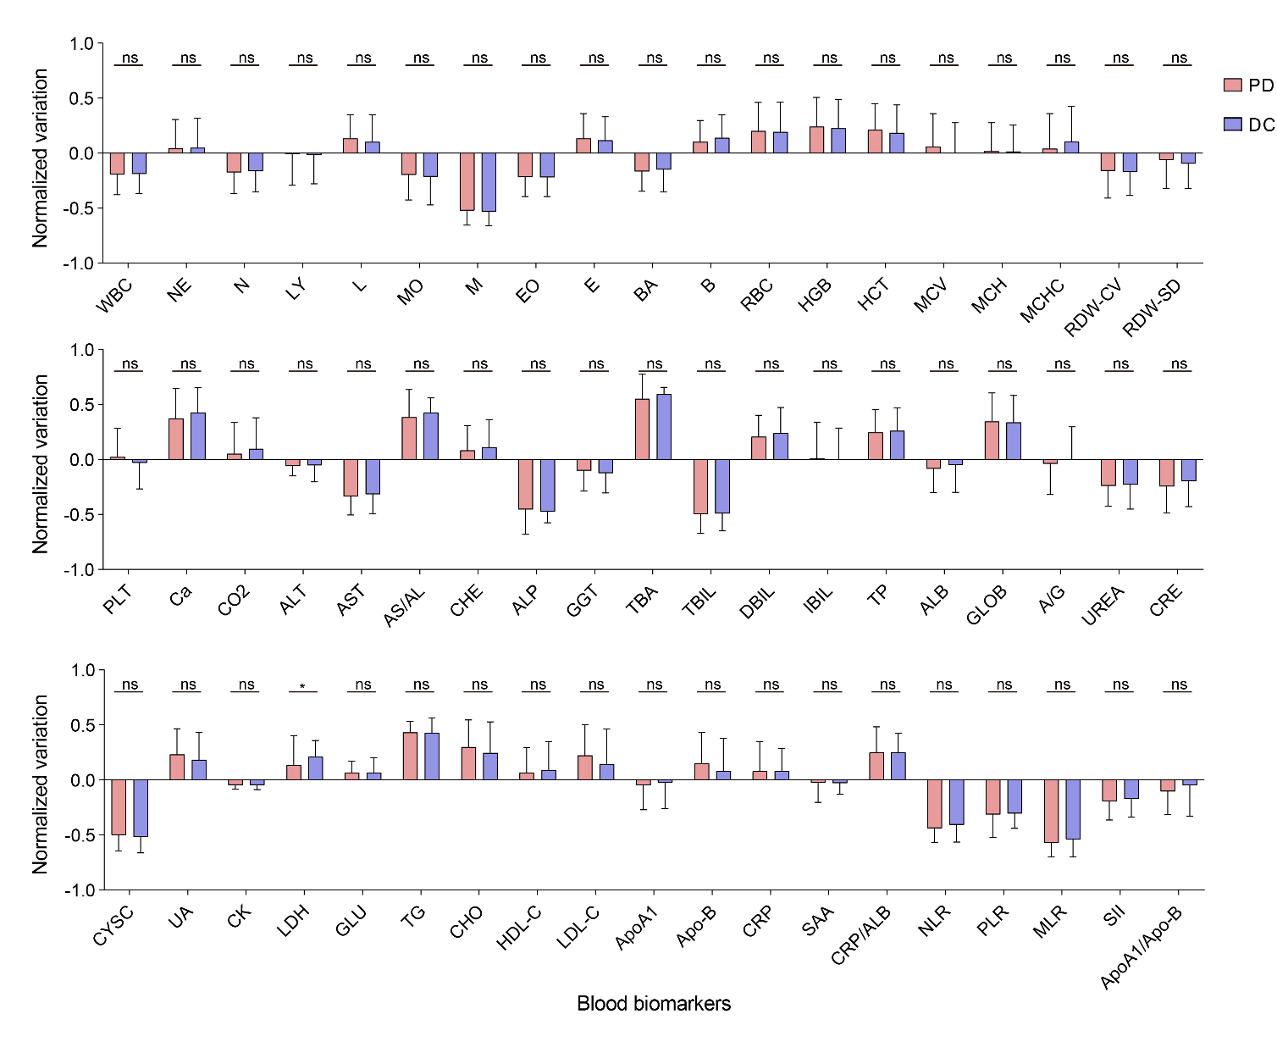
Fig. S1. Statistical analysis of blood biomarkers of training dataset. * denotes p<0.05, ** denotes p<0.01, *** denotes p<0.001, ns denotes not significant.

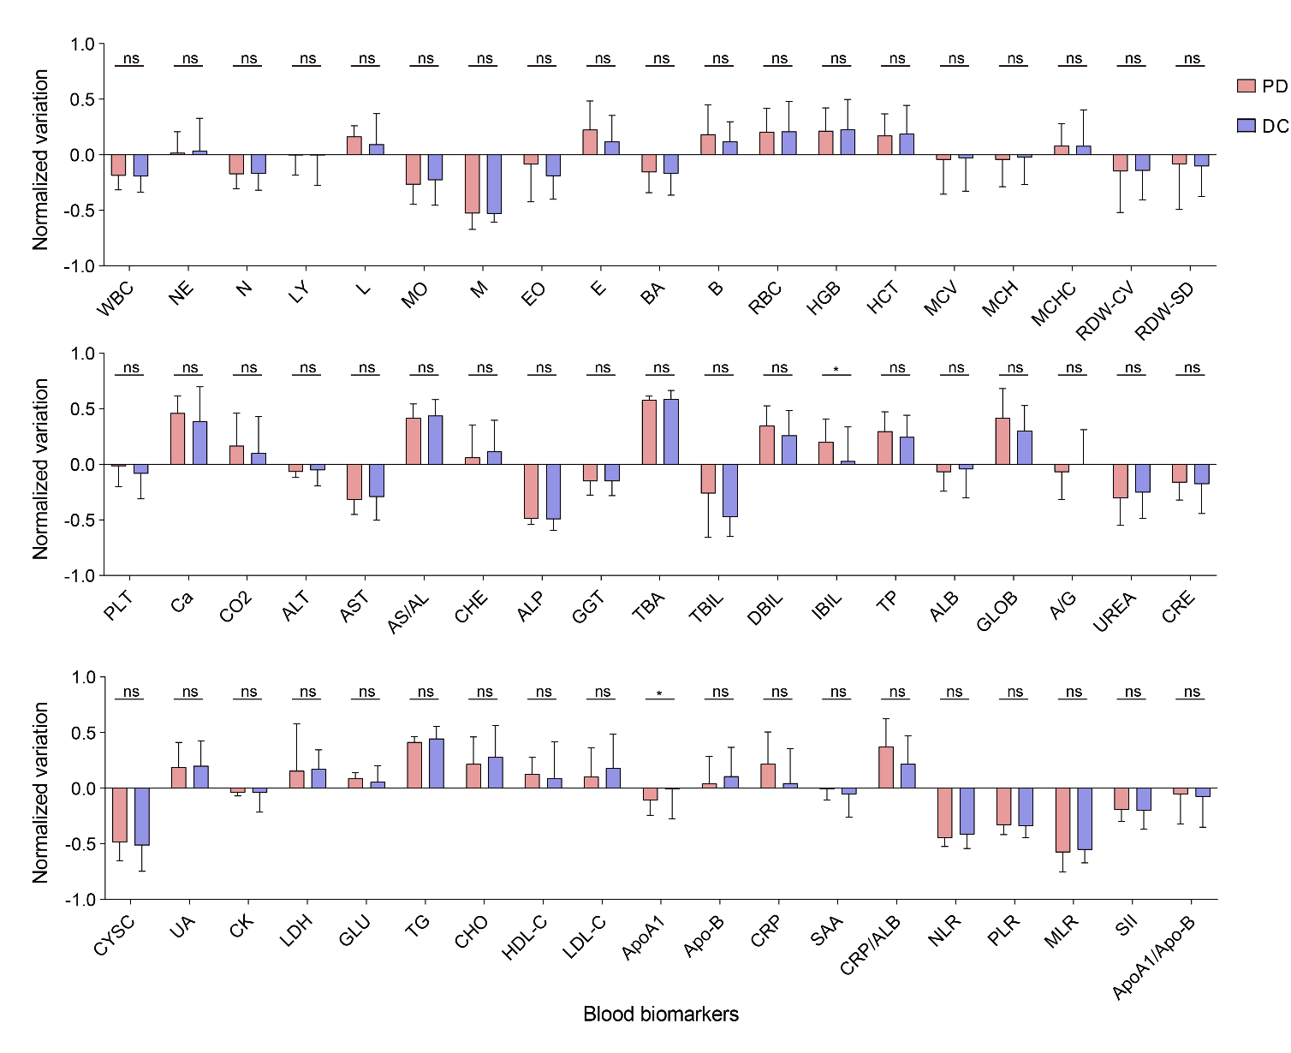
Figure S2. Statistical analysis of blood biomarkers of testing dataset. * denotes p<0.05, ** denotes p<0.01, *** denotes p<0.001, ns denotes not significant.

