Supplementary Figure
Supplementary Figure S1
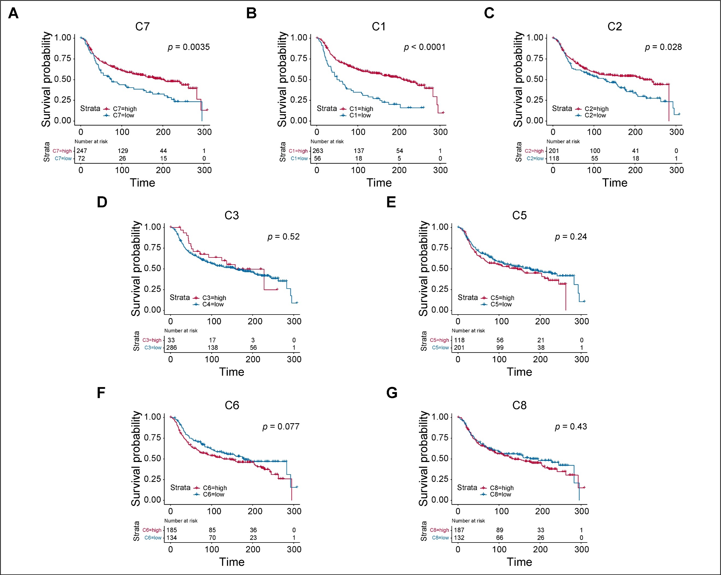
Figure S1 The overall survival of patients with high- and low- abundance of distinct tumor subgroup. A-G Kaplan-Meier curves showing the prognostic outcome of TNBC patients with the filtration level of C7 (A), C1 (B), C2 (C), C3 (D), C5(E), C6 (F), C8 (G).

Supplementary Figure S2
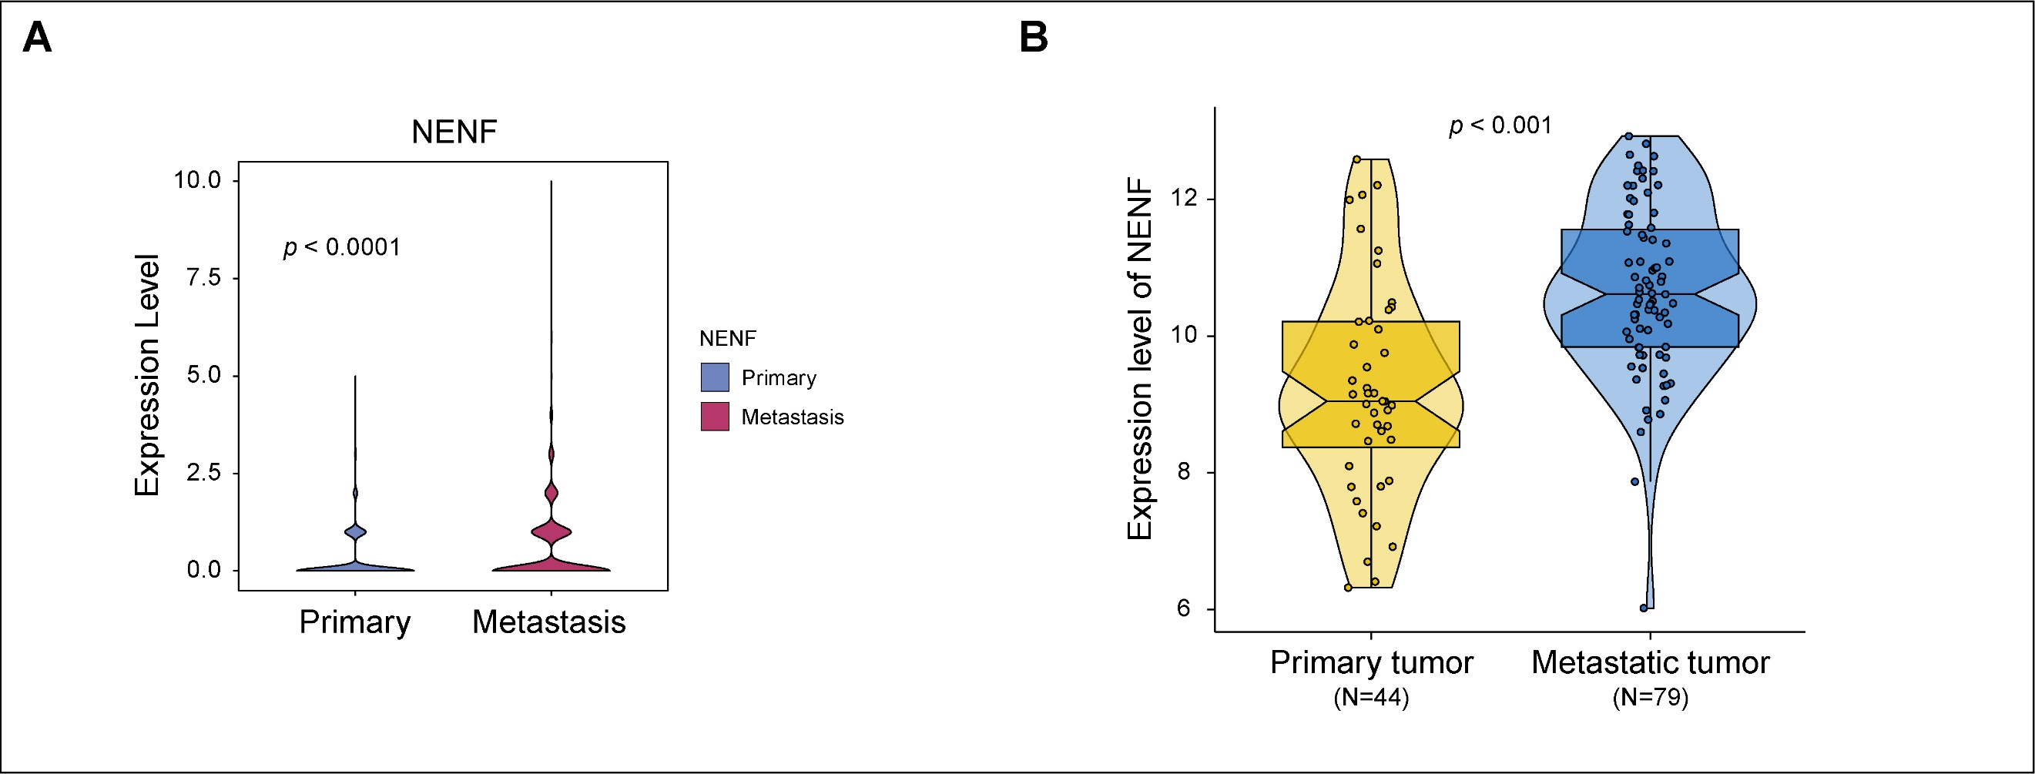
Figure S2 The expression level of NENF in breast cancer. A The expression level of NENF in primary malignant cells and metastatic malignant cells in single-cell RNA datasets. B The expression level of NENF in primary and metastatic breast tumor based on GSE209998.

