Supplementary Materials:
Figure S1. The correlation between the expression levels of HECW2 and Stromal score, Immune score and ESTIMATE score.
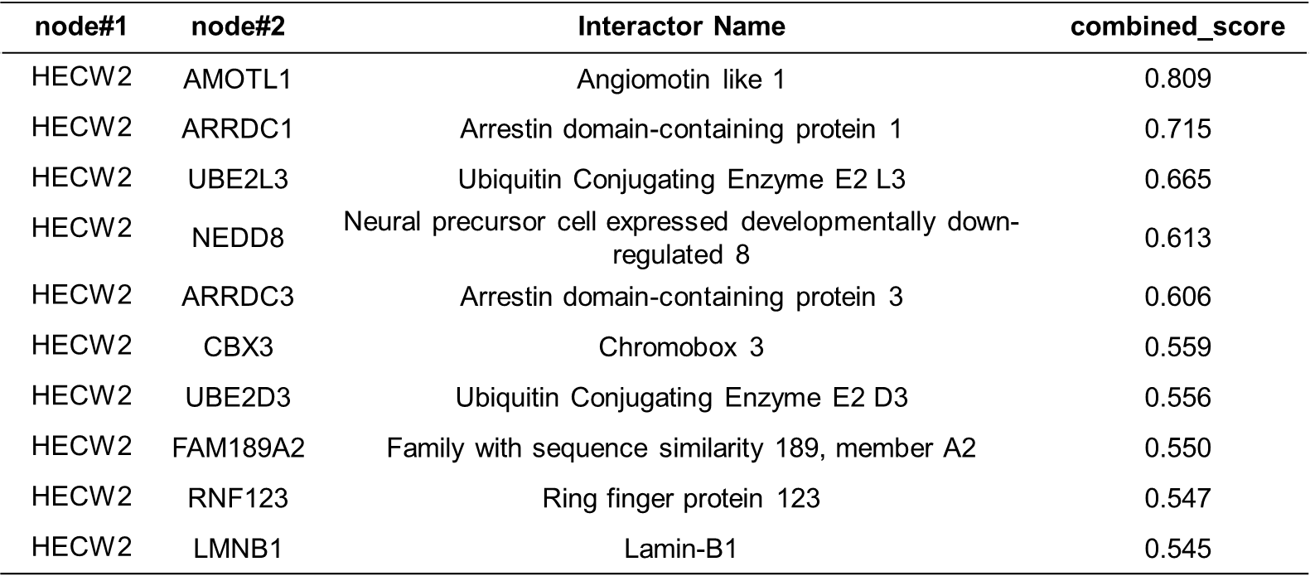
Table S1. Proteins interacting with HECW2 in STRING database.

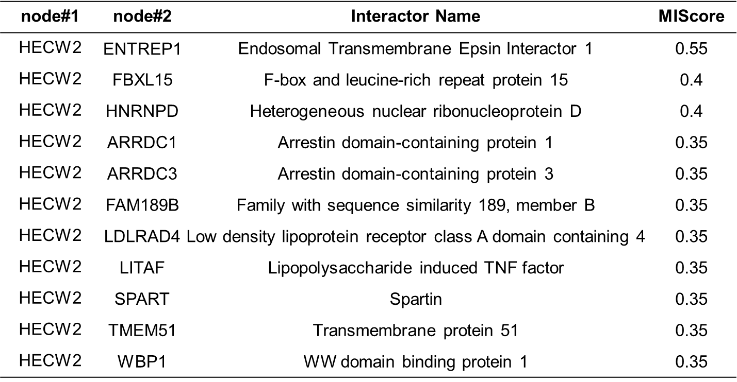
Table S2. Proteins interacting with HECW2 in IntAct database.
Table S3. Molecules interacting with HECW2 were analyzed using the BioGrid and BioPlex databases.
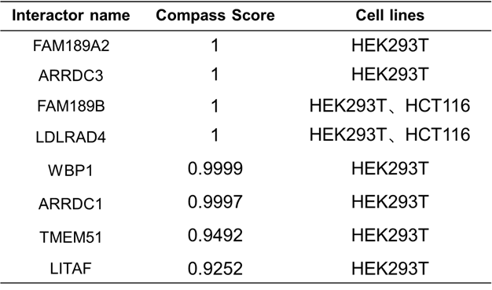

Table S4. Known ubiquitination substrates of HECW2.
