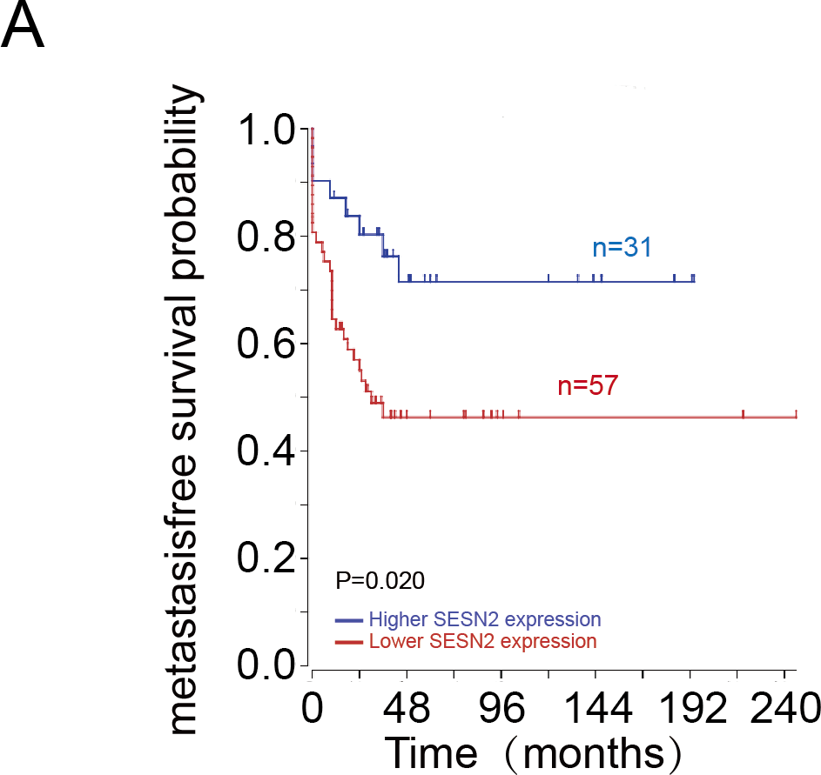
Figure S1 Kaplan–Meier curves showing the association between SESN2 expression and metastasisfree survival
A. Kaplan–Meier curves showing the association between SESN2 expression and metastasisfree survival.

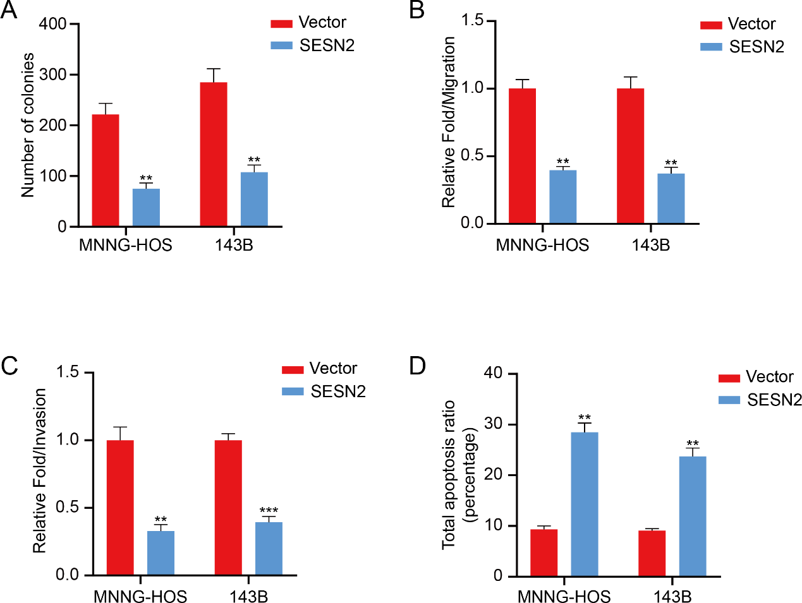

Figure S2 SESN2 attenuates OS cell progression through activating the mTOR pathway
A. Quantification of colonies from the Figure 5D. Values are means ± SD *p<0.05, **p < 0.01, *** p < 0.001 (Student's t-test).
B and C. The migration and invasion relative-folds were normalized against vehicle cells from the Figure 5E, F. Values are means ± SD, ***p<0.001 (Student's t-test).
D. Quantification of apoptosis ratio from the Figure 5G, H. Values are means ± SD *p<0.05, **p < 0.01, *** p < 0.001 (Student's t-test).
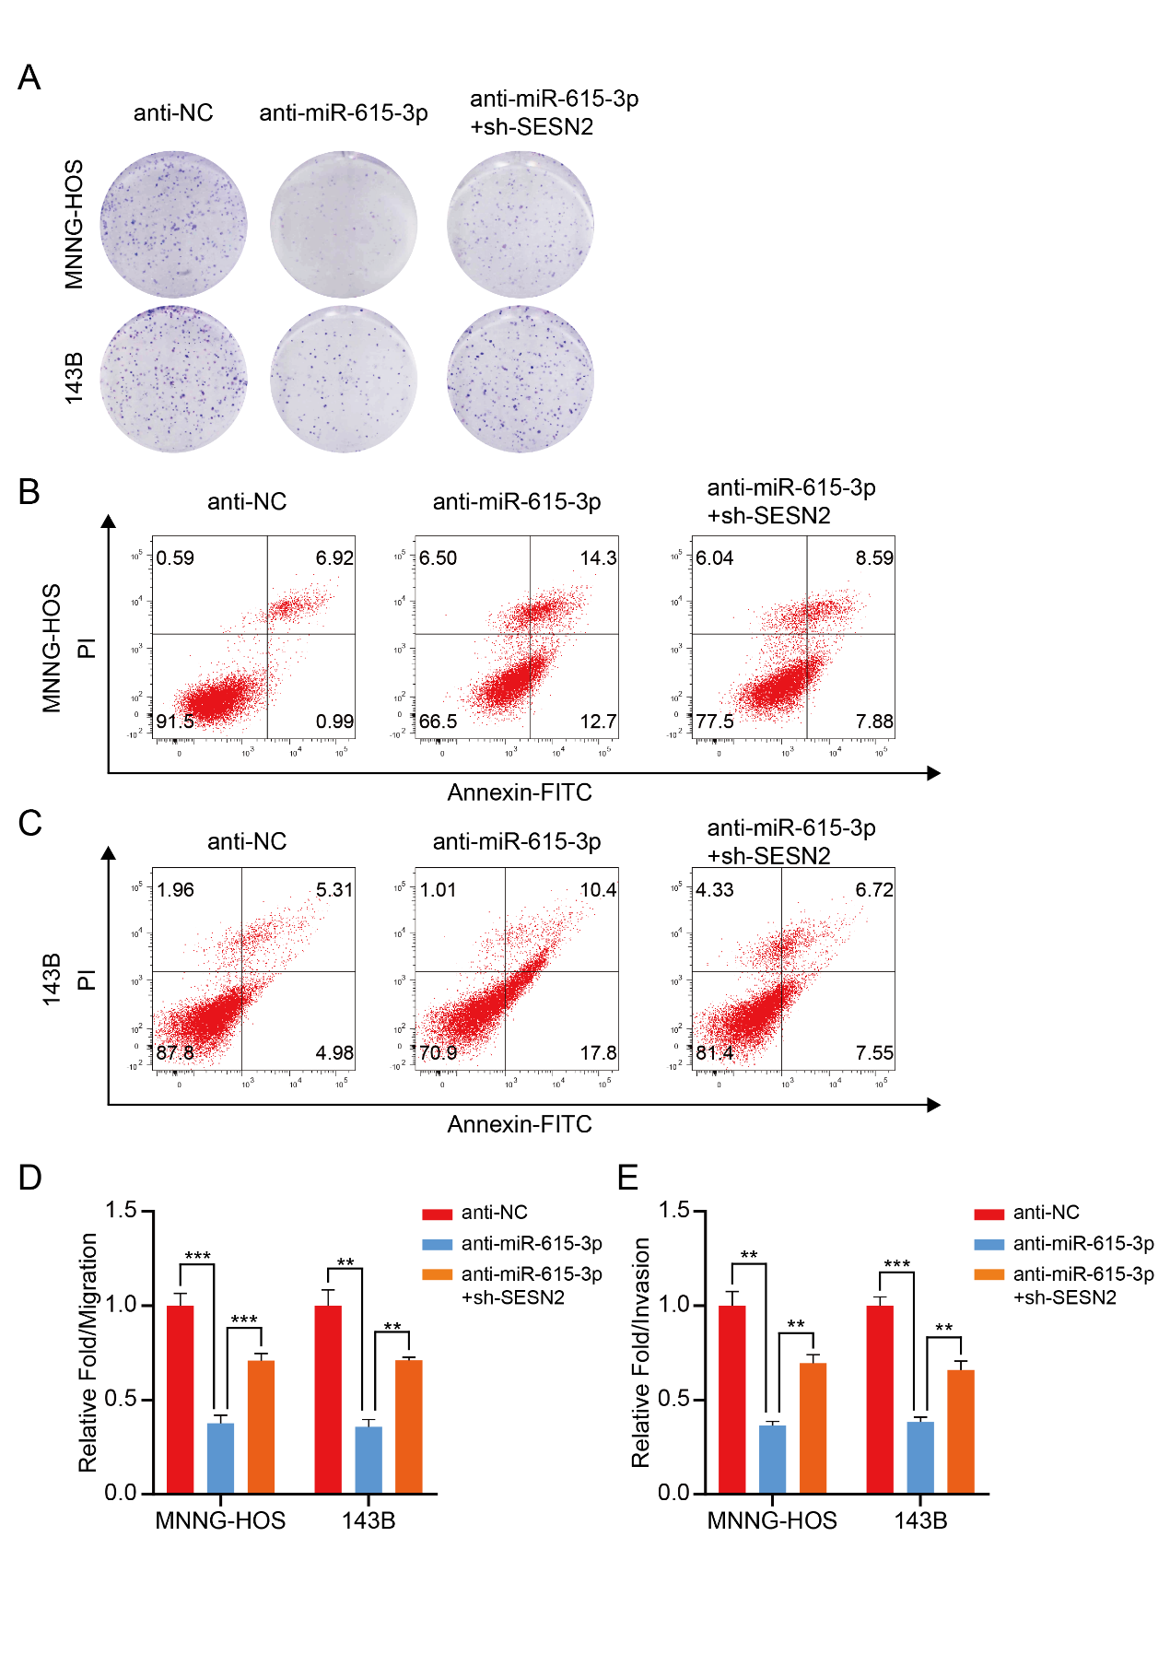
Figure S3 miR-615-3p promotes OS development via SESN2-mediated mTOR pathway
A. Representative images of OS colony formation assay in different groups (anti-NC, anti-miR-615-3p, anti-miR-615-3p + sh-SESN2) are shown.
B and C. Representative images of cell apoptosis assay in different groups (anti-NC, anti-miR-615-3p, anti-miR-615-3p + sh-SESN2) are shown.
D and E. The migration and invasion relative-folds were normalized against vehicle cells from the Figure. 6F, G. Values are means ± SD *p<0.05, **p < 0.01, *** p < 0.001 (Student's t-test).

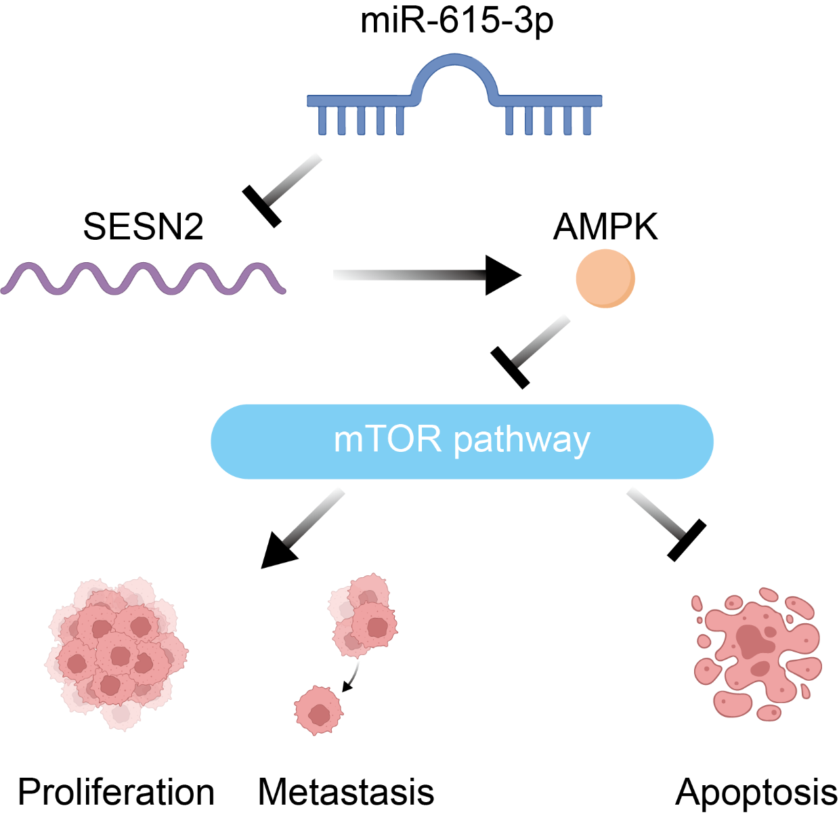
Figure S4 miR-615-3p promotes osteosarcoma progression via the SESN2/AMPK/mTOR pathway
Schematic diagram showing the mechanism of HOTAIRM1 stimulating proliferation in OS.

