The expression landscape and clinical significance of methyltransferase-like 17 in human cancer and hepatocellular carcinoma: a pan-cancer analysis using multiple databases

Methods
Genetic alterations and genomic heterogeneity analysis
We analyzed the samples from Primary Blood-Derived Cancer-Peripheral Blood, Primary Tumors. Simultaneously, we obtained the Simple Nucleotide Variation dataset for TCGA that were processed using the MuTect2 program from Genomic Data Commons (GDC) (https://portal.gdc.cancer.gov/). Next, we integrated the mutation data and gene expression data from the samples.

Analysis of immune cell inﬁltration for METTL17
ESTIMATE is an algorithm that quantiﬁes the immune inﬁltration level in tumor samples based on gene expression data, which can reﬂect the diversity of the stroma and immune cells. In this study, the estimate package in R was used to estimate the content of stromal cells and immune cells in pan-cancer. The immune, matrix and ESTIMATE scores of METTL17 expression were evaluated using the ESTIMATE algorithm.

Diverse landscapes of METTL17 expression among hepatocellular carcinoma
Firstly, we examined the RNA and protein expression levels of METTL17 in each HCC cell line using the HPA database (https://www.proteinatlas.org/ENSG00000165792-METTL17/cell+line). Subsequently, our group evaluated bulk RNA data from human and mouse organoids to identify variations in METTL17 expression among different organoids (http://www.inbirg.com/organoid_db/genes). To uncover the correlation between circulating tumor cells (CTCs) and METTL17 expression, we analyzed the expression of METTL17 at each site in primary or metastatic HCC, utilizing Bulk RNA data from the ctcRbase database. (http://www.origin-gene.cn/database/ctcRbase/detail.php?entry_ID=LIHC04488).

Clinical Analysis on METTL17 and its related prognostic state in HCC.
We extracted the expression data of the ENSG00000165792 (METTL17) gene from the University of California Santa Cruz (UCSC) (https://xenabrowser.net/) database. We analyzed METTL17 expression levels in both HCC and non-tumor groups using the “limma” package in the R package (V3.6.2). Multivariate Cox analysis was applied to analyze the inﬂuence of METTL17 expression on prognosis along with other clinicopathologic factors (TNM stage, Histologic grade, Age, and Gender). The importance of METTL17 in predicting overall survival (OS), disease-speciﬁc survival (DSS), and disease-free interval (DFI) was assessed using Kaplan-Meier survival analysis. Median of METTL17 expression level was chosen as the cut-off value. In all tests, P < 0.05 was deﬁned statistically signiﬁcant.

Results
Genetic alterations and genomic heterogeneity analysis
The structural domain information of METTL17 was acquired via the R package maftools (version 2.2.10), as depicted in Figure S2A. Our research revealed a significant association between METTL17 and copy number variation (CNV) in patients with GBM, GBMLGG, LGG, CESC, LUAD, COADREAD, BRCA, ESCA, STES, SARC, KIPAN, STAD, PRAD, HNSC, KIRC, LUSC, LIHC, OV, BLCA, and ACC (P < 0.05) (Figure S2B) (Table S5). Following the completion of data processing, we obtained expression data for single nucleotide variant (SNV) or SNV with synonymous mutations for a total of six or seven tumors, respectively (Figure S2 C-D) (Table S6-7).

Figure S3A demonstrated a positive correlation between METTL17 expression and tumor mutational burden (TMB) in COADREAD, ESCA, STES, STAD, READ, and TGCT. However, a negative connection was observed in LAML (P < 0.05). In the context of mutant-allele tumor heterogeneity (MATH), the expression of METTL17 was found to be positively associated with MATH in LUAD, ESCA, OV, and KICH, but negatively associated in COADREAD, PRAD, and READ (P < 0.05) (Figure S3B). The expression of METTL17 was positively correlated with the Neoantigen (NEO) in COAD, COADREAD, and PRAD (P < 0.05) (Figure S3C). In addition, there is a positive correlation between the expression of METTL17 and ploidy in LGG and STES, while a negative association was displayed in BLCA (Figure S3F). A substantial association was found between the expression of METTL17 and microsatellite instability (MSI) (Figure S3D), tumor purity (Figure S3E), homologous recombination deficiency (HRD) (Figure S3G), and loss of heterozygosity (LOH) (Figure S3H) in most cancer cases (P < 0.05).

Analysis of immune cell inﬁltration for METTL17
In LAML, the expression of METTL17 showed a significant and positive correlation with the infiltration of immune cells. However, in GBM, GBMLGG, LGG, UCEC, TCGA-BRCA, LUAD, STES, SARC, KIRP, KIPAN, COAD, COADREAD, STAD, HNSC, KIRC, LUSC, THYM, LIHC, WT, SKCM, BLCA, SKCM-M, THCA, NB, OV, PAAD, ACC, and CHOL, the expression of METTL17 was negatively correlated with immune cell infiltration (Figure S6).

Diverse landscapes of METTL17 expression among hepatocellular carcinoma.
Initially, we examined the RNA and protein expression levels of METTL17 in 24 HCC cell lines, as demonstrated in Figure S7A. Subsequently, we examined bulk-RNA data from human and mouse organoids to identify variations in METTL17 expression across various organoids, including the liver (Figure S7B-C). The expression of METTL17 in HCC tissues (median = 42.34, range = 19.87 to 51.69) was markedly elevated compared to that in normal liver tissues (median = 9.17, range = 6.45 to 19.3), as determined by comparing the Bulk RNA data of human organoids (Figure S7D). Nevertheless, mouse organoid data indicate a markedly elevated expression of METTL17 in HCC tissues (median = 9.01, range = 2.78 to 15.24), yet bulk RNA data for METTL17 in normal liver tissues are absent (Figure S7E). To uncover the correlation between CTCs and METTL17 expression, we analyzed 137 CTCs’ RNA sequencing data. The results showed that the METTL17 had a higher expression in the CTCs (median = 4.8, range = 0.94 to 6.32) than the local site (median = 2.74, range = 1.05 to 4.72) but lower than white blood cell (WBC) (median =5.68, range = 0.76 to 6.71) (Figure S7F). Among metastatic HCC, the METTL17 expression in CTCs (median = 0.58, range = -0.56 to 1.32) is lower compared to the local site (median = 1.6, range = 0.46 to 2.73), adrenal gland (median = 1.28, range = 1.01 to 1.46), lymph node (median = 1.2, range = 1.16 to 1.37), and lung (median =1.14, range = 0.96 to 1.36) (P<0.05) (Figure S7G).

The Connection Between the Expression Level of METTL17 and Clinicopathologic Variables in HCC.
Figure 3B shows notable gender differences in METTL17 levels across HCC patients (P = 0.03). Nevertheless, no notable association was observed between age and METTL17 expression (Figure 3C). Figure S8A illustrates that a higher level of METTL17 was strongly associated with the histological grade (P = 0.019). However, there was no significant link with the pathologic stage (P = 0.21) as shown in Figure S8B.

Kaplan–Meier survival plots comparing the low and high expression of METTL17 in HCC
The OS rates of HCC patients were significantly increased among samples with lower expression of METTL17 than patients with higher expression of METTL17 (P = 0.004) (Figure S9A). Furthermore, DSS and PFI in the lower METTL17 cohort were significantly longer than the higher METTL17 cohort (P = 0.002 and P = 0.00071) (Figures S9B-C). We also have validated the prognostic value of METTL17 in the HCC dataset, and the results indicated that higher expression of METTL17 was signiﬁcantly related to poor prognosis (P = 0.000053) (Figure S9D).

Table S1. METTL17 expression in pan-cancer

Tumor type | Tumor tissues | Normal tissues | P value
GBM | 5.14±0.68 | 4.98±1.12 | 3.50E-05
GBMLGG | 5.08±0.58 | 4.98±1.12 | 1.40E-09
LGG | 5.06±0.55 | 4.98±1.12 | 2.00E-07
UCEC | 5.29±0.64 | 4.82±0.46 | 1.30E-04
KIRP | 5.14±0.59 | 4.77±0.67 | 3.50E-11
KIPAN | 4.93±0.69 | 4.77±0.67 | 5.40E-04
HNSC | 4.80±0.67 | 4.11±0.50 | 4.90E-11
WT | 5.11±0.57 | 4.77±0.67 | 4.50E-09
ALL | 4.33±0.84 | 3.12±1.21 | 3.30E-25
LAML | 5.85±0.51 | 3.12±1.21 | 7.10E-72
KICH | 5.02±0.52 | 4.77±0.67 | 6.50E-04
CHOL | 5.49±0.48 | 3.94±0.30 | 2.30E-09
BRCA | 4.82±0.56 | 5.72±0.82 | 8.50E-58
CESC | 5.57±0.60 | 6.20±0.86 | 2.70E-03
LUAD | 4.96±0.66 | 5.68±0.92 | 1.70E-38
ESCA | 4.64±0.50 | 6.02±0.54 | 6.00E-82
STES | 4.45±0.56 | 5.85±0.72 | 3.90E-175
COAD | 4.97±0.60 | 6.09±0.62 | 4.10E-68
COADREAD | 4.93±0.58 | 6.06±0.65 | 5.40E-76
PRAD | 4.52±0.48 | 5.71±1.04 | 9.50E-30
STAD | 4.37±0.56 | 5.30±0.91 | 9.10E-39
LUSC | 5.06±0.69 | 5.68±0.92 | 2.30E-30
LIHC | 4.55±0.60 | 4.88±0.97 | 7.40E-07
SKCM | 5.10±0.63 | 6.24±0.41 | 1.80E-46
THCA | 4.76±0.48 | 6.38±0.75 | 5.20E-101
OV | 4.76±0.77 | 6.49±0.39 | 2.60E-44
TGCT | 5.60±0.41 | 6.45±0.18 | 4.50E-46
UCS | 5.37±0.55 | 6.75±0.42 | 4.70E-21
PCPG | 4.53±0.44 | 5.78±0.10 | 3.40E-03
ACC | 5.92±0.80 | 6.65±0.35 | 1.60E-13

Table S2. The overall survival (OS) analysis of METTL17 expression in pan-cancer

Cancer Code | P value |  | HR | Lower | Upper | Hazard Ratio(95%CI)
LAML(N=142) | 6.30E-05 |  | 1.7319609 | 1.3229723 | 2.26738576 | 1.73(1.32,2.27)
LAML(N=209) | 1.00E-03 |  | 1.45403605 | 1.16200459 | 1.81945996 | 1.45(1.16,1.82)
KIRC(N=515) | 0.01 |  | 1.31008308 | 1.06150905 | 1.61686579 | 1.31(1.06,1.62)
LIHC(N=341) | 0.03 |  | 1.40048204 | 1.02901782 | 1.90604079 | 1.40(1.03,1.91)
UVM(N=74) | 0.03 |  | 2.12813552 | 1.06805912 | 4.24036526 | 2.13(1.07,4.24)
GBMLGG(N=619) | 0.06 |  | 1.2480079 | 0.9949724 | 1.56539389 | 1.25(0.99,1.57)
KICH(N=64) | 0.06 |  | 3.8489861 | 0.91819156 | 16.1346441 | 3.85(0.92,16.13)
PRAD(N=492) | 0.11 |  | 3.17061022 | 0.77932862 | 12.8992686 | 3.17(0.78,12.90)
PCPG(N=170) | 0.16 |  | 3.81531769 | 0.62481509 | 23.2975312 | 3.82(0.62,23.30)
ALL-R(N=99) | 0.18 |  | 1.22832642 | 0.90999186 | 1.6580212 | 1.23(0.91,1.66)
WT(N=80) | 0.19 |  | 1.30274235 | 0.87968988 | 1.92924538 | 1.30(0.88,1.93)
ACC(N=77) | 0.21 |  | 1.38353418 | 0.83260261 | 2.29901613 | 1.38(0.83,2.30)
KIPAN(N=855) | 0.27 |  | 1.1149057 | 0.91810105 | 1.3538975 | 1.11(0.92,1.35)
SKCM-P(N=97) | 0.45 |  | 1.23523361 | 0.71276408 | 2.14068316 | 1.24(0.71,2.14)
SARC(N=254) | 0.46 |  | 1.10987057 | 0.84076284 | 1.46511312 | 1.11(0.84,1.47)
LGG(N=474) | 0.47 |  | 1.13007012 | 0.8130169 | 1.57076499 | 1.13(0.81,1.57)
MESO(N=84) | 0.49 |  | 1.21486356 | 0.69671629 | 2.11835648 | 1.21(0.70,2.12)
THCA(N=501) | 0.6 |  | 1.32971501 | 0.45871814 | 3.85452826 | 1.33(0.46,3.85)
ESCA(N=175) | 0.85 |  | 1.05052435 | 0.62884697 | 1.75496022 | 1.05(0.63,1.75)
HNSC(N=509) | 0.9 |  | 1.0125298 | 0.83248504 | 1.23151353 | 1.01(0.83,1.23)
THYM(N=117) | 0.02 |  | 0.18542875 | 0.04382142 | 0.78463506 | 0.19(0.04,0.78)
KIRP(N=276) | 0.2 |  | 0.71868639 | 0.43432526 | 1.18922424 | 0.72(0.43,1.19)
TGCT(N=128) | 0.2 |  | 0.11957394 | 0.00457329 | 3.12639769 | 0.12(4.6e-3,3.13)
STAD(N=372) | 0.24 |  | 0.83015657 | 0.60704259 | 1.13527444 | 0.83(0.61,1.14)
ALL(N=86) | 0.25 |  | 0.83877368 | 0.62121462 | 1.13252532 | 0.84(0.62,1.13)
BLCA(N=398) | 0.27 |  | 0.87265362 | 0.68467023 | 1.11224981 | 0.87(0.68,1.11)
NB(N=151) | 0.27 |  | 0.83237226 | 0.60238967 | 1.15015847 | 0.83(0.60,1.15)
PAAD(N=172) | 0.39 |  | 0.86873207 | 0.62997946 | 1.19796828 | 0.87(0.63,1.20)
BRCA(N=1044) | 0.42 |  | 0.88517282 | 0.65759212 | 1.19151506 | 0.89(0.66,1.19)
DLBC(N=44) | 0.45 |  | 0.54203866 | 0.11037249 | 2.66194874 | 0.54(0.11,2.66)
SKCM-M(N=347) | 0.46 |  | 0.91148055 | 0.71298369 | 1.16523954 | 0.91(0.71,1.17)
STES(N=547) | 0.48 |  | 0.90961255 | 0.70104344 | 1.18023356 | 0.91(0.70,1.18)
LUAD(N=490) | 0.53 |  | 0.93524536 | 0.75934698 | 1.15188958 | 0.94(0.76,1.15)
SKCM(N=444) | 0.61 |  | 0.94364356 | 0.75296935 | 1.18260214 | 0.94(0.75,1.18)
CHOL(N=33) | 0.7 |  | 0.81674895 | 0.29252269 | 2.28043455 | 0.82(0.29,2.28)
LUSC(N=468) | 0.8 |  | 0.97278637 | 0.78852828 | 1.20010068 | 0.97(0.79,1.20)
OV(N=406) | 0.81 |  | 0.9796605 | 0.82752026 | 1.15977184 | 0.98(0.83,1.16)
UCS(N=55) | 0.83 |  | 0.93163604 | 0.48492167 | 1.78986784 | 0.93(0.48,1.79)
GBM(N=144) | 0.89 |  | 0.98126518 | 0.7449529 | 1.2925399 | 0.98(0.74,1.29)
UCEC(N=166) | 0.9 |  | 0.96982875 | 0.59285843 | 1.58649649 | 0.97(0.59,1.59)
COAD(N=278) |  | 0.9 | 0.97439474 | 0.65501121 | 1.44950971 | 0.97(0.66,1.45)
CESC(N=273) |  | 0.93 | 0.97846743 | 0.61993743 | 1.54434701 | 0.98(0.62,1.54)
READ(N=90) |  | 0.94 | 0.9633207 | 0.33757579 | 2.74897309 | 0.96(0.34,2.75)
COADREAD(N=368) |  | 0.98 | 0.99449551 | 0.68135972 | 1.45154064 | 0.99(0.68,1.45)

Table S3. The disease-speciﬁc survival (DSS) analysis of METTL17 expression in pan-cancer

Cancer Code | P value | HR | Lower | Upper | Hazard Ratio(95%CI)
PCPG(N=170) | 8.30E-03 | 16.4872666 | 2.12819731 | 127.7278 | 16.49(2.13,127.73)
LIHC(N=333) | 0.02 | 1.57135445 | 1.06672767 | 2.31470025 | 1.57(1.07,2.31)
THCA(N=495) | 0.02 | 7.76614283 | 1.44925433 | 41.6165562 | 7.77(1.45,41.62)
UVM(N=74) | 0.04 | 2.12702881 | 1.03696332 | 4.36298126 | 2.13(1.04,4.36)
PRAD(N=490) | 0.05 | 8.53405358 | 1.00803188 | 72.2497689 | 8.53(1.01,72.25)
KICH(N=64) | 0.11 | 3.68601971 | 0.7314326 | 18.5755205 | 3.69(0.73,18.58)
GBMLGG(N=598) | 0.17 | 1.18441646 | 0.93237449 | 1.50459108 | 1.18(0.93,1.50)
ACC(N=75) | 0.17 | 1.44571097 | 0.85087813 | 2.45638021 | 1.45(0.85,2.46)
KIRC(N=504) | 0.22 | 1.17678928 | 0.90535002 | 1.52961062 | 1.18(0.91,1.53)
LUSC(N=418) | 0.34 | 1.16530853 | 0.85218663 | 1.5934819 | 1.17(0.85,1.59)
MESO(N=64) | 0.37 | 1.36684052 | 0.69020308 | 2.70681638 | 1.37(0.69,2.71)
SKCM-P(N=97) | 0.43 | 1.30423444 | 0.67744069 | 2.51096147 | 1.30(0.68,2.51)
READ(N=84) | 0.44 | 2.00807277 | 0.33466333 | 12.0489933 | 2.01(0.33,12.05)
SARC(N=248) | 0.49 | 1.11309876 | 0.81929578 | 1.51226074 | 1.11(0.82,1.51)
LGG(N=466) | 0.63 | 1.08761783 | 0.77063965 | 1.53497493 | 1.09(0.77,1.53)
COADREAD(N=347) | 0.83 | 1.0625294 | 0.61707134 | 1.82955948 | 1.06(0.62,1.83)
KIRP(N=272) | 0.04 | 0.54130408 | 0.29715485 | 0.98605192 | 0.54(0.30,0.99)
TGCT(N=128) | 0.13 | 0.0495181 | 0.00087123 | 2.81446824 | 0.05(8.7e-4,2.81)
THYM(N=117) | 0.16 | 0.22522464 | 0.02891498 | 1.7543201 | 0.23(0.03,1.75)
PAAD(N=166) | 0.23 | 0.79906152 | 0.55493935 | 1.15057495 | 0.80(0.55,1.15)
STAD(N=351) | 0.32 | 0.81412067 | 0.54202334 | 1.22281167 | 0.81(0.54,1.22)
DLBC(N=44) | 0.35 | 0.37510244 | 0.04787285 | 2.93907367 | 0.38(0.05,2.94)
LUAD(N=457) | 0.4 | 0.89336137 | 0.68775833 | 1.16042875 | 0.89(0.69,1.16)
SKCM-M(N=341) | 0.4 | 0.89573568 | 0.69157288 | 1.16017042 | 0.90(0.69,1.16)
STES(N=524) | 0.42 | 0.8723663 | 0.62617609 | 1.21534975 | 0.87(0.63,1.22)
SKCM(N=438) | 0.51 | 0.92281599 | 0.72527376 | 1.17416262 | 0.92(0.73,1.17)
CHOL(N=32) | 0.55 | 0.72571483 | 0.2509795 | 2.09842647 | 0.73(0.25,2.10)
OV(N=377) | 0.65 | 0.95895597 | 0.79969005 | 1.14994123 | 0.96(0.80,1.15)
ESCA(N=173) | 0.67 | 0.87485983 | 0.46955215 | 1.6300207 | 0.87(0.47,1.63)
UCEC(N=164) | 0.76 | 0.91543872 | 0.51652929 | 1.62242118 | 0.92(0.52,1.62)
BRCA(N=1025) | 0.79 | 0.94705097 | 0.6359541 | 1.41033063 | 0.95(0.64,1.41)
BLCA(N=385) | 0.79 | 0.96020501 | 0.71579861 | 1.28806294 | 0.96(0.72,1.29)
GBM(N=131) | 0.83 | 0.96771152 | 0.72268138 | 1.29582084 | 0.97(0.72,1.30)
KIPAN(N=840) | 0.84 | 0.97611703 | 0.76882733 | 1.23929577 | 0.98(0.77,1.24)
COAD(N=263) | 0.86 | 0.95424626 | 0.56920396 | 1.59975332 | 0.95(0.57,1.60)
CESC(N=269) | 0.88 | 0.96020906 | 0.57351765 | 1.6076252 | 0.96(0.57,1.61)
UCS(N=53) | 0.93 | 0.97230042 | 0.50034732 | 1.88942375 | 0.97(0.50,1.89)
HNSC(N=485) | 0.99 | 0.99762586 | 0.77417314 | 1.28557464 | 1.00(0.77,1.29)
Table S4. The disease-free interval (DFI) analysis of METTL17 expression in pan-cancer

Cancer Code | P value | HR | Lower | Upper | Hazard Ratio(95%CI)
PRAD(N=337) | 1.90E-04 | 4.63639019 | 2.12512688 | 10.1152144 | 4.64(2.13,10.12)
LIHC(N=294) | 2.50E-03 | 1.54302448 | 1.16544314 | 2.04293496 | 1.54(1.17,2.04)
CESC(N=171) | 0.01 | 2.86307245 | 1.28771593 | 6.36567717 | 2.86(1.29,6.37)
ACC(N=44) | 0.05 | 2.31327278 | 0.99316595 | 5.38805319 | 2.31(0.99,5.39)
GBMLGG(N=127) | 0.09 | 1.94517373 | 0.91353759 | 4.14181189 | 1.95(0.91,4.14)
LGG(N=126) | 0.1 | 1.93227156 | 0.89639964 | 4.1651884 | 1.93(0.90,4.17)
KIRP(N=177) | 0.13 | 1.81430161 | 0.82856815 | 3.97274545 | 1.81(0.83,3.97)
TGCT(N=101) | 0.19 | 1.96797274 | 0.71596975 | 5.40933007 | 1.97(0.72,5.41)
STES(N=316) | 0.46 | 1.20283226 | 0.73744906 | 1.9619056 | 1.20(0.74,1.96)
OV(N=203) | 0.55 | 1.0711443 | 0.85545262 | 1.34121993 | 1.07(0.86,1.34)
THCA(N=352) | 0.57 | 1.28767305 | 0.53752811 | 3.08467936 | 1.29(0.54,3.08)
KIPAN(N=319) | 0.61 | 1.12246035 | 0.71594661 | 1.75979216 | 1.12(0.72,1.76)
CHOL(N=23) | 0.63 | 1.34585318 | 0.40373789 | 4.486378 | 1.35(0.40,4.49)
MESO(N=14) | 0.64 | 1.51135901 | 0.26164196 | 8.73027428 | 1.51(0.26,8.73)
PCPG(N=152) | 0.65 | 1.65050348 | 0.19358698 | 14.0720295 | 1.65(0.19,14.07)
SARC(N=149) | 0.69 | 1.0765837 | 0.74763641 | 1.55026221 | 1.08(0.75,1.55)
UCS(N=26) | 0.73 | 1.21860874 | 0.38825315 | 3.82484276 | 1.22(0.39,3.82)
STAD(N=232) | 0.74 | 1.10983026 | 0.60503031 | 2.03580414 | 1.11(0.61,2.04)
HNSC(N=128) | 0.82 | 1.06358687 | 0.62155171 | 1.8199886 | 1.06(0.62,1.82)
LUAD(N=295) | 0.91 | 1.0166648 | 0.75743341 | 1.36461808 | 1.02(0.76,1.36)
UCEC(N=115) | 0.93 | 1.02962742 | 0.51730601 | 2.04933367 | 1.03(0.52,2.05)
DLBC(N=26) | 0.95 | 1.15214595 | 0.01350987 | 98.2570401 | 1.15(0.01,98.26)
BRCA(N=904) | 0.12 | 0.73456622 | 0.49835426 | 1.08273886 | 0.73(0.50,1.08)
KIRC(N=113) | 0.12 | 0.56413909 | 0.27353872 | 1.16346567 | 0.56(0.27,1.16)
READ(N=29) | 0.31 | 0.37068982 | 0.05298857 | 2.59321843 | 0.37(0.05,2.59)
PAAD(N=68) | 0.47 | 0.77711431 | 0.39168441 | 1.54181948 | 0.78(0.39,1.54)
KICH(N=29) | 0.52 | 0.43722223 | 0.03474933 | 5.50120693 | 0.44(0.03,5.50)
LUSC(N=292) | 0.62 | 0.91129661 | 0.63376631 | 1.31035921 | 0.91(0.63,1.31)
BLCA(N=184) | 0.66 | 0.87249805 | 0.47520188 | 1.60195672 | 0.87(0.48,1.60)
COADREAD(N=132) | 0.68 | 0.84040779 | 0.36901954 | 1.91395082 | 0.84(0.37,1.91)
COAD(N=103) | 0.92 | 0.95604636 | 0.37923966 | 2.41015044 | 0.96(0.38,2.41)
ESCA(N=84) | 0.95 | 0.97215285 | 0.39523911 | 2.39116308 | 0.97(0.40,2.39)

Table S5. METTL17 expression and related copy number variants (CNV) in pan-cancer

Label | Experimental Group  (Mean±std) | Control Group  (Mean±std) | Kruskal-Wallis test | Kruskal-Wallis rank sum test
GBM  (Neutral=140,Loss=8) | Neutral  (5.17±0.69) | Loss  (4.69±0.48) | 0.02 | 0.02
GBMLGG  (Neutral=628,Loss=15,Gain=14) | Neutral  (5.08±0.57) | Loss  (4.67±0.49) | 4.60E-03 | 1.10E-03
 | Neutral  (5.08±0.57) | Gain  (5.56±0.77) | 0.02
 | Loss  (4.67±0.49) | Gain  (5.56±0.77) | 7.60E-04
LGG  (Neutral=488,Loss=7,Gain=13) | Neutral  (5.05±0.53) | Loss  (4.65±0.53) | 0.06 | 0.01
 | Neutral  (5.05±0.53) | Gain  (5.55±0.80) | 0.02
 | Loss  (4.65±0.53) | Gain  (5.55±0.80) | 0.01
CESC  (Neutral=265,Gain=16,Loss=11) | Neutral  (5.57±0.59) | Gain  (5.95±0.49) | 0.01 | 0.02
 | Neutral  (5.57±0.59) | Loss  (5.34±0.74) | 0.29
 | Gain  (5.95±0.49) | Loss  (5.34±0.74) | 0.02
LUAD  (Neutral=451,Gain=39,Loss=21) | Neutral  (4.93±0.64) | Gain  (5.44±0.65) | 3.40E-06 | 1.70E-05
 | Neutral  (4.93±0.64) | Loss  (4.78±0.82) | 0.52
 | Gain  (5.44±0.65) | Loss  (4.78±0.82) | 4.40E-03
COAD  (Neutral=281,Loss=4) | Neutral  (4.97±0.60) | Loss  (4.86±0.70) | 0.73 | 0.73
COADREAD  (Neutral=367,Loss=9) | Neutral  (4.94±0.58) | Loss  (4.60±0.55) | 0.05 | 0.05
BRCA  (Neutral=970,Gain=87,Loss=26) | Neutral  (4.80±0.55) | Gain  (5.16±0.51) | 3.50E-09 | 9.80E-13
 | Neutral  (4.80±0.55) | Loss  (4.36±0.42) | 1.20E-05
 | Gain  (5.16±0.51) | Loss  (4.36±0.42) | 2.90E-09
ESCA  (Neutral=156,Gain=10,Loss=14) | Neutral  (4.64±0.47) | Gain  (5.29±0.51) | 4.00E-04 | 1.30E-05
 | Neutral  (4.64±0.47) | Loss  (4.24±0.43) | 2.10E-03
 | Gain  (5.29±0.51) | Loss  (4.24±0.43) | 7.10E-06
STES  (Neutral=529,Loss=26,Gain=36) | Neutral  (4.43±0.53) | Loss  (4.07±0.52) | 9.70E-04 | 4.10E-11
 | Neutral  (4.43±0.53) | Gain  (5.04±0.65) | 2.00E-09
 | Loss  (4.07±0.52) | Gain  (5.04±0.65) | 9.00E-10
SARC  (Neutral=203,Loss=15,Gain=39) | Neutral  (5.03±0.67) | Loss  (4.95±0.54) | 0.47 | 1.20E-04
 | Neutral  (5.03±0.67) | Gain  (5.54±0.67) | 4.40E-05
 | Loss(4.95±0.54) | Gain  (5.54±0.67) | 2.00E-03
KIRP  (Neutral=278,Loss=6,Gain=3) | Neutral  (5.15±0.58) | Loss  (4.56±0.57) | 0.02 | 0.05
 | Neutral  (5.15±0.58) | Gain  (5.46±0.55) | 0.42
 | Loss  (4.56±0.57) | Gain  (5.46±0.55) | 0.05
KIPAN  (Neutral=858,Loss=8,Gain=13) | Neutral  (4.93±0.69) | Loss  (4.50±0.50) | 0.06 | 0.01
 | Neutral  (4.93±0.69) | Gain  (5.37±0.41) | 0.02
 | Loss  (4.50±0.50) | Gain  (5.37±0.41) | 6.60E-04
STAD  (Neutral=373,Loss=12,Gain=26) | Neutral  (4.35±0.53) | Loss  (3.87±0.55) | 7.00E-03 | 7.20E-08
 | Neutral  (4.35±0.53) | Gain  (4.94±0.69) | 4.90E-07
 | Loss  (3.87±0.55) | Gain  (4.94±0.69) | 6.20E-06
PRAD  (Neutral=483,Loss=7) | Neutral  (4.52±0.47) | Loss  (3.96±0.65) | 0.02 | 0.02
UCEC  (Neutral=153,Gain=19,Loss=8) | Neutral  (5.26±0.63) | Gain  (5.63±0.57) | 0.02 | 4.90E-03
 | Neutral  (5.26±0.63) | Loss  (4.84±0.51) | 0.03
 | Gain  (5.63±0.57) | Loss  (4.84±0.51) | 4.40E-03
HNSC  (Neutral=439,Gain=29,Loss=44) | Neutral  (4.79±0.62) | Gain  (5.50±0.83) | 2.30E-06 | 6.80E-09
 | Neutral  (4.79±0.62) | Loss  (4.39±0.67) | 1.40E-04
 | Gain  (5.50±0.83) | Loss  (4.39±0.67) | 6.90E-08
KIRC  (Neutral=515,Gain=9) | Neutral  (4.80±0.74) | Gain  (5.31±0.40) | 0.03 | 0.03
LUSC  (Neutral=409,Loss=43,Gain=45) | Neutral  (5.02±0.67) | Loss  (4.75±0.56) | 5.70E-03 | 2.20E-09
 | Neutral  (5.02±0.67) | Gain  (5.66±0.69) | 4.40E-08
 | Loss  (4.75±0.56) | Gain  (5.66±0.69) | 3.70E-09
LIHC  (Neutral=331,Gain=33,Loss=3) | Neutral  (4.51±0.57) | Gain  (4.93±0.68) | 1.20E-03 | 4.50E-03
 | Neutral  (4.51±0.57) | Loss  (4.30±0.81) | 0.63
 | Gain  (4.93±0.68) | Loss  (4.30±0.81) | 0.2
READ  (Neutral=86,Loss=5) | Neutral  (4.82±0.48) | Loss  (4.40±0.33) | 0.04 | 0.04
PAAD  (Neutral=169,Loss=7) | Neutral  (5.09±0.62) | Loss  (4.78±0.31) | 0.06 | 0.06
OV  (Neutral=280,Loss=24,Gain=111) | Neutral  (4.65±0.66) | Loss  (4.19±0.47) | 1.50E-04 | 2.50E-10
 | Neutral  (4.65±0.66) | Gain  (5.16±0.90) | 3.10E-07
 | Loss  (4.19±0.47) | Gain  (5.16±0.90) | 1.30E-07
TGCT  (Neutral=140,Gain=5,Loss=3) | Neutral  (5.59±0.41) | Gain  (5.91±0.18) | 0.04 | 0.11
 | Neutral  (5.59±0.41) | Loss  (5.63±0.26) | 0.78
 | Gain  (5.91±0.18) | Loss  (5.63±0.26) | 0.14
SKCM  (Neutral=97,Gain=3) | Neutral  (5.09±0.64) | Gain  (5.63±0.21) | 0.08 | 0.08
UCS  (Neutral=44,Gain=9,Loss=3) | Neutral  (5.33±0.55) | Gain  (5.64±0.56) | 0.15 | 0.26
 | Neutral  (5.33±0.55) | Loss  (5.11±0.43) | 0.55
 | Gain  (5.64±0.56) | Loss  (5.11±0.43) | 0.28
BLCA  (Neutral=355,Gain=35,Loss=15) | Neutral  (5.12±0.56) | Gain  (5.51±0.83) | 3.80E-03 | 2.60E-04
 | Neutral  (5.12±0.56) | Loss  (4.66±0.56) | 5.40E-03
 | Gain  (5.51±0.83) | Loss  (4.66±0.56) | 5.20E-04
ACC  (Neutral=67,Gain=7) | Neutral  (5.84±0.79) | Gain  (6.68±0.47) | 5.60E-03 | 5.60E-03

Table S6. METTL17 expression and related single nucleotide variants (SNV) in pan-cancer
Label | Experimental Group  (Mean±std) | Control Group(Mean±std) | Kruskal-Wallis test | Kruskal-Wallis rank sum test
LUAD(WT=503,Mut=5) | WT(4.96±0.67) | Mut(4.63±0.34) | 0.19 | 0.19
BRCA(WT=976,Mut=4) | WT(4.80±0.56) | Mut(5.32±0.61) | 0.1 | 0.1
STES(Mut=10,WT=579) | Mut(4.57±0.60) | WT(4.45±0.56) | 0.44 | 0.44
STAD(WT=400,Mut=9) | WT(4.37±0.56) | Mut(4.48±0.56) | 0.49 | 0.49
HNSC(WT=494,Mut=4) | WT(4.80±0.67) | Mut(4.82±0.62) | 0.97 | 0.97
LUSC(WT=482,Mut=3) | WT(5.06±0.70) | Mut(5.38±0.35) | 0.31 | 0.31

Table S7. METTL17 expression and related single nucleotide variants (SNV) with synonymous mutation in pan-cancer

Label | Experimental Group  (Mean±std) | Control Group  (Mean±std) | Kruskal-Wallis test | Kruskal-Wallis rank sum test
LUAD(WT=503,Mut=5) | WT(4.96±0.67) | Mut(4.63±0.34) | 0.19 | 0.19
BRCA(WT=975,Mut=5) | WT(4.80±0.56) | Mut(5.09±0.73) | 0.36 | 0.36
STES(Mut=10,WT=579) | Mut(4.57±0.60) | WT(4.45±0.56) | 0.44 | 0.44
STAD(WT=400,Mut=9) | WT(4.37±0.56) | Mut(4.48±0.56) | 0.49 | 0.49
UCEC(WT=172,Mut=3) | WT(5.29±0.65) | Mut(5.29±0.33) | 0.74 | 0.74
HNSC(WT=494,Mut=4) | WT(4.80±0.67) | Mut(4.82±0.62) | 0.97 | 0.97
LUSC(WT=481,Mut=4) | WT(5.06±0.70) | Mut(5.44±0.31) | 0.15 | 0.15

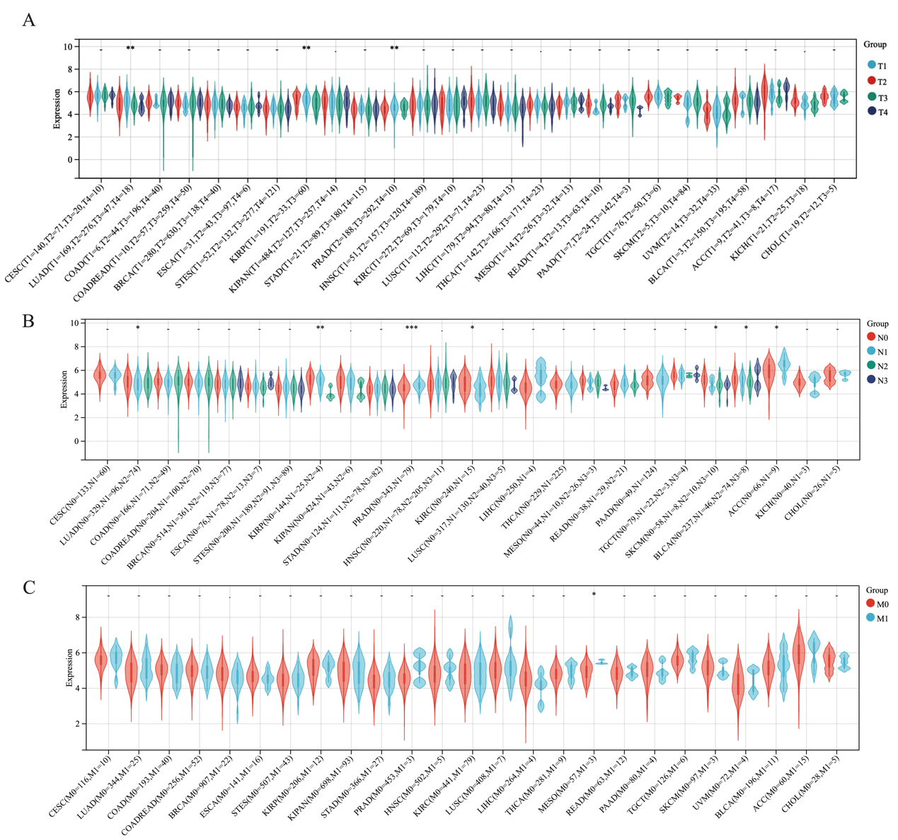
Figure S1. METTL17 expression of different clinical grades (tumor node metastasis classification, TNM).
Figure S2. Genetic alterations of METTL17.
(A) The structural domain information of METTL17. (B) The relationship between METTL17 expression and copy number variation (CNV). (C) The relationship between METTL17 expression and single nucleotide variant (SNV). (D) The relationship between METTL17 expression and SNV (with synonymous mutations).

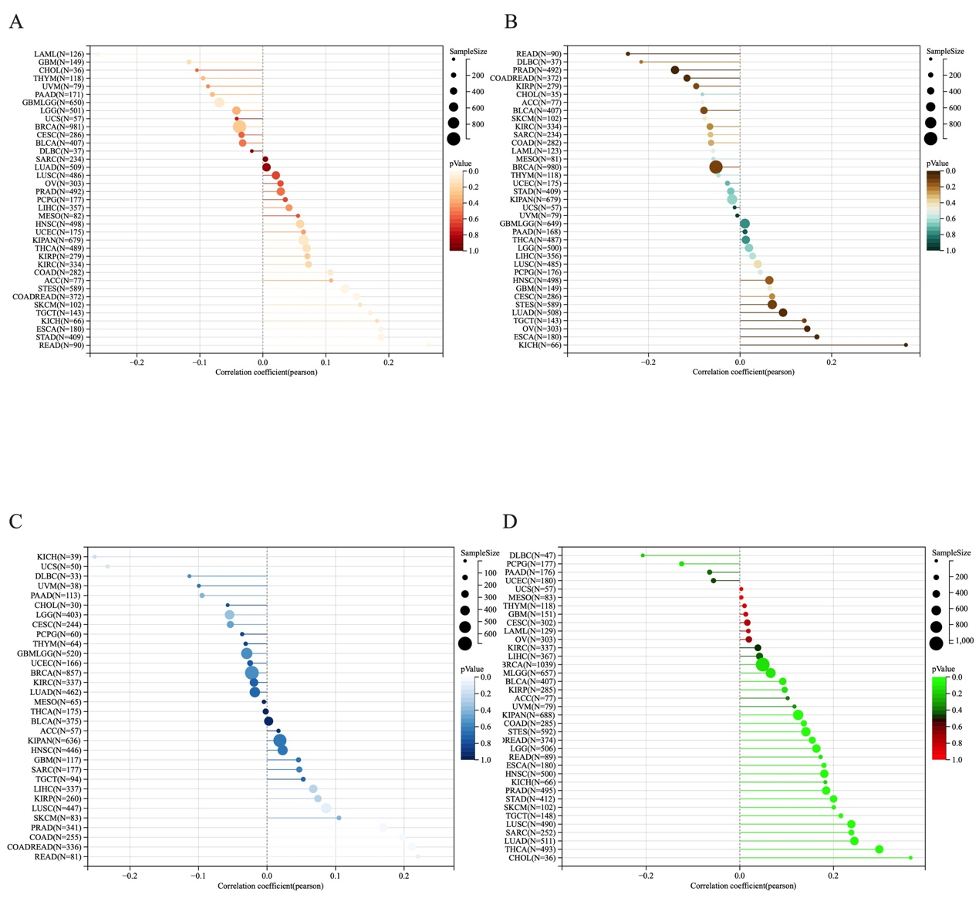

Figure S3. The relationship between METTL17 expression and genomic heterogeneity.
(A) The association between METTL17 expression and tumor mutational burden (TMB). (B) The association between METTL17 expression and mutant-allele tumor heterogeneity (MATH). (C) The association between METTL17 expression and Neoantigen (NEO). (D) The association between METTL17 expression and microsatellite instability (MSI). (E) The association between METTL17 expression and tumor purity. (F) The association between METTL17 expression and tumor ploidy. (G) The association between METTL17 expression and homologous recombination deficiency (HRD). (H) The association between METTL17 expression and loss of heterozygosity (LOH).
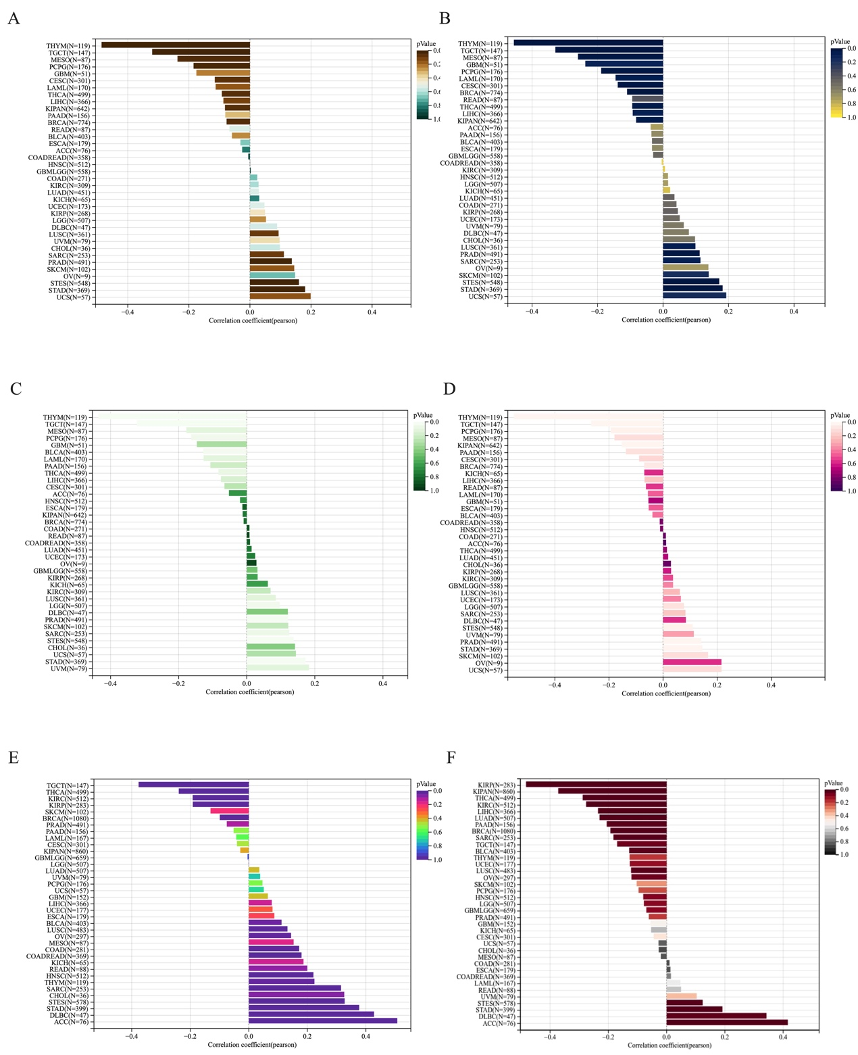
Figure S4. Associations of METTL17 expression with tumor stemness index.
(A) The correlation between METTL17 levels and DNA stemness score (DNAss). (B) The correlation between METTL17 levels and RNA stemness score (RNAss). (C) The correlation between METTL17 levels and differentially methylated probes-based (DMPss). (D) The correlation between METTL17 levels and enhancer elements/DNA methylation-based (ENHss). (E) The correlation between METTL17 levels and DNA methylation-based (EREG-METHss). (F) The correlation between METTL17 levels and RNA expression-based (EREG.EXPss).

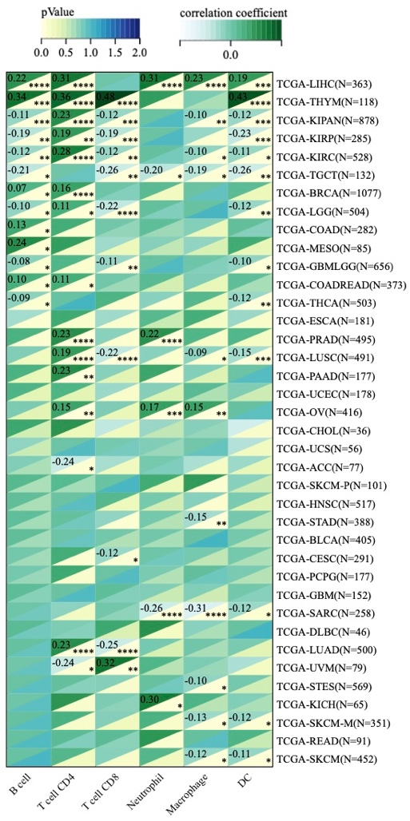
Figure S5. Analysis of immune cell inﬁltration (TIMER score)

Stromal Score

Immune Score

ESTIMATE Score

Figure S6. Analysis of immune cell inﬁltration (ESTIMATE score)
(A). Analysis of the association between METTL17 expression and stromal scores. (B). Analysis of the association between METTL17 expression and immune scores. (C). Analysis of the association between METTL17 expression and ESTIMATE scores.

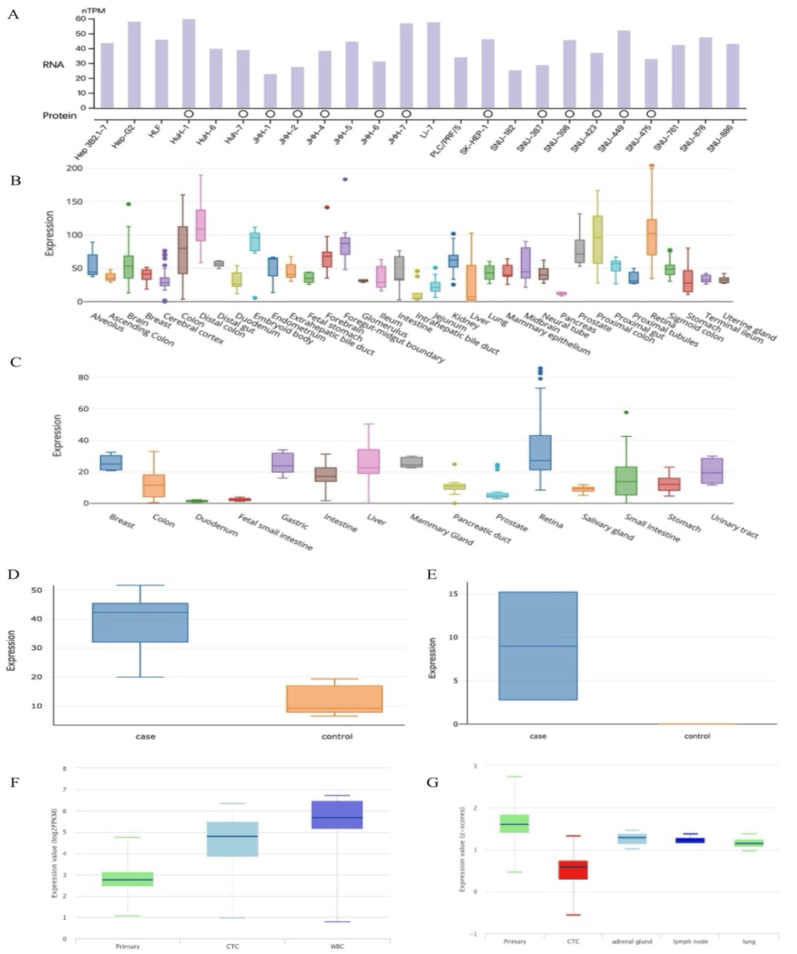
Figure S7. Diverse landscapes of METTL17 expression among hepatocellular carcinoma.
(A) METTL17 expression across various HCC cell lines. (B) METTL17 expression in multiple human organoids. (C) METTL17 expression in multiple mouse organoids. (D) METTL17 expression comparison between HCC tissues VS normal tissues (Human organoid). (E) METTL17 expression comparison between HCC tissues VS normal tissues (Mouse organoid). (F) The METTL17 expression profile in HCC. (G) The METTL17 expression profile in metastatic HCC.
Figure S8. The Connection Between the Expression Level of METTL17 and Clinicopathologic Variables in HCC.
(A) histological grade. (B) pathologic stage.

Figure S9. Kaplan–Meier survival plots comparing the low and high expression of METTL17 in HCC.
(A) Survival curves of overall urvival (OS) between high and low expression of METTL17 in patients with HCC. (B) Survival curves of disease-specific survival (DSS) between high and low expression of METTL17 in patients with HCC. (C) Survival curves of disease-free interval (DFI) between high and low expression of METTL17 in patients with HCC. (D) Survival curves of progression-free interval (PFI) between high and low expression of METTL17 in patients with HCC.

Figure S10. Decision curve analysis of METTL17-related prediction models.

