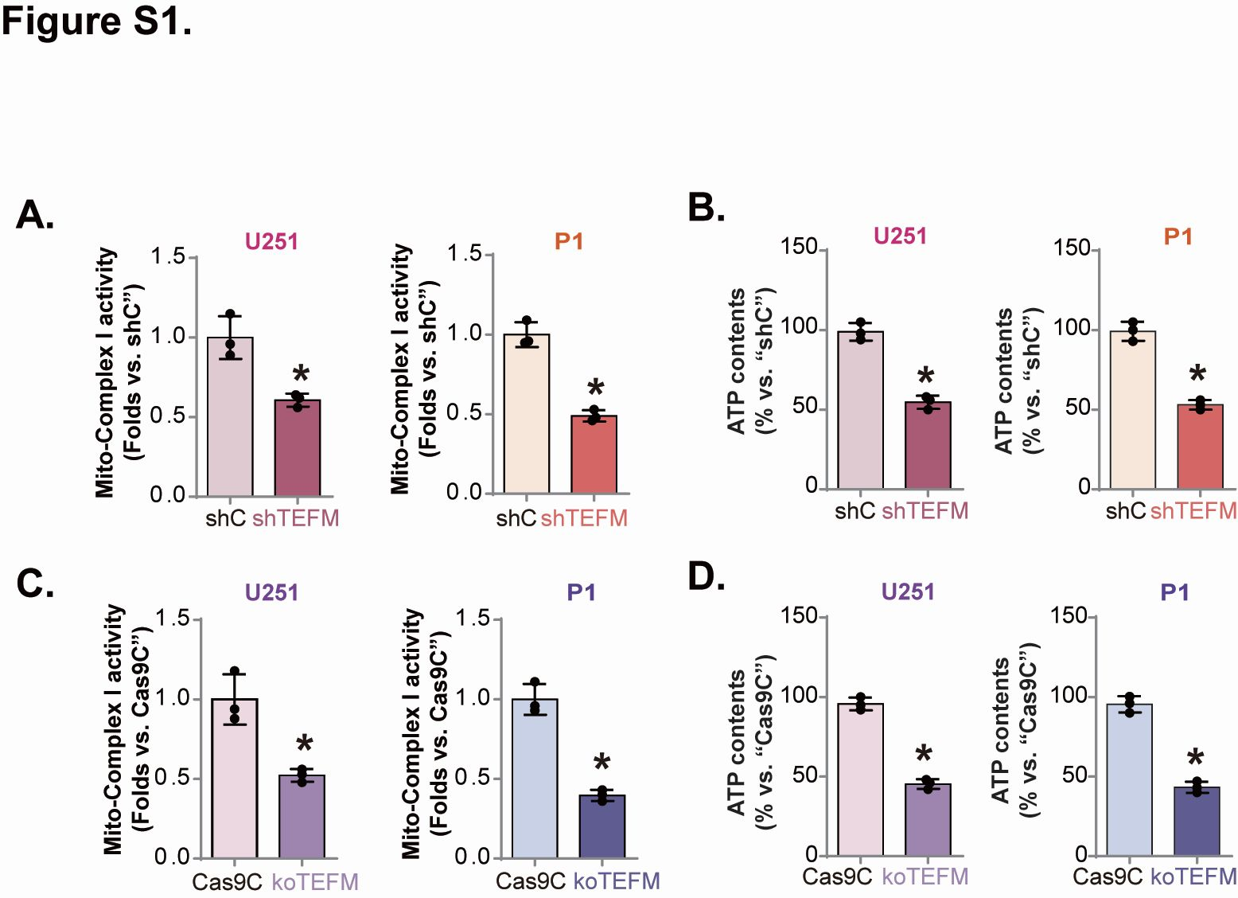
Figure S1: U251 and P1 cells were transfected with TEFM shRNA lentivirus (shTEFM-1) and negative control lentivirus (shC), as well as U251 and P1 cells with TEFM sgRNA lentivirus (koTEFM) and control airborne lentivirus (Cas9C). The above cells were cultured for the indicated times and the expression of mtDNA transcripts (A,C) and cellular ATP content (B,D) were measured. Data are expressed as mean ± standard deviation (SD, n = 3). * P < 0.05 versus "shC"/"Cas9C". the experiment was repeated three times with similar results.

