Supplementary Figure S1. Plasma cell yield assessment in a representative case. (A) Smear slides using FACS (right)- and MACS (left)-sorted samples Wright-Giemsa stained (case 8), looked under a microscope (x40). (B) Gating results of FACS (right)- and MACS (left)-sorted samples (case 5).
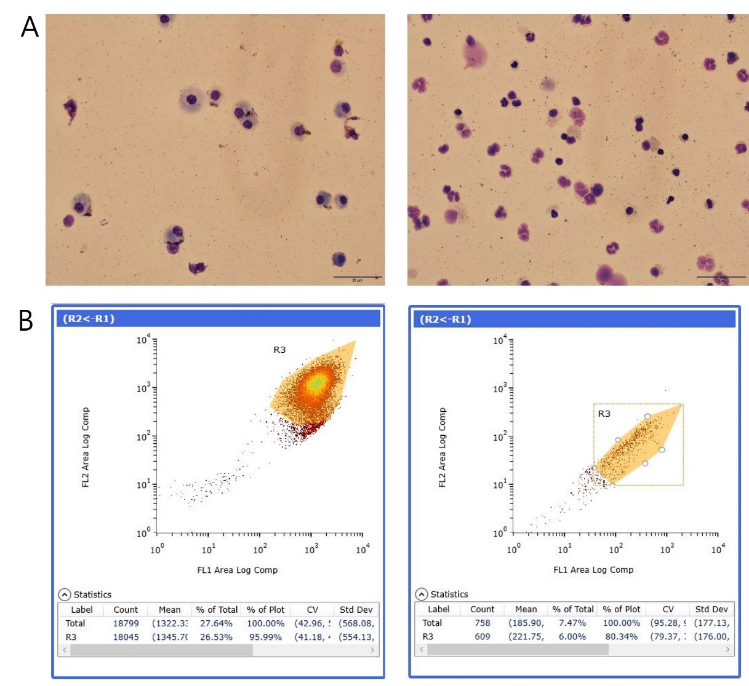

Supplementary Table S1. Genes included in the next-generation sequencing panel used in this study
ALK, ARID1A, ARID5B, ASXL1, ASXL3, ATM, B2M, BCL11B, BCL2, BCL6, BCOR, BCORL1, BIRC3, BIRC6, BRAF, BTG1, BTG2, BTK, CARD11, CCND1, CCND3, CD28, CD58, CD70, CD79A, CD79B, CDKN1B, CDKN2A, CDKN2B, CIITA, CREBBP, CXCR4, DDX3X, DIS3, DNMT3A, DTX1, DUSP22, EBF1, EGFR, EGR1, EP300, ETV6, EZH2, FAS, FBXW7, FOXO1, FYN, GNA13, H1-4, ID3, IDH2, IKZF3, IRF4, IRF8, ITPKB, JAK1, JAK3, KDM6A, KIT, KLHL14, KLHL6, KMT2A, KMT2C, KMT2D, KRAS, LRP1B, MAP2K1, MEF2B, MGA, MTOR, MYC, MYD88, NCOR1, NF1, NFKB2, NFKBIA, NOTCH1, NOTCH2, NRAS, NSD2, PAX5, PHF6, PIM1, PLCG1, PRDM1, PTEN, RB1, REL, RHOA, SETD1B, SETD2, SF3B1, SGK1, SMARCA4, SOCS1, SPEN, STAT3, STAT5B, STAT6, TBL1XR1, TCF3, TENT5C, TET1, TET2, TET3, TNFAIP3, TNFRSF14, TP53, TP63, TRAF3, UBR5, XPO1

Supplementary Table S2. Demographic characteristics of 31 plasma cell neoplasm patients
Patient ID | Sex | Age | Diagnosis | Bone marrow plasma cell (%) | Hb (g/dL) | Ca2+ (mg/dL) | Creatinine (mg/dL) | Albumin (g/dL) | β2-microglobulin (mg/dL) | Serum FLC ratio | Serum M-protein (g/dL) | Heavy-chain type | Light-chain type | Karyotype
01 | F | 73 | Plasma cell leukemia | 86 | 8.1 | 12.8 | 4.3 | 3.8 | 26.5 | 429.61 | 2.13 | IgG | kappa | 45,X,-X,der(8)t(8;16)(p11.2;p11.2),t(11;14)(q13;q32),-13,-16,+18,-22,+mar1,+mar2[18]/46,idem,+7[3]
02 | M | 62 | Plasma cell myeloma | 91.9 | 10.8 | 9.7 | 1.21 | 3.9 | 6.08 | 0.01 | 4.35 | IgG | lambda | 51~56,XY,der(1)t(1;?)(p36.1;?),der(1)t(1;?)(p13;?),+5,-6,+9,+11,der(11)t(11;?)(p15;?),der(11)t(11;?)(q13;?),+15,+19,+21,+21,+mar[cp5]/46,XY[17]
03 | M | 67 | Plasma cell myeloma | 34.2 | 12.9 | 8.9 | 0.94 | 4 | 2.23 | 0.98 | 1.66 | IgA | lambda | 56,XY,+dic(1;6)(p11;q14),+3,+5,+7,+9,+9,+15,+18,+19,+21[4]/46,XY[16]
04 | M | 76 | Plasma cell myeloma | 70.4 | 10.9 | 9.2 | 1.01 | 3.7 | 4.76 | 313.3 | 3.82 | IgA | kappa | 46,XY[15]
05 | F | 75 | Plasma cell myeloma | 86.1 | 5.8 | 8.5 | 1.97 | 3.2 | 12.4 | 202.99 | 5.06 | IgG | kappa | 50~53,X,-X,+5,der(6;12)(p10;q10),+der(7)t(7;?)(p11.2;?),del(7)(q32),+9,+11,+15,+19,+19,-20,+21,+mar[cp16]/46,XX[4]
06 | M | 62 | Plasma cell myeloma | 16 | 12.1 | 8.6 | 0.88 | 3.9 | 2.46 | 0.02 | 0.51 | IgG | lambda | 46,XY[20]
07 | F | 78 | Plasma cell myeloma | 98.4 | 7.2 | 9.7 | 1.36 | 3.2 | 11 | 0.01 | 3.57 | IgA | lambda | 53~55,X,-X,+der(1;16)(q10;?p10),der(2)t(2;?),der(4)t(4;?)(p14;?),+5,+der(6)t(6;?)(q21;?),+9,+11,+der(11)t(11;?)(p11.2;?),der(12)t(12;?)(p11.2;?),-13,+15,+15,+18,+1~2mar[cp19]/46,XX[1]
08 | M | 61 | Plasma cell myeloma | 11.2 | 14.5 | 9 | 0.95 | 4.3 | 1.82 | 3.48 | 0.89 | IgG | kappa | 46,XY[20]
09 | M | 75 | Monoclonal gammopathy of undetermined significance | 8.6 | 8.5 | 8 | 0.83 | 2.9 | - | 1.55 | 0.43 | IgG | kappa | 46,XY[20]
10 | M | 54 | Plasma cell myeloma | 12.8 | 8.6 | 13.6 | 5.56 | 3.3 | 25.4 | 0.2 | 0.42 | IgA,  IgG | lambda(beta region.)  lambda(gamma region) | 46,XY[20]
11 | M | 74 | Plasmacytoma | 3.2 | 14 | 9.2 | 0.76 | 4.5 | 1.94 | 10.36 | 0 | No monoclonal band | No monoclonal band | 46,XY[20]
12 | M | 59 | Plasma cell myeloma | 25 | 13 | 9 | 0.88 | 4.1 | 2.09 | 0.03 | 1 | IgM | lambda | 46,XY[20]
13 | M | 73 | Amyloidosis | 3.7 | 11.7 | 8.7 | 2.05 | 3.9 | 6.05 | 13.49 | 0.33 | IgM | kappa | Not interpretable result
14 | M | 44 | Monoclonal gammopathy of undetermined significance | 0.3 | 13.2 | 8.6 | 0.66 | 4.1 | 1.25 | 2.37 | 0 | IgG | kappa | 46,XY[20]
15 | F | 84 | Lymphoma-associated monoclonal gammopathy | 2.5 | 9.6 | 8.4 | 1.06 | 3.6 | - | 1.97 | 1.04 | IgG | kappa | 46,XX[20]
16 | F | 57 | Plasma cell myeloma | 24 | 10.8 | 9.5 | 0.68 | 5 | 1.99 | 0.06 | 0 | - | Lambda | 46,XX[11]
17 | M | 81 | Plasma cell myeloma | 40.9 | 5.8 | 9 | 1.59 | 2.7 | 22.5 | <0.01 | 0.46 | IgA | lambda(beta region.)  lambda(gamma region) | Not interpretable results
18 | F | 73 | Known plasma cell myeloma s/p chemotherapy | 18 | 11.9 | 9.2 | 1.07 | 4 | 2.91 | 22.23 | 1.25 | IgG | kappa | 46,XX[20]
19 | M | 39 | Plasma cell myeloma | 14.6 | 15.7 | 9.6 | 0.91 | 5 | 1.46 | <0.01 | 0.08 | IgD | lambda | 46,XY[20]
20 | F | 71 | Plasma cell myeloma | 31.9 | 11.7 | 8.7 | 1.01 | 3.7 | 3.85 | 0.17 | 2.49 | IgG | lambda | 46,XX[20]
21 | M | 73 | Plasma cell myeloma | 87.4 | 8.3 | 8.5 | 1.97 | 2.9 | 7.9 | 0.01 | 2.87 | IgG | lambda | 53,XY,+3,+5,+7,+9,der(9;12)(q10;q10),?der(14),+der(15)t(1;15)(q11;p11-13),+19,+19,+21[12]/55,XY,+3,+5,+6,+7,+9,+der(15)t(1;15),+19,+19,+21[4]/46,XY[4]
22 | M | 83 | Plasma cell neoplasm | 10.5 | 8.4 | 8.4 | 2.42 | 3.7 | 3.56 | 11.52 | 0.54 | IgG | kappa | 46,XY[20]
23 | M | 78 | Plasma cell myeloma | 9 | 10.6 | 8.6 | 0.63 | 4.4 | 2.53 | 0.01 | 0.04 | IgG | kappa  Lambda paraprotein (light chain disease) | 46,XY[20]
24 | F | 47 | Monoclonal gammopathy of undetermined significance | 3 | 7.7 | 9.6 | 5.68 | 3.2 | 2.59 | 1.29 | 0.32 | IgG | kappa | 46,XX[20]
25 | F | 52 | Monoclonal gammopathy of undetermined significance | 7 | 13.9 | 9.2 | 0.74 | 4.3 | 3.91 | 2.15 | 0 | No monoclonal band | No monoclonal band | 46,XX[20]
26 | M | 67 | Plasma cell myeloma | 21.3 | 12 | 8.6 | 0.73 | 3.8 | 3.04 | 85.75 | 4.29 | IgG | kappa | 46,XY[20]
27 | F | 41 | Monoclonal gammopathy of undetermined significance | 8.1 | 9.1 | 9.2 | 0.45 | 3.5 | 2.83 | 0.83 | 0.47 | IgG | lambda | 46,XX[20]
28 | M | 75 | Plasma cell myeloma | 37.8 | 11.7 | 10.1 | 2.12 | 4.3 | 4.15 | 198.9 | 2.8 | IgG | kappa | 45,X,-Y[17]/46~52,XY,-1,-4,+5,-7,+9,-10,+11,+15,+18,+19,-20,+1~4mar[cp3]
29 | M | 74 | Plasma cell myeloma | 53.8 | 9.1 | 8.3 | 1.19 | 3.5 | 6.89 | 375.24 | 3.85 | IgG | kappa | 46,XY[20]
30 | F | 35 | Monoclonal gammopathy of undetermined significance | 5.8 | 8.8 | 6.2 | 1.07 | 2.6 | 11.3 | 0.7 | 0.09 | IgG | kappa | 46,XX[20]
31 | M | 64 | Plasma cell myeloma s/p autologous hematopoietic stem cell transplantation | 1 | 11.2 | 9.5 | 0.95 | 4.3 | 2.58 | 5.49 | 1.39 | IgG | kappa | Not interpretable results

Supplementary Table S3. FISH results from 10 plasma cell neoplasm patients
Patient ID | BM plasma cell (%) | Method | FISH results*
Patient ID | BM plasma cell (%) | Method | TP53/17cen | FGFR3/IGH | CCND1/IGH | IGH/MAF | CDKN2C/CKS1B
20 | 31.9 | FACS | Negative | nuc ish(FGFR3x2,IGHx3)[175/240] | nuc ish(CCND1,IGH)x3(CCND1 con IGHx2)[187/238] | nuc ish(IGHx3,MAFx1)[219/311] | Negative
20 | 31.9 | MACS | Negative | nuc ish(FGFR3x2,IGHx3)[137/189] | nuc ish(CCND1,IGH)x3(CCND1 con IGHx2)[125/153] | nuc ish(IGHx3,MAFx1)[231/257] | Negative
21 | 87.4 | FACS | Negative | Negative | Negative | Negative | nuc ish(CDKN2Cx2,CKS1Bx3)[267/296]
21 | 87.4 | MACS | Negative | Negative | Negative | Negative | nuc ish(CDKN2Cx2,CKS1Bx3)[209/227]
23 | 9 | FACS | Negative | nuc ish(FGFR3x2,IGHx3)[35/319] | nuc ish(CCND1x2,IGHx3)[22/216] | nuc ish(IGHx3,MAFx2)[26/250] | nuc ish(CDKN2Cx2,CKS1Bx3~4)[98/311]
23 | 9 | MACS | Negative | nuc ish(FGFR3x2,IGHx3)[48/331] | nuc ish(CCND1x2,IGHx3)[52/334] | nuc ish(IGHx3,MAFx2)[46/332] | nuc ish(CDKN2Cx2,CKS1Bx3~4)[318/372]
24 | 3 | FACS | Negative | Negative | Negative | Negative | Negative
24 | 3 | MACS | Negative | Negative | Negative | Negative | Negative
25 | 7 | FACS | Negative | Negative | Negative | Negative | Negative
25 | 7 | MACS | Negative | Negative | Negative | Negative | Negative
26 | 21.3 | FACS | Negative | nuc ish(FGFR3,IGH)x3(FGFR3 con IGHx2)[48/199] | nuc ish(CCND1x2,IGHx3)[54/245] | nuc ish(IGHx3,MAFx2)[52/244] | nuc ish(CDKN2Cx2,CKS1Bx3)[75/227]
26 | 21.3 | MACS | Negative | nuc ish(FGFR3,IGH)x3(FGFR3 con IGHx2)[122/198] | nuc ish(CCND1x2,IGHx3)[122/224] | nuc ish(IGHx3,MAFx2)[175/288] | nuc ish(CDKN2Cx2~3,CKS1Bx3)[124/175]
27 | 8.1 | FACS | Negative | Negative | Negative | Negative | Negative
27 | 8.1 | MACS | Negative | Negative | Negative | Negative | Negative
28 | 37.8 | FACS | nuc ish(TP53x1,CEP17x2)[33/203] | nuc ish(FGFR3x2,IGHx3)[78/147] | nuc ish(CCND1x3,IGHx3)[94/137] | nuc ish(MAFx2,IGHx3)[72/150] | Negative
28 | 37.8 | MACS | nuc ish(TP53x1,CEP17x2)[16/254] | nuc ish(FGFR3x2,IGHx3)[123/183] | nuc ish(CCND1x3,IGHx3)[114/139] | nuc ish(IGHX3,MAFx2)[101/156] | Negative
29 | 53.8 | FACS | Negative | Negative | nuc ish(CCND1X3,IGHx2)[105/130] | Negative | Negative
29 | 53.8 | MACS | Negative | Negative | nuc ish(CCND1X3,IGHx2)[111/124] | Negative | Negative
31 | 1 | FACS | Negative | Negative | Negative | Negative | Negative
31 | 1 | MACS | Negative | Negative | Negative | Negative | Negative
FISH panel was done with five commercial probes, including XL TP53/17cen, XL FGFR3/IGH DF, XL t(11;14) CCND1/IGH DF, XL t(14;16) IGH/MAF DF, and XL CDKN2C/CKS1B (all MetaSystems, Altlussheim, Germany).
ND, not done
Supplementary Table S4. All detected mutations and their corresponding variant allele frequencies from both FACS and MACS
Patient ID | Gene | HGVSc | HGVSp | VAF (FACS) | VAF (MACS)
1 | TP53 | c.658T>A | p.Tyr220Asn | 0.48092 | 0.49931
1 | TP53 | c.524G>A | p.Arg175His | 0.47287 | 0.47658
1 | NRAS | c.181C>A | p.Gln61Lys | 0.02685 | 0.02708
1 | NRAS | c.183A>C | p.Gln61His | 0.03736 | 0.03674
1 | NRAS | c.182A>G | p.Gln61Arg | 0.01615 | 0.0113
1 | NRAS | c.37G>C | p.Gly13Arg | 0.00325 | ND
1 | NRAS | c.38G>A | p.Gly13Asp | ND | 0.00269
1 | KRAS | c.53C>A | p.Ala18Asp | 0.13034 | 0.13346
1 | KRAS | c.183A>C | p.Gln61His | 0.03736 | 0.005
1 | RB1 | Whole gene deletion |  | D | D
1 | DIS3 | Whole gene deletion |  | D | D
2 | NRAS | c.35G>A | p.Gly12Asp | 0.8349 | 0.93634
3 | BRAF | c.1790T>G | p.Leu597Arg | 0.1371 | 0.12115
3 | BRAF | c.1514T>A | p.Leu505His | 0.00681 | 0.00456
3 | KRAS | c.190T>G | p.Tyr64Asp | 0.0262 | 0.027
3 | KRAS | c.182A>G | p.Gln61Arg | 0.00409 | 0.00442
3 | NRAS | c.34G>C | p.Gly12Arg | 0.008 | 0.01327
3 | NRAS | c.38G>A | p.Gly13Asp | 0.025 | 0.04083
4 | KRAS | c.437C>T | p.Ala146Val | 0.17953 | 0.21092
4 | KRAS | c.182A>G | p.Gln61Arg | 0.05854 | 0.07611
4 | KRAS | c.38G>A | p.Gly13Asp | 0.00728 | 0.00517
4 | SF3B1 | c.1997A>T | p.Lys666Met | 0.23178 | 0.27888
5 | TET2 | c.1648C>T | p.Arg550Ter | 0.01104 | ND
5 | SGK1 | Whole gene deletion |  | D | D
5 | PRDM1 | Whole gene deletion |  | D | D
5 | TNFAIP3 | Whole gene deletion |  | D | D
6 | CREBBP | c.3917_3920del | p.Phe1306CysfsTer6 | ND | 0.00292
6 | PRDM1 | Whole gene deletion |  | ND | D
6 | TNFAIP3 | Whole gene deletion |  | ND | D
6 | SGK1 | Whole gene deletion |  | ND | D
7 | RB1 | c.297G>A | p.Trp99Ter | 0.00863 | 0.00857
7 | RB1 | c.1393G>T | p.Glu465Ter | 0.16537 | 0.2759
7 | KRAS | c.38G>A | p.Gly13Asp | 0.29483 | 0.34362
7 | KRAS | c.35G>T | p.Gly12Val | 0.00537 | 0.0838
7 | BTG1 | c.133C>T | p.Gln45Ter | 0.42843 | 0.4961
7 | ASXL1 | c.3162_3163insCCAA | p.Arg1055ProfsTer33 | 0.003 | ND
7 | TET2 | c.1723del | p.Ala575ArgfsTer5 | 0.00632 | ND
7 | DNMT3A | c.1668G>C | p.Arg556Ser | 0.02475 | ND
7 | RB1 | Whole gene deletion |  | D | D
7 | DIS3 | Whole gene deletion |  | D | D
7 | BRAF | Whole gene duplication/amplification |  | D | D
7 | IRF8 | Whole gene deletion |  | D | D
8 | ATM | c.7889T>A | p.Leu2630Ter | 0.00216 | ND
8 | MAP2K1 | c.361T>A | p.Cys121Ser | 0.03542 | 0.03567
9 | BIRC3 | c.1299_1302del | p.Arg434GlnfsTer12 | ND | 0.00192
10 | -
11 | -
12 | BRAF | c.1789C>G | p.Leu597Val | 0.00184 | ND
12 | TNFRSF14 | Whole gene deletion |  | D | ND
12 | CDKN1B | Whole gene deletion |  | D | D
12 | RB1 | Whole gene deletion |  | ND | D
13 | -
14 | -
15 | IDH2 | c.419G>A | p.Arg140Gln | 0.00868 | ND
16 | KRAS | c.64C>A | p.Gln22Lys | 0.00759 | ND
16 | RB1 | Whole gene deletion |  | ND | D
17 | -
18 | TP53 | c.841G>A | p.Asp281Asn | 0.23244 | 0.6766
18 | TP53 | c.499C>T | p.Gln167Ter | 0.01233 | 0.01305
18 | PTEN | c.655C>T | p.Gln219Ter | 0.00153 | ND
18 | DNMT3A | c.2622T>A | p.Tyr874Ter | 0.02471 | 0.00731
18 | ASXL1 | c.2427del | p.Asp810ThrfsTer8 | 0.00358 | ND
18 | TET2 | c.817C>T | p.Gln273Ter | 0.0085 | ND
18 | TET2 | c.3315_3316insAA | p.Glu1106LysfsTer8 | 0.00184 | ND
19 | ARID1A | c.2077C>T | p.Arg693Ter | 0.02461 | 0.04001
19 | ARID1A | c.6143G>A | p.Trp2048Ter | 0.07555 | 0.1409
19 | DNMT3A | c.994G>A | p.Gly332Arg | 0.00233 | ND
20 | KRAS | c.35G>T | p.Gly12Val | 0.01031 | 0.00918
20 | TRAF3 | c.487C>T | p.Arg163Ter | 0.20365 | 0.26853
20 | TRAF3 | c.854del | p.Asn285ThrfsTer38 | 0.17707 | 0.27235
20 | TRAF3 | c.1063dup | p.Glu355GlyfsTer35 | 0.01073 | 0.01384
20 | BRAF | c.1780G>A | p.Asp594Asn | 0.00544 | 0.00526
20 | NRAS | c.34G>C | p.Gly12Arg | ND | 0.00857
21 | KRAS | c.38G>A | p.Gly13Asp | 0.67361 | 0.75385
22 | ASXL1 | c.1762C>T | p.Gln588Ter | 0.18695 | 0.1497
22 | MGA | c.6061_6062del | p.Leu2021GlufsTer2 | 0.03659 | 0.03808
22 | TET2 | c.4122T>A | p.Cys1374Ter | 0.13498 | 0.13424
22 | TET2 | c.5158A>T | p.Lys1720Ter | ND | 0.00152
23 | DNMT3A | c.1554+1G>A |  | 0.00679 | ND
23 | RB1 | Whole gene deletion |  | ND | D
23 | DIS3 | Whole gene deletion |  | ND | D
23 | CDKN1B | Whole gene deletion |  | ND | D
24 | -
VAF, variant allele frequency; D, detected; ND, not detected

