SUPPLEMENTARY INFORMATION
Clinical relevance of macromolecular complexes involving integrins, potassium and sodium ion channels and the sodium/proton antiporter in human breast cancer

Elena Lastraioli^{1,2#}, Jessica Iorio¹, Francesco Piazza^{2,3}, Chiara Capitani¹, Michele Santillo^{1,4}, Claudia Duranti^{1,5}, Simonetta Bianchi⁶, Icro Meattini^{7,8}, Scott P. Fraser⁹, Mustafa B. A. Djamgoz^{9,10}, Andrea Becchetti¹¹, and Annarosa Arcangeli^{1,2,5}

¹Department of Experimental and Clinical Medicine, University of Florence, Florence, Italy
²CSDC (Center for the Study of complex dynamics), University of Florence, Florence, Italy
³Department of Physics, University of Florence and Florence Section of INFN, Florence, Italy
⁴Department of Medical Biotechnologies, University of Siena, Italy
⁵MCK Therapeutics Srl, Pistoia, Italy
⁶Department of Health Sciences, Division of Pathological Anatomy, University of Florence, 50134 Florence, Italy
⁷Department of Experimental and Clinical Biomedical Sciences Mario Serio, University of Florence, Florence, Italy
⁸Radiation Oncology Unit, Oncology Department, Azienda Ospedaliero Universitaria Careggi, Florence, Italy
⁹Imperial College London, Department of Life Sciences, London, United Kingdom
¹⁰Biotechnology Research Centre, Cyprus International University, Haspolat, TRNC, Mersin 10, Türkiye
¹¹Department of Biotechnology and Biosciences, University of Milano Bicocca, Milan, Italy

#Correspondence: elena.lastraioli@unifi.it, Phone: +39 055 2751319
The authors declare no potential conflicts of interest.

Running Title: Macromolecular complexes in breast cancer

SUPPLEMENTARY FIGURES

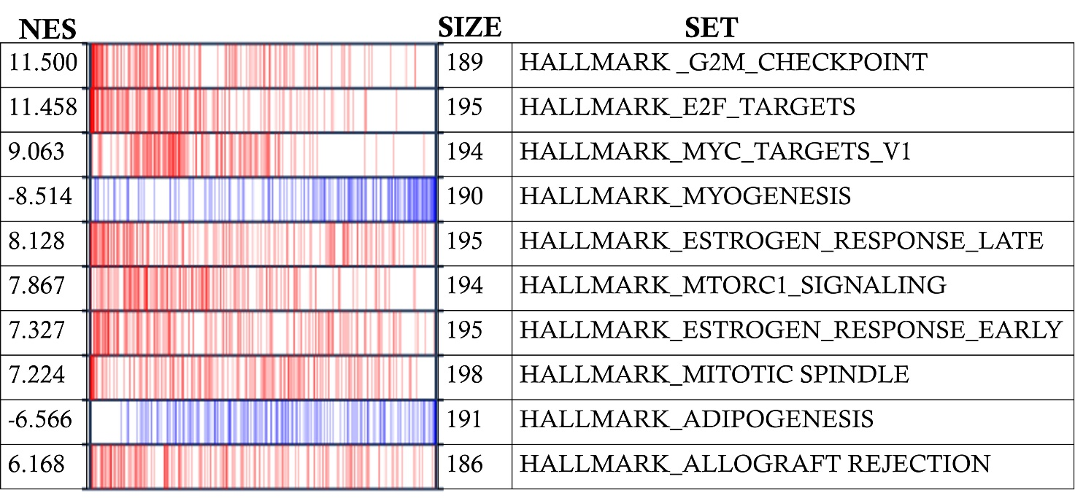
Figure S1- GSEA in BCa samples stored in TCGA datasets compared with healthy breast (stored in GTEx databases). The upregulated hallmarks are highlighted in red while the down regulated ones are in blue. The table shows the top enriched gene sets with the normalized enrichment score (NES).

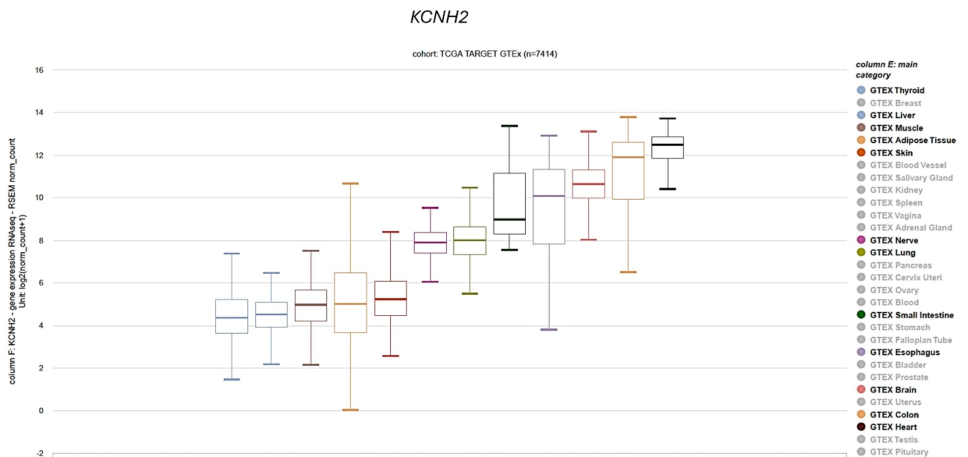
Figure S2- KCNH2 expression in healthy tissues (GTEx cohorts, UCSC Xena Browser).

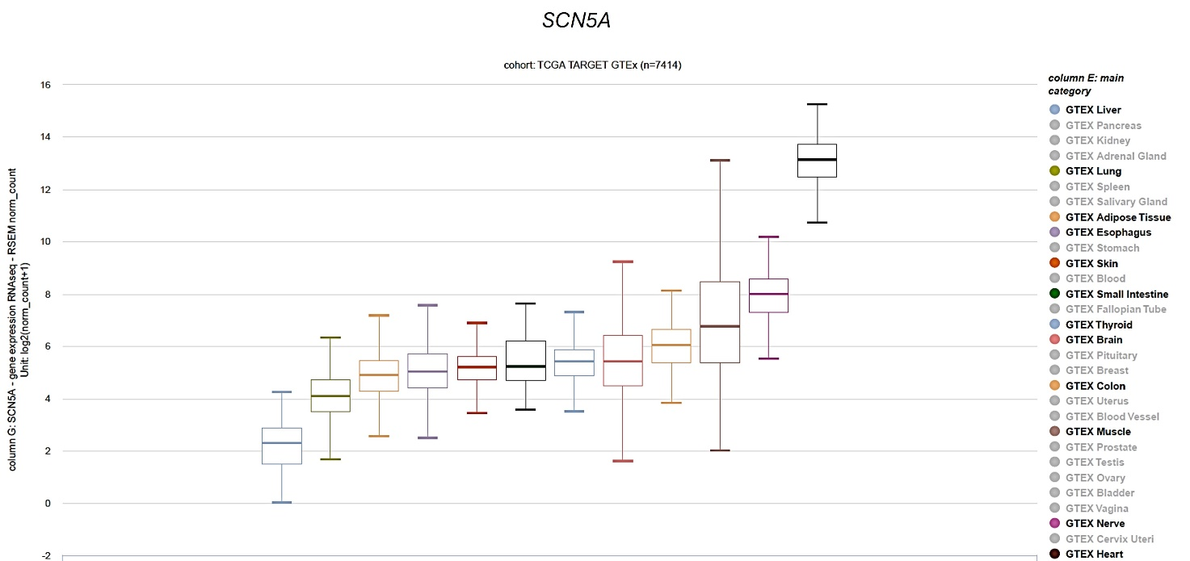
Figure S3- SCN5A expression in healthy tissues (GTEx cohorts, UCSC Xena Browser).

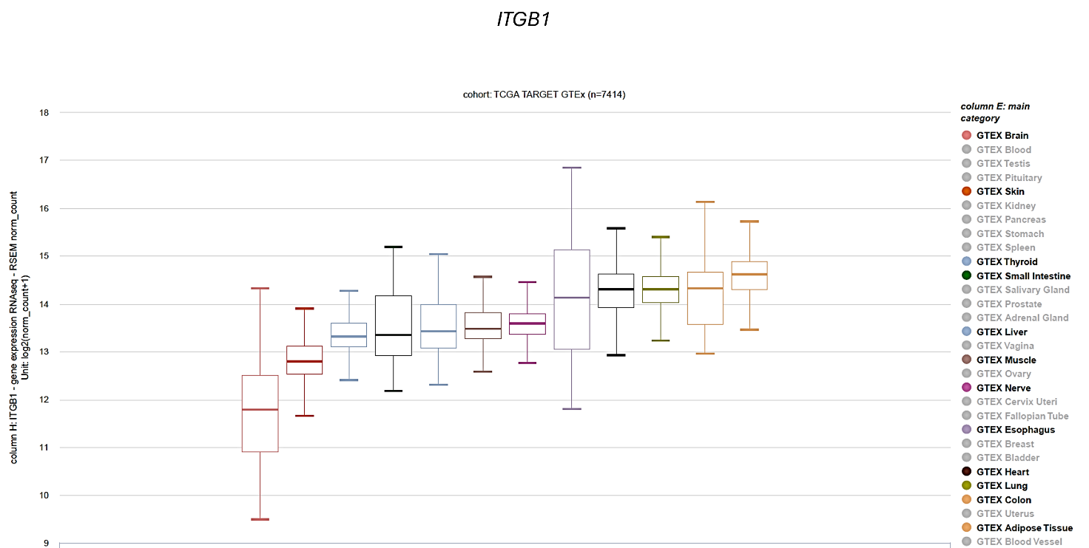
Figure S4- ITGB1 expression in healthy tissues (GTEx cohorts, UCSC Xena Browser).

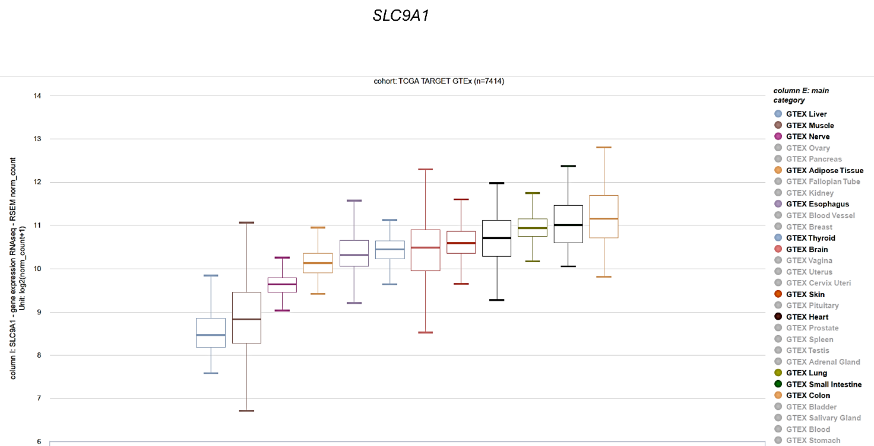
Figure S5- SLC9A1 expression in healthy tissues (GTEx cohorts, UCSC Xena Browser).

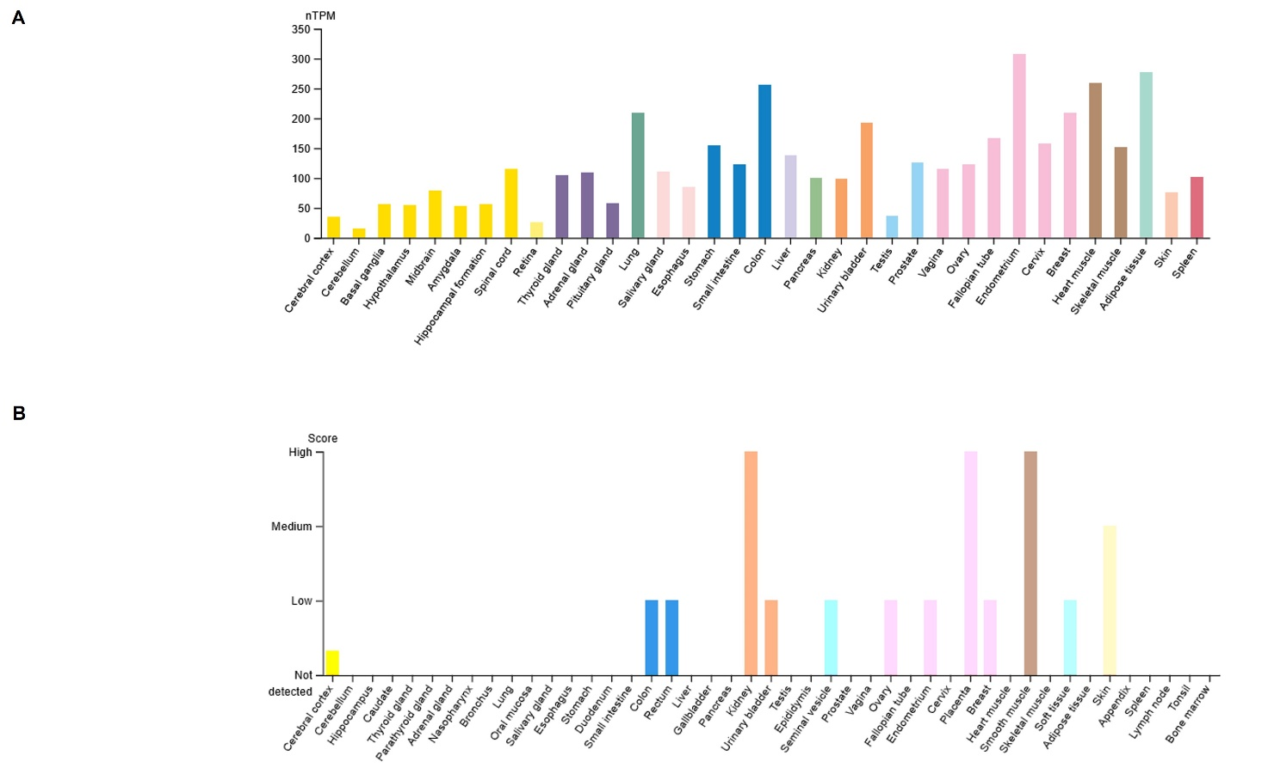
Figure S6- ITGB1 gene (A) and beta1 integrin protein (B) expression in healthy tissues (https://www.proteinatlas.org/ENSG00000150093-ITGB1/tissue).

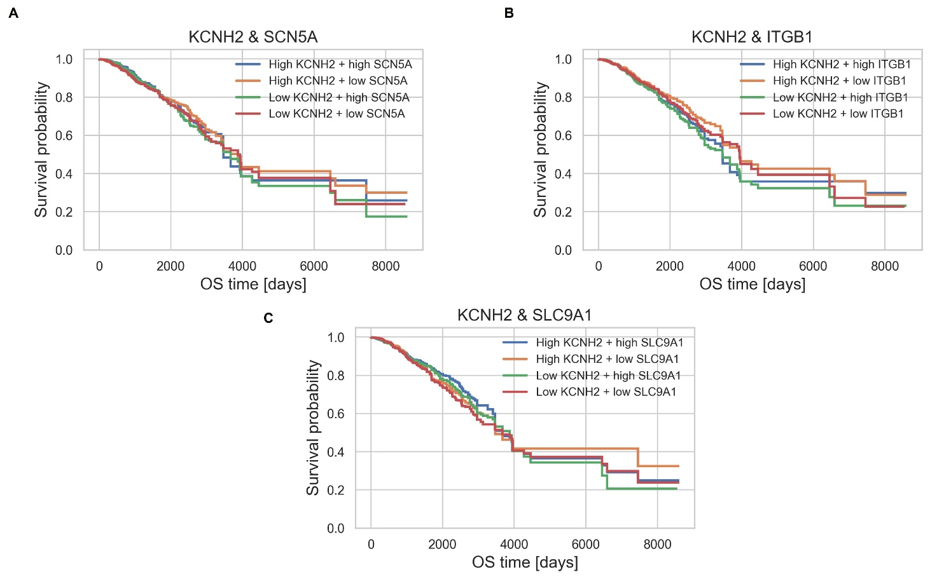
Figure S7- Survival analysis of in-silico BCa cohort. Combined Kaplan Meier plots of OS for KCNH2, SCN5A, ITGB1 and SLC9A1. Blue curves: high KCNH2-high SCN5A/ITGB1/SLC9A1 expression; Orange curves: high KCNH2- low SCN5A/ITGB1/SLC9A1 expression; Green curves: low KCNH2- high SCN5A/ITGB1/SLC9A1 expression; Red curves: low KCNH2- low SCN5A/ITGB1/SLC9A1. The in-silico analyses were carried out through in a TCGA BCa dataset retrieved by UCSC Xena Browser.

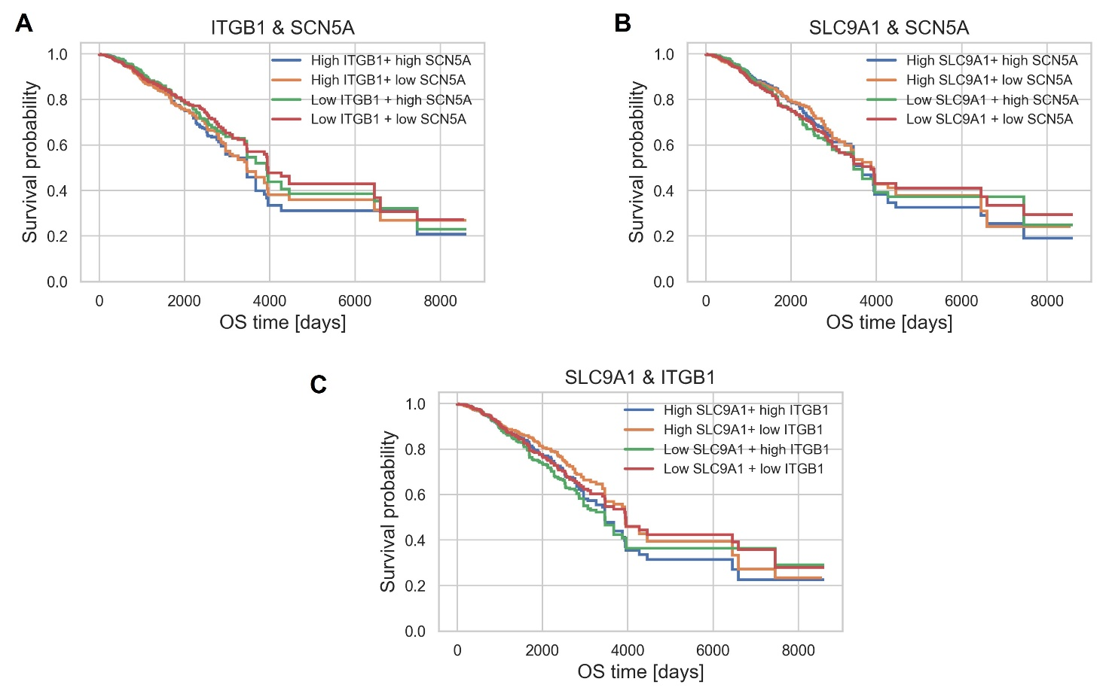
Figure S8- Survival analysis of in-silico BCa cohort. Combined Kaplan Meier plots of OS for SCN5A, ITGB1 and SLC9A1. The in-silico analyses were carried out through in a TCGA BCa dataset retrieved by UCSC Xena Browser.

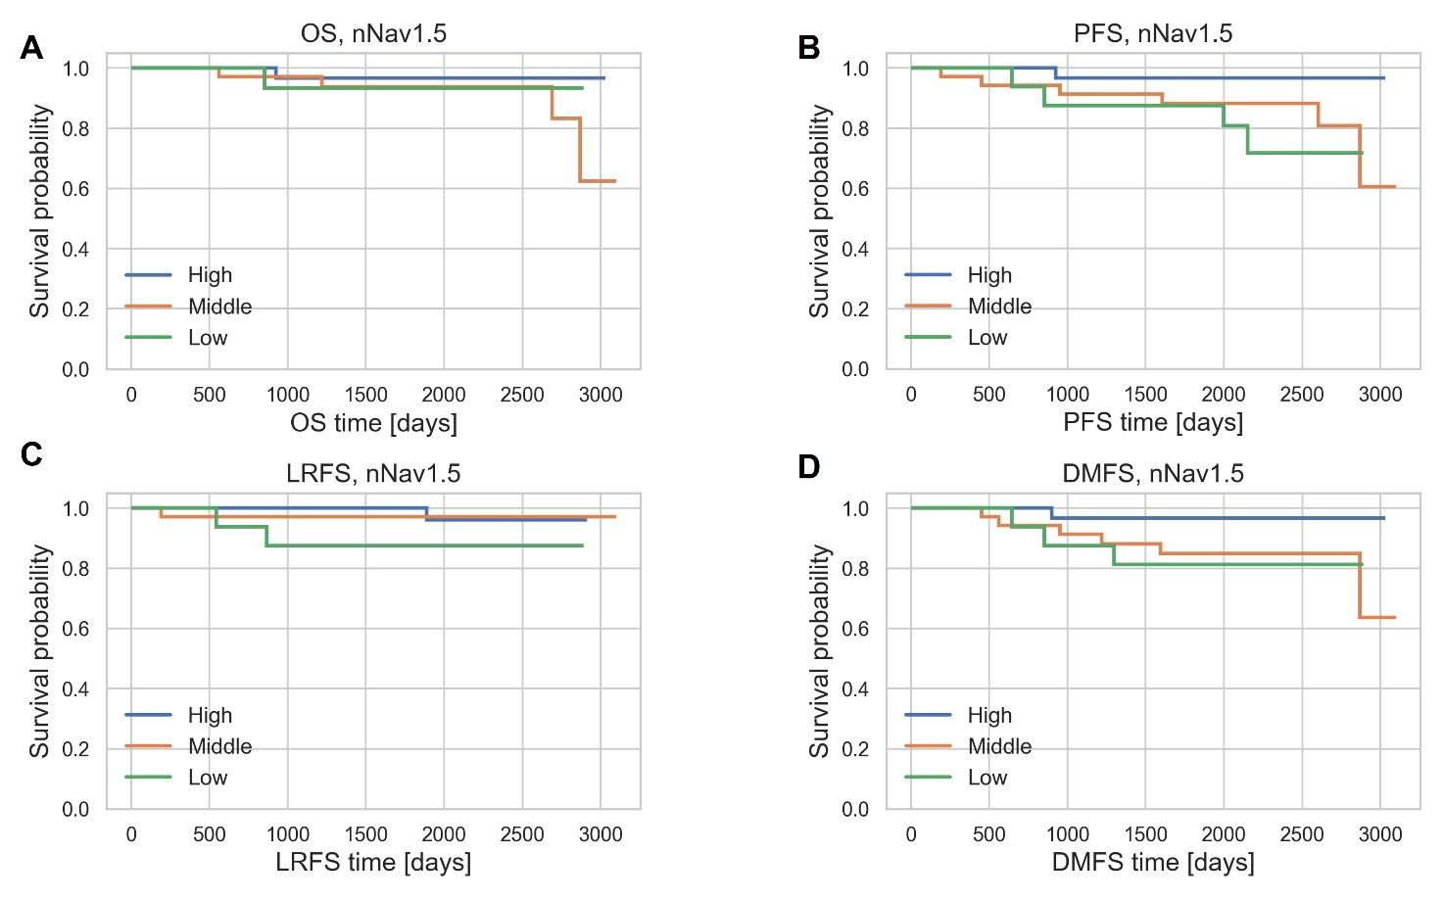
Figure S9- Survival analyses for nNav1.5. A) Kaplan Meier plots of OS. B) Kaplan Meier plots of PFS. C) Kaplan Meier plots of LRFS. D) Kaplan Meier plots of DMFS. Blue curves: high nNav1.5 expression; Orange curves: middle nNav1.5 expression; Green curves: low nNav1.5 expression.

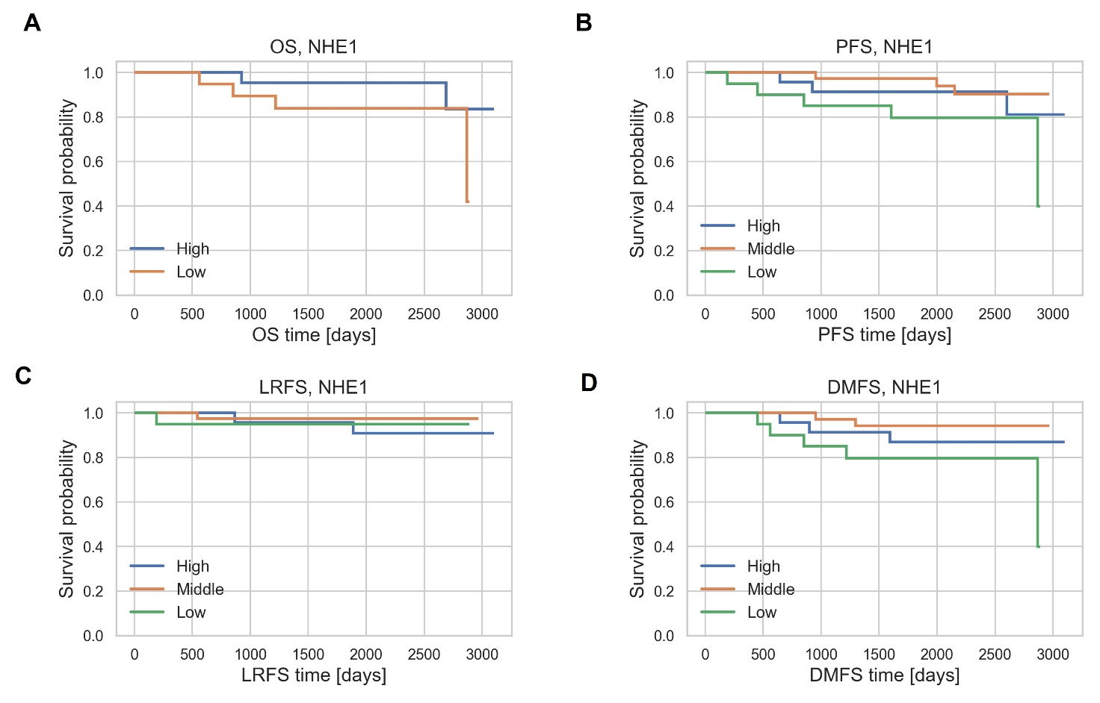
Figure S10- Survival analyses for NHE1. A) Kaplan Meier plots of OS. B) Kaplan Meier plots of PFS. C) Kaplan Meier plots of LRFS. D) Kaplan Meier plots of DMFS. Blue curves: high NHE1 expression; Orange curves: middle NHE1 expression; Green curves: low NHE1 expression.

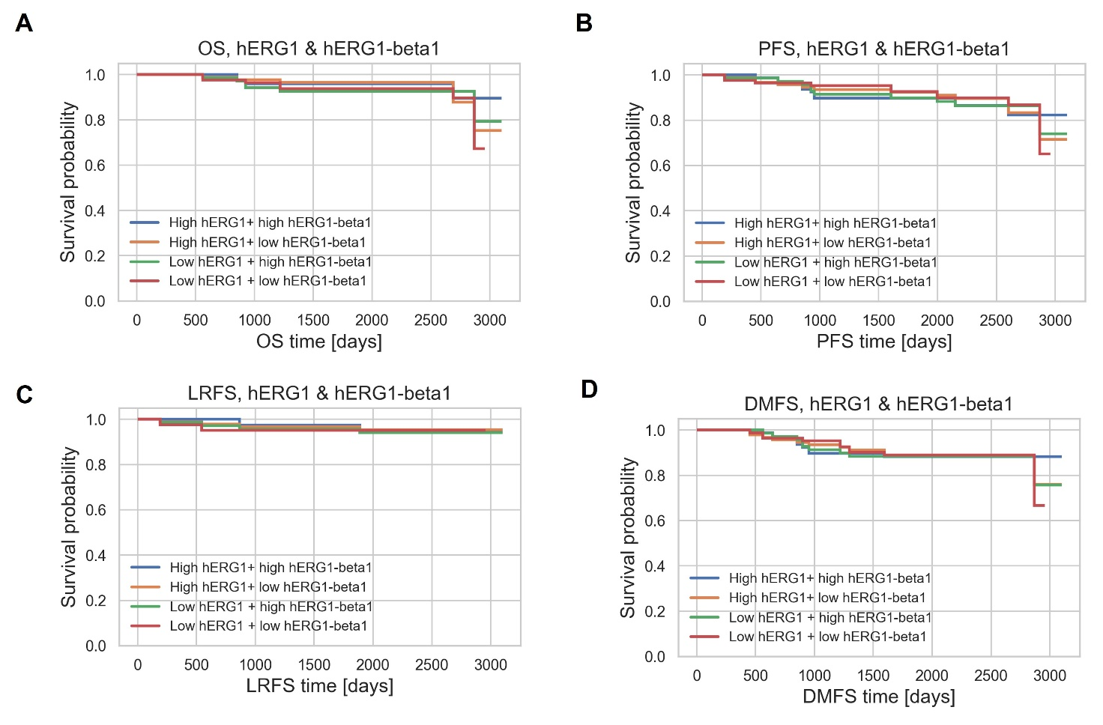
Figure S11- Combined Kaplan Meier plots of OS, PFS, LRFS and DMFS for hERG1, hERG1/β1.

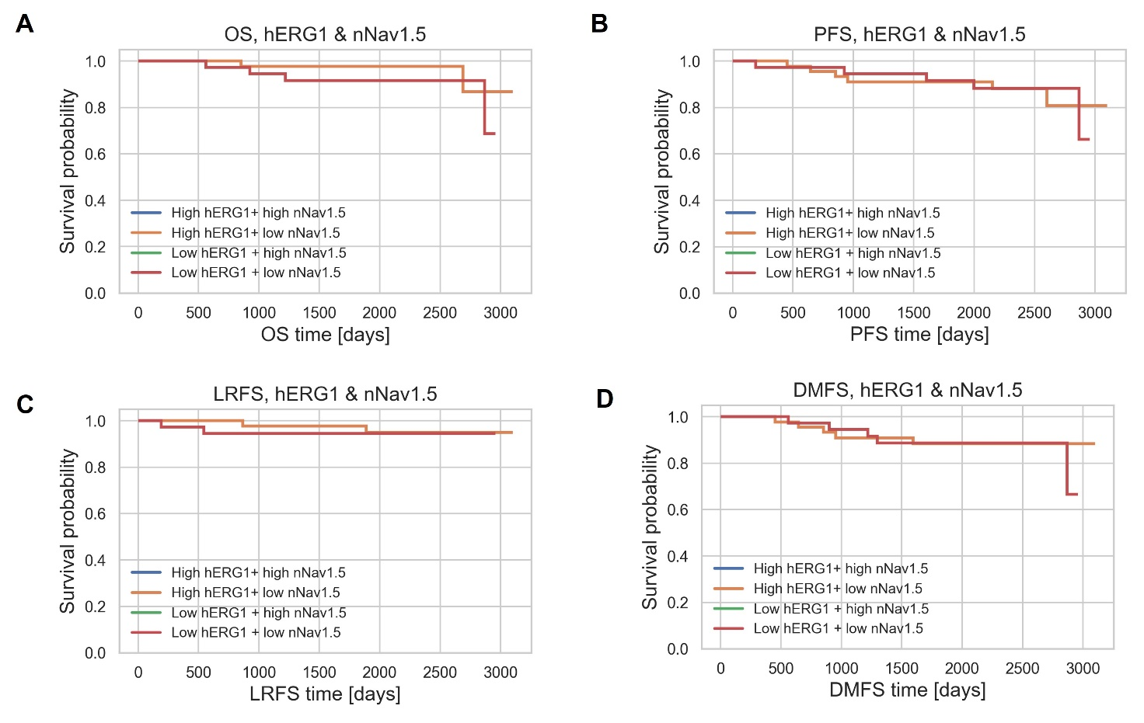
Figure S12- Combined Kaplan Meier plots of OS, PFS, LRFS and DMFS for hERG1, nNav1.5.

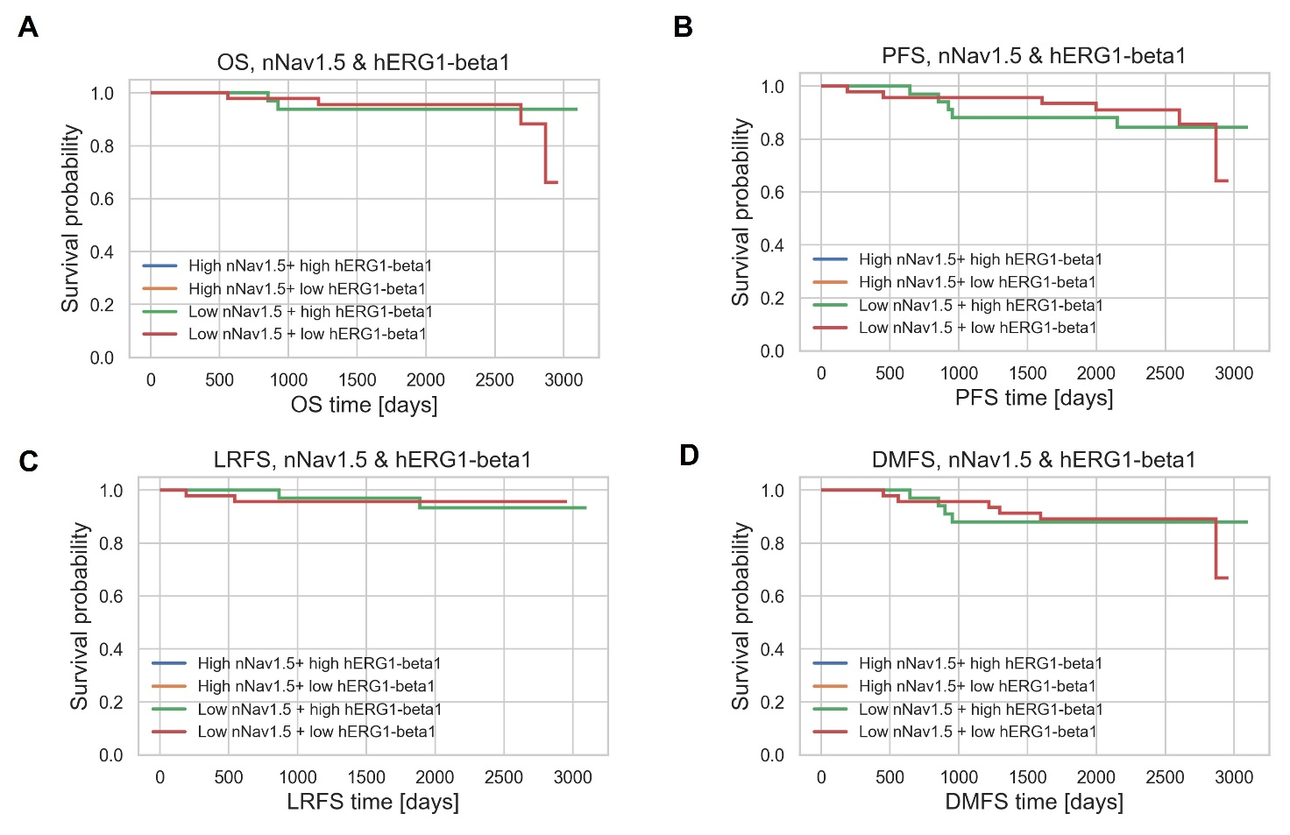
Figure S13- Combined Kaplan Meier plots of OS, PFS, LRFS and DMFS for nNav1.5, hERG1/β1.

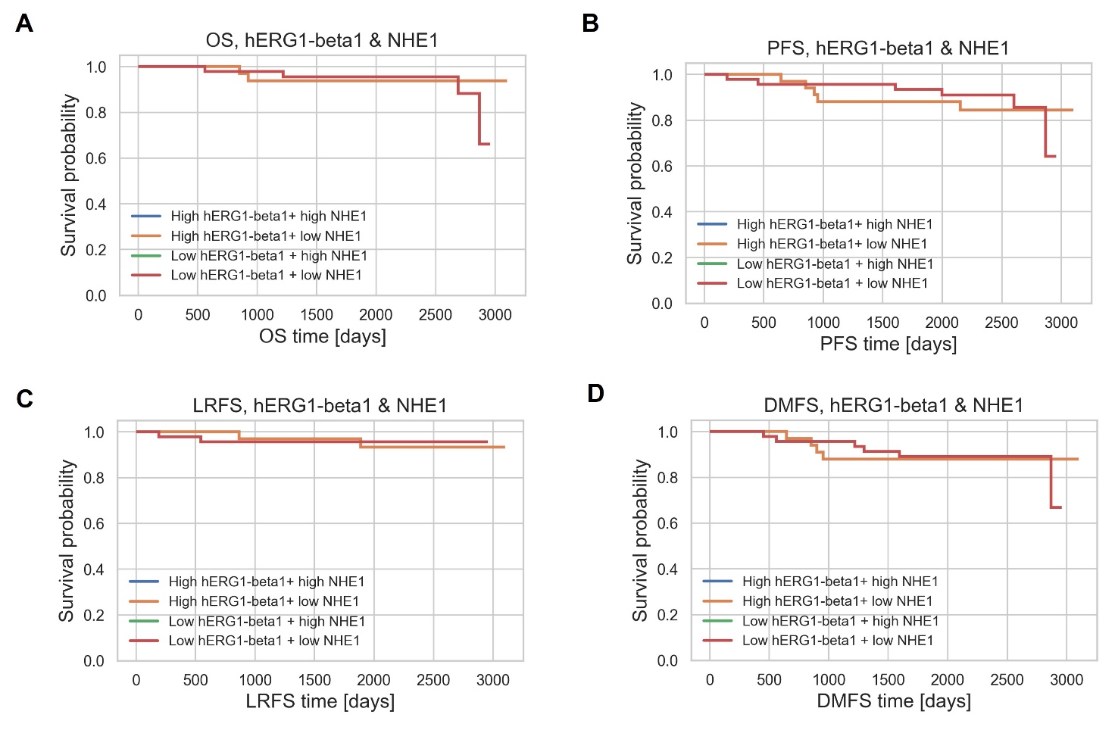
Figure S14- Combined Kaplan Meier plots of OS, PFS, LRFS and DMFS for NHE1, hERG1/β1.

