Potential value of immunogenic cell death related-genes in refining European LeukemiaNet guidelines classification and predicting the immune infiltration landscape in acute myeloid leukemia

Changqing Jiao^{1,2} | Xiaoyu Ma^{1,2} | Jianling Cui^{1,2} | Bobin Su^{1,2} | Fei Xu^{1,2} | Enbo Chen^{1,2} | Junjie Zhou¹ | Jifei Dai^{1,2,3} | Mengya Pan^{1,2} | Zhangbiao Long^{1,2,3}| Jian Ge^{1,2,3*}

¹Department of Hematology, the First Affiliated Hospital of Anhui Medical University, Hefei 230022, China
²Anhui Medical University, Hefei 230032, China
³National Clinical Medical Research Centre for Blood System Diseases, Anhui Branch Centre, Hefei 230032, China

*Correspondence should be addressed to:
gejian@ahmu.edu.cn

Changqing Jiao and Xiaoyu Ma have contributed equally to this work.

List of supplementary information

- Supplementary tables
- Supplementary figures

Table S1 ICD-related gene list
Gene | Full name
ATG5 | Autophagy related 5
BAX | BCL2 Associated X
CALR | Calreticulin
CASP1 | Cysteine-aspartic acid protease-1
CASP8 | Cysteine-aspartic acid protease-8
CD4 | CD4 molecule
CD8A | CD8 subunit alpha
CD8B | CD8 subunit beta
CXCR3 | C-X-C motif chemokine receptor 3
EIF2AK3 | Eukaryotic translation initiation factor 2 alpha kinase 3
ENTPD1 | Ectonucleoside triphosphate diphosphohydrolase 1
FOXP3 | Forkhead box P3
HMGB1 | High mobility group box 1
HSP90AA1 | Heat shock protein 90 alpha family class A member 1
IFNA1 | Interferon alpha 1
IFNB1 | Interferon beta 2
IFNG | Interferon gamma
IFNGR1 | Interferon gamma receptor 1
IL10 | Interleukin 10
IL17A | Interleukin 17A
IL17RA | Interleukin 17 receptor A
IL1B | Interleukin 1 beta
IL1R1 | Interleukin 1 receptor type 1
IL6 | Interleukin 6
LY96 | Lymphocyte antigen 96
MYD88 | MYD88 innate immune signal transduction adaptor
NLRP3 | NLR family pyrin domain containing 3
NT5E | 5'-nucleotidase ecto
P2RX7 | Purinergic receptor P2X 7
PDIA3 | Protein disulfide isomerase family A member 3
PIK3CA | Phosphatidylinositol-4,5-bisphosphate 3-kinase catalytic subunit alpha
PRF1 | Perforin 1
TLR4 | Toll like receptor 4
TNF | Tumor necrosis factor

Table S2 Univariate Cox regression analysis of 31 ICD-related genes for overall survival of TCGA-LAML patients.
Gene | HR(95%) | pvalue
CALR | 0.58(0.41,0.83) | 0.003
CASP1 | 1.39(1.12,1.73) | 0.003
CD4 | 1.22(1.03,1.45) | 0.02
EIF2AK3 | 0.66(0.49,0.90) | 0.008
IFNGR1 | 1.37(1.08,1.74) | 0.009
IL10 | 1.26(1.09,1.46) | 0.002
LY96 | 1.16(1.00,1.33) | 0.048
PIK3CA | 0.57(0.40,0.83) | 0.003

Table S3 Lasso coefficient
Gene | Coef
CALR | -0.662
CASP1 | 0.009
IFNGR1 | 0.0643
IL10 | 0.0436
PIK3CA | -0.726

Table S4 Drug sensitivity analysis
Drug name | Type | ICD risk group
ABT737 | Bcl-2 inhibitor | high
Alisertib | AAK inhibitor | high
AT13148 | AGCK inhibitor | high
AZD5991 | Mcl-1 inhibitor | high
BI-2536 | PLK1 inhibitor | high
Carmustine | alkylator | high
Crizotinib | ALK&c-Met inhibitor | high
Daporinad | NMPRTase inhibitor | high
Entinostat | HDAC inhibitor | high
Gallibiscoquinazole |  | high
GSK2578215A | LRRK2 kinase inhibitor | high
IGF1R_3801 |  | high
Navitoclax | Bcl-2 inhibitor | high
Nilotinib | Bcr-Abl | high
P22077 | USP7 inhibitor | high
Sepantronium bromide | YM155（survivin） | high
Tozasertib | Aurora A/B/C | high
UMI-77 | Mcl-1 inhibitor | high
Vorinostat | HDAC inhibitor | high
Venetoclax | Bcl-2 inhibitor | high
5-Fluorouracil | Antitumor | low
Axitinib | VEGFR 1-3 inhibitor | low
AZD8186 | PI3K inhibitor | low
Dactolisib | PI3K inhibitor | low
GNE-317 | PI3K inhibitor | low
KRAS (G12C) Inhibitor-12 | KRAS G12C inhibitor | low
PF-4708671 | S6K1 inhibitor | low
Pictilisib | PI3K inhibitor | low
Ribociclib | CDK4/6 inhibitor | low
Taselisib | PI3K inhibitor | low

ELN risk stratification
n=265
Intermediate
Adverse
Intermediate
Adverse

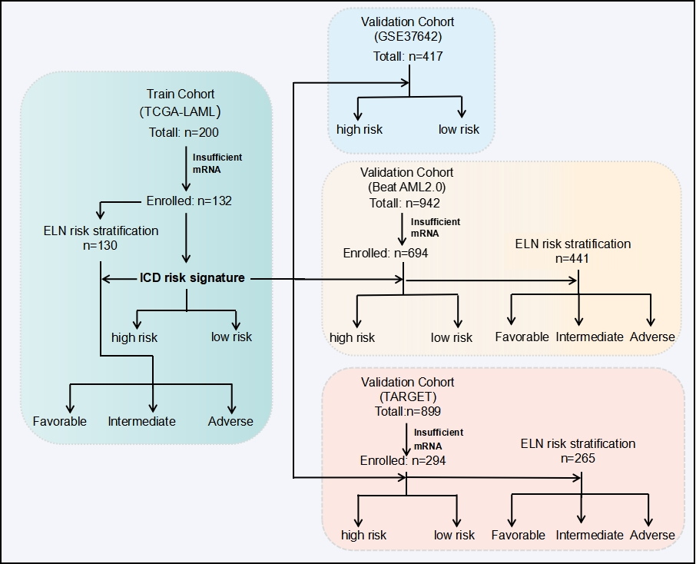
Figure S1| Study algorithm. There are four cohorts: TCGA-LAML cohort, GSE37642 cohort, Beat AML2.0 cohort and TARGET cohort. On the left is the discovery cohort (TCGA-AML). On the right, there are three validation cohorts: GSE37642 cohort, Beat AML2.0 and TARGET, totally enrolled 1,537 AMLpatients
Figure S2| Construction of an ICD risk score model for patients with acute myeloid leukemia. (A) (B) Principal Component Analysis（PCA） plot before and after batch effect of TCGA, GEO, TARGET, and Beat AML databases. (C) Univariate Cox analysis to assess the prognostic value of ICD-related genes. (D)(E) Five genes linked to OS were identified in the TCGA-LAML cohort by Lasso Cox regression analysis.

Figure S3| Validating the ICD risk signature. Validating the ICD risk signature. (A, B) Overall survival, (C, D)risk scores distribution, (E, F)survival status of each patient, and (G, H)heatmaps of ICD risk signature in Beat AML2.0 cohort and TARGET cohort.

Figure S4| Somatic mutation analysis of TCGA-LAML patients.

