Supplementary Material
- Supplementary Table
Table 1 Primer sequences used in qRT-RCR
Primer | Sequence (5'-3')
U6 | Forward-CTCGCTTCGGCAGCACA
U6 | Reverse-AACGCTTCACGAATTTGCGT
miR-7 | Forward-CGC GCT GGA AGA CTA GTG A
miR-7 | Reverse-GTG CAG GGT CCG AGG T
18S | Forward-GTAACCCGTTGAACCCCATT
18S | Reverse-CCATCCAATCGGTAGTAGCG
tRNA scaffold | Forward-ACGTAGCTCAGTTGGTTAGAGCAG
tRNA scaffold | Reverse- GTGGCTACGACGGGATTCGA

- Supplementary Figure
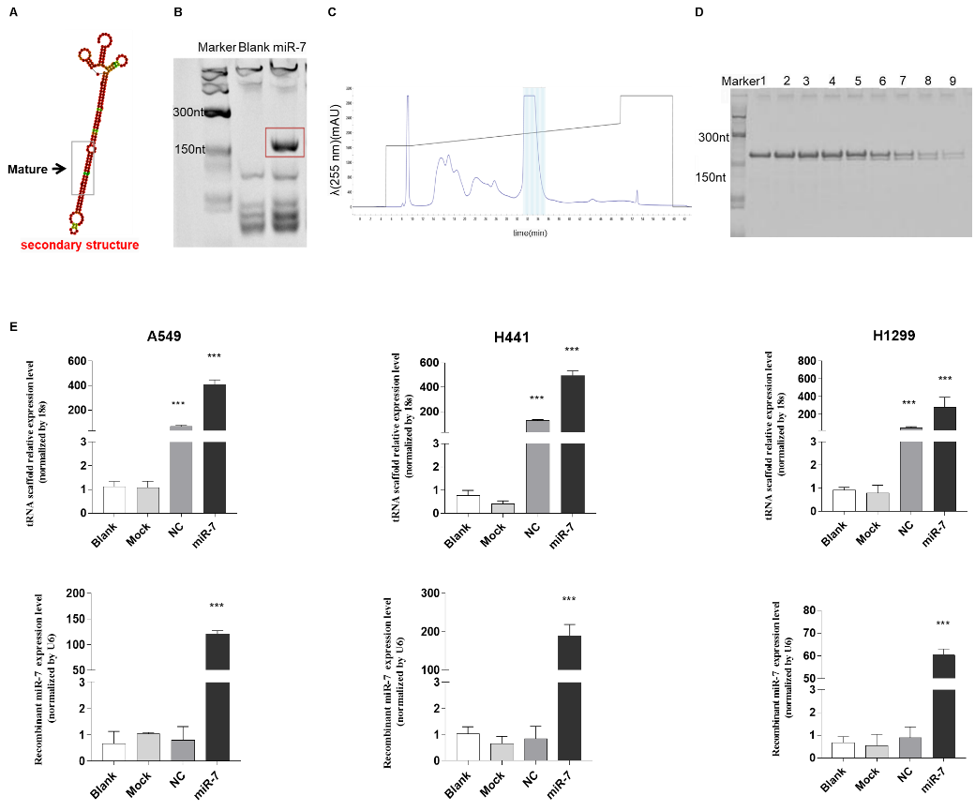
Figure S1. Bio-engineered miR-7 was produced using novel hybrid tRNA scaffold. (A) The CentroidFold online tool was used to predict the secondary structure of miR-7; (B) The expression of bio-engineered miR-7 was detected by PAGE; (C) Bio-engineered miR-7 was purified by FPLC chromatography; (D) The purity of bio-engineered miR-7 was evaluated by PAGE; (E) qRT-PCR was employed to detect the expression of bio-engineered miR-7 and tRNA scaffold in NSCLC cell lines (A549 cells, H441 cells and H1299 cells). Data were represented as mean ± SD. Significances were determined using student’s t-test between two groups. P value less than 0.05 was considered significant in all cases (***P<0.001).
Figure S2. Representative images of the lung luminance signals of nude mice detecting by Caliper IVIS Lumina II.
Figure S3. Downstream targets and signal pathways of miR-7 were predicted by bioinformatics.
Figure S4. The expression of Akt1, Akt2, Akt3, and p53 in the NSCLC cells. The expression of Akt1, Akt2, Akt3, and p53 was assessed by qPCR in the NSCLC cells. Data were represented as mean ± SD. Significances were determined using student’s t-test between two groups. P value less than 0.05 was considered significant in all cases (*P＜0.05, ***P< 0.001).
Figure S5. Western blot analysis of protein expression. Data were represented as mean ± SD. Significances were determined using student’s t-test between two groups. P value less than 0.05 was considered significant in all cases (*P＜0.05, **P< 0.01).
Figure S6. The cell viability of NSCLC after exposure to bio-engineered miR-7 and Akt3 overexpression plasmids as detected by CCK8 kit. Data were represented as mean ± SD. Significances were determined using student’s t-test between two groups. P value less than 0.05 was considered significant in all cases (**P＜0.01, ***P< 0.001).

