Supplementary Figure 1 A. The relative P4HA2 mRNA level in BHP10-3 and TPC-1 cell lines after P4HA2 overexpression. B. The relative P4HA2 mRNA level in BHP10-3 and TPC-1 cell lines after P4HA2 knockdown. C. A volcano plot of DEGs between control and P4HA2 overexpressing BHP10-3 cell lines from RNA sequencing is shown. D. The relative P4HA2 and IκBα mRNA level in BHP10-3 cell lines. E. The qPCR analyse of the mRNA levels of NF-κB target genes. F. HA-UB plasmids with or without Flag-P4HA2 were transfected in BHP10-3 cells. Anti-IκBα beads were used to immunoprecipitate IκBα , then the Ub levels were detected by HA antibody. G. The cytotoxicity of the Bay 11-7082 was detected by CCK8 assay.

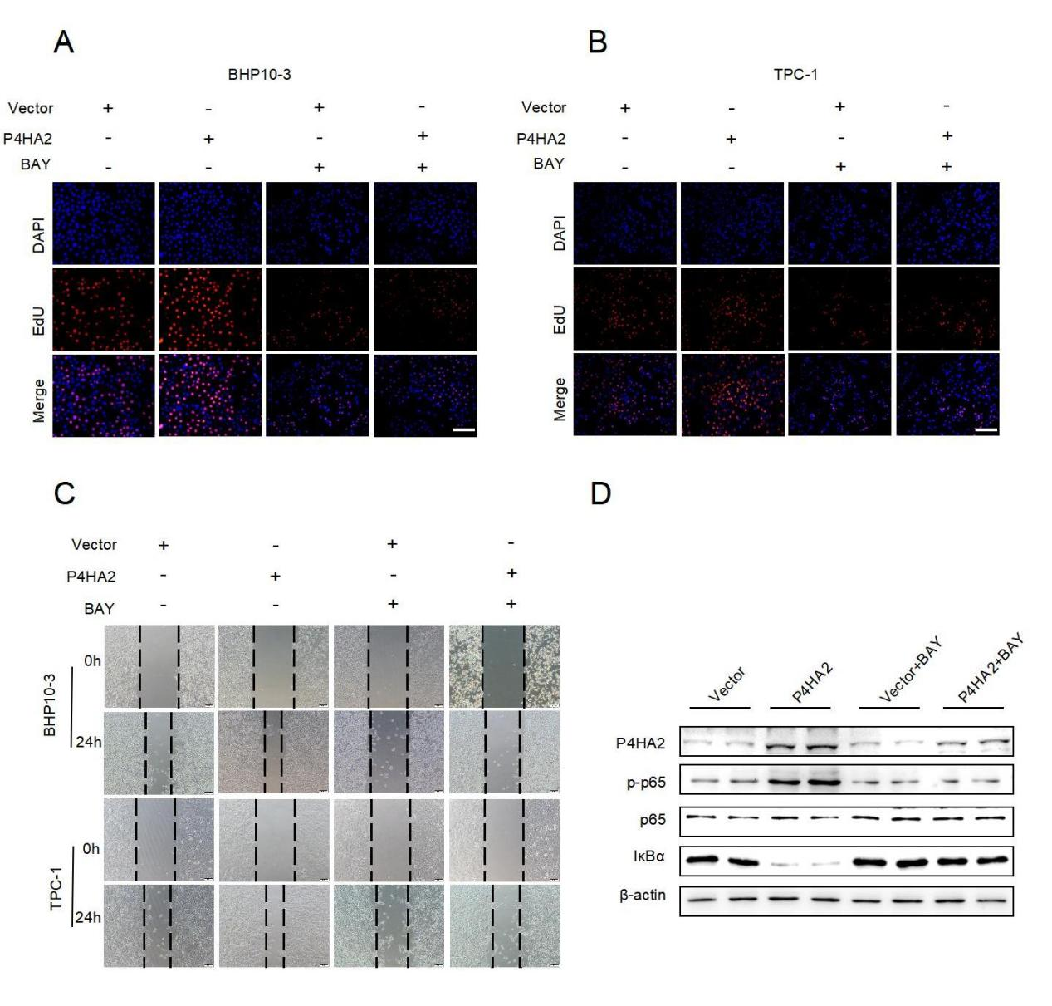
Supplementary Figure 2 A-B. After P4HA2 overexpression, BHP10-3 (A) and TPC-1 (B) cell lines were treated with BAY 11-7082 (1μM), and cell proliferation were detected using EdU assays. Three replicate wells were set up for each sample. C. After P4HA2 overexpression, BHP10-3 and TPC-1 cell lines were treated with BAY 11-7082 (1μM), wound healing assays were used to detect the migration ability. Three replicate wells were set up for each sample. D. The protein level of P4HA2, p65, pp65, and IκBα in subcutaneous tumors of different groups were detected by western blot analysis.

Supplementary Table 1 The primers designed for RT-qPCR.
Primers | Sequence（5'-3')
β-actin(h)-F | AGTTGCGTTACACCCTTTC
β-actin(h)-R | CCTTCACCGTTCCAGTTT
P4HA2(h)-F | CAAACTGGTGAAGCGGCTAAA
P4HA2(h)-R | GCACAGAGAGGTTGGCGATA
Vimentin(h)-F | AGTCCACTGAGTACCGGAGAC
Vimentin(h)-R | CATTTCACGCATCTGGCGTTC
E-cad(h)-F | CGGGAATGCAGTTGAGGATC
E-cad(h)-R | AGGATGGTGTAAGCGATGGC
N-cad(h)-F | AGCCAACCTTAACTGAGGAGT
N-cad(h)-R | GAAACCGGGCTATCTGCTCG
p65(h)-F | GAGCTACATTGCAACTAGAC
p65(h)-R | CTATGACCTACGACTGATCC
IKBA(h)-F | CACTCCATCCTGAAGGCTACCAA
IKBA(h)-R | AAGGGCAGTCCGGCCATTA

