Online supplementary for:

Methylated cfDNA may distinguish between high- and intermediate-risk uveal melanoma: a pilot study

Authors: Mike Wu^{1,2,3‡}, Daniël P. de Bruyn^{1,2,3‡}, Ruben G. Boers⁴, Aaron B. Beasley⁵, Daan M. Hazelaar⁶, Stavros Makrodimitris^{2,6}, Joachim Boers⁴, Jolanda Vaarwater^{1,3}, Ronald O.B. de Keizer⁷, Robert M. Verdijk^{7,8,9}, Nicole C. Naus^{1,3}, Dion Paridaens^{1,7}, Saskia M. Wilting⁶, Elin S. Gray⁵, Wilfred F.J. van IJcken¹⁰, Joost Gribnau⁴, Annelies de Klein^{2,3}, Erwin Brosens^{2,3,†} and Emine Kiliç^{1,3,†}, on behalf of the Rotterdam Ocular Melanoma Studygroup.*

¹Department of Ophthalmology, Erasmus MC, 3015 GD Rotterdam, The Netherlands: ²Department of Clinical Genetics, 3015 GD Rotterdam, The Netherlands;
³Erasmus MC Cancer Institute, 3015 GD Rotterdam, The Netherlands;
⁴Department of Developmental Biology, 3015 GD Rotterdam, The Netherlands;
⁵Centre for Precision Health, School of Medical and Health Sciences, Edith Cowan University, Joondalup, WA 6027, Australia;
⁶Department of Medical Oncology, 3015 GD Rotterdam, The Netherlands;
⁷The Rotterdam Eye Hospital, 3011 BH Rotterdam, The Netherlands;
⁸Department of Pathology, Section Ophthalmic Pathology, Erasmus MC Rotterdam, 3000 CA Rotterdam, The Netherlands;
⁹Department of Pathology, Leiden University Medical Center, 2333 ZA Leiden, The Netherlands.
¹⁰Center for Biomics, Erasmus University Medical Center, 3015 GD Rotterdam, The Netherlands.

†, ‡ These authors contributed equally to this work, shared position.
*The Rotterdam Ocular Melanoma Study Group (ROMS) is a collaborative research group with members from the Rotterdam Eye Hospital, Departments of Ophthalmology, Pathology and Clinical Genetics, of the Erasmus MC, Rotterdam, The Netherlands.

Correspondence: e.brosens@erasmusmc.nl and e.kilic@erasmusmc.nl

Supplementary title and legends

Figure S1. Metastasis-free survival for high and intermediate risk UM
Legend: Patients (N=22) were classified as high risk (harboring a BAP1-mutation and/or monosomy 3) and intermediate risk (harboring a SF3B1-mutation and/or disomy 3). The difference in metastasis-free survival between intermediate risk and high risk UM patients did not reach statistical significance (P=0.11, log-rank test).

Figure S2. Normal CNV profiles using IchorCNA and SNP-array
Legend: Here we display the copy number variations (CNVs) profiles of one patient who provided two samples, one cfDNA sample with a circulating tumor DNA (ctDNA) fraction of <10% (A) and a tumor sample showing no CNVs on either IchorCNA (B) or SNP-array (C).

Figure S3: Principal component analysis
A. Principal component analysis (PCA) was performed to identify clusters and potential outliers in the promoter region, CpG islands and gene body of cfDNA samples. Samples with a circulating tumor DNA fraction > 10% (ctDNA+) are marked with a white fill. A-C. In the UM cfDNA methylation signature, some cfDNA samples from the UM patients (dark blue) cannot be distinguished from healthy blood donors (HBDs, red). This overlap is the most in the promoter region and CpG islands, and least in the gene body. The ctDNA+ samples are not identified as separate clusters or outliers in any of the methylation signatures. D-F. Of the Metastatic risk signature, the PC values of high metastatic risk (HR) cfDNA samples cannot be distinguished from all but one intermediate metastatic risk (IR) cfDNA samples.

Figure S4. Evaluation of the UM cfDNA methylation signature through clustering of leukocyte subsets
Legend: Methylated reads of leukocyte subsets including monocytes, neutrophils, B lymphocytes, and T lymphocytes, were incorporated into the cfDNA methylation signature of uveal melanoma (UM) patients and healthy blood donors (HBDs). Overall, the leukocyte subsets exhibit a relatively high number of differentially methylated regions (DMRs) associated with hypermethylation in UM cfDNA samples, while showing fewer DMRs linked to hypermethylation of HBDs.

Figure S5. Evaluation of the cfDNA metastatic risksignature through clustering of of HBDs
Methylated reads of HBDs were incorporated into the cfDNA methylation signature of patients with high and intermediate metastatic risk. Multiple heterogenous clusters of high risk (HR) patients , intermediate risk (IR) patients, and healthy blood donors (HBDs), were observed.

Figure S6. Heatmap and dendrogram of primary tumor DNA methylation signature
Legend: Four out of 10 SF3B1 samples cluster on the left based on hypermethylated reads on chr. 6. Nine out of 10 BAP1 samples cluster in the middle based on hypermethylated reads located on chr. 8, 18, 19 and 20. Six out of 10 EIF1AX samples cluster on the right based on hypermethylated reads on chr. 3, 5, 10, 11 and 14.

Figure S7. Evaluation of primary tumor DNA methylation signaturethrough clustering with ctDNA+ samples and melanocytes
Methylated reads of samples with tumor fraction > 5% (ctDNA+, N=2) and foreskin-derived neonatal melanocytes (N=5) were incorporated into the primary tumor DNA methylation signature. The ctDNA+ sample SE22-4155, presumably a BAP1 mutation based on loss of chromosome 3, clustered with the BAP1 tumor samples. The other ctDNA+ sample SE22-4154, had a SF3B1 mutation, but clustered with the EIF1AX-mutated tumors. The five melanocyte samples clustered together based on hypomethylated reads on chromosomes 3, 6, 9, 11, and 14

Figure S8. Flowchart of DMRs from the UM cfDNA methylation signature for gene set enrichment analysis.
After filtering on a fold change (FC) > 2.0, AUC between 0.20 and 0.80, and excluding unmapped DMRs, 207 DMR associated genes were utilized for the gene set enrichment analysis (GSEA).

Figure S9. Flowdiagram of literature search for genes related to methylation in cfDNA or ctDNA of UM patients
Legend: A total of 77 unique genes were included from the literature, after removal of duplicates and screening 229 articles on title and abstract. The overlap between those genes and the DMRs of our four methylation signatures was zero.

Figure S10. Venn diagram of the three cfDNA methylation signatures
The number of DMRs with a fold change (FC) > 2 obtained from the UM cfDNA signature, metastatic risk signature and primary tumor DNA signature was 402, 12, and 49, respectively. No overlap between the methylation signatures was revealed.

Table S1. Baseline characteristics of (cell-free) DNA samples
Legend: AJCC = The American Joint Committee on Cancer; ND = Not determined; BAP1 = BRCA1 associated deubiquitinase 1 ; CpG = Cytosine-phosphate-guanosine; CNV = Copy number variations; L = Loss; G = Gain;

Table S2. Baseline characteristics of ROMS patients and Perth patients
Legend: AJCC = The American Joint Committee on Cancer; BAP1 = BRCA1 associated deubiquitinase 1; ND = Not determined; M3 = Monosomy 3; D3 Disomy 3; Values are means (SDs) for continuous variables and percentages for categorical variables.

Table S3. Baseline characteristics of all UM patients and healthy blood donors (HBDs)
Legend: AJCC = The American Joint Committee on Cancer; N/A = not available; ND = Not determined; M3 = Monosomy 3; D3 = Disomy 3; GNA11 = G protein subunit alpha 11; GNAQ = G protein subunit alpha q; PLCB4 = phospholipase C beta 4; BAP1 = BRCA1 associated protein 1; SF3B1 = splicing factor 3b subunit 1; Values are means (SDs) for continuous variables and percentages for categorical variables.

Table S4. Baseline characteristics of tumor samples
Legend: AJCC = The American Joint Committee on Cancer; BAP1 = BRCA1 associated protein 1; IHC = immunohistochemistry; GNA11 = G protein subunit alpha 11; GNAQ = G protein subunit alpha q; SF3B1 = splicing factor 3b subunit 1; EIF1AX: Eukaryotic translation Initiation Factor 1A X-linked; Values are means (SDs) for continuous variables and percentages for categorical variables.

Table S5. Differentially methylated regions (DMRS) between UM patients and healthy blood donors (HBDs)
Legend: AUC = Area under the curve; CpG = Cytosine-phosphate-guanosine; Ensemble ID: Gene and CpG island annotations were downloaded from Ensembl (https://www.ensembl.org). Ratio = bidirectional value of FoldChange; postTSS1KB-TES = 1 kb after TSS until transcription end site (gene body); TSS = transcription start site (1 kb before and 1 kb after promotor; UM = Uveal Melanoma.

Table S6. Differentially methylated regions (DMRS) between high risk (HR) and intermediate risk (IR) UM patients
Legend: AUC = Area under the curve; CpG = Cytosine-phosphate-guanosine; Ensemble ID: Gene and CpG island annotations were downloaded from Ensembl (https://www.ensembl.org). Ratio = bidirectional value of FoldChange; postTSS1KB-TES = 1 kb after TSS until transcription end site (gene body); TSS = transcription start site (1 kb before and 1 kb after promotor; UM = Uveal Melanoma.

Table S7. Differentially methylated regions (DMRS) between tumor subgroups with BAP1 mutation, SF3B1 mutation and EIF1AX mutation
Legend: AUC = Area under the curve; BAP1 = BRCA1 associated protein 1; CpG = Cytosine-phosphate-guanosine; EIF1AX: Eukaryotic translation Initiation Factor 1A X-linked; Ensemble ID: Gene and CpG island annotations were downloaded from Ensembl (https://www.ensembl.org). Ratio = bidirectional value of FoldChange; postTSS1KB-TES = 1 kb after TSS until transcription end site (gene body); SF3B1 = splicing factor 3b subunit 1; TSS = transcription start site (1 kb before and 1 kb after promotor; UM = Uveal Melanoma.

Table S8. Results of literature search for potential biomarkers related to methylation in cfDNA or ctDNA of UM patients.
Legend: A total of 77 unique genes from 27 articles were retrieved from the literature search performed on 24-10-2024 using the search query “uveal melanoma AND (epigenetics OR DNA methylation or cfDNA or ctDNA)”.

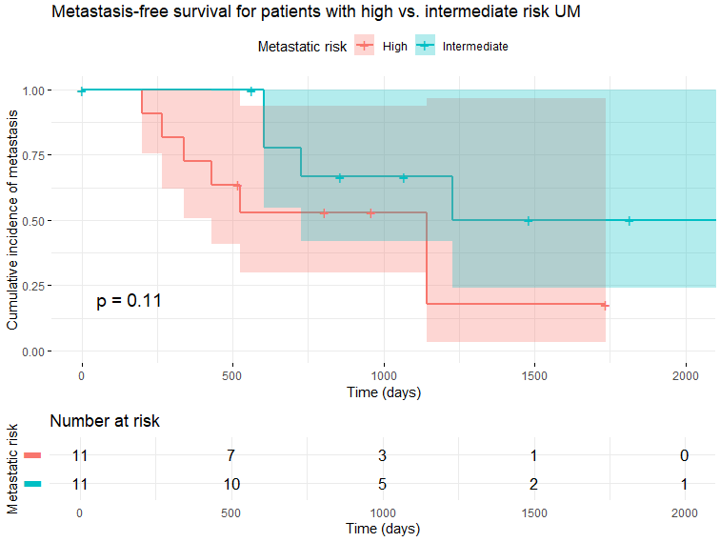

Figure S1. Metastasis-free survival for high and intermediate risk UM
Patients (N=22) were classified as high risk (harboring a BAP1-mutation and/or monosomy 3) and intermediate risk (harboring a SF3B1-mutation and/or disomy 3). The difference in metastasis-free survival between intermediate risk and high risk UM patients did not reach statistical significance (P=0.11, log-rank test).

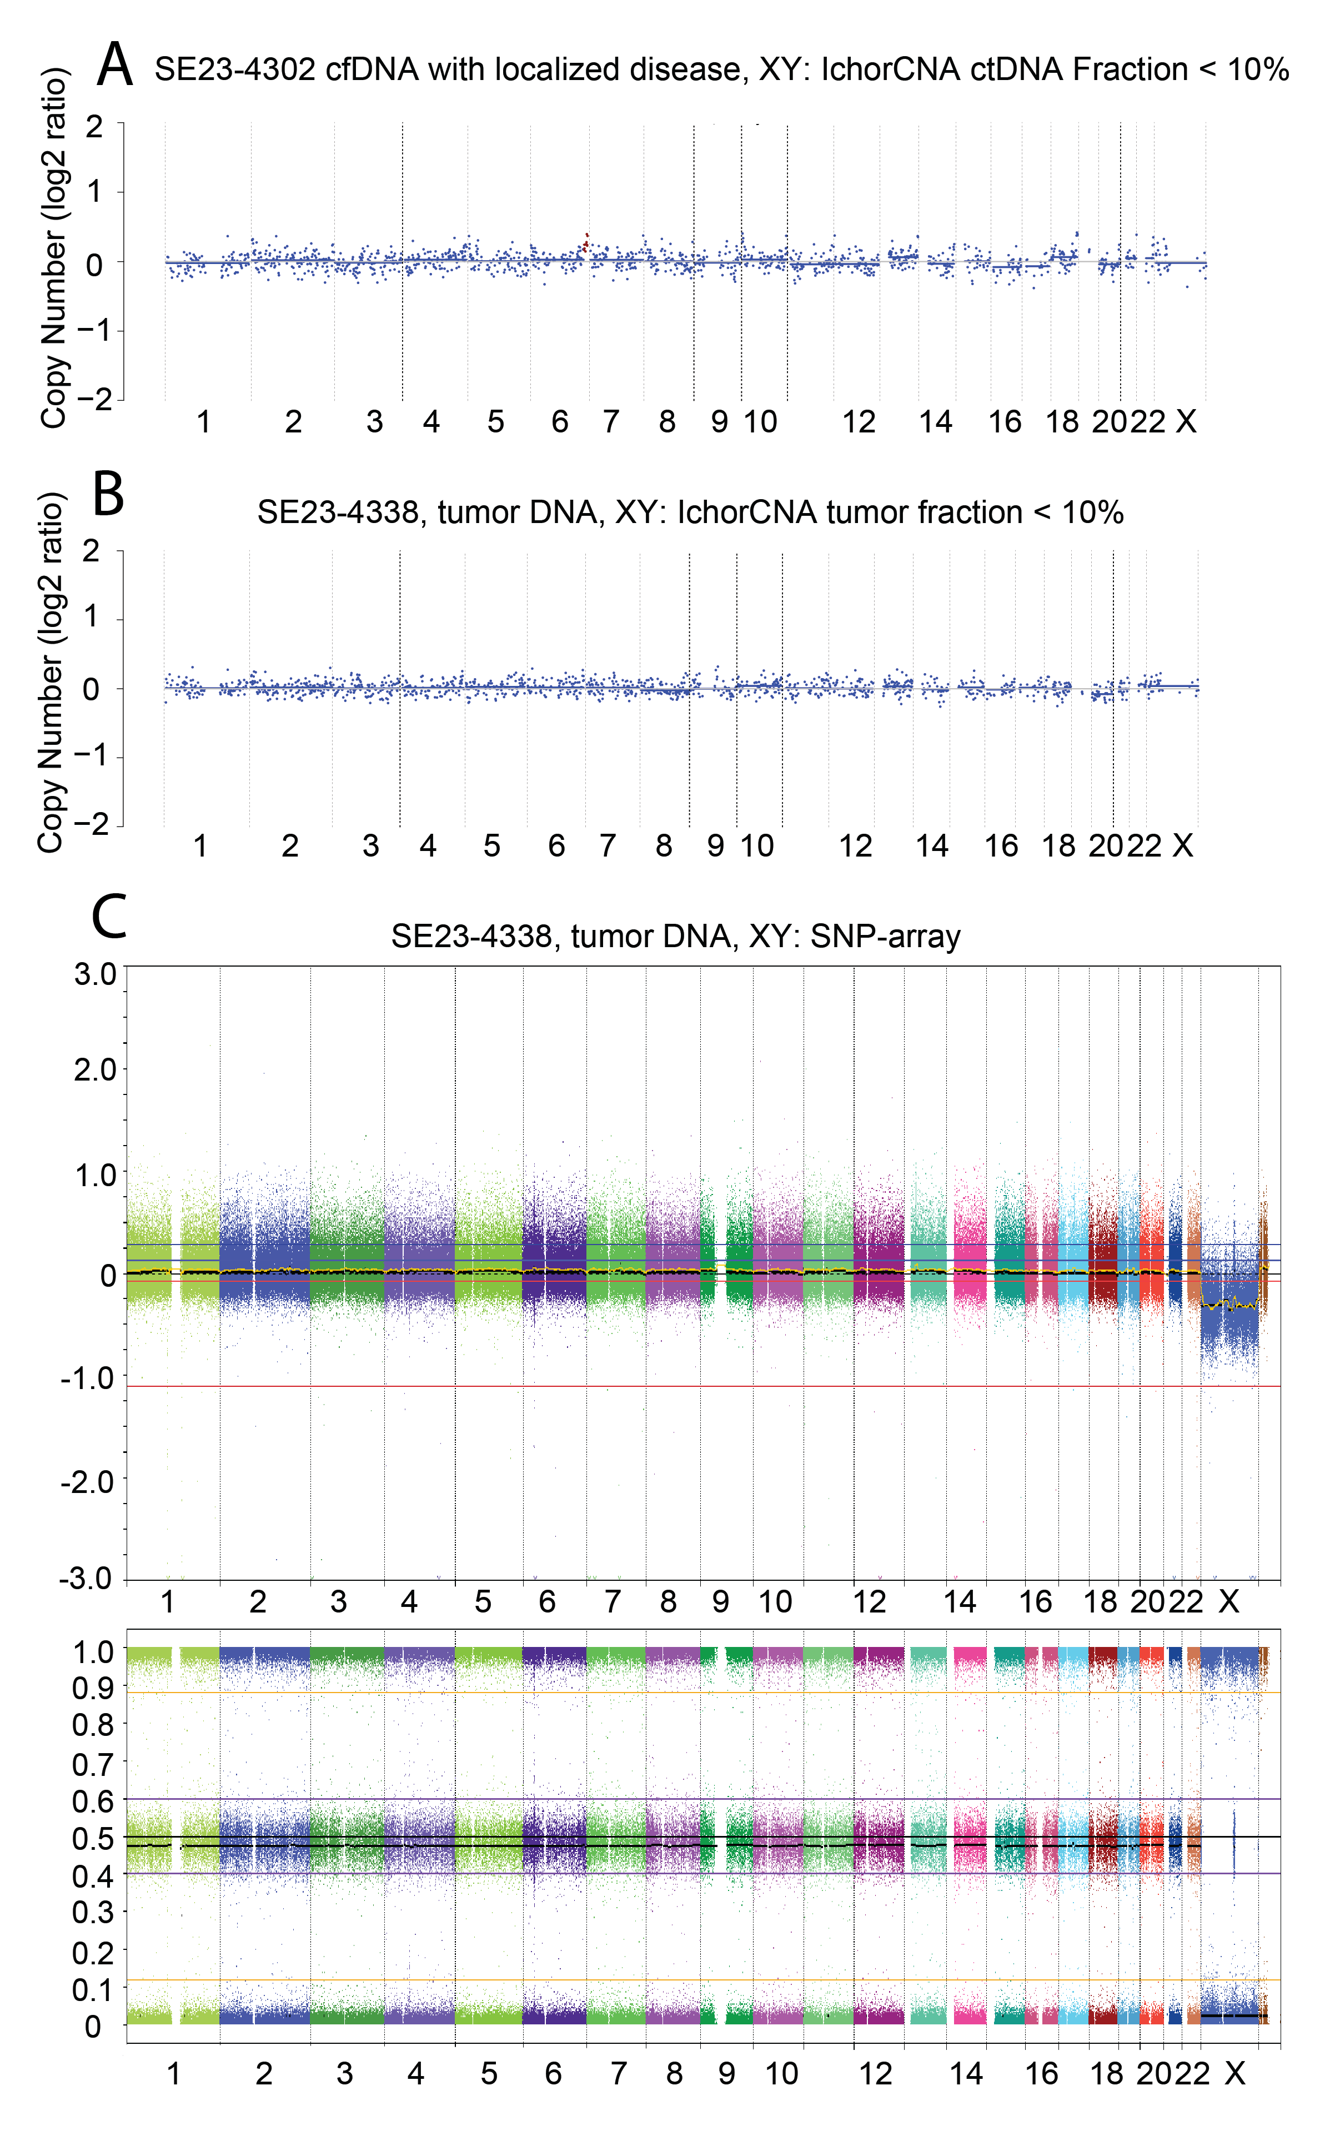

Figure S2. Normal CNV profiles using IchorCNA and SNP-array
Here we display the copy number variations (CNVs) profiles of one patient who provided two samples, one cfDNA sample with a circulating tumor DNA (ctDNA) fraction of <10% (A) and a tumor sample showing no CNVs on either IchorCNA (B) or SNP-array (C).

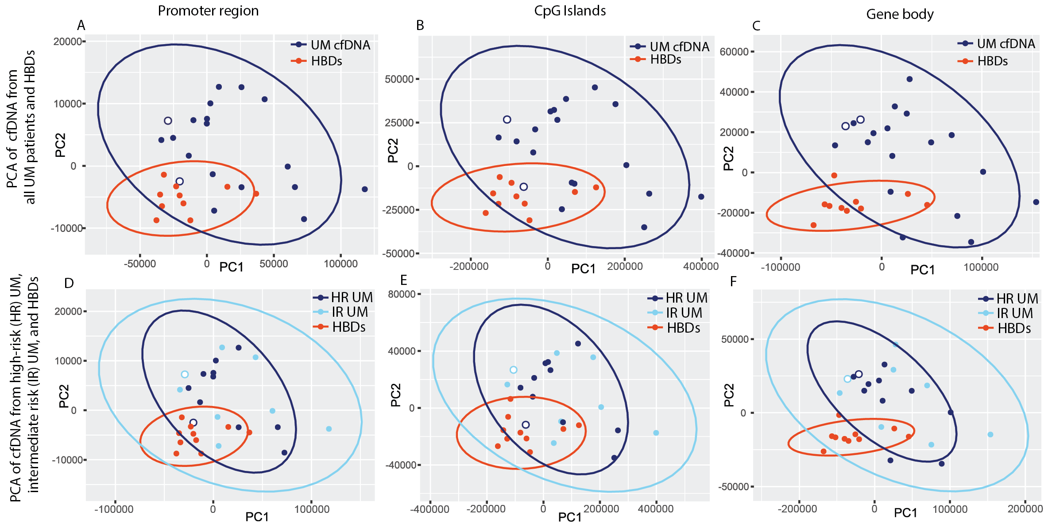

Figure S3: Principal component analysis
A. Principal component analysis (PCA) was performed to identify clusters and potential outliers in the promoter region, CpG islands and gene body of cfDNA samples. Samples with a circulating tumor DNA fraction > 10% (ctDNA+) are marked with a white fill. A-C. In the UM cfDNA methylation signature, some cfDNA samples from the UM patients (dark blue) cannot be distinguished from healthy blood donors (HBDs, red). This overlap is the most in the promoter region and CpG islands, and least in the gene body. The ctDNA+ samples are not identified as separate clusters or outliers in any of the methylation signatures. D-F. Of the Metastatic risk signature, the PC values of high metastatic risk (HR) cfDNA samples cannot be distinguished from all but one intermediate metastatic risk (IR) cfDNA samples.

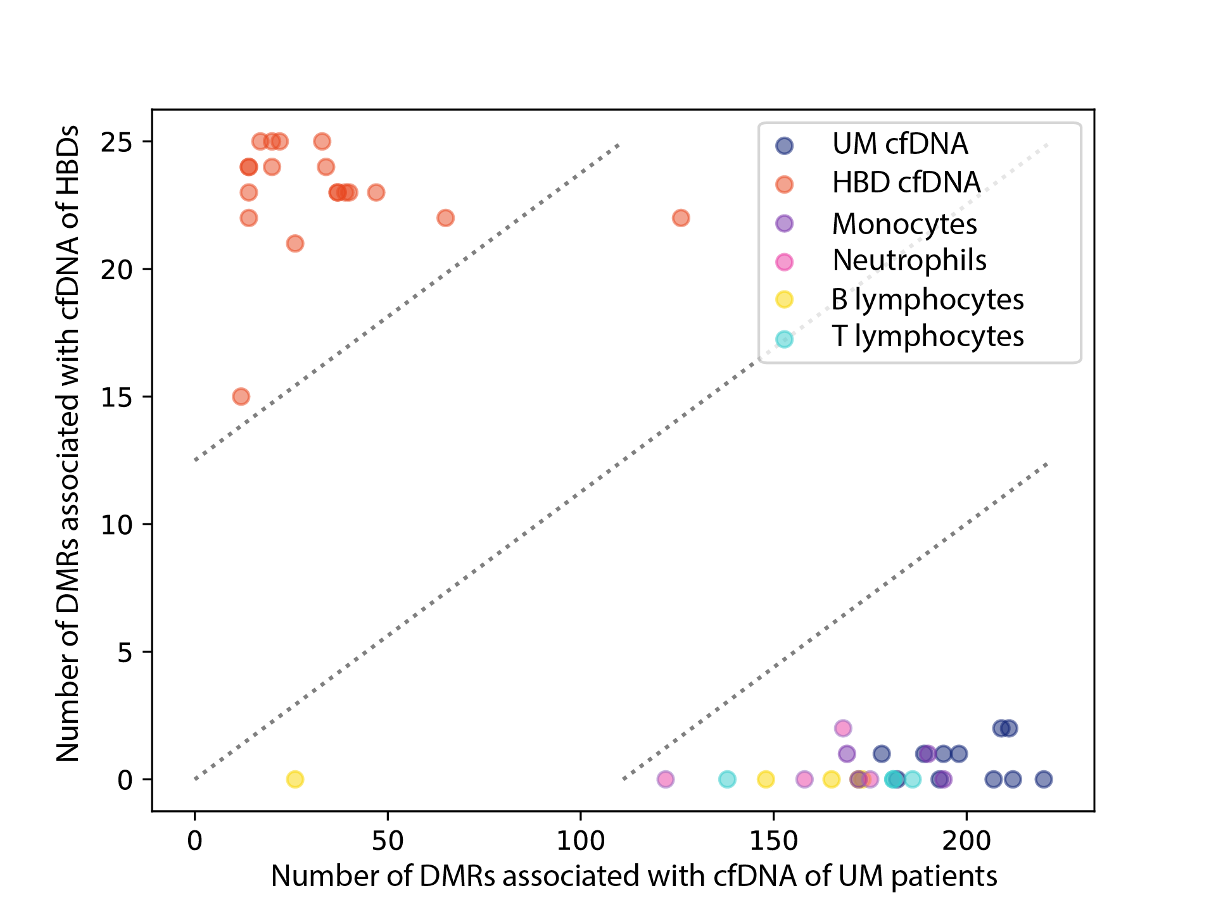

Figure S4. Evaluation of the UM cfDNA methylation signature through clustering of leukocyte subsets
Methylated reads of leukocyte subsets including monocytes, neutrophils, B lymphocytes, and T lymphocytes, were incorporated into the cfDNA methylation signature of uveal melanoma (UM) patients and healthy blood donors (HBDs). Overall, the leukocyte subsets exhibit a relatively high number of differentially methylated regions (DMRs) associated with hypermethylation in UM cfDNA samples, while showing fewer DMRs linked to hypermethylation of HBDs.

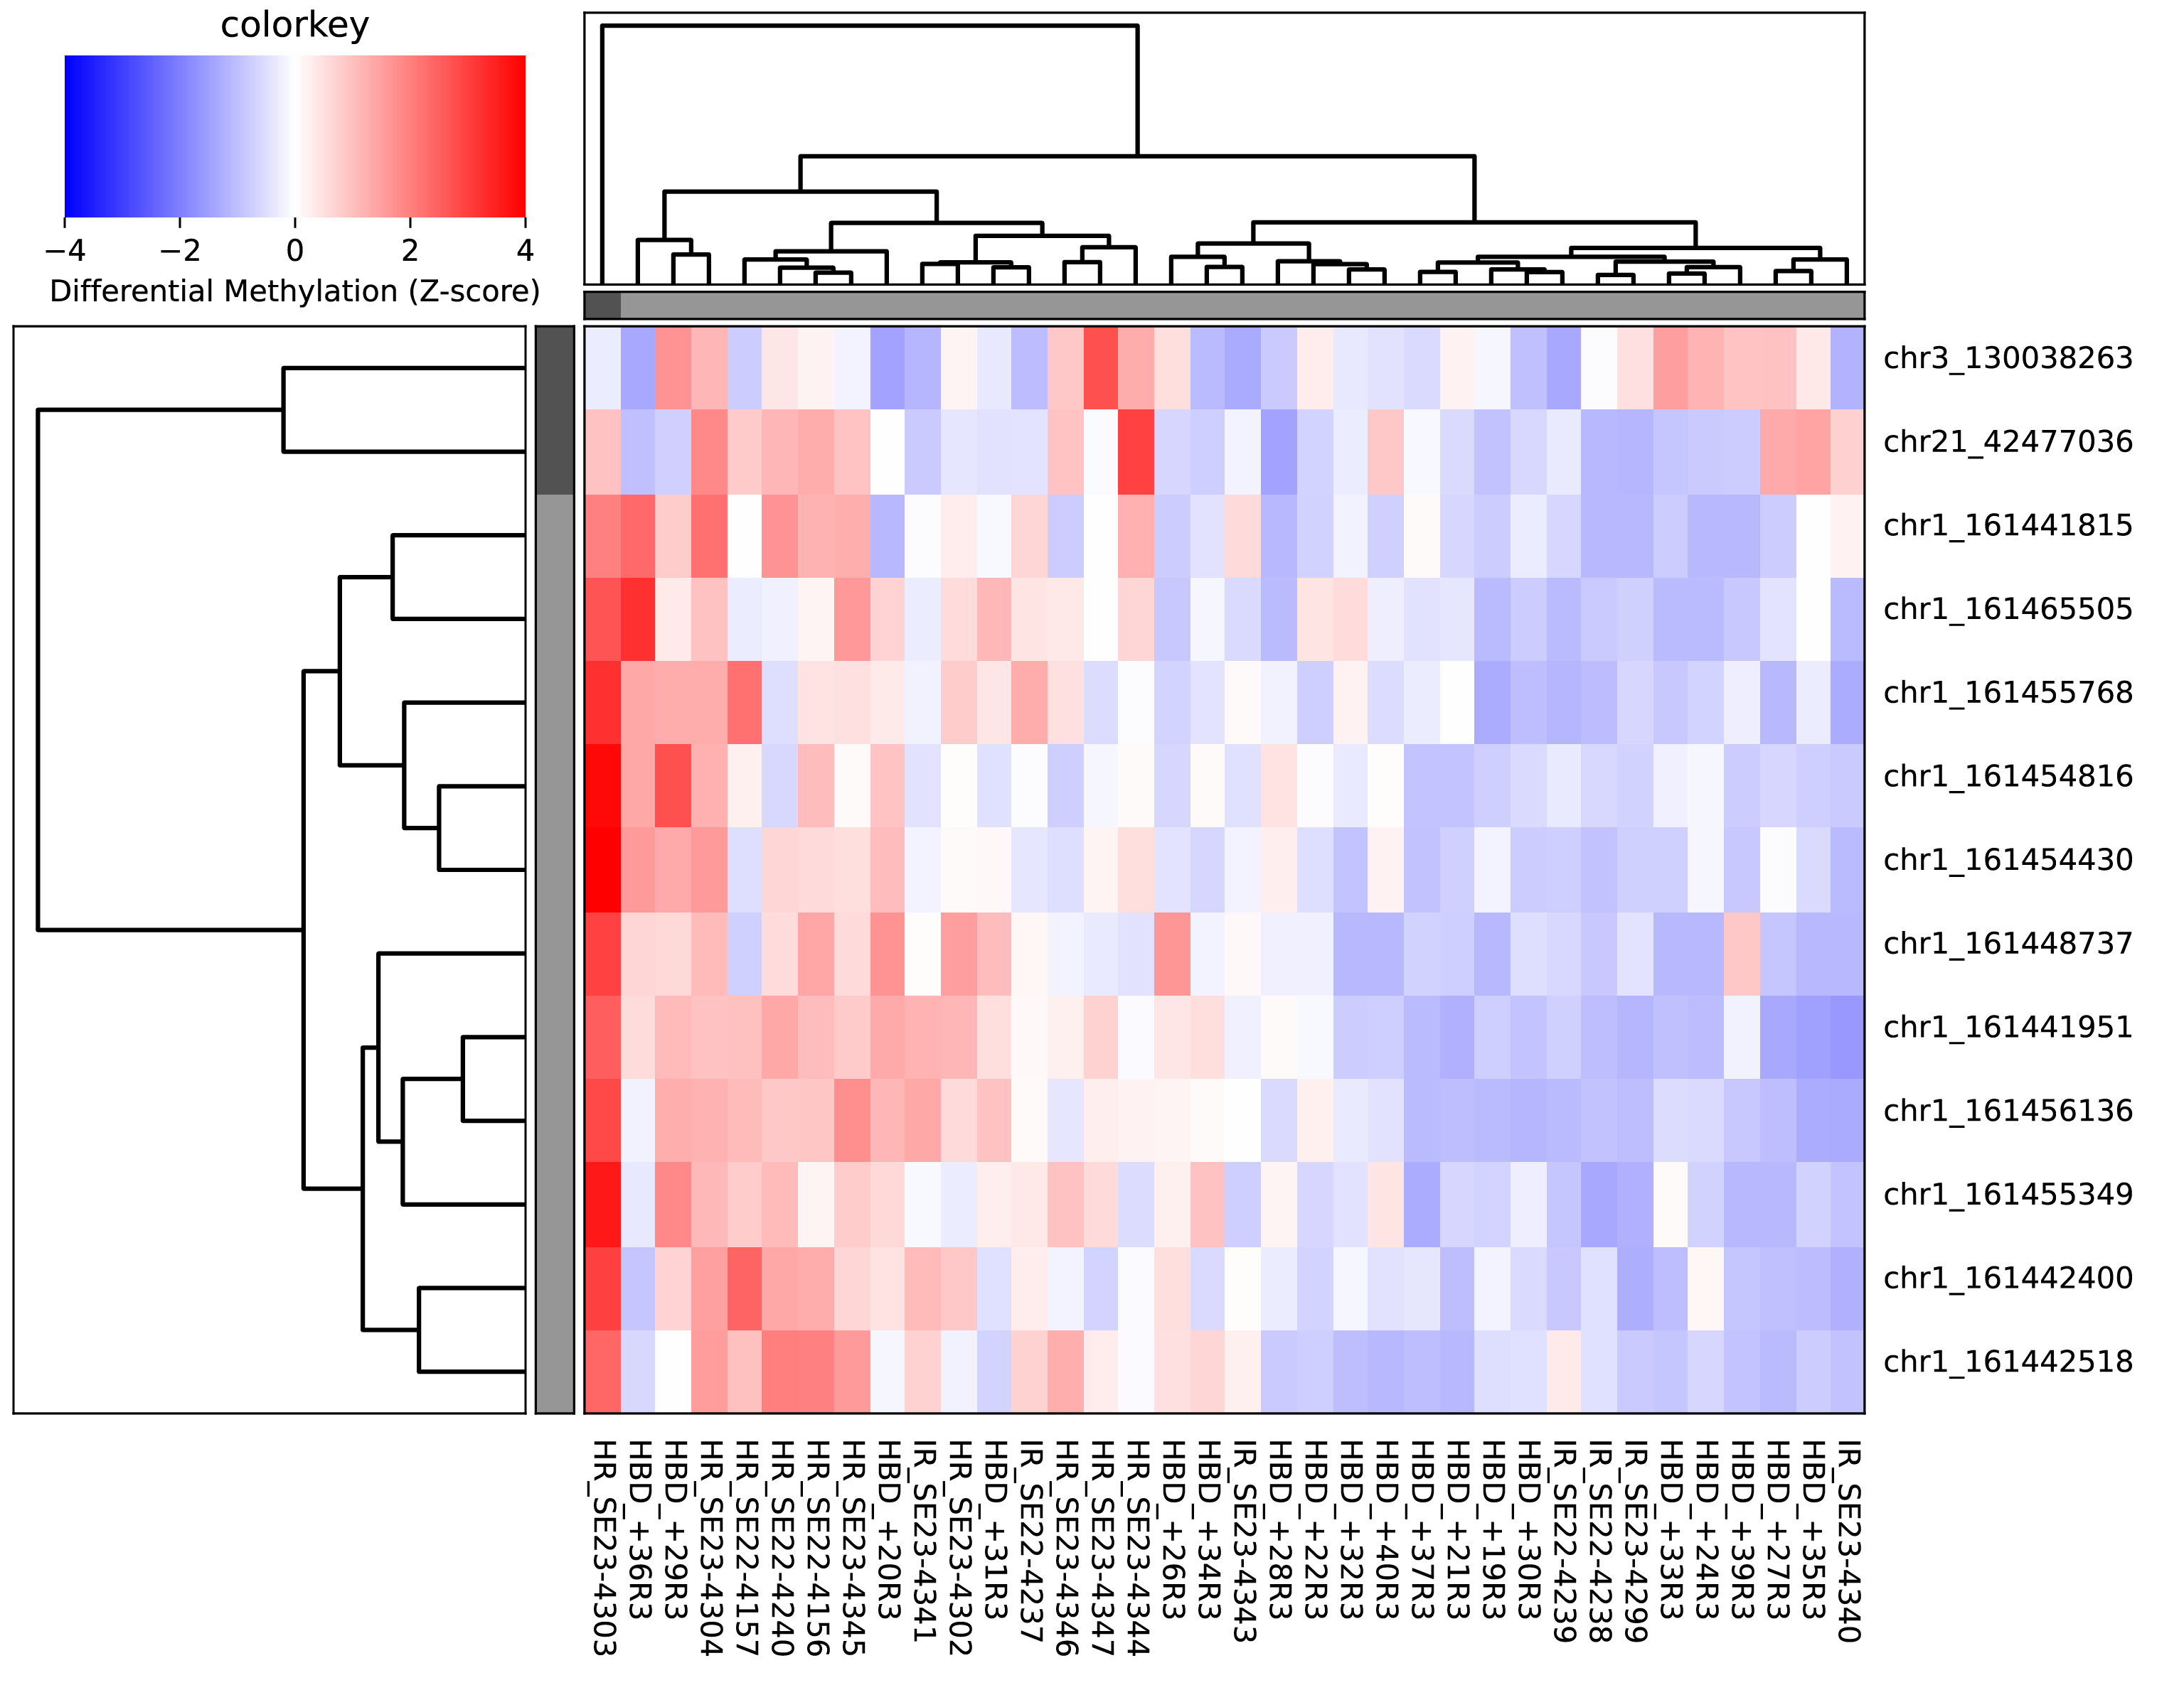

Figure S5. Evaluation of the cfDNA metastatic risk signature through clustering of of HBDs
Methylated reads of HBDs were incorporated into the cfDNA methylation signature of patients with high and intermediate metastatic risk. Multiple heterogenous clusters of high risk (HR) patients, intermediate risk (IR) patients, and healthy blood donors (HBDs), were observed.

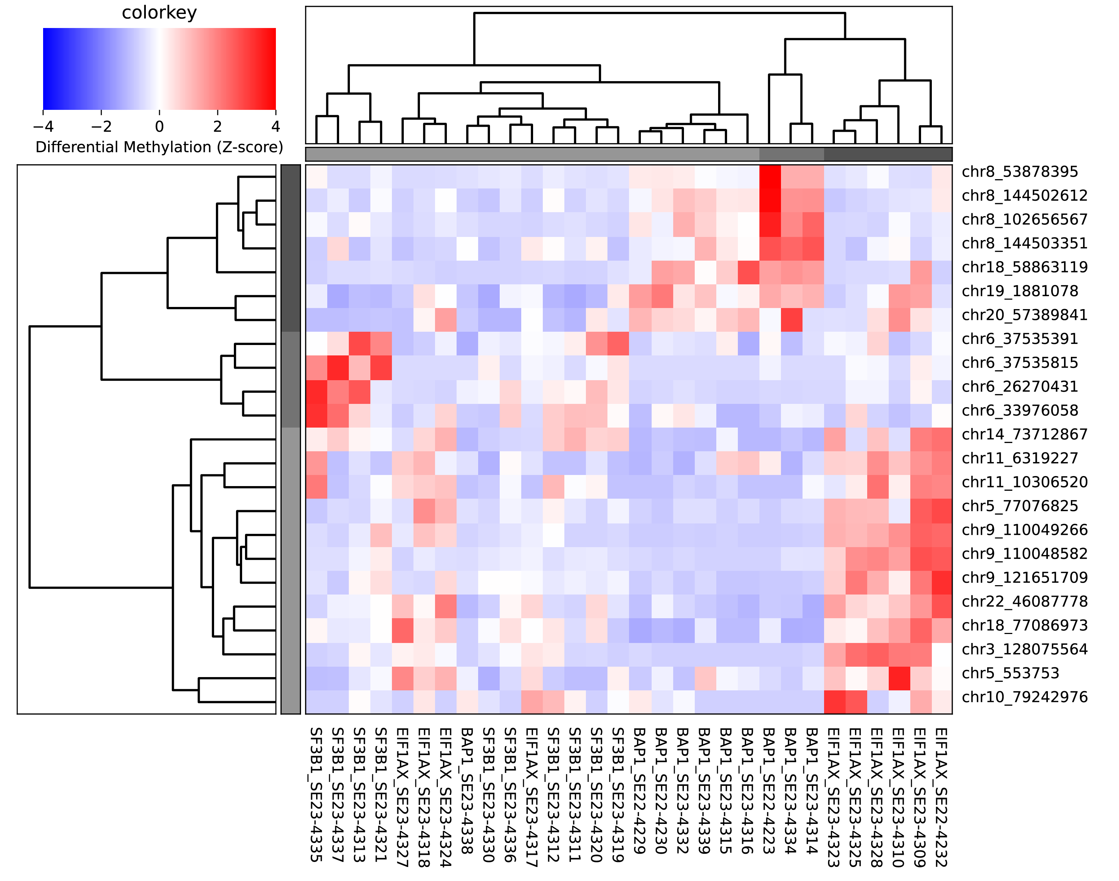

Figure S6. Heatmap and dendrogram of primary tumor DNA methylation signature
Four out of 10 SF3B1 samples cluster on the left based on hypermethylated reads on chr. 6.
Nine out of 10 BAP1 samples cluster in the middle based on hypermethylated reads located on chr. 8, 18, 19 and 20. Six out of 10 EIF1AX samples cluster on the right based on hypermethylated reads on chr. 3, 5, 10, 11 and 14.

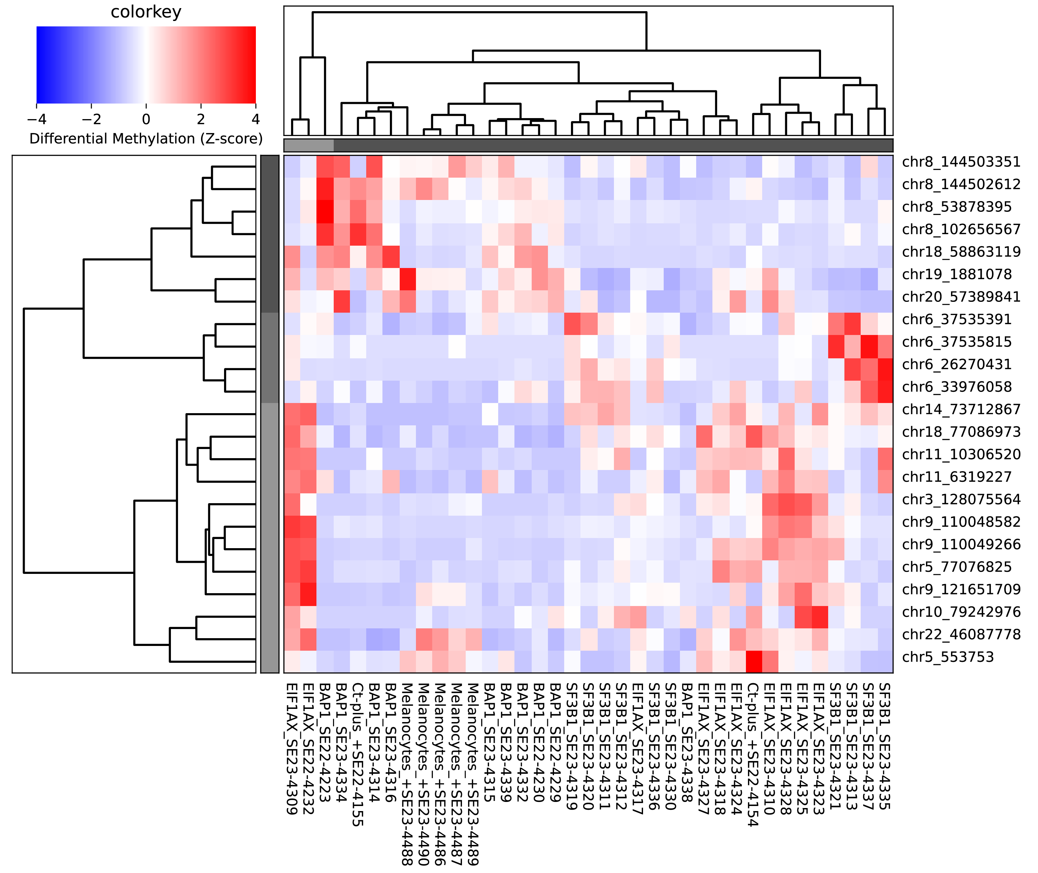

Figure S7. Evaluation of primary tumor DNA methylation signature through clustering with ctDNA+ samples and melanocytes
Methylated reads of samples with tumor fraction > 5% (ctDNA+, N=2) and foreskin-derived neonatal melanocytes (N=5) were incorporated into the primary tumor DNA methylation signature. The ctDNA+ sample SE22-4155, presumably a BAP1 mutation based on loss of chromosome 3, clustered with the BAP1 tumor samples. The other ctDNA+ sample SE22-4154, had a SF3B1 mutation, but clustered with the EIF1AX-mutated tumors. The five melanocyte samples clustered together based on hypomethylated reads on chromosomes 3, 6, 9, 11, and 14.

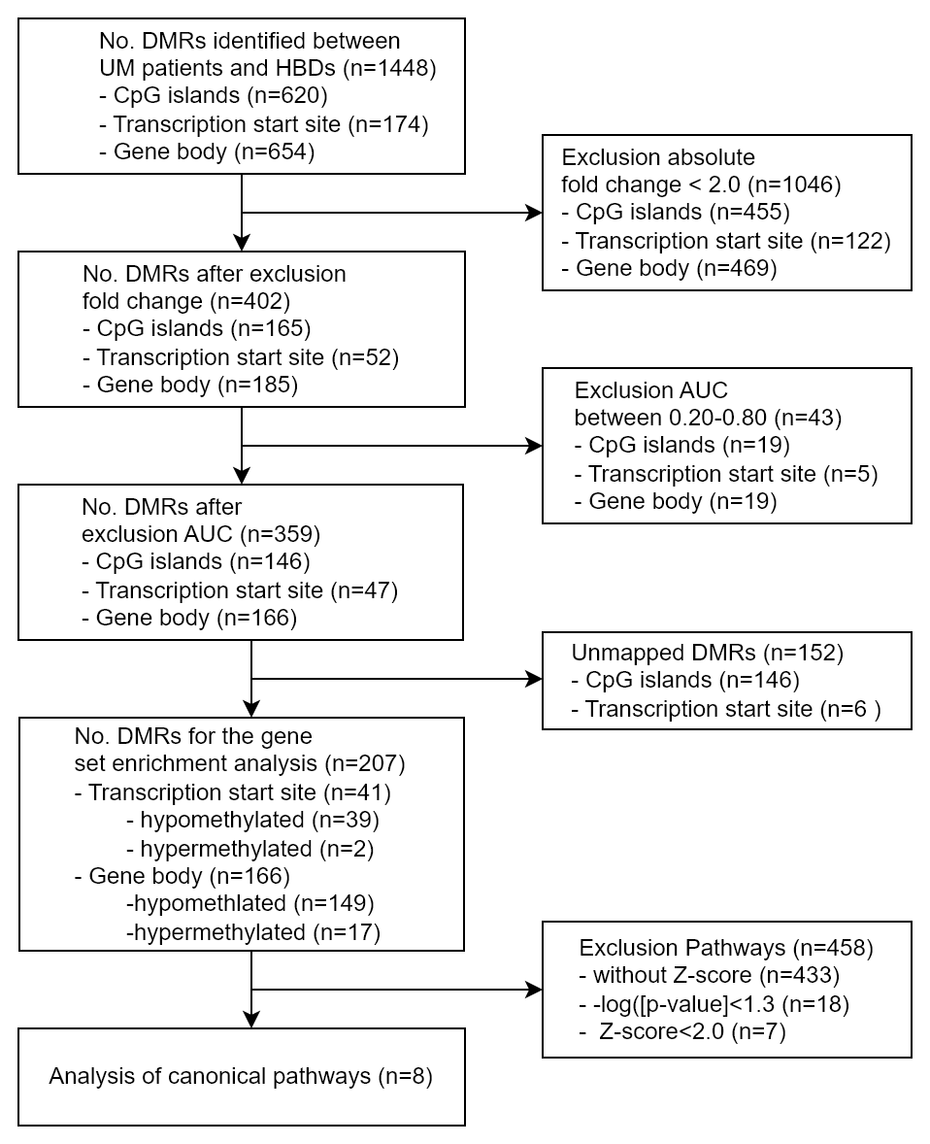

Figure S8. Flowchart of DMRs from the UM cfDNA methylation signature for gene set enrichment analysis.
After filtering on a fold change (FC) > 2.0, AUC between 0.20 and 0.80, and excluding unmapped DMRs, 207 DMR associated genes were utilized for the gene set enrichment analysis (GSEA).

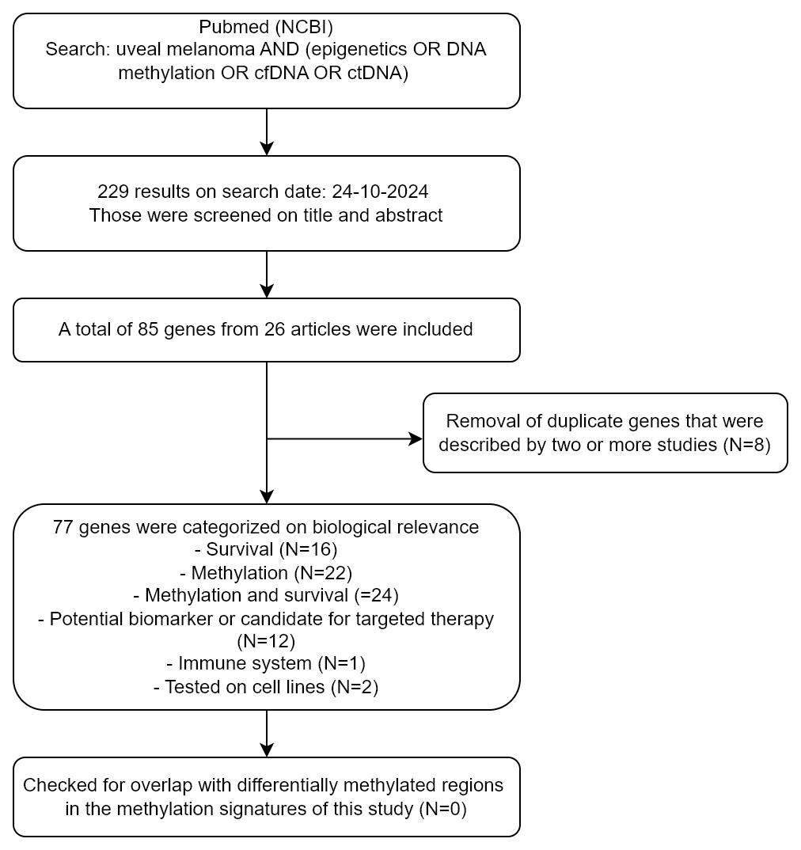

Figure S9. Flow diagram of literature search for genes related to methylation in cfDNA or ctDNA of UM patients
A total of 77 unique genes were included from the literature, after removal of duplicates and screening 229 articles on title and abstract. The overlap between those genes and the DMRs of our four methylation signatures was zero.

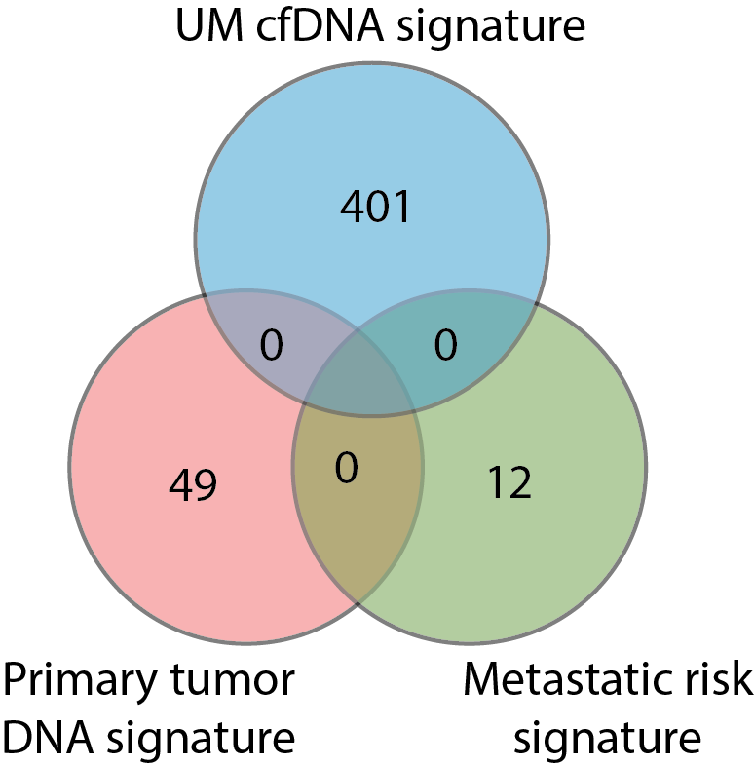

Figure S10. Venn diagram of the three cfDNA methylation signatures
The number of DMRs with a fold change (FC) > 2 obtained from the UM cfDNA signature, metastatic risk signature and primary tumor DNA signature was 402, 12, and 49, respectively. No overlap between the methylation signatures was revealed.

