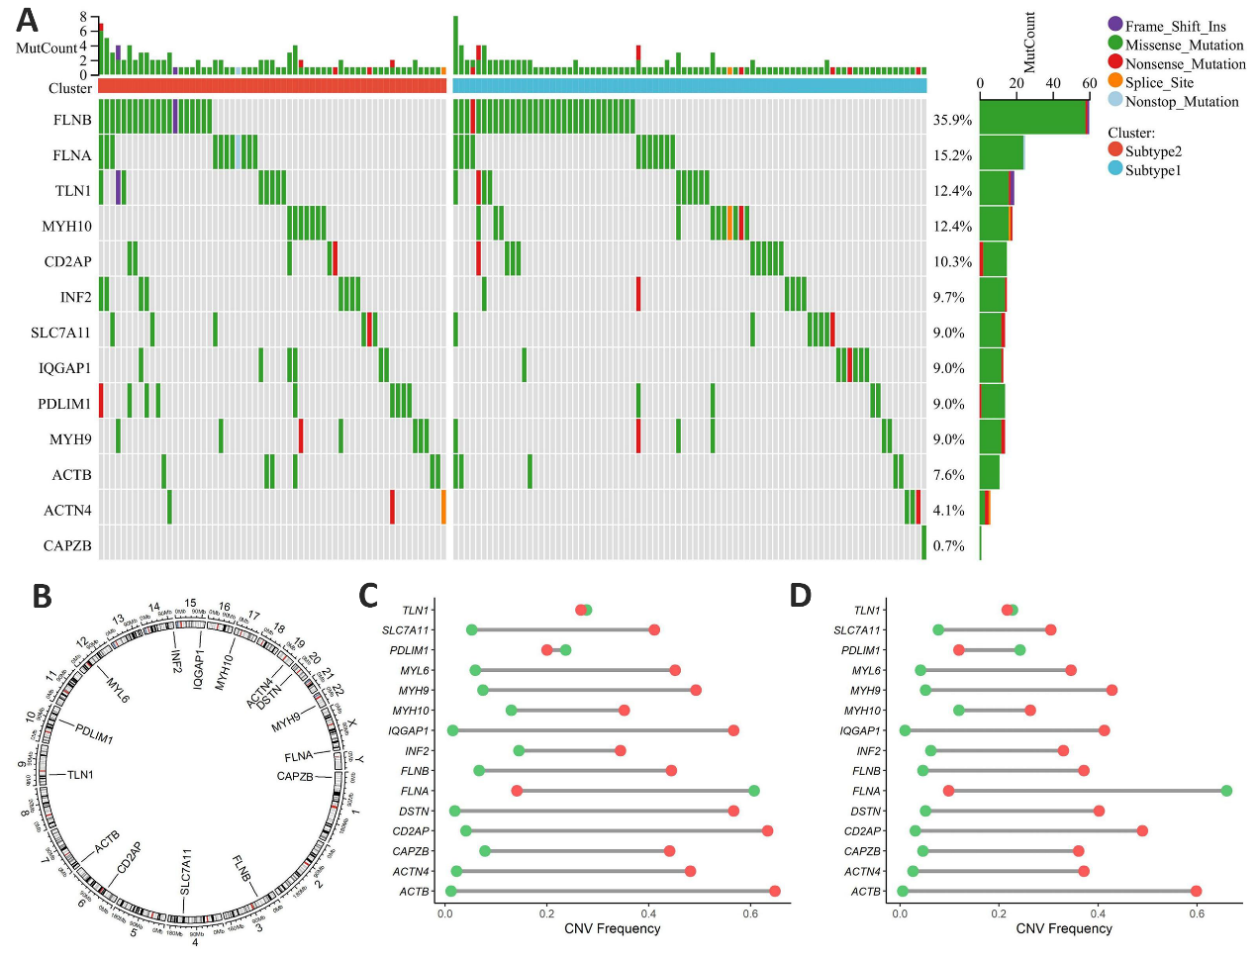Figure S1. Genomic characteristics of disulfidptosis-related melanoma subtypes
(A) Waterfall plot of short variants in disulfidoptosis-related genes across Subtype 1 and Subtype 2. (B) Chromosomal localization of disulfidoptosis-related genes in the human genome. (C) Frequency of CNV in disulfidoptosis-related genes in Subtype 1. (D) Frequency of CNV in disulfidoptosis-related genes in Subtype 2. (In the figures, red dots represent copy number gains, while green dots indicate copy number losses)

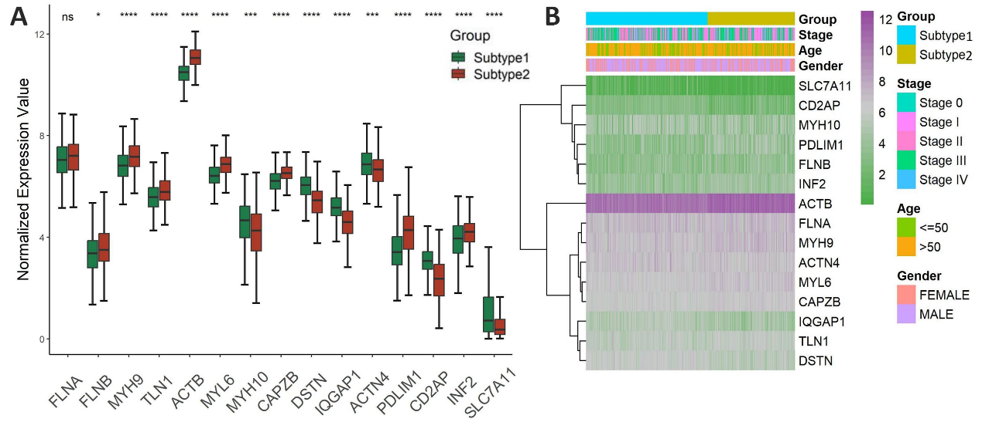Figure S2. Expression analysis of DRGs in melanoma subtypes
(A) Box plots showing the expression differences of 15 disulfidoptosis-related genes between the two subtypes. (B) Heatmap illustrating the expression patterns of disulfidoptosis-related genes in melanoma sample. (ns indicates no significant difference; * P < 0.05; *** P < 0.001; **** P < 0.0001).

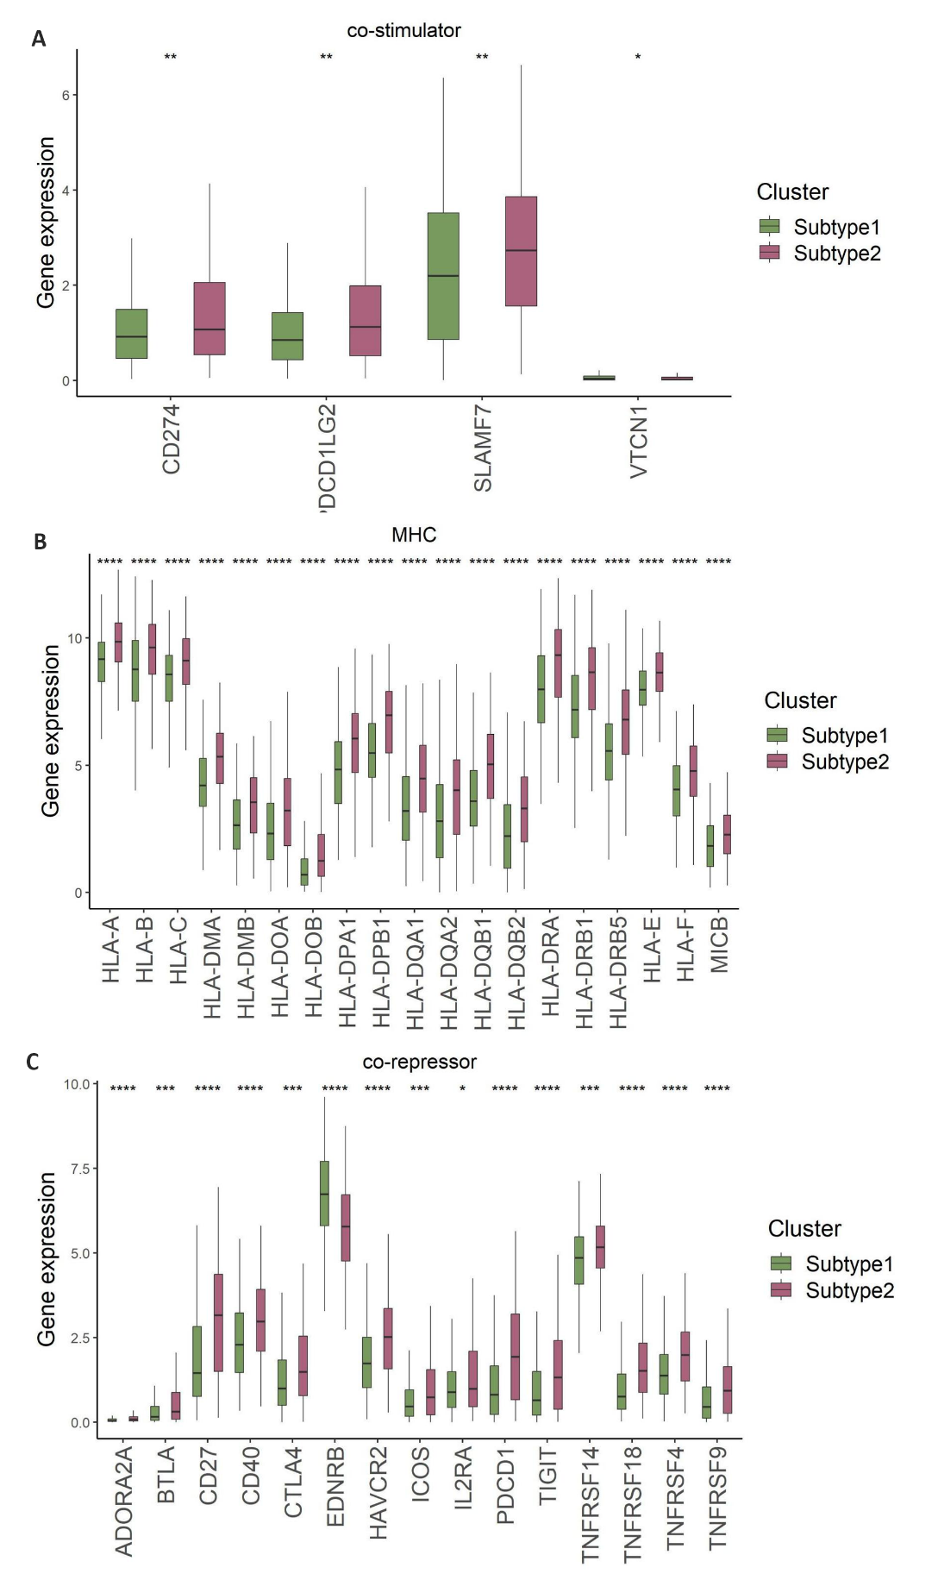
Figure S3. Molecular differences among tumor subtypes associated with disulfidptosis.
(A) Four costimulatory molecules showing significant intergroup differences. (B) Nineteen MHC molecules with significant intergroup differences. (C) Fifteen coinhibitory molecules with significant intergroup differences. (* P < 0.05; ** P < 0.01; *** P < 0.001; **** P < 0.0001).

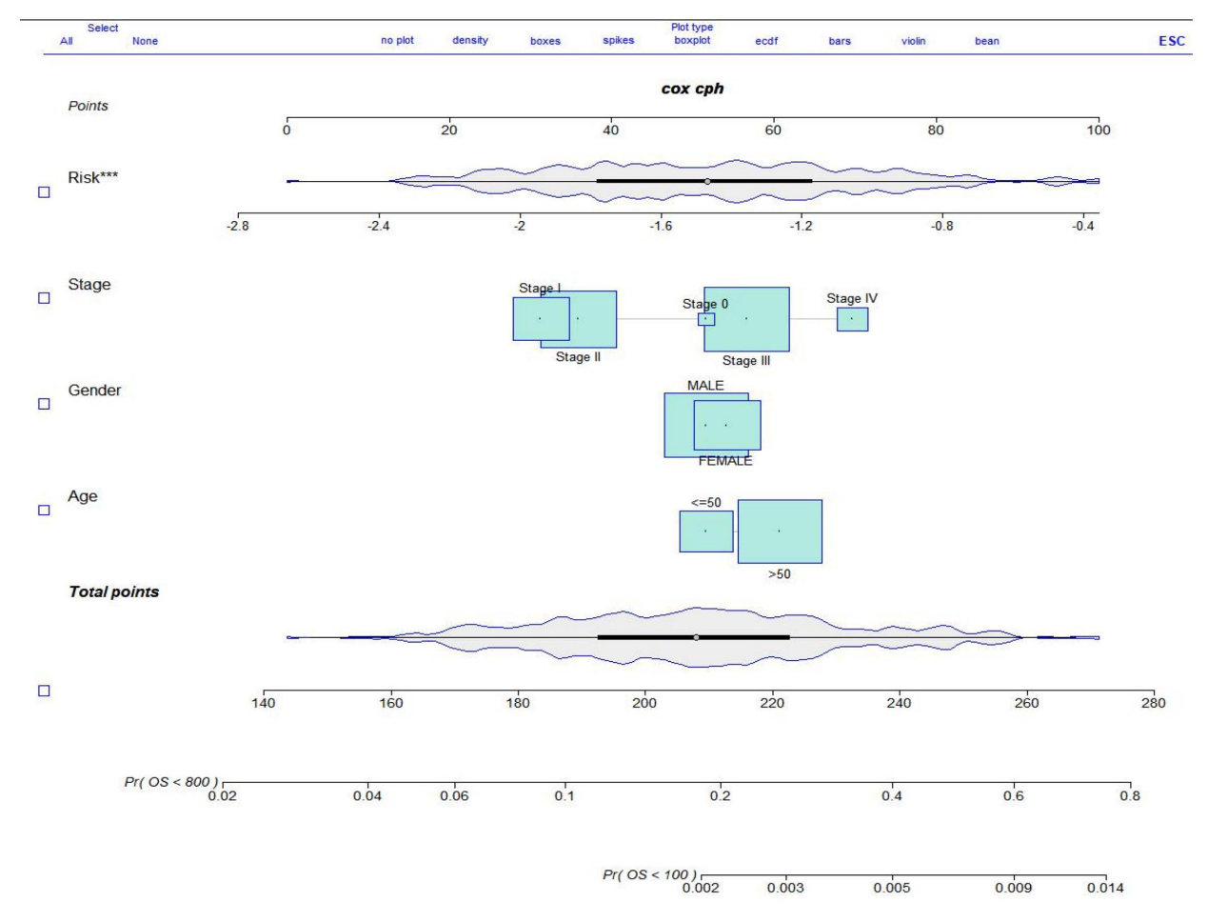Figure S4. Nomogram for individualized survival prediction
Nomogram integrating risk score with gender, age, and cancer stage.
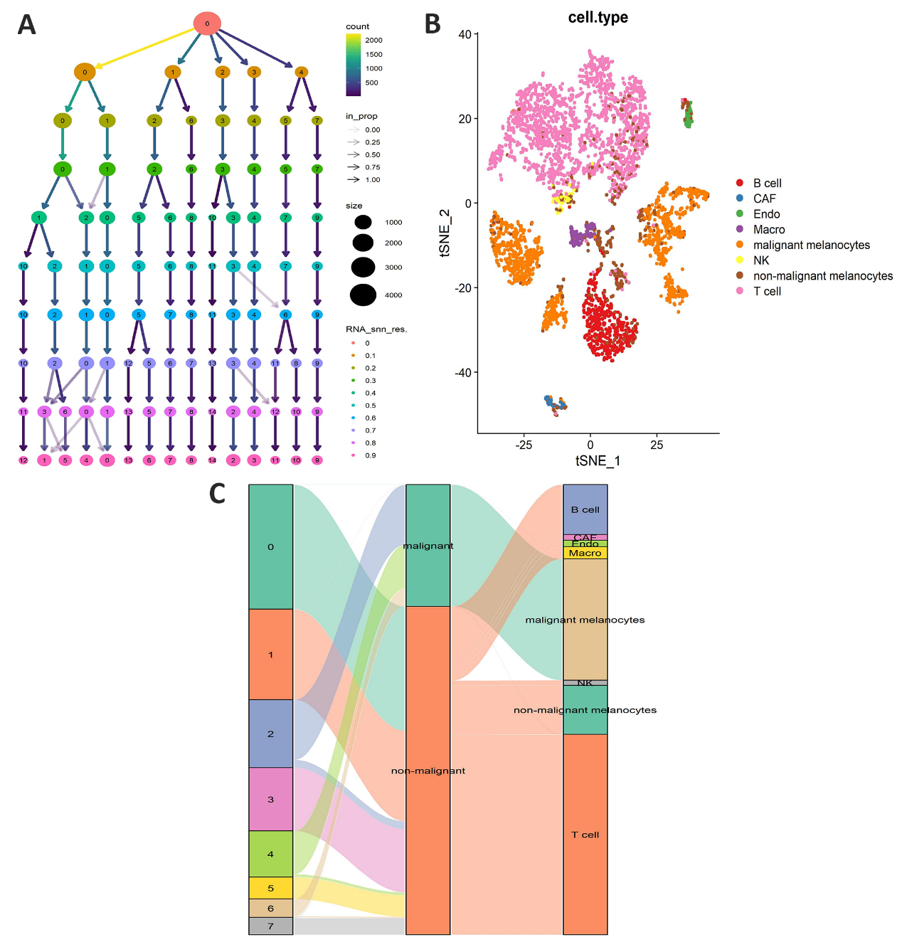Figure S5. scRNA-seq validation of melanoma.
(A) Cell subcluster results based on the t-SNE algorithm under different resolution settings. (B) Scatter plot showing cell annotation results after t-SNE dimensionality reduction. (C) Sankey diagram showing intercellular associations.
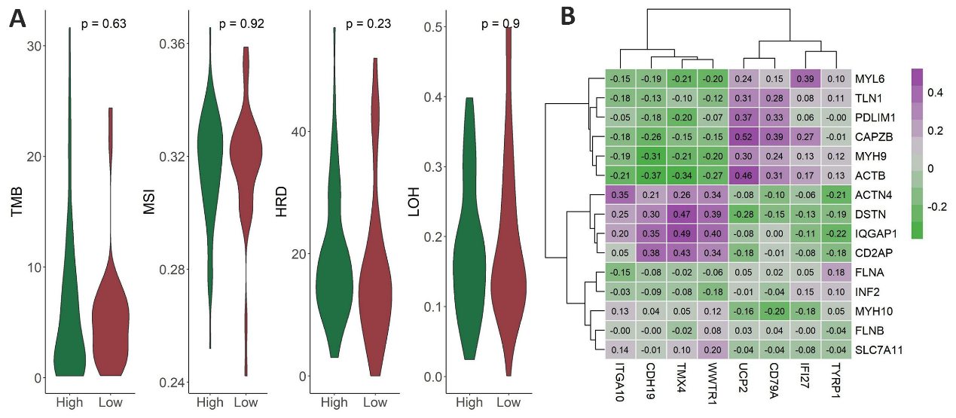Figure S6. Genomic heterogeneity and gene correlation analysis of the prognostic risk model
(A) Impact of four genomic heterogeneity markers on high- and low-risk groups. (B) Cluster heatmap of correlation coefficients between the eight risk model-associated genes and the fifteen DRGs.

