Supplementary information for
miR-145-5p/CAMSAP2 axis modulates cisplatin sensitivity in non-small cell lung cancer
Natsaranyatron Singharajkomron¹, Wanatchaporn Arunmanee², Sedthawut Laotee², Boon-Cher Goh^{3,4,5}, Win Lwin Thuya³, Chayanan Sodsee¹, Pharot Khoykaew¹, Suphong Plangsothorn¹, Iksen Iksen^{6,7}, Pithi Chanvorachote¹, Chanida Vinayanuwattikun⁸, Varisa Pongrakhananon^{1,9*}
¹Department of Pharmacology and Physiology, Faculty of Pharmaceutical Sciences, Chulalongkorn University, Bangkok 10330, Thailand
²Department of Biochemistry and Microbiology, Faculty of Pharmaceutical Sciences, Chulalongkorn University, Bangkok 10330, Thailand
^{3﻿}Cancer Science Institute of Singapore, National University of Singapore, Singapore 117599 Singapore
⁴Department of Medicine, Yong Loo Lin School of Medicine, National University of Singapore, Singapore 119228 Singapore
⁵﻿NUS Centre for Cancer Research (N2CR), Yong Loo Lin School of Medicine, National University of Singapore, Singapore 117599 Singapore
⁶Department of Research and Development, Provenedge Co. Ltd., Bangkok 10330 Thailand
⁷Department of Pharmacy, Faculty of Technology and Health Sciences, Universitas Senior Medan, Medan, 20141, Indonesia
⁸Division of Medical Oncology, Department of Medicine, Faculty of Medicine, Chulalongkorn University, Bangkok, Thailand
⁹Center of Excellence in Preclinical Toxicity and Efficacy Assessment of Medicines and Chemicals, Chulalongkorn University, Bangkok 10330, Thailand

*Corresponding to: Varisa Pongrakhananon, Department of Pharmacology and Physiology, Faculty of Pharmaceutical Sciences, Chulalongkorn University, Bangkok 10330, Thailand
Email: varisa.p@pharm.chula.ac.th

Supplementary Methods
Patient derived lung cancer cells (ELC12 and ELC16) were generated and characterized as described [1]. Cells were cultured in Roswell Park Memorial Institute (RPMI) 1640 medium supplemented with 10 % fetal bovine serum (FBS), 2 mM L-glutamine, 100 units/mL penicillin, and 100 μg/mL streptomycin. Cells were maintained at 37 °C in a humidified atmosphere with 5% CO₂.

Reference
1. Petsri K, Yokoya M, Tungsukruthai S, Rungrotmongkol T, Nutho B, Vinayanuwattikun C, et al. Structure–activity relationships and molecular docking analysis of Mcl-1 targeting Renieramycin T analogues in patient-derived lung cancer cells. Cancers 2020. Multidisciplinary Digital Publishing Institute; 2020;12:875. https://doi.org/10.3390/CANCERS12040875

Supplementary Figures
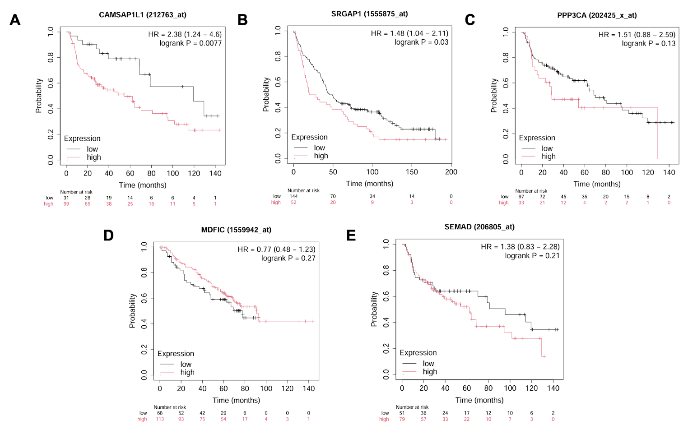
Fig. S1 ﻿Kaplan–Meier survival analysis of lung cancer patients based on gene expression levels. ﻿Kaplan–Meier curves showing overall survival of lung cancer patients from GEO cohort stratified by high and low expression levels of (A) CAMSAP2 (also referred to as CAMSAP1L1), (B) SRGAP1, (C) PPP3CA, (D) MDFIC, and (E) SEMAD. The hazard ratio (HR) and corresponding P-values are indicated in each plot.

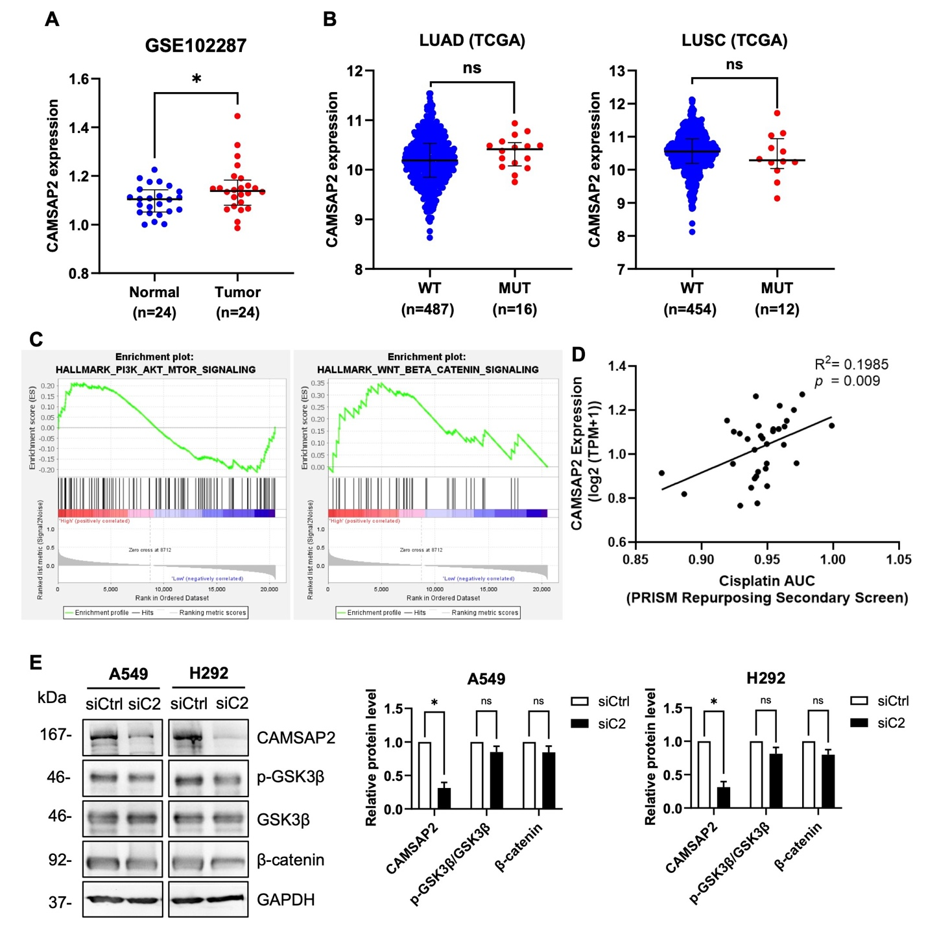
Fig. S2 CAMSAP2 overexpression and its association with lung cancer and cisplatin sensitivity. (A) CAMSAP2 mRNA expression levels in lung tumor tissues compared to normal lung tissues were analyzed using GEO database GSE102287. *P < 0.05 vs. normal lung tissues. (B) CAMSAP2 mRNA levels in lung adenocarcinoma (LUAD, left) and lung squamous cell carcinoma (LUSC, right) tissues were compared between CAMSAP2 wild-type (WT) and mutant (MUT) cases using TCGA datasets. ns = not significant. (C) Signaling pathway enrichment analysis of the CAMSAP2 gene signature revealed associations with Wnt/β-catenin and PI3K/AKT/mTOR pathways. (D) Correlation analysis between CAMSAP2 expression and cisplatin sensitivity in lung adenocarcinoma cell lines (n=33) was performed using data from the DepMap portal. (E) A549 and H292 cells were transfected with siCAMSAP2 or control siRNA (siCtrl). Protein levels of CAMSAP2, GSK3β, phosphorylated GSK3β (p-GSK3β) and β-catenin were examined by immunoblotting and normalized with GAPDH expression. Quantification is shown as mean ± SEM (n = 3). *P < 0.05 vs. siCtrl; ns = not significant.

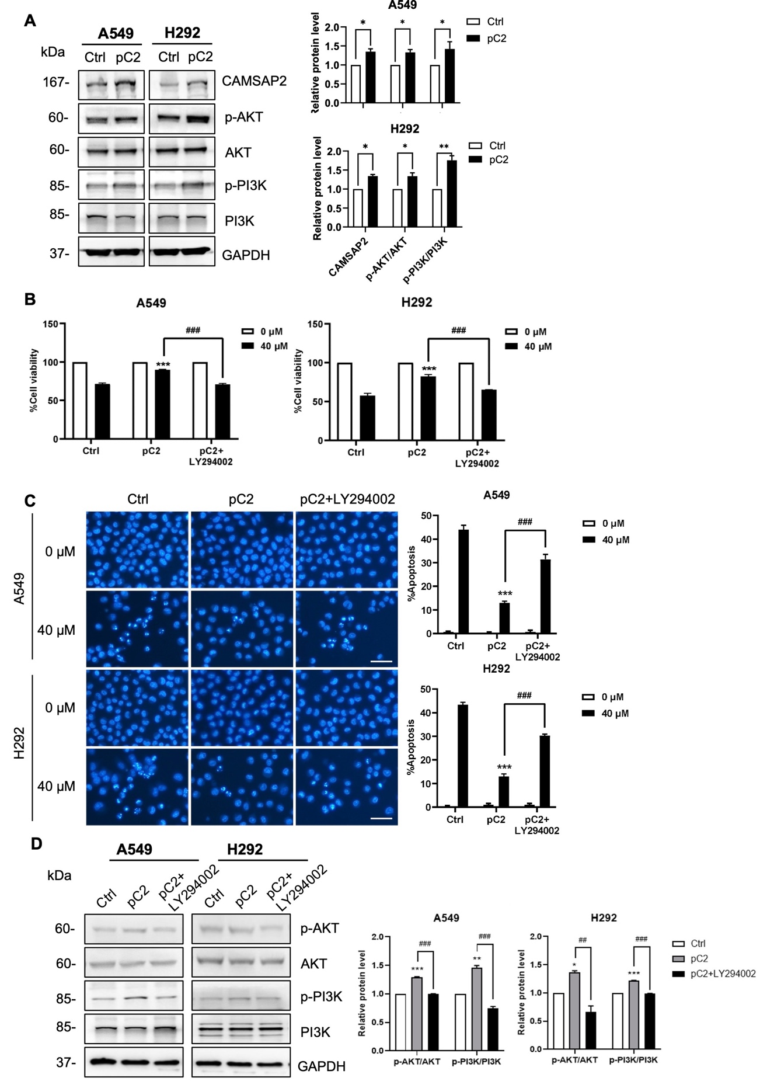
Fig. S3 CAMSAP2 induces cisplatin resistance via activation of the PI3K/AKT signaling pathway.
(A) A549 and H292 cells were transfected with a CAMSAP2 expression plasmid (pC2) or control vector (Ctrl). Protein levels of CAMSAP2, phosphorylated AKT (p-AKT), total AKT, phosphorylated PI3K (p-PI3K), and total PI3K were analyzed by western blotting. GAPDH was used as a loading control. Representative blots and quantitative analysis of relative protein expression are shown. *P < 0.05, **P < 0.01, ***P < 0.005 vs control (ctrl) cells. (B) Control and CAMSAP2-overexpressing A549 and H292 cells were pretreated with the PI3K inhibitor LY294002 for 1 h, followed by exposure to cisplatin (40 μM) for 24 h. Cell viability was assessed using the MTT assay. ***P < 0.005 vs cisplatin-treated control (ctrl) cells; ###P < 0.005 vs cisplatin-treated CAMSAP2-overexpressing (pC2) cells. (C) Apoptosis was evaluated by Hoechst 33342 staining. Representative fluorescence images and quantitative analysis of apoptotic cells are shown. Data are presented as mean ± SEM (n = 3). ***P < 0.005 vs cisplatin-treated control (ctrl) cells; ###P < 0.005 vs with cisplatin-treated CAMSAP2-overexpressing (pC2) cells. (D) Protein levels of phosphorylated AKT (p-AKT), total AKT, phosphorylated PI3K (p-PI3K), and total PI3K were analyzed by western blotting. GAPDH was used as a loading control. Representative blots and quantitative analysis of relative protein expression are shown. The charts were plotted from triplicated experiments. *P < 0.05, **P < 0.01, ***P < 0.005 vs control (ctrl) cells; ##P < 0.01, ###P < 0.005 vs cisplatin-treated CAMSAP2-overexpressing (pC2) cells.

Fig. S4 A549 and H292 cells were co-transfected with either a miR-145-5p mimic or a control miR-NC, along with the CAMSAP2 overexpression plasmid (pC2). AKT, phosphorylated AKT (p-AKT), PI3K, phosphorylated PI3K (p-PI3K), Bcl-2 and Bax levels were analyzed by immunoblotting and normalized to GAPDH expression. The data are presented as the means ± SEMs (n = 3). *P < 0.05, **P < 0.01, ***P < 0.005 vs. NC group; ##P < 0.01, ###P < 0.005 vs. miR-145-5p group. The charts were plotted from triplicated experiments.

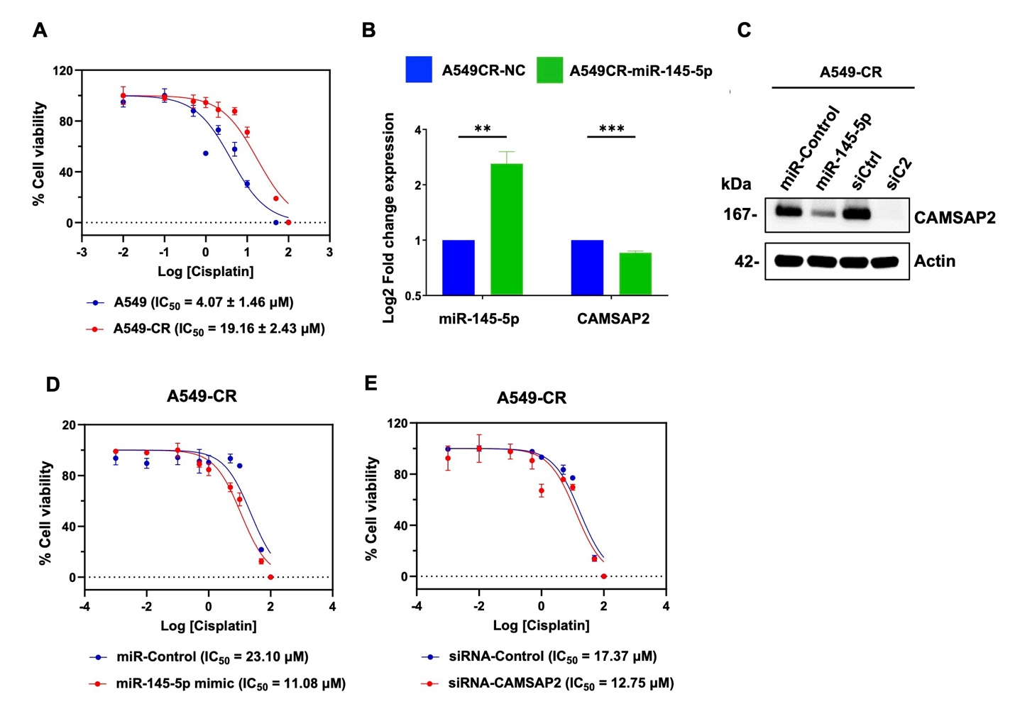
Fig. S5 miR145-5p restores cisplatin sensitivity in cisplatin-resistant cells by targeting CAMSAP2.
(A) Parental A549 and cisplatin-resistant A549 cells (A549-CR) were treated with various concentrations of cisplatin for 72 h and cell viability was assessed. The IC₅₀ values were calculated using Prism 9 software. (B) A549-CR cells were transfected with miR-145-5p or negative control (miR-NC), and the expression of miR-145-5p and CAMSAP2 mRNA expression was measured by qRT-PCR. Data are presented as mean ± SEM (n = 3). **P < 0.01, ***P < 0.005 vs. A549-CR-NC. (C) A549-CR cells were transfected with miR-145-5p mimic or siCAMSAP2 or their respective negative control. CAMSAP2 protein expression level was analyzed by immunoblotting. (D) A549-CR cells transfected with either miR-145-5p or miR-Ctrl were treated with various concentrations of cisplatin and cell viability was examined. The IC₅₀ of both cells were shown. (E) A549-CR cells transfected with either siCAMSAP2 or siCtrl were treated with various concentrations of cisplatin and cell viability was examined. The IC₅₀ of both cells were shown.

Fig. S6 Patient-derived lung cancer cells (ELC12 and ELC16) were cotransfected with either a miR-145-5p mimic or a control miR-NC, along with the CAMSAP2 overexpression plasmid (pC2). (A) The expression levels of miR-145-5p and CAMSAP2 were evaluated by qRT-PCR. The data are presented as the means ± SEMs (n = 3). *P < 0.05, **P < 0.01, ***P < 0.005 vs. NC; #P < 0.05, ##P < 0.01, ###P < 0.005 vs. miR-145-5p. (B) All of the transfectants were treated with or without cisplatin (40 μM) for 24 h. Cell viability was examined using the MTT assay, and the results are expressed as a percentage of viable cells. The data are presented as the means ± SEMs (n = 3). **P < 0.01, ***P < 0.005 vs. cisplatin-treated NC group; #P < 0.05, ##P < 0.01 vs. cisplatin-treated miR-145-5p group. (C) Apoptosis cell death was analyzed by H33342 nuclear staining. Apoptotic cells were quantified as a percentage of total cells per field. The data are presented as the means ± SEMs (n = 3). ***P < 0.005 vs. cisplatin-treated NC group; ##P < 0.01, ###P < 0.005 vs. cisplatin-treated miR-145-5p group.

Supplementary Table
Table S1 Clinical characteristics of lung cancer patients from the TCGA-LUAD data
Characteristics | Normal (n=59) | Tumor (n=530) | p-valueª
Sex — no. (%) |  |  | 0.5853
Female | 34 (57.63) | 285 (53.77)
Male | 25 (42.37) | 245 (46.22)
Age — years |  |  | 0.6064
Median (Min, Max) | 66 (42, 86) | 66 (33, 88)
Stage — no. (%)
I |  | 288 (55.17)
II |  | 124 (23.76)
III |  | 84 (16.09)
IV |  | 26 (4.98)
ªAnalysed based on Mann–Whitney U test and Fisher's exact test.
Table S2 Clinical characteristics of lung cancer patients from TCGA-LUSC data
Characteristics | Normal (n=51) | Tumor (n=501) | p-valueª
Sex — no. (%) |  |  | 0.8672
Female | 14 (27.45) | 130 (25.95)
Male | 37 (72.55) | 371 (74.05)
Age — years |  |  | 0.5607
Median (Min, Max) | 68 (45, 85) | 68 (39, 90)
Stage — no. (%)
I |  | 244 (49.10)
II |  | 162 (32.60)
III |  | 84 (16.90)
IV |  | 7 (1.41)
ªAnalysed based on Mann–Whitney U test and Fisher's exact test.
Table S3 List of five candidate miRNAs overlapping between the TCGA-derived DEmiRNAs and DDR-related miRNAs

No. | Candidate miRNAs
1 | miR-145
2 | miR-140
3 | miR-34c
4 | miR-223
5 | miR-30a

Table S4 List of five potential target genes of miR-145-5p
No. | Targets of miR-145-5p
1 | Calmodulin-regulated spectrin-associated protein 2 (CAMSAP2, CAMSAP1L1)
2 | SLIT-ROBO Rho GTPase-activating protein 1 (SRGAP1)
3 | Protein phosphatase 3 catalytic subunit alpha (PPP3CA)
4 | MyoD family inhibitor domain-containing protein (MDFIC)
5 | Semaphorin-3A (SEMA3A, SEMAD)

