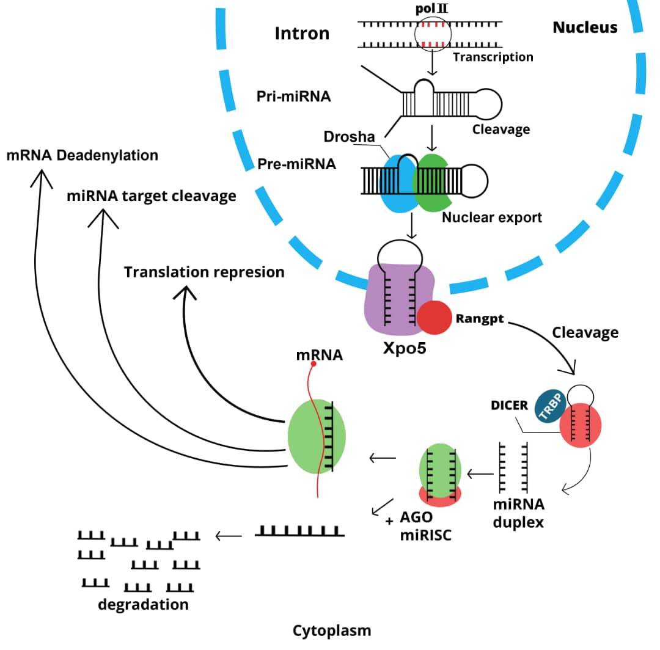

Figure 1. miRNA biogenesis pathways: RNA polymerase II or III transcribes pri-miRNA. Within the nucleus, pri-miRNA is cleaved by Drosha-DGCR8. The resulting pre-miRNA is then transported from the nucleus to the cytoplasm via the exportin-5-Ran-GTP complex. Finally, pre-miRNA is processed to its mature form.

