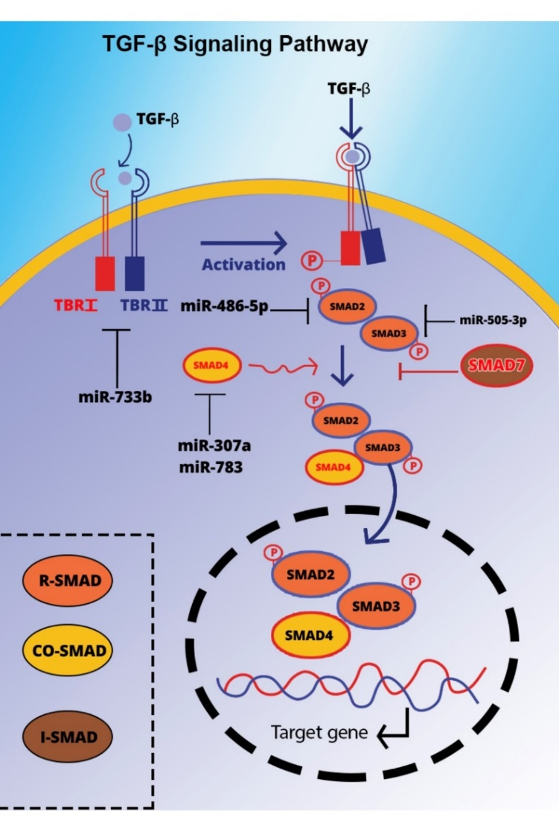

Figure 2. The interaction of TGF-β ligands with their receptor, modulated by various miRNAs, facilitates heterotetramer formation. The signal is transmitted to the nucleus by restricting Smad (R-Smad). Activated R-Smads form a complex with common Smads (e.g., Smad4) and translocate to the nucleus to regulate miRNA transcription. Examples of miRNAs that target TGF-β signaling components are depicted.

