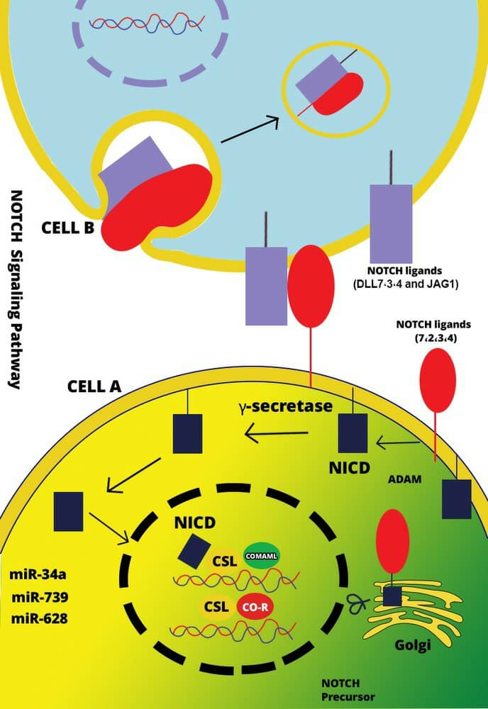

Figure 3. The Notch signaling pathway and associated miRNAs: Notch signaling is activated by the interaction of Notch transmembrane receptors with their specific ligands on neighbouring cells. Upon activation, Notch undergoes cleavage, resulting in the release of the Notch intracellular domain (NICD) via the γ-secretase complex. The NICD can then translocate into the nucleus to activate transcription of Notch target genes.

