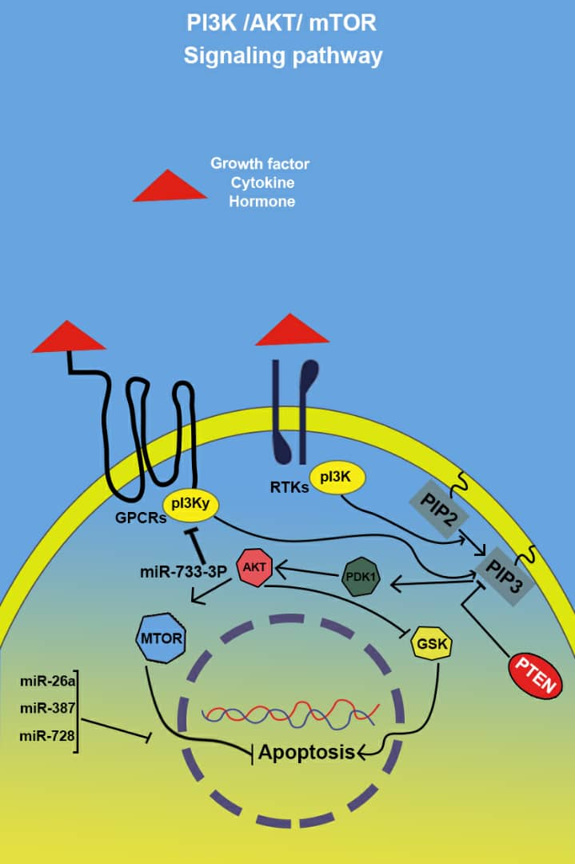

Figure 4. Interaction between miRNAs and PI3K/AKT/mTOR signaling pathway in PCa: Activated PI3K converts PIP2 into PIP3. PTEN negatively regulates this pathway by dephosphorylating PIP3. Activated Akt subsequently regulates downstream proteins, including mTOR, Bcl‐2 family, and glycogensynthase kinase 3 can promote cellular processes.

