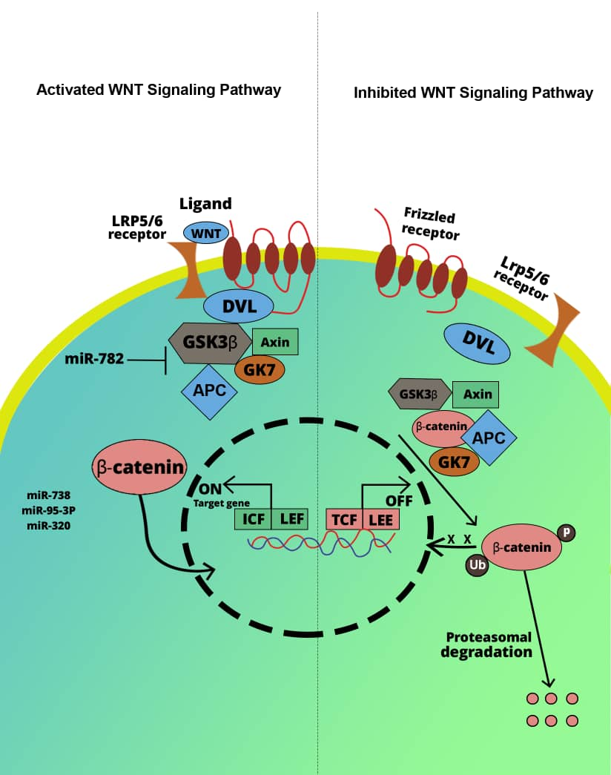

Figure 5. Regulation of miRs on Wnt/β-catenin signaling pathway: Left panel: Interaction of Wnt ligands with their cognate receptors leads to the the inhibition of β-catenin phosphorylation via GSK-3β. Then, the TCF/LEF complex enhances the transcription of some important genes, including Snail Twist, thereby promoting EMT. Right panel: In the absence of Wnt ligands, GSK-3β phosphorylates β-catenin as part of a destruction complex with CKIα and Axin, resulting in β-catenin degradation via the ubiquitin-proteasome pathway.

