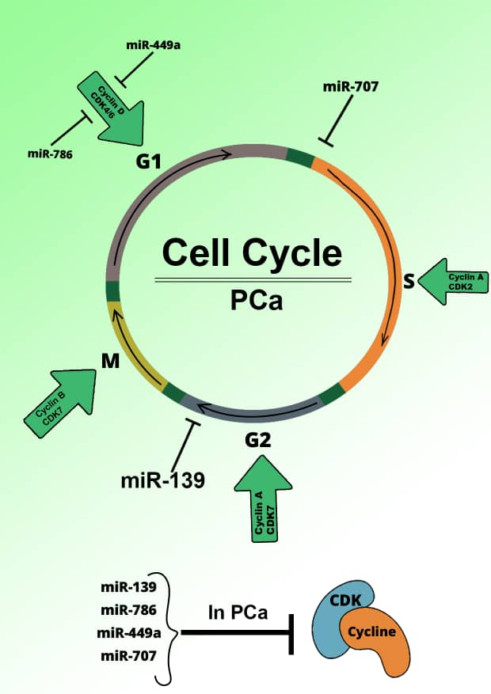

Figure 7. miRNA–cell cycle regulation network: As shown, a network of key regulatory components, including cyclins, CDKs, and CDK inhibitors, governs progression through the four stages of the cell cycle.

