Supplementary materials

Methods
Single-Cell RNA-Seq Data Analysis
Unless otherwise specified, all analytical steps were performed using default software parameters. Single-cell RNA sequencing (scRNA-seq) data from uveal melanoma (UM) patients across two independent cohorts were first merged into a combined Seurat object using the merge function in the Seurat package. Quality control was applied by calculating the percentage of mitochondrial gene expression per cell via the PercentageFeatureSet function. Cells were retained if they expressed between 500 and 7,000 genes and contained less than 35% mitochondrial reads. Following merging, global expression normalization was performed using a log-normalization approach. The top 2,000 highly variable genes were identified with the FindVariableFeatures function and used for downstream analysis. Data scaling and principal component analysis (PCA) were carried out using the ScaleData and RunPCA functions, respectively.

Table S1. Clinical information of the sample donors of the scRNA datasets.
 |  | Sample type | Gender | Age (year) | Largest basal diameter (mm) | Cell type | Months to Metastasis
GSE139829 | GSM4147093 | Primary | Female | 86 | 15 | Mixed | 20
GSE139829 | GSM4147094 | Primary | Female | 71 | 19 | Mixed | 9
GSE139829 | GSM4147095 | Primary | Male | 69 | 9 | Mixed | 1
GSE139829 | GSM4147096 | Primary | Male | 66 | 20 | Mixed | 13
GSE139829 | GSM4147097 | Primary | Male | 77 | 20 | Mixed | 2
GSE139829 | GSM4147098 | Primary | Female | 44 | 10 | Mixed | 1
GSE139829 | GSM4147099 | Primary | Male | 53 | 18.4 | Epithelioid | 7
GSE139829 | GSM4147101 | Primary | Female | 80 | 19.8 | NA | 3
GSE139829 | GSM4147091 | Metastasis | Female | 68 | NA | NA | NA
GSE139829 | GSM4147100 | Metastasis | Male | 73 | NA | NA | NA
GSE139829 | GSM4147092 | Metastasis | Female | 63 | NA | NA | NA
GSE138433 | GSM4107899 | Primary | Female | 84 | 14 | Spindle | No metastasis within 5 years after first diagnosis
GSE138433 | GSM4107900 | Primary | Male | 69 | 18 | Epithelioid | No metastasis within 5 years after first diagnosis
GSE138433 | GSM4107901 | Primary | Male | 84 | 19 | Mixed | No metastasis within 5 years after first diagnosis
GSE138433 | GSM4107902 | Primary | Male | 65 | 10 | Spindle | No metastasis within 5 years after first diagnosis
GSE138433 | GSM4107903 | Primary | Male | 85 | 15 | Spindle | No metastasis within 5 years after first diagnosis
GSE138433 | GSM4107904 | Primary | Male | 31 | 17 | Spindle | No metastasis within 5 years after first diagnosis
GSE176029 | GSM5353203 | Metastasis | Male | 69 | 14 | NA | 54
GSE176029 | GSM5353204 | Metastasis | Male | 69 | 14 | NA | 54
NA: not applicable.

Table S2. Primers used in this study.
1 | β-actin | 5′-CATGTACGTTGCTATCCAGGC-3′
 |  | 5′-CTCCTTAATGTCACGCACGAT-3′
2 | CD74 | 5′-GACGAGAACGGCAACTATCTG-3′
 |  | 5′-GTTGGGGAAGACACACCAGC-3′
3 | MIF | 5′-CCGGACAGGGTCTACATCAACTATTAC-3′
 |  | 5′-TAGGCGAAGGTGGAGTTGTTCC-3′

Table S3. The diversity score of Chao1, InvSimpson, and True diversity indices in the control and UM samples from TRUST4 analysis.
 | Clonotype Count | Chao1 | InvSimpson | True diversity indices
Control group
Diversity score (mean ± SD) | 106.33 ± 71.43 | 5541.67 ± 779.48 | 1.28 ± 0.04 | 2.33 ± 0.58
95% Confidence Interval (CI) | (19.84- 402.50) | (3605.34-7478.00) | (1.19-1.38) | (0.90-3.37)
UM group
Diversity score (mean ± SD) | 1055.33 ± 377.24 | 1102.67 ± 805.52 | 1.13 ± 0.06 | 6.33 ± 1.15
95% Confidence Interval (CI) | (118.22- 1992.44) | (15.19- 3580.52) | (0.97-1.28) | (3.46-9.20)
P | < 0.05 | < 0.05 | < 0.05 | < 0.05

Table S4. The percentage of different B cell subgroups between the primary and the metastasis UM samples.
 | Naïve (%) | Memory (%) | Plasma (%) | T-like (%) | Myeloids (%)
Primary | 14.35 | 18.02 | 44.65 | 15.88 | 7.10
Metastasis | 19.75 | 23.05 | 32.13 | 16.98 | 8.09
P value | < 0.05 | < 0.05 | < 0.05 | > 0.05 | > 0.05

Figure S1. Clinical multi-model images of UM patients. (A) Fundus image of the mushroom like tumor originated from the choroid. (B) B-scan image of the UM demonstrate the blood flow signal and the size of the tumor. (C-D) The association between the expression risk score of BCR related genes and tumor diameter, height and metastasis stage. **: P<0.01; ***: P<0.001. BCR: B-cell receptor; UM: uveal melanoma.
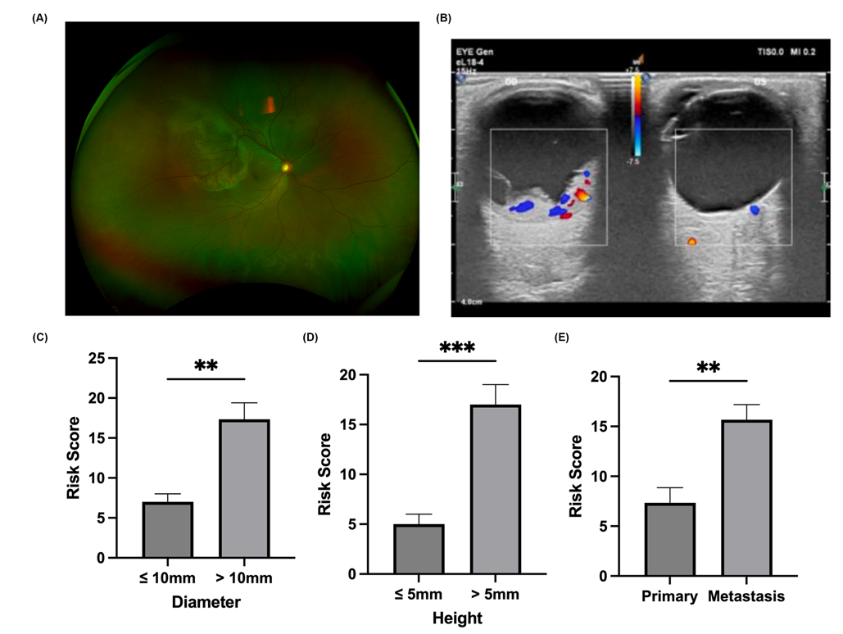

Figure S2. Blood proteomic assay analysis results. (A) Principal component analysis to evaluate the repeatability of protein quantification between the primary and metastasis UM groups. (B) Heatmap showing the expression of different genes between the primary and metastasis UM groups. UM: Uveal melanoma.
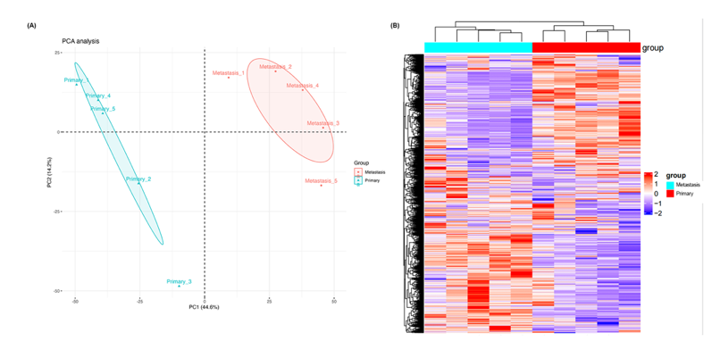

Figure S3. Single-cell RNA analysis reveals the MIF signaling pathway interactions in B cell subtypes in UM samples. (A) UMAP visualization of the distribution of the primary and the metastasis UM samples in the combination cohort of GSE138433, GSE176029, and GSE139829. (B) CellChat analysis shows the number and weight of cell communications in the B cell subtypes in metastasis UM samples. (C) Chord plot showing the interactions of MIF signaling pathway between in the B cell subtypes metastasis UM samples. (D) Heatmap plot showing the relative contribution of each B cell type of MIF signaling network in metastasis UM samples. UM: uveal melanoma; UAMP: uniform manifold approximation and projection; MIF: Macrophage Migration Inhibitory Factor. (T cells refers to T cells-like B cells)
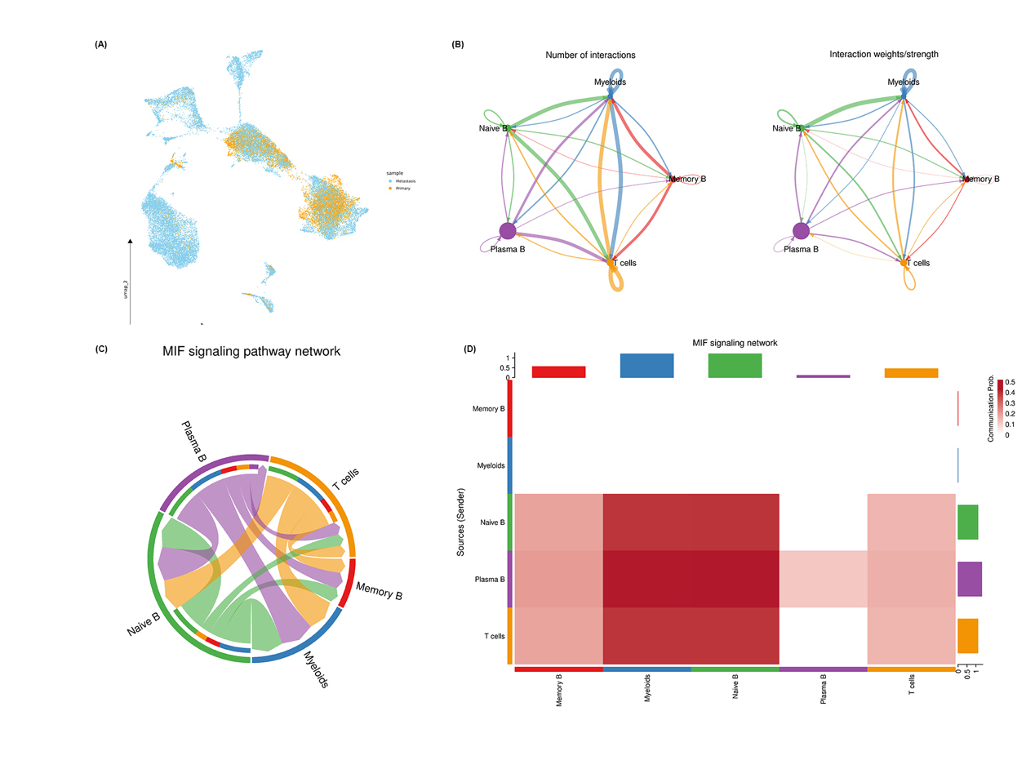

Figure S4. Single-cell RNA analysis reveals the heterogeneity of B cell development in GSE176029. (A) UMAP visualization of the distribution of the metastasis UM samples in GSE176029. (B) Pseudotime analysis demonstrates the trajectory of B cell development with two UM metastasis. UM: uveal melanoma; UAMP: uniform manifold approximation and projection.
