Supporting Information
Search strategies used in each database:
Source: PubMed
#1 | “colo*”[tiab] OR “rect*”[tiab]
#2 | “tumor”[tiab] OR “neoplasma”[tiab] OR “carcinoma”[tiab] OR “cancer”[tiab] OR “adenocarcinoma”[tiab]
#3 | “prognos*”[tiab] OR “relapse”[tiab] OR “risk”[tiab] OR “recurren*”[tiab] OR “predict*”[tiab] OR “marker*”[tiab] OR “survival”[tiab] OR “metasta*”[tiab]
#4 | "fibronectin*"[tiab] OR “FN1”[tiab] OR “FN”[tiab]
Search | #1 AND #2 AND #3 AND #4
Source: EMBASE
#1 | ‘colo*’:ti,ab,kw OR ‘rect*’:ti,ab,kw
#2 | ‘tumor’:ti,ab,kw OR ‘neoplasma’:ti,ab,kw OR “carcinoma’:ti,ab,kw OR ‘cancer’:ti,ab,kw OR ‘adenocarcinoma’:ti,ab,kw
#3 | ‘prognos’:ti,ab,kw OR ‘relapse’:ti,ab,kw OR ‘risk’:ti,ab,kw OR ‘recurren*’:ti,ab,kw OR ‘predict*’:ti,ab,kw OR ‘marker*’:ti,ab,kw OR ‘survival’:ti,ab,kw OR ‘metasta*’:ti,ab,kw
#4 | ‘fibronectin*’:ti,ab,kw OR ‘FN1’:ti,ab,kw OR ‘FN’:ti,ab,kw
Search | #1 AND #2 AND #3 AND #4

Source: Web of Science (WOS)
#1 | AB=(“colo*” OR “rect*”) OR TI=(“colo*” OR “rect*”)
#2 | AB=(“tumor” OR “neoplasma” OR “carcinoma” OR “cancer” OR “adenocarcinoma”) OR TI=(“tumor” OR “neoplasma” OR “carcinoma” OR “cancer” OR “adenocarcinoma”)
#3 | AB= (“prognos*” OR “relapse” OR “risk” OR “recurren*” OR “predict*” OR “marker*” OR “survival” OR “metasta*”) OR TI= (“prognos*” OR “relapse” OR “risk” OR “recurren*” OR “predict*” OR “marker*” OR “survival” OR “metasta*”)
#4 | AB=("fibronectin*" OR “FN1” OR “FN”) OR TI=("fibronectin*" OR “FN1” OR “FN”)
Search | #1 AND #2 AND #3 AND #4

Table S1. Converting weights (gram) to induce pressure (pascals) [51].
Method | Wound healing |  |  | Chamber invasion |  |  | 3D invasion
Area (cm²) | 7.065 |  |  | 0.38465 |  |  | 0.283
Weight (Gram) | 27.7 | 46.7 | 101.7 | 1.53 | 2.53 | 5.53 | 1
Pascals (Pa) | 384.2 | 647.9 | 1411.4 | 388.7 | 643.7 | 1408.6 | 346.7

Table S2. Primers Used for Quantitative Real-Time PCR
Gene | Forward primer (5’-3’) | Reverse primer (5’-3’)
FN1 | CGGTGGCTGTCAGTCAAAG | AAACCTCGGCTTCCTCCATAA
TGFBR1 | AGAGCTGTGAAGCCTTGAG | TGATGCCTTCCTGTTGACTG
SMAD2 | CGTCCATCTTGCCATTCACG | CTCAAGCTCATCTAATCGTCCTG
SMAD4 | ACGAACGAGTTGTATCACCTGG | TGCACGATTACTTGGTGGATG
ROCK1 | AACATGCTGCTGGATAAATCTGG | TGTATCACATCGTACCATGCCT
OCT4 | CTGGGTTGATCCTCGGACCT | CACAGAACTCATACGGCGGG
NANOG | TTTGTGGGCGTGAAGAAAACT | AGGGCTGTCCTGAATAAGCAG
EEF1A1 | GCTGGAAGATGGCCCTAAAT | CCAAAGGTGGATAGTCTGAGAAG

Table S3. Fibronectin level between CRC patients and non-CRC patients (n=8).
Author | Comparison | Technique | Parameter | CRC |  |  | Non-CRC |  |  | p-value
 |  |  |  | Sample | n | Measure | Sample | n | Measure | p-value
Aleksandar Bogdanovic [83] | Pairs | PCR | 2^(-∆Ct) | Colorectal liver metastases | 24 | 7.65 (mean) | Non-tumor liver tissue | 24 | 0.57 (mean) | <0.001
Xun Cai [43] | Pairs | qPCR | mRNA expression | Tumor | 108 | 8.5-13 (Range) | Adjacent non-tumor colon mucosa | 108 | 5-9.2 (Range) | <0.001
Noboru Saito [72] | Independent | ELISA | μg/ml | Serum | 113 | 115.1 (mean) | Serum | 40 | 88.55 (mean) | >0.05
Noboru Saito [72] | Independent | ELISA | ng/mg·Cre | Urine | 113 | 293.03  (mean) | Urine | 40 | 151.98  (mean) | <0.001
Wenzhong Yi [64] | Independent | qPCR | mRNA relative expression | Tumor | 107 | 6.74 (mean) | Normal colorectal tissues | 115 | 3.32 (mean) | <0.05
Manveen K Sethi [79] | Pairs | Proteomic | Protein fold change | Tumor | 8 | -12.3 (median) | Adjacent non-tumor colon mucosa | 8 | -7.3 (median) | 0.02
Łukasz Zadka [85] | Independent | IHC | IHC index | Tumor | 78 | 2.95 (mean) | Normal colorectal tissues | 29 | 2.36 (mean) | <0.001
Margareta Žlajpah [82] | Pairs | qPCR | Fold change | Tumor, N0 | 10 | -1.1 (mean) | Normal colorectal tissues | 20 | 0 (mean) | >0.05
 |  |  |  | Tumor, N+ | 10 | 5.5 (mean) | Normal colorectal tissues | 20 | 0 (mean) | >0.05
Seçil Durel Avcıoğlu [86] | Independent | qPCR | Fold change | Tumor | 130 | -0.129 (median) | Normal colorectal tissues | 70 | 0.645 (median) | <0.01
Seçil Durel Avcıoğlu [86] | Pairs | qPCR | Fold change | Tumor | 160 | -1.321 (median) | Normal colorectal tissues | 160 | -0.917 (median) | <0.01

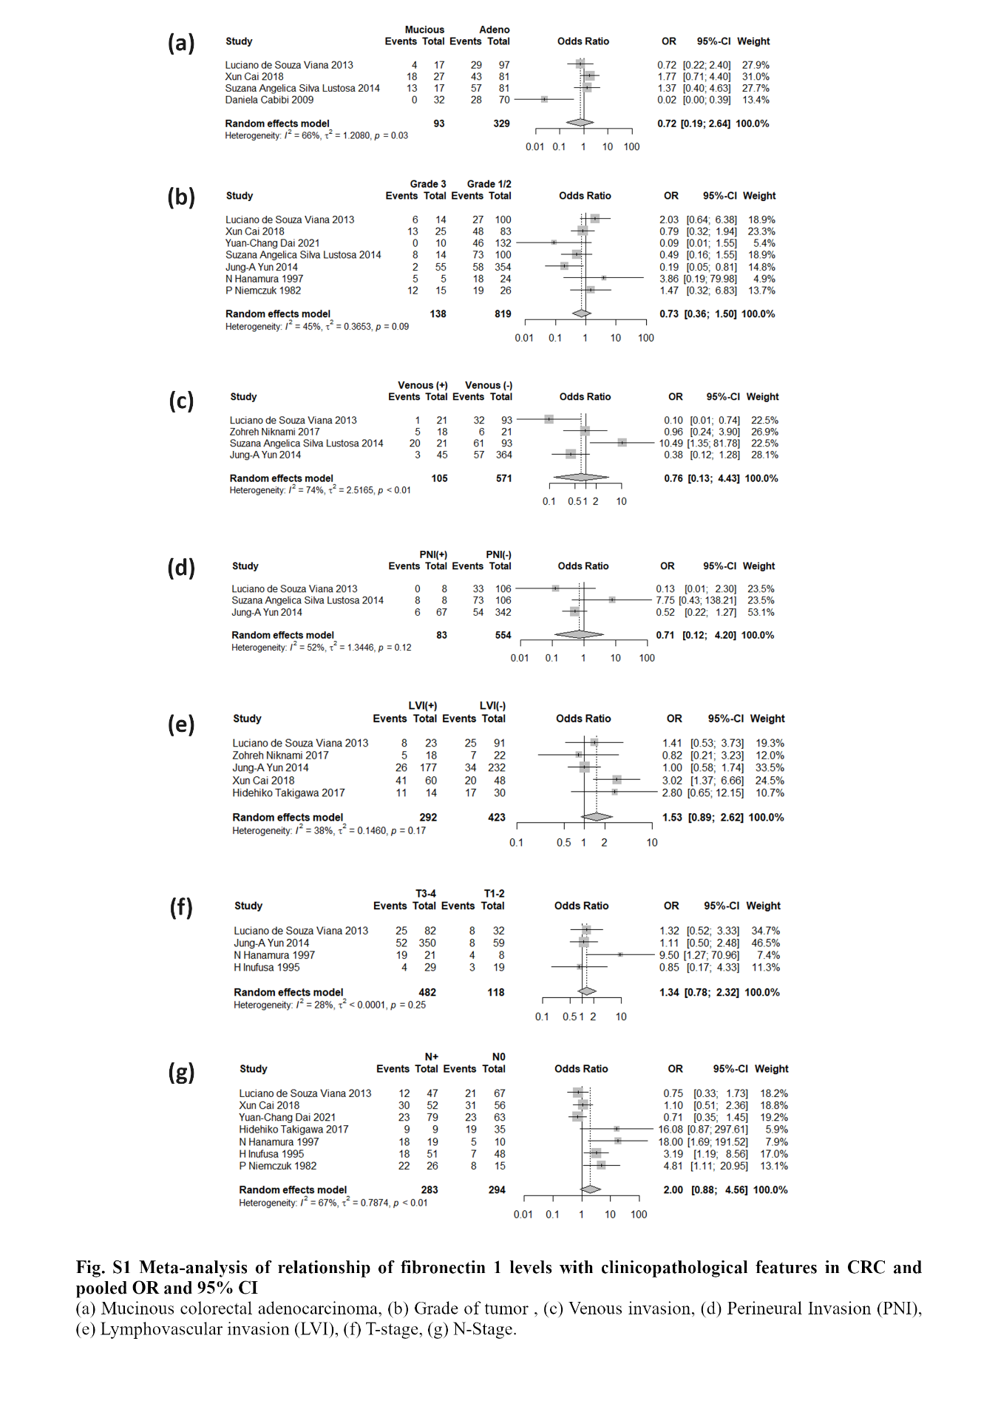
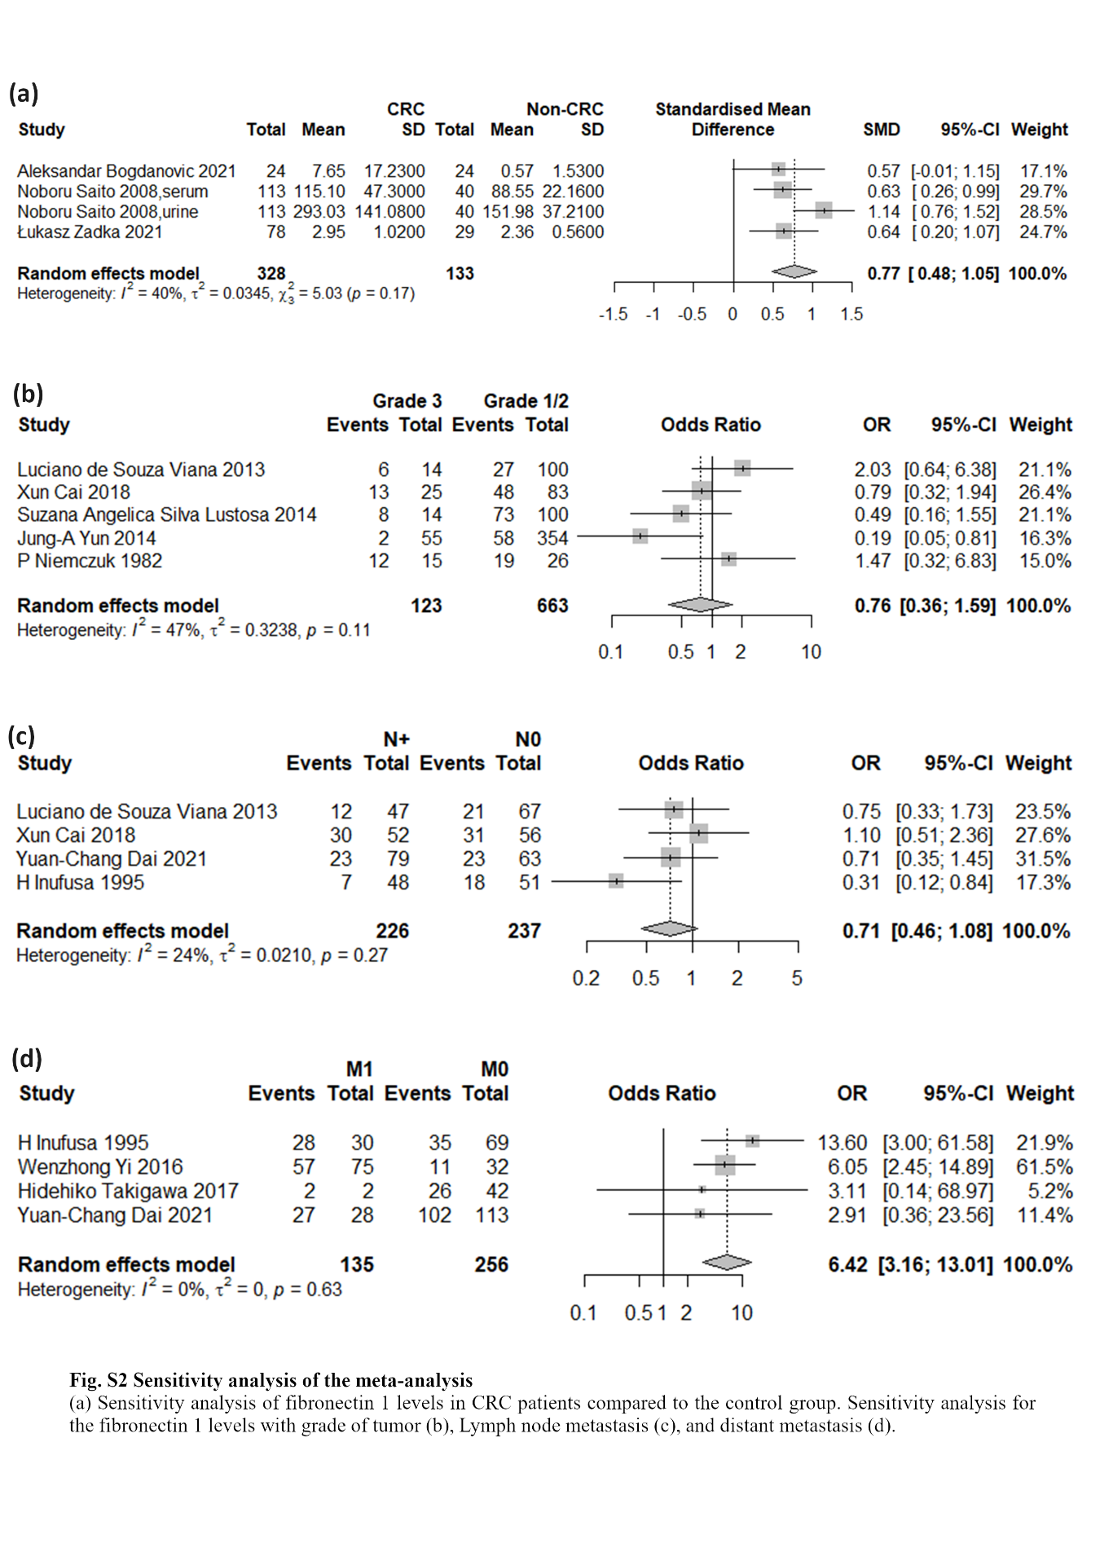
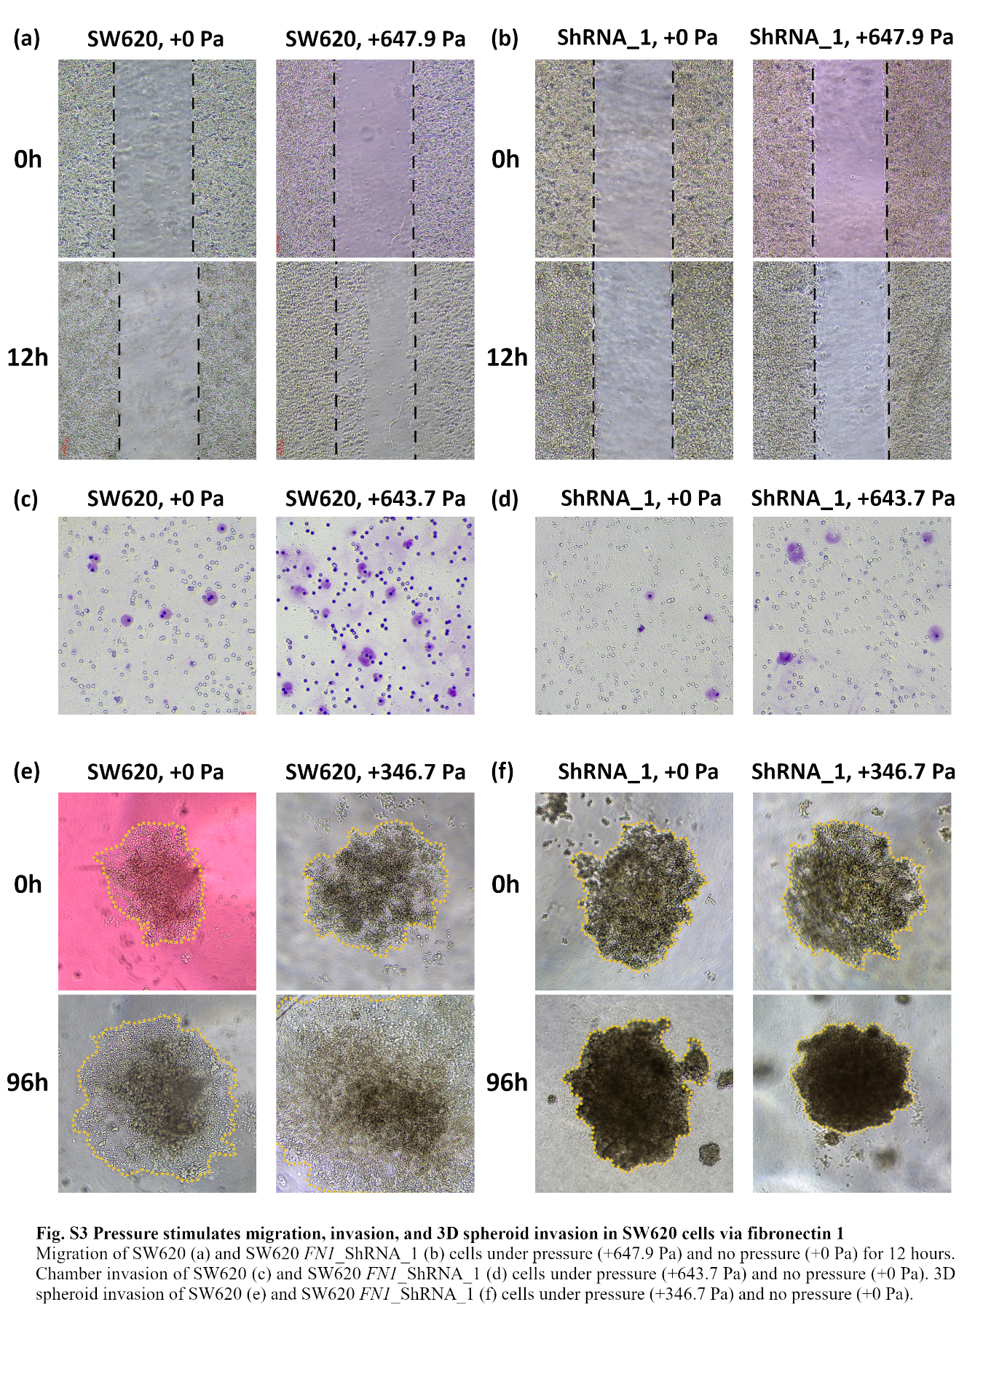
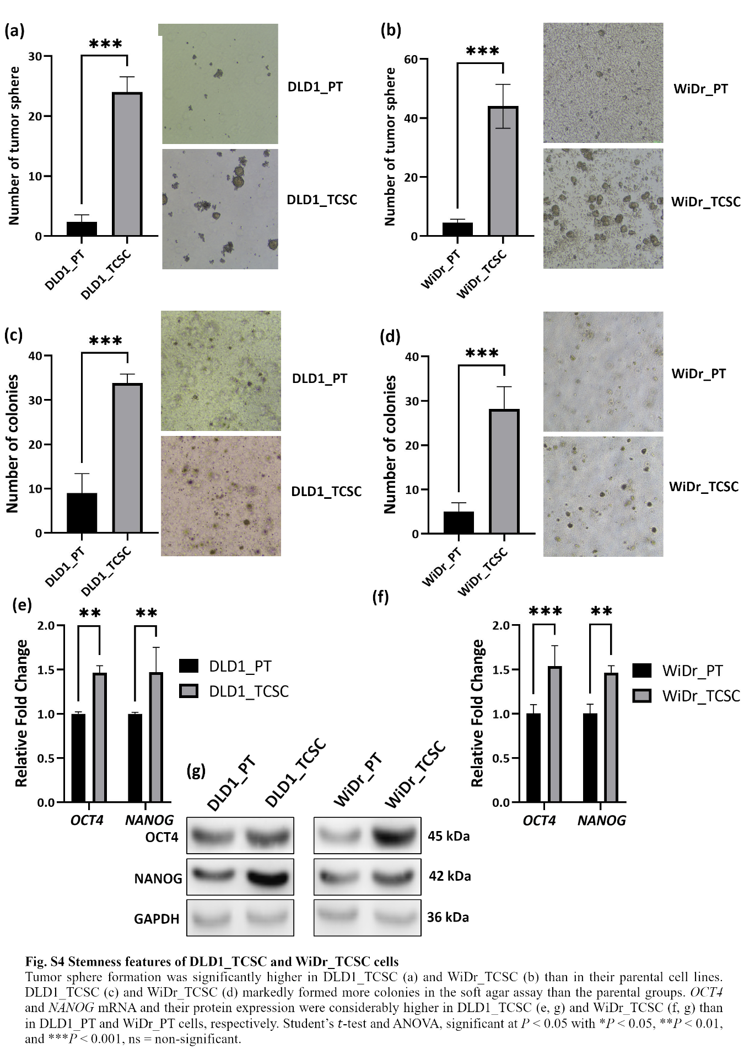
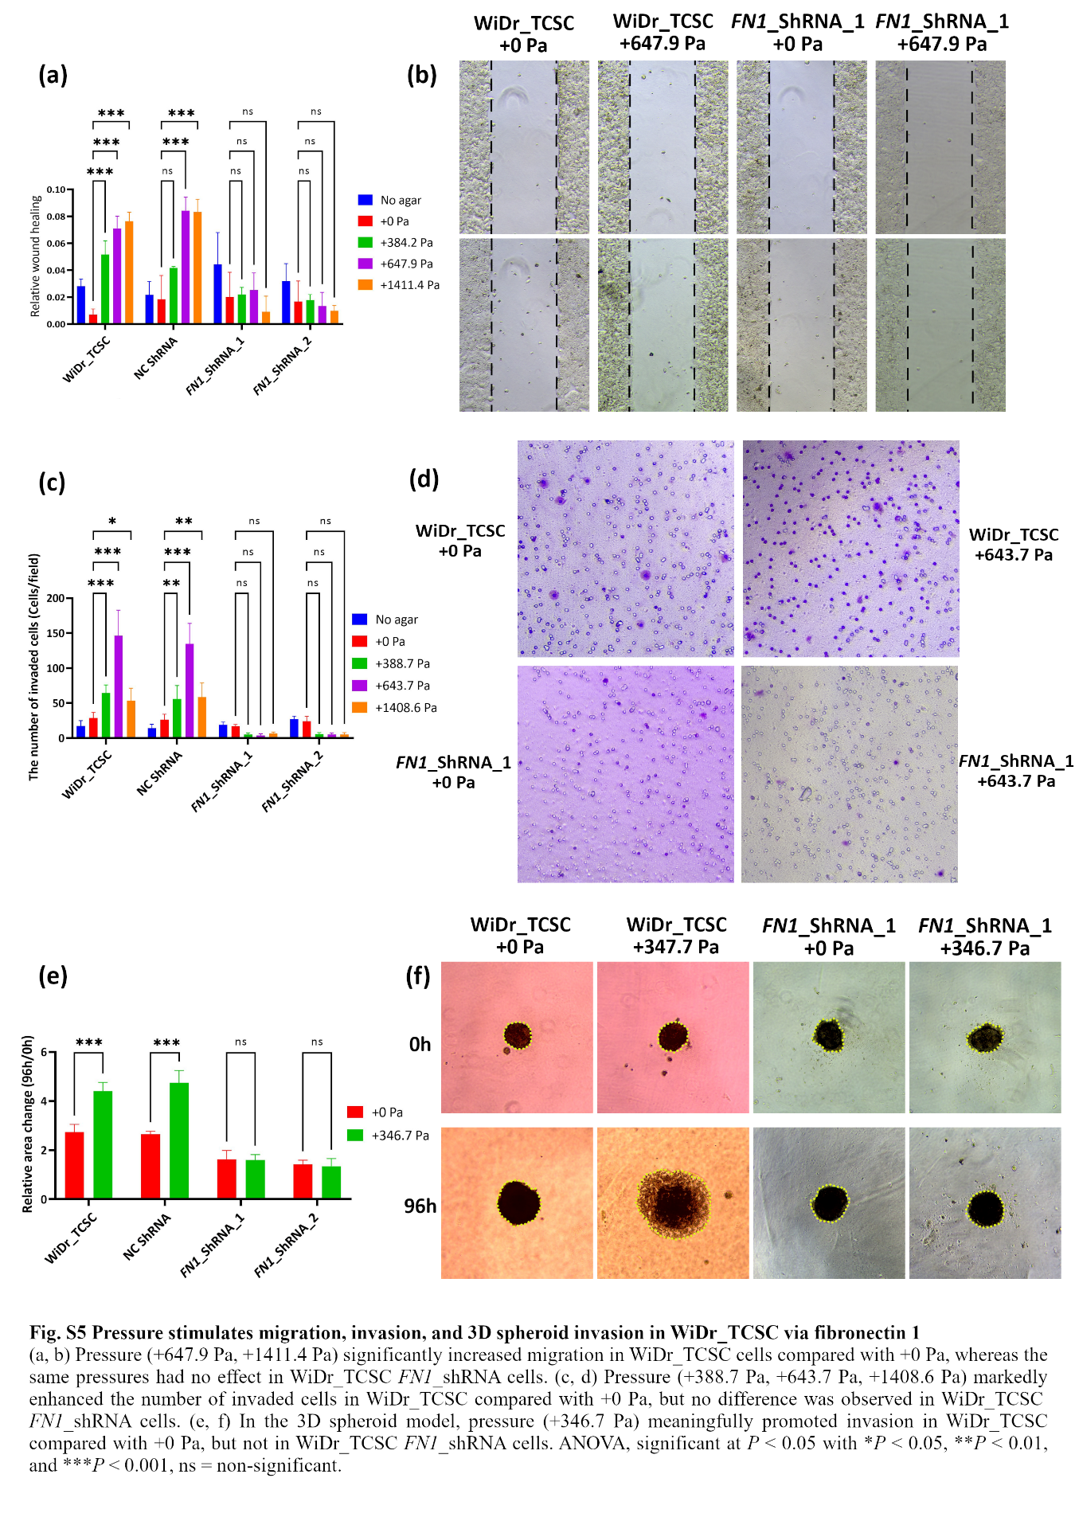
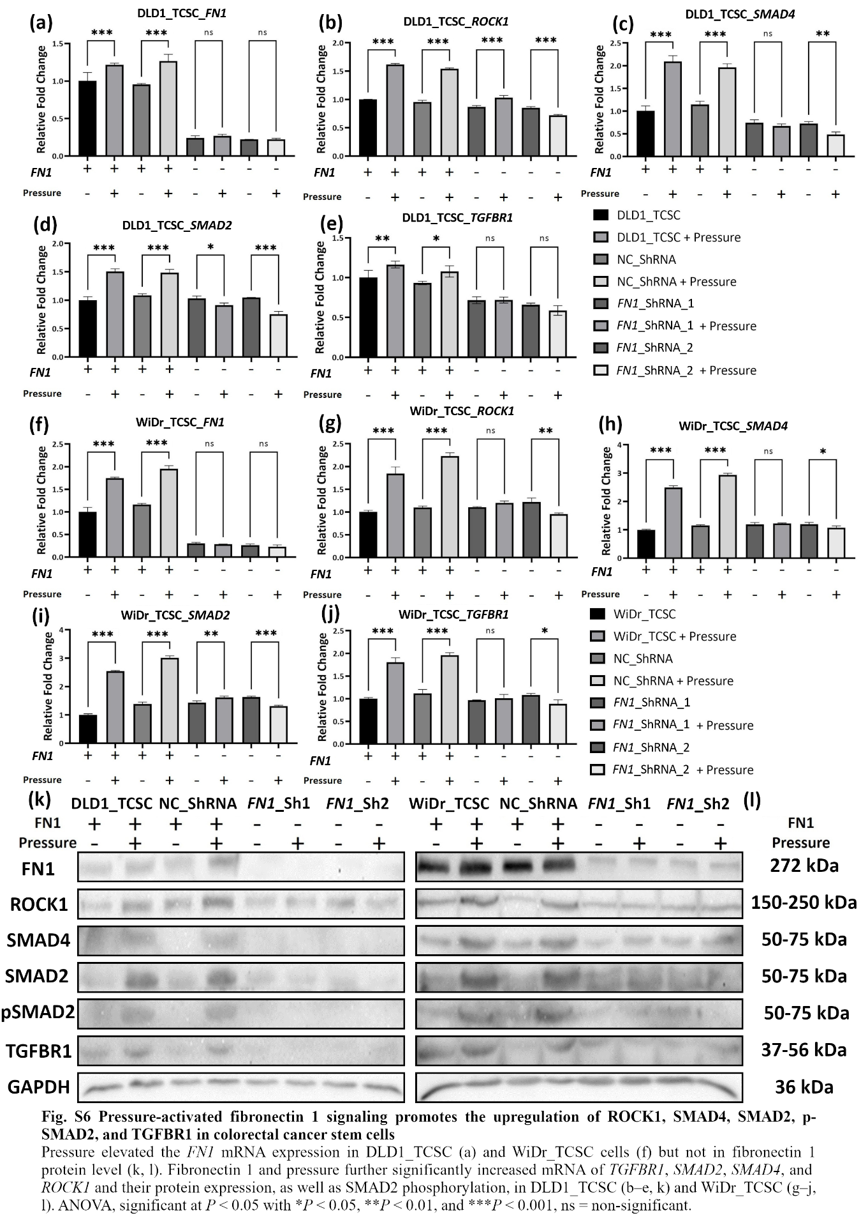
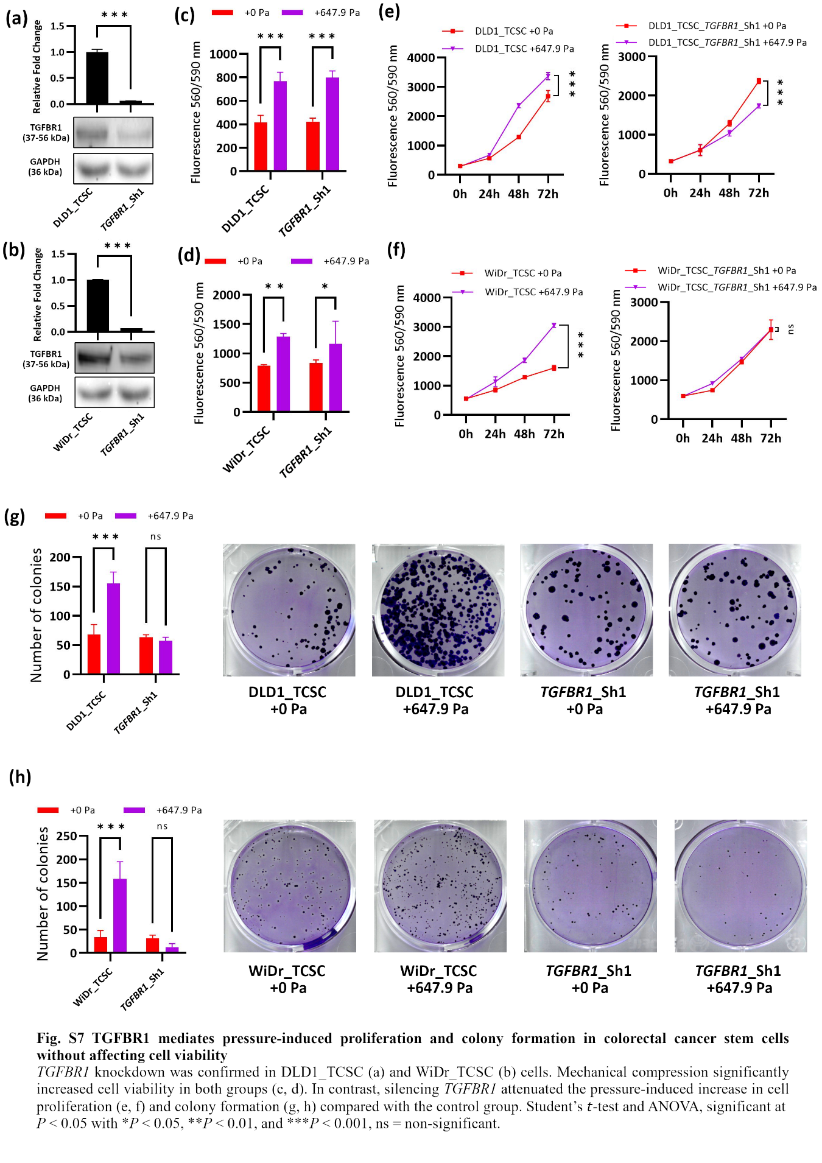
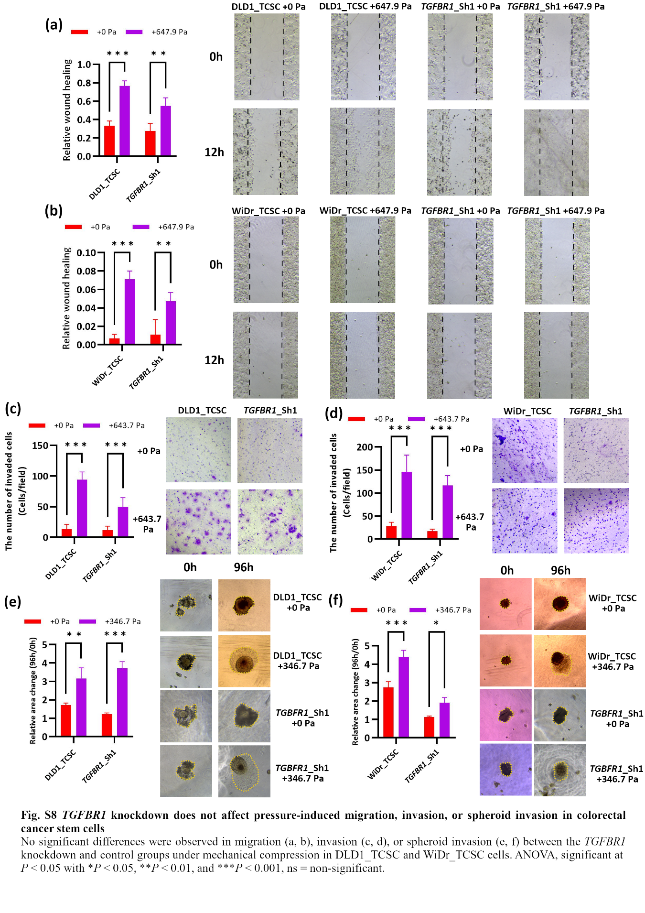
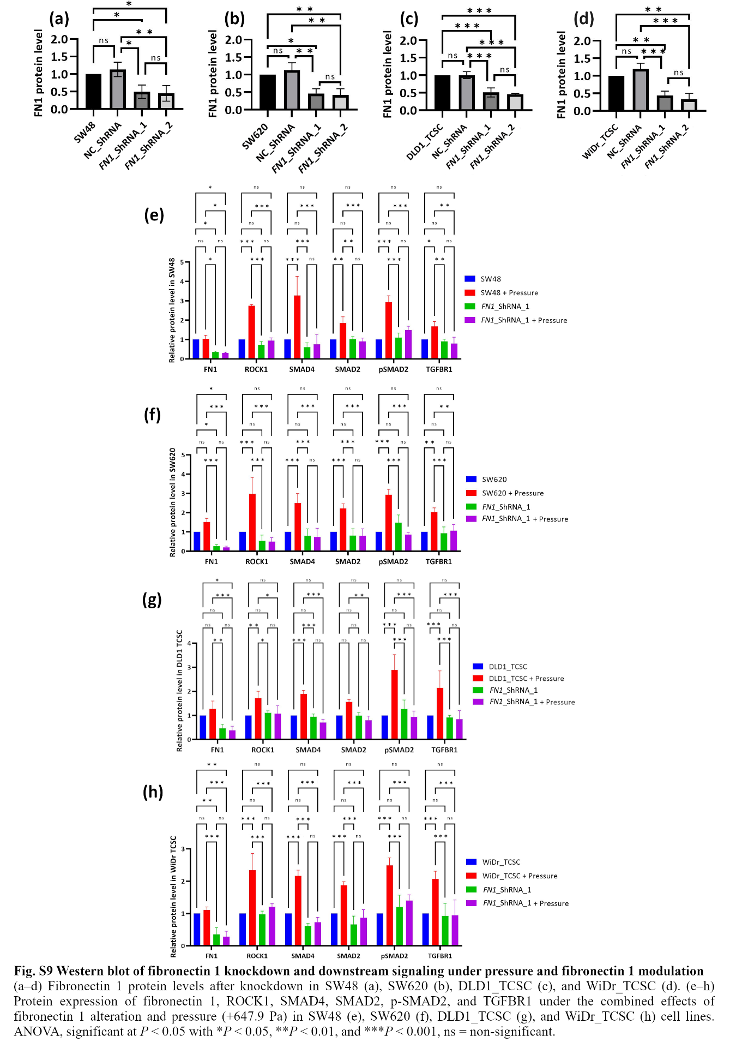
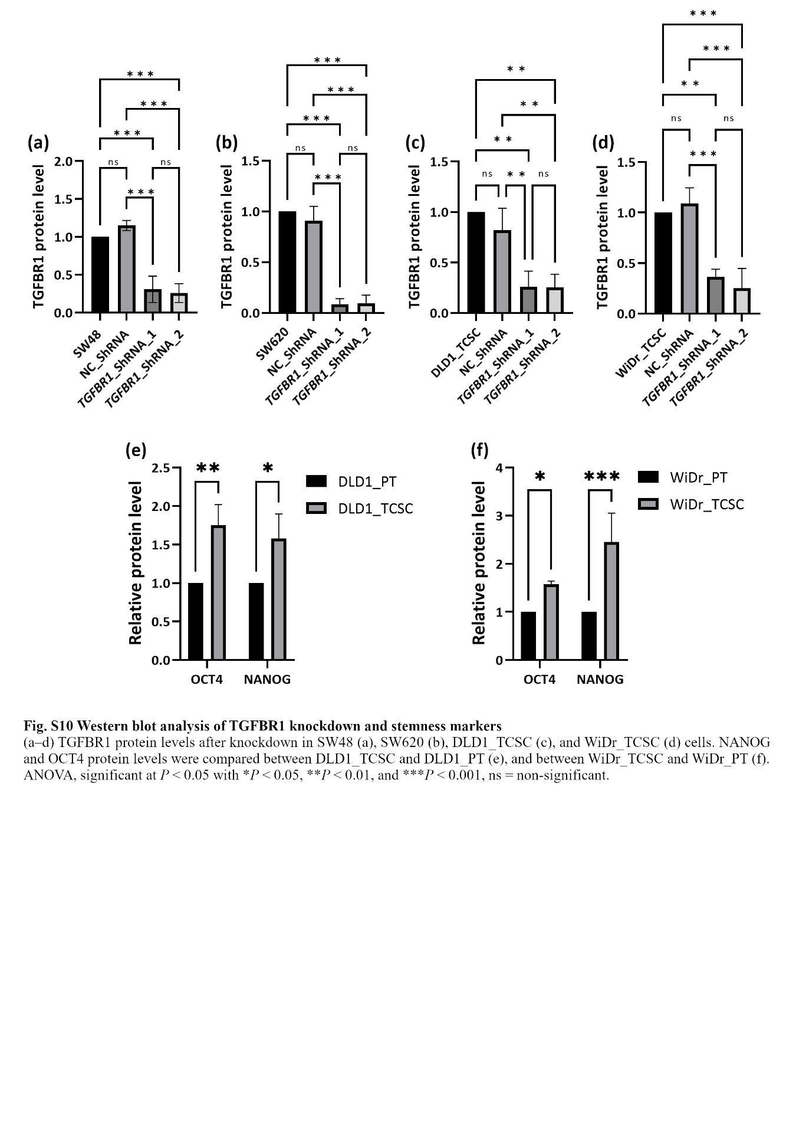
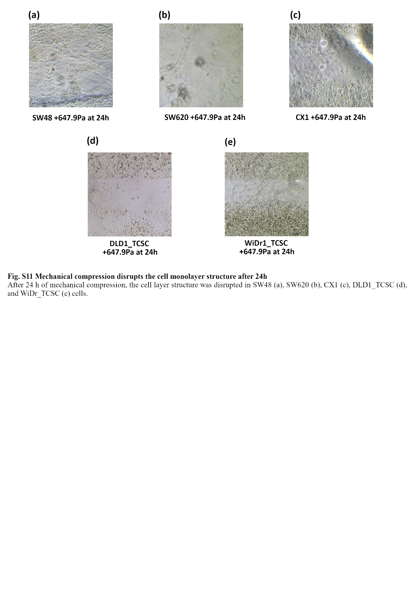

Section and Topic | Item # | Checklist item | Location where item is reported
TITLE
Title | 1 | Identify the report as a systematic review. | Page 2
ABSTRACT
Abstract | 2 | See the PRISMA 2020 for Abstracts checklist. | Page 40
INTRODUCTION
Rationale | 3 | Describe the rationale for the review in the context of existing knowledge. | Pages 3,4
Objectives | 4 | Provide an explicit statement of the objective(s) or question(s) the review addresses. | Pages 3,4
METHODS
Eligibility criteria | 5 | Specify the inclusion and exclusion criteria for the review and how studies were grouped for the syntheses. | Pages 4,5
Information sources | 6 | Specify all databases, registers, websites, organisations, reference lists and other sources searched or consulted to identify studies. Specify the date when each source was last searched or consulted. | Pages 4,5
Search strategy | 7 | Present the full search strategies for all databases, registers and websites, including any filters and limits used. | Supporting Information, pages 1-2
Selection process | 8 | Specify the methods used to decide whether a study met the inclusion criteria of the review, including how many reviewers screened each record and each report retrieved, whether they worked independently, and if applicable, details of automation tools used in the process. | Page 4,5
Data collection process | 9 | Specify the methods used to collect data from reports, including how many reviewers collected data from each report, whether they worked independently, any processes for obtaining or confirming data from study investigators, and if applicable, details of automation tools used in the process. | Pages 4,5
Data items | 10a | List and define all outcomes for which data were sought. Specify whether all results that were compatible with each outcome domain in each study were sought (e.g. for all measures, time points, analyses), and if not, the methods used to decide which results to collect. | Page 4,5
Data items | 10b | List and define all other variables for which data were sought (e.g. participant and intervention characteristics, funding sources). Describe any assumptions made about any missing or unclear information. | Page 4,5
Study risk of bias assessment | 11 | Specify the methods used to assess risk of bias in the included studies, including details of the tool(s) used, how many reviewers assessed each study and whether they worked independently, and if applicable, details of automation tools used in the process. | Pages 4,5, 11
Effect measures | 12 | Specify for each outcome the effect measure(s) (e.g. risk ratio, mean difference) used in the synthesis or presentation of results. | Pages 10,11
Synthesis methods | 13a | Describe the processes used to decide which studies were eligible for each synthesis (e.g. tabulating the study intervention characteristics and comparing against the planned groups for each synthesis (item #5)). | Pages 10,11
Synthesis methods | 13b | Describe any methods required to prepare the data for presentation or synthesis, such as handling of missing summary statistics, or data conversions. | Pages 10,11
Synthesis methods | 13c | Describe any methods used to tabulate or visually display results of individual studies and syntheses. | Pages 10,11
Synthesis methods | 13d | Describe any methods used to synthesize results and provide a rationale for the choice(s). If meta-analysis was performed, describe the model(s), method(s) to identify the presence and extent of statistical heterogeneity, and software package(s) used. | Pages 10,11
Synthesis methods | 13e | Describe any methods used to explore possible causes of heterogeneity among study results (e.g. subgroup analysis, meta-regression). | Pages 10,11
Synthesis methods | 13f | Describe any sensitivity analyses conducted to assess robustness of the synthesized results. | Page 10,11
Reporting bias assessment | 14 | Describe any methods used to assess risk of bias due to missing results in a synthesis (arising from reporting biases). | Pages 10,11, 17
Certainty assessment | 15 | Describe any methods used to assess certainty (or confidence) in the body of evidence for an outcome.
RESULTS
Study selection | 16a | Describe the results of the search and selection process, from the number of records identified in the search to the number of studies included in the review, ideally using a flow diagram. | Pages 10,11
Study selection | 16b | Cite studies that might appear to meet the inclusion criteria, but which were excluded, and explain why they were excluded.
Study characteristics | 17 | Cite each included study and present its characteristics. | Pages 38,39
Risk of bias in studies | 18 | Present assessments of risk of bias for each included study. | Pages 38,39
Results of individual studies | 19 | For all outcomes, present, for each study: (a) summary statistics for each group (where appropriate) and (b) an effect estimate and its precision (e.g. confidence/credible interval), ideally using structured tables or plots. | Pages 10,11
Results of syntheses | 20a | For each synthesis, briefly summarise the characteristics and risk of bias among contributing studies. | Pages 38,39
Results of syntheses | 20b | Present results of all statistical syntheses conducted. If meta-analysis was done, present for each the summary estimate and its precision (e.g. confidence/credible interval) and measures of statistical heterogeneity. If comparing groups, describe the direction of the effect. | Pages 38,39  Supporting Information, pages 4-6
Results of syntheses | 20c | Present results of all investigations of possible causes of heterogeneity among study results. | Pages 16, 17
Results of syntheses | 20d | Present results of all sensitivity analyses conducted to assess the robustness of the synthesized results. | Pages 16, 17
Reporting biases | 21 | Present assessments of risk of bias due to missing results (arising from reporting biases) for each synthesis assessed. | Pages 16, 17
Certainty of evidence | 22 | Present assessments of certainty (or confidence) in the body of evidence for each outcome assessed.
DISCUSSION
Discussion | 23a | Provide a general interpretation of the results in the context of other evidence. | Pages 16, 17
Discussion | 23b | Discuss any limitations of the evidence included in the review. | Pages 16, 17
Discussion | 23c | Discuss any limitations of the review processes used. | Pages 16, 17
Discussion | 23d | Discuss implications of the results for practice, policy, and future research. | Pages 16, 17
OTHER INFORMATION
Registration and protocol | 24a | Provide registration information for the review, including register name and registration number, or state that the review was not registered. | Page 2
Registration and protocol | 24b | Indicate where the review protocol can be accessed, or state that a protocol was not prepared.
Registration and protocol | 24c | Describe and explain any amendments to information provided at registration or in the protocol.
Support | 25 | Describe sources of financial or non-financial support for the review, and the role of the funders or sponsors in the review. | Pages 20, 21
Competing interests | 26 | Declare any competing interests of review authors. | Pages 20, 21
Availability of data, code and other materials | 27 | Report which of the following are publicly available and where they can be found: template data collection forms; data extracted from included studies; data used for all analyses; analytic code; any other materials used in the review. | Pages 38,39  Supporting Information, pages 1-4

From: Page MJ, McKenzie JE, Bossuyt PM, Boutron I, Hoffmann TC, Mulrow CD, et al. The PRISMA 2020 statement: an updated guideline for reporting systematic reviews. BMJ 2021;372:n71. doi: 10.1136/bmj.n71

