Supplementary Figures

The miR105/767 cluster as Coordinator of Apoptosis and PD-L1 Expression in Non-Small Cell Lung Cancer
Authors:
Maryam Abdipourbozorgbaghi^{1,2,3}, Ramin Radpour^{1,2,4*}, Simon Haefliger^{1,2,4*}

Affiliations:
¹ Department of Medical Oncology, Inselspital, Bern University Hospital, University of Bern, Bern, Switzerland.
² Department of BioMedical Research (DBMR), University of Bern, Bern, Switzerland.
³ Graduate School of Cellular and Biomedical Sciences, University of Bern, Bern, Switzerland.
⁴ These authors jointly supervised this work.
* Corresponding authors

Correspondence:
Simon Haefliger, Department of Medical Oncology, Inselspital, Bern University Hospital, 3010 Bern, Switzerland. E-mail: simon.haefliger@insel.ch, Telephone: +41-31-632-4114, Fax: +41-31-632-4119.

Ramin Radpour, Department of Medical Oncology, Inselspital, Bern University Hospital, 3010 Bern, Switzerland. E-mail: ramin.radpour@unibe.ch, Telephone: +41-31-632-0956, Fax: +41-31-632-4119.

Supplementary Figures

- Supplementary Figure 1.Kaplan–Meier overall survival curves for LUSC patients with Stage II and Stage III.
- Supplementary Figure 2. Transfection efficiency assessed by fluorescent microscopy in the KD/MIMIC condition of miR105/767 cluster.
- Supplementary Figure 3. Gene set enrichment analysis (GSEA) in the MIMIC condition of miR105/767 cluster compared to the negative CTRL.
- Supplementary Figure 4. Transfection efficiency assessed by fluorescent microscopy in ASAH2.

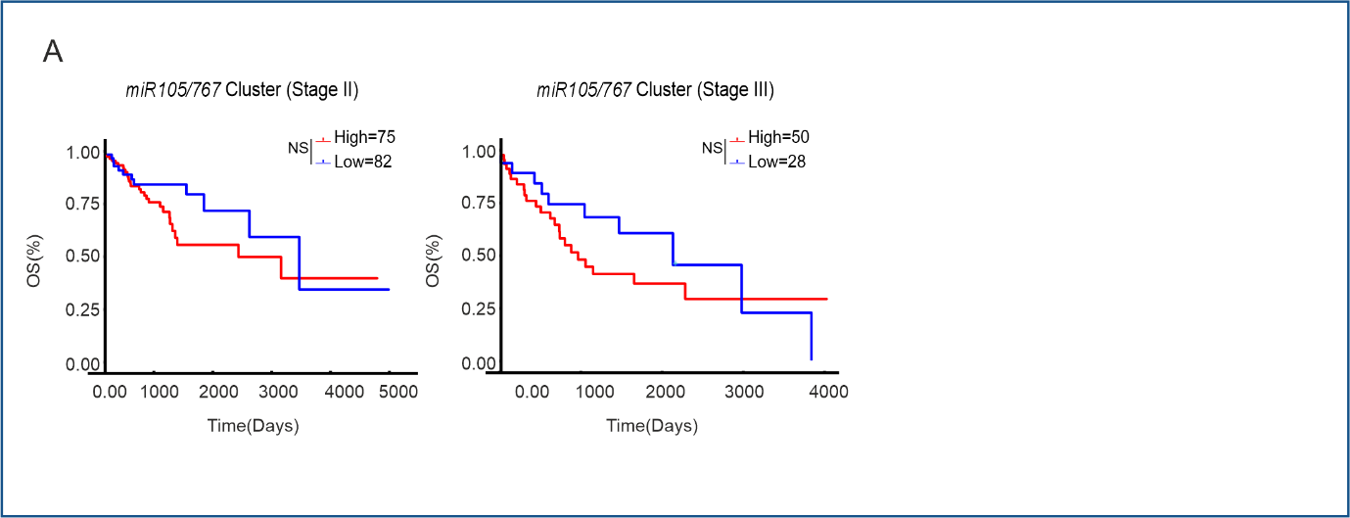
Supplementary Figure 1.Kaplan–Meier overall survival curves for LUSC patients with Stage II and Stage III.
- Kaplan–Meier overall survival curves for LUSC patients with Stage II (left) and Stage III right.High-expression (red) and low-expression (blue) groups. Survival probability is shown over time (days). Statistical significance is defined as *P ≤ 0.05, **P ≤ 0.01, ***P ≤ 0.001, and not significant (NS) defined as P > 0.05.

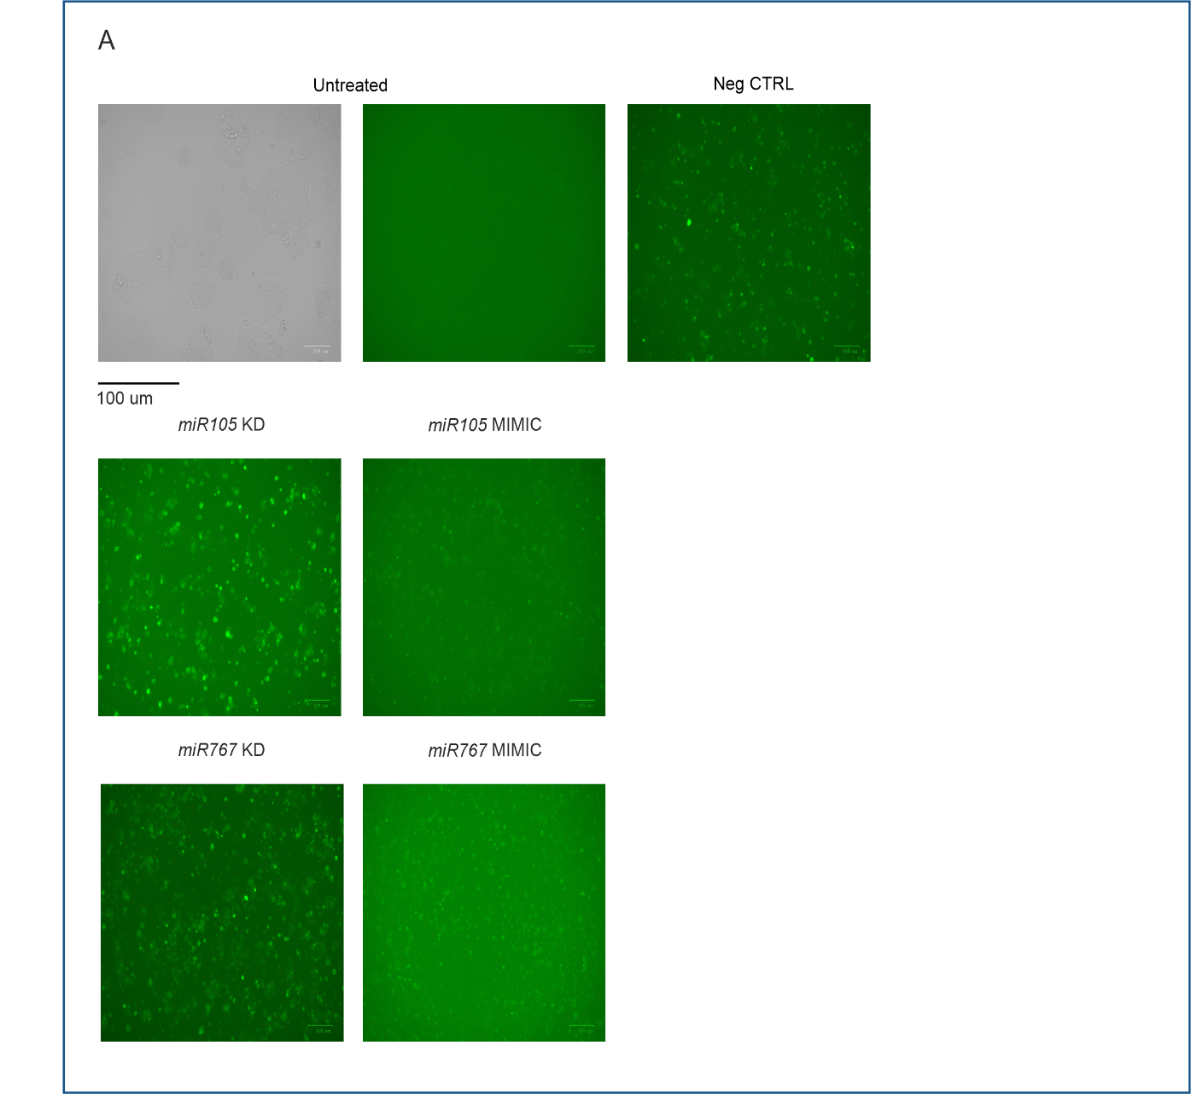
Supplementary Figure 2. Transfection efficiency assessed by fluorescent microscopy in the KD/MIMIC condition of miR105/767 cluster.
- Respective fluorescent microscopy imaging of FAM-labeled AntimiR and MIMIC to address transfection efficiency in untreated, negative control, miR-105-5p KD/MIMIC, and miR-767-5p KD/MIMIC conditions in H520 cell line.

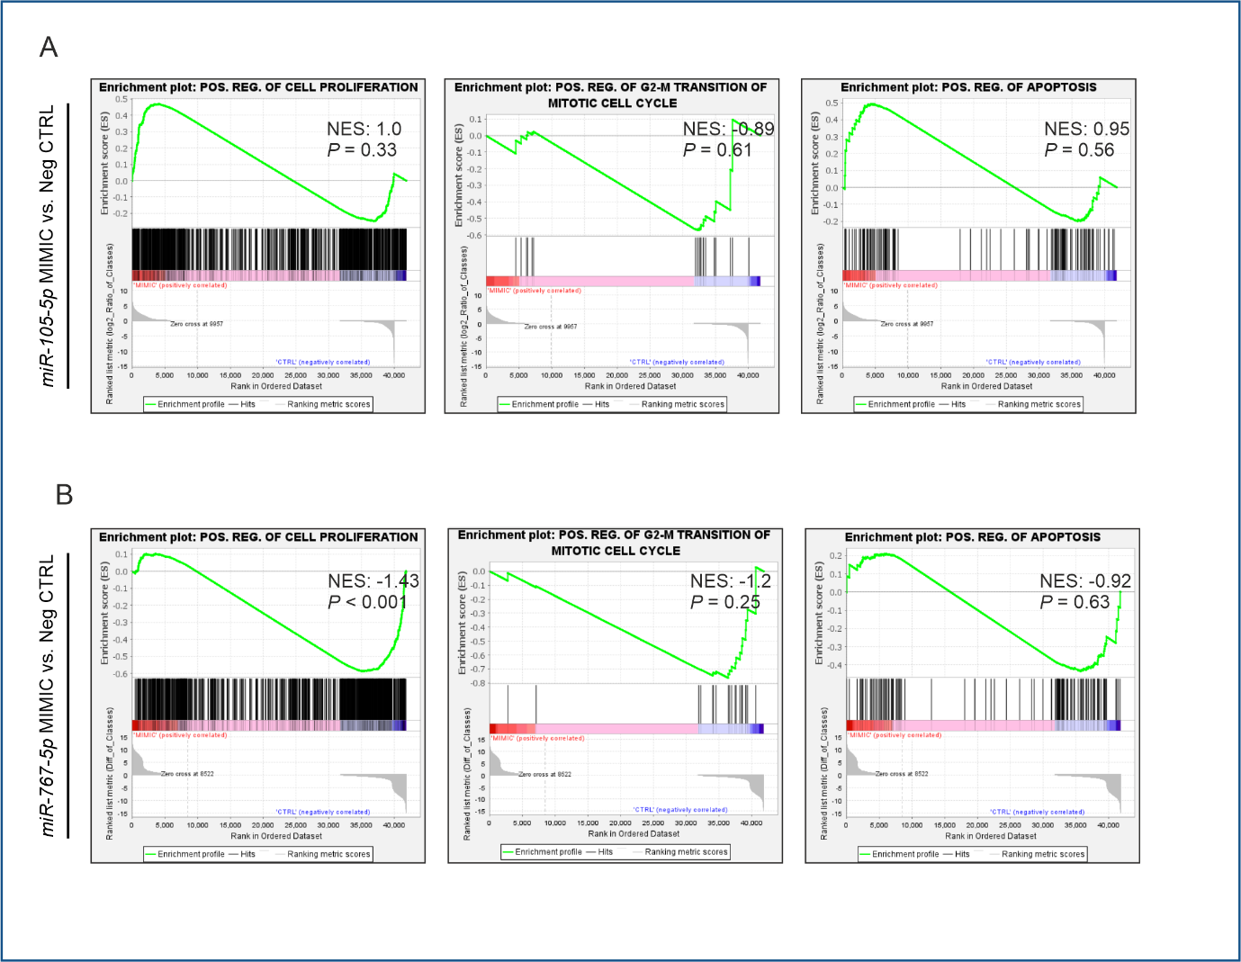
Supplementary Figure 3. Gene set enrichment analysis (GSEA) in the MIMIC condition of miR105/767 cluster compared to the negative CTRL.
A & B) GSEA plots show enrichment pathways in miR105/767 cluster MIMIC conditions compared to negative control. Positive value of NES shows the positive enrichment while negative value shows a negative enrichment of the pathway. Statistical significance is defined as *P ≤ 0.05, **P ≤ 0.01, ***P ≤ 0.001, and not significant (NS) defined as P > 0.05.

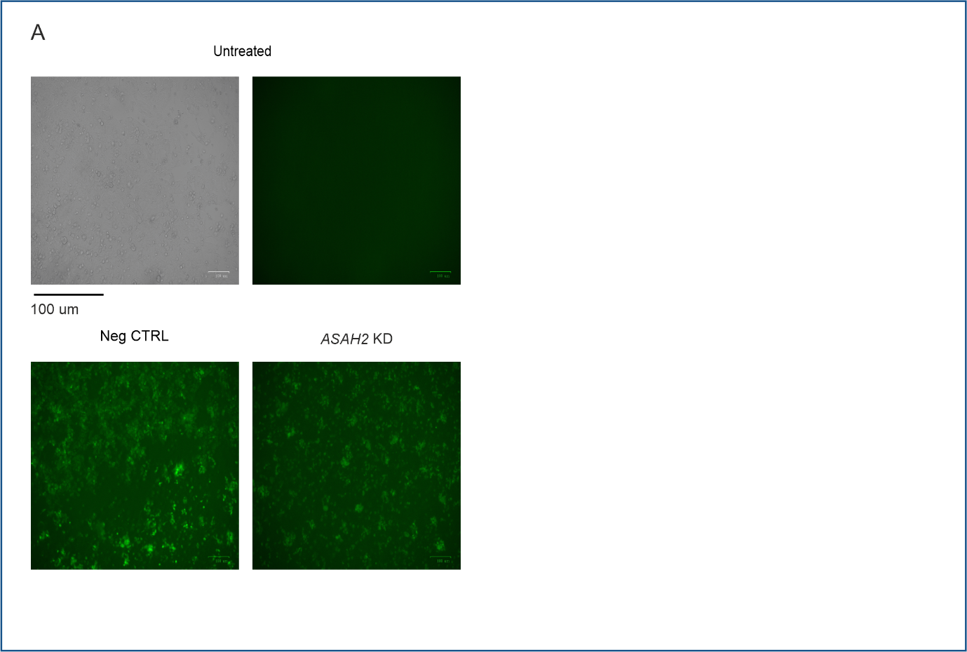
Supplementary Figure 4. Transfection efficiency assessed by fluorescent microscopy in ASAH2.
- Respective fluorescent microscopy imaging of FAM-labeled AntimiR to address transfection efficiency in untreated, negative control and ASAH2 KD conditions in H520 cell line.

