Figure1
CD63

TSG101

GAPDH

Figure2A
TLR4

GAPDH
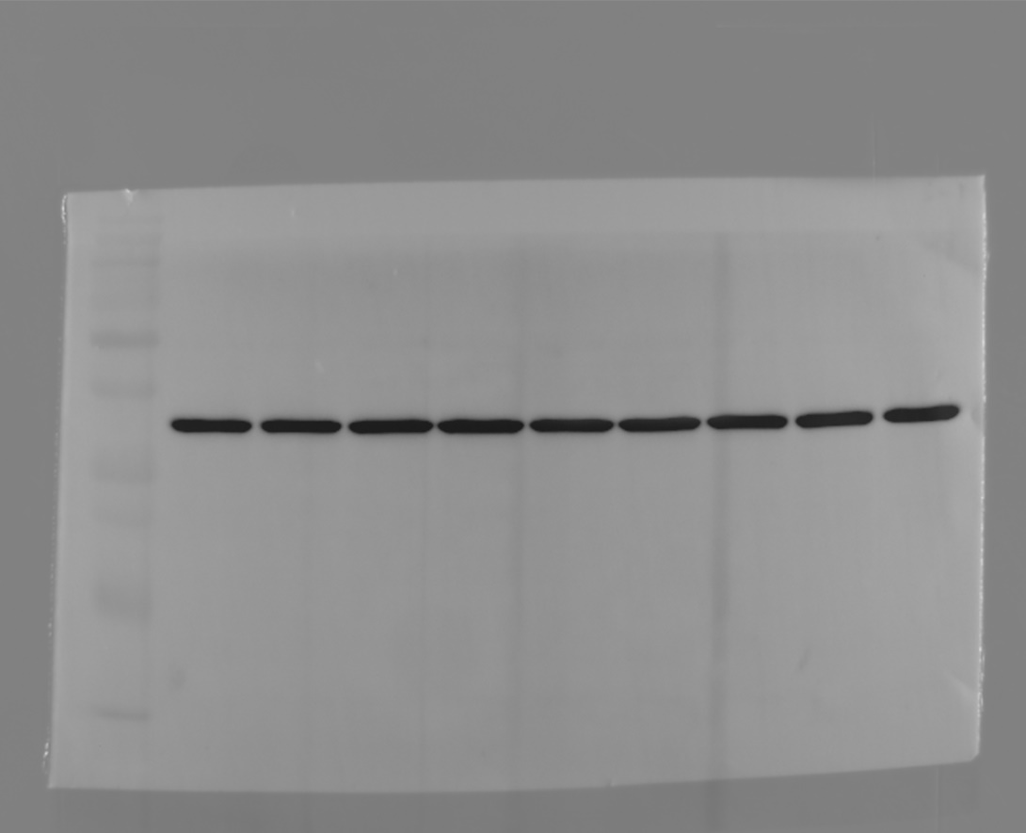

Figure2C
Cit H3

MPO

PAD4

GAPDH

Figure 2J
TLR4

GAPDH

Figure3B
TLR4

GAPDH

Figure 3D
Cit H3
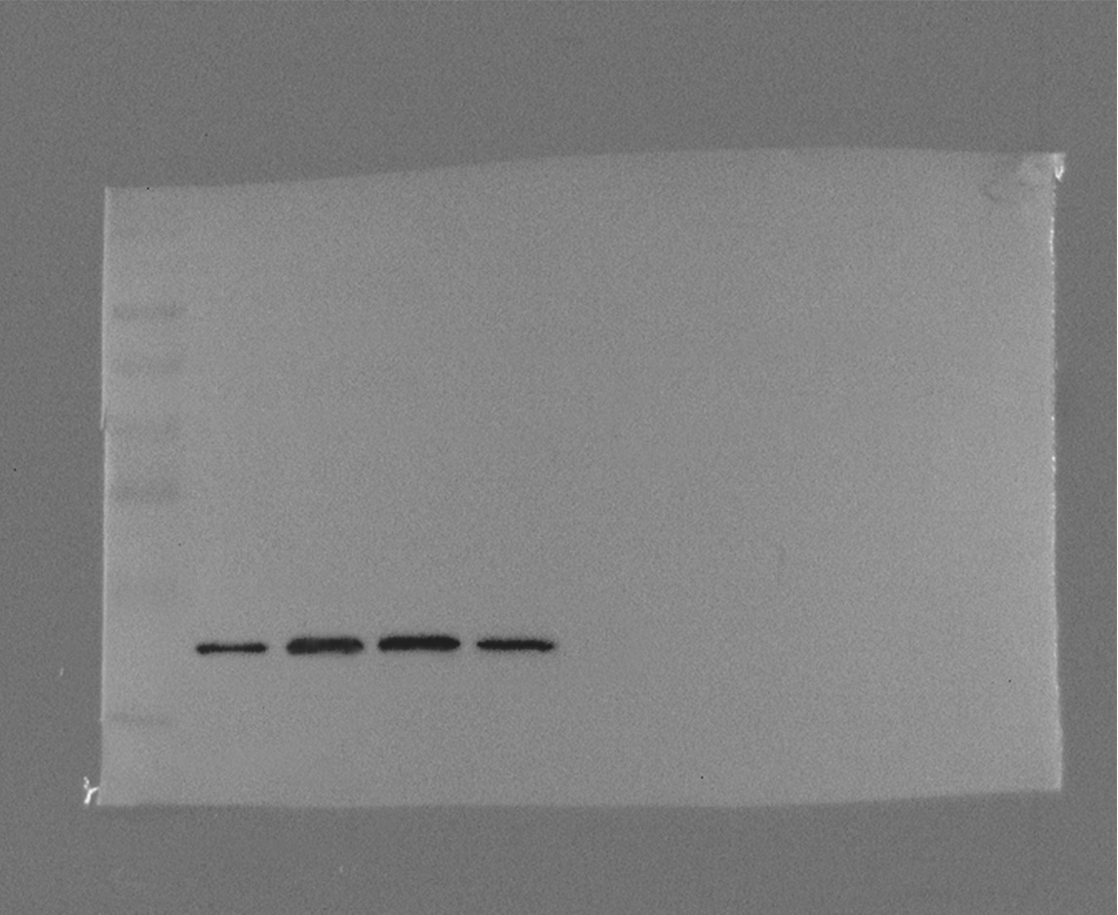

MPO
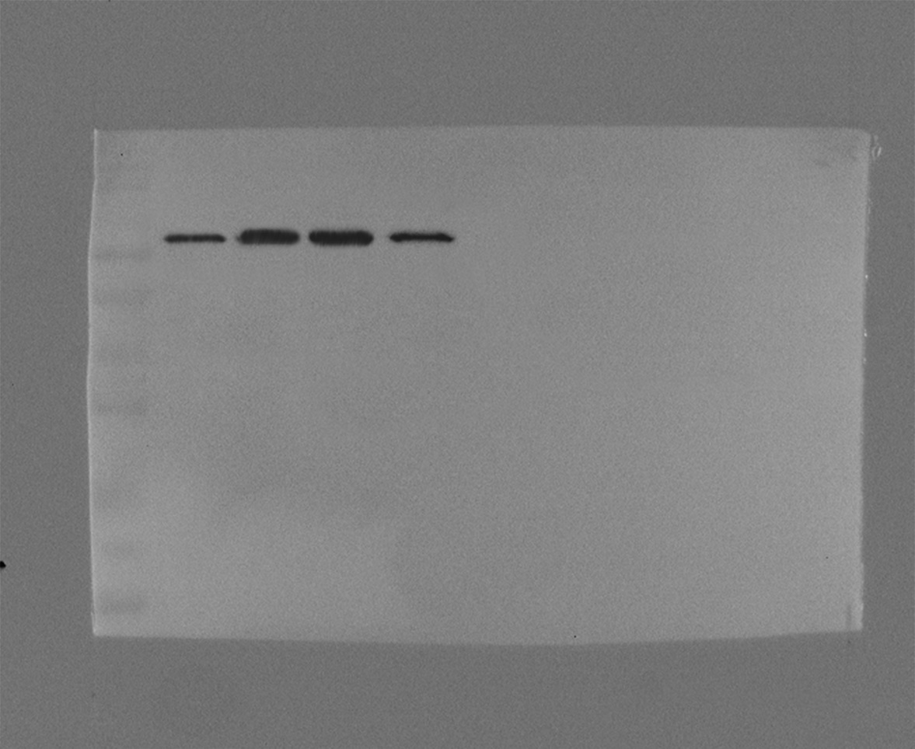

PAD4

GAPDH

Figure 4A
TLR4

GAPDH
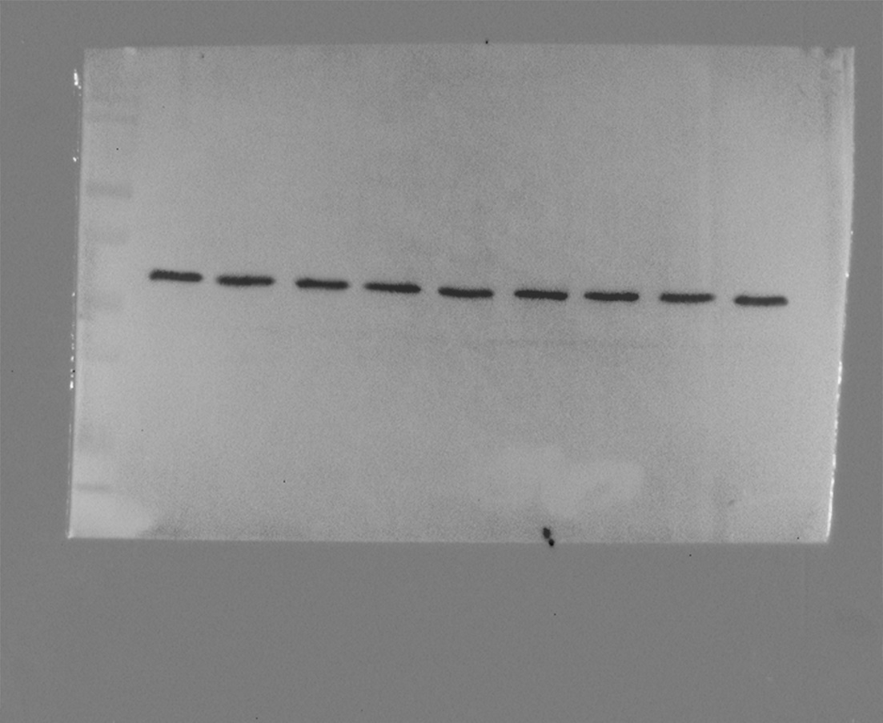

Figure 4C
Cit H3

MPO

PAD4

GAPDH
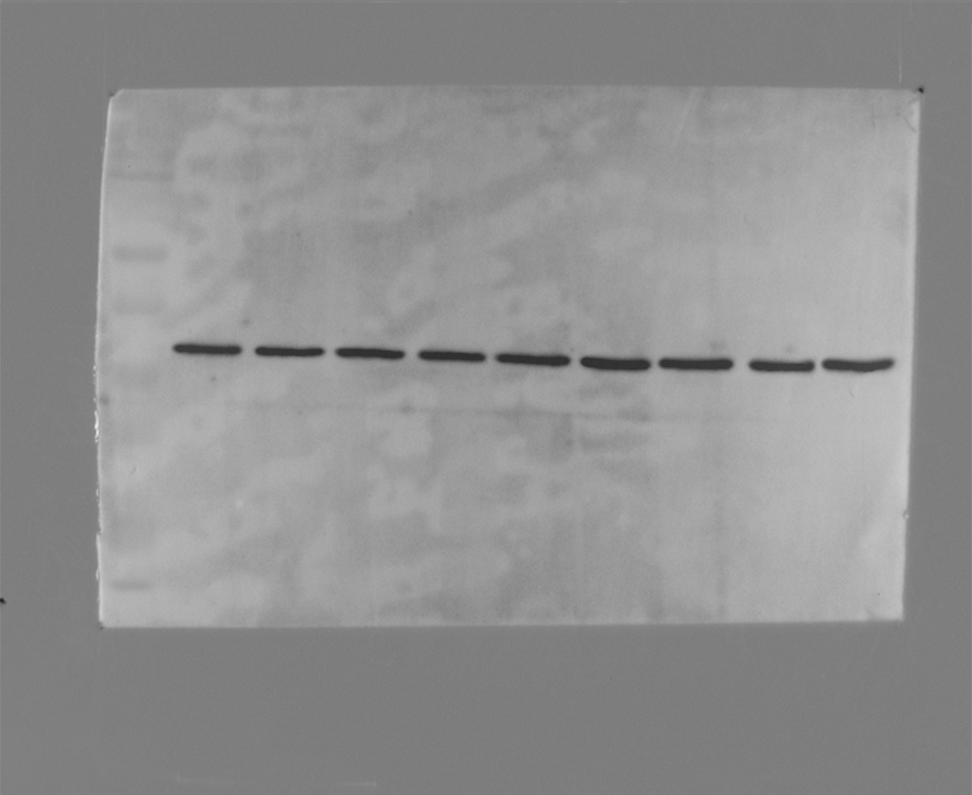

Figure 6B
TLR4

GAPDH

Figure 6C
Cit H3

MPO

PAD4

GAPDH
