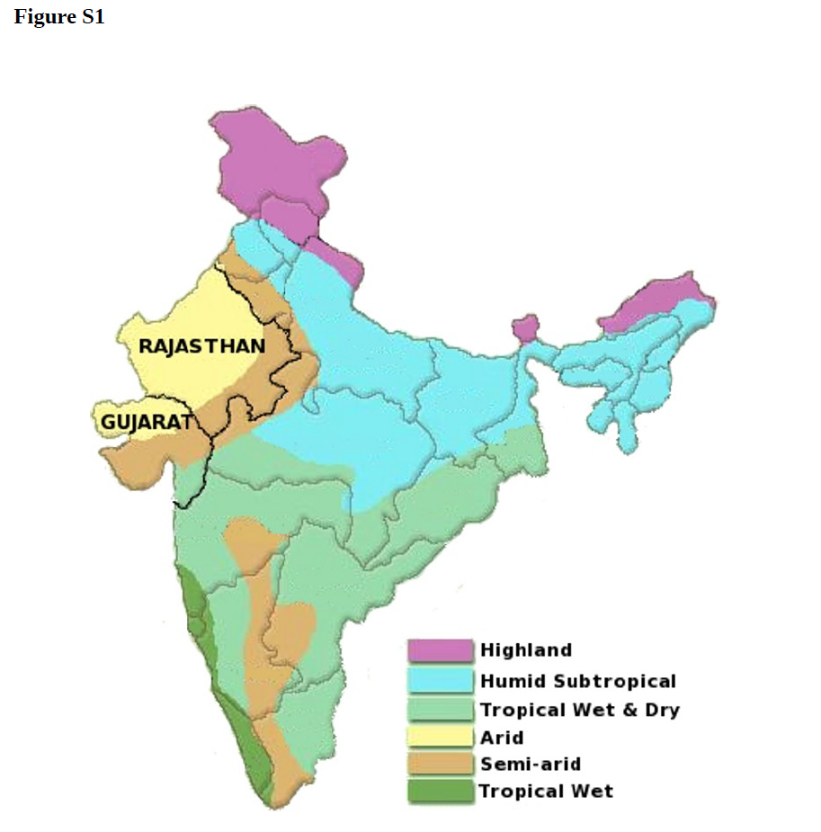

Figure S1. Major climate regions of India
The figure illustrates the major climate zones of India, highlighting the arid and semi-arid climate conditions that span most of the states of Gujarat and Rajasthan in NW India (adapted from the original source in http://besttofind.com/Img/india_climate_map.jpg).

