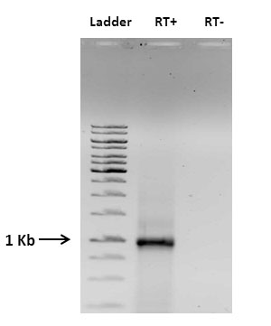

Additional figure 1 (Additional file 3). Agarose gel of the RT-PCR products of mixed stage parasite RNA. Expected size of the RT-PCR product is ~1kb (RT+). RT- reaction (without reverse transcriptase) was used as negative control. The primer used for RT-PCR reaction can amplify several var genes (21). For size comparison 1 kb step up DNA ladder (Thermo Scientific) was loaded.

