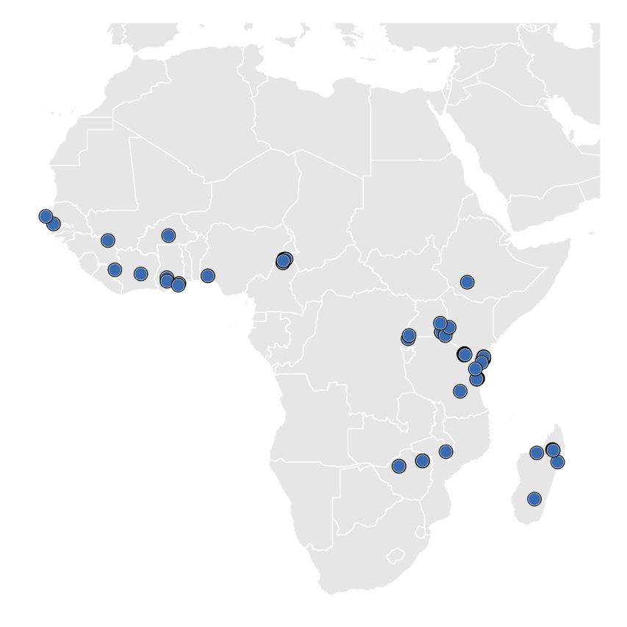
Figure A1: Data location used in the generalised additive model (GAM)

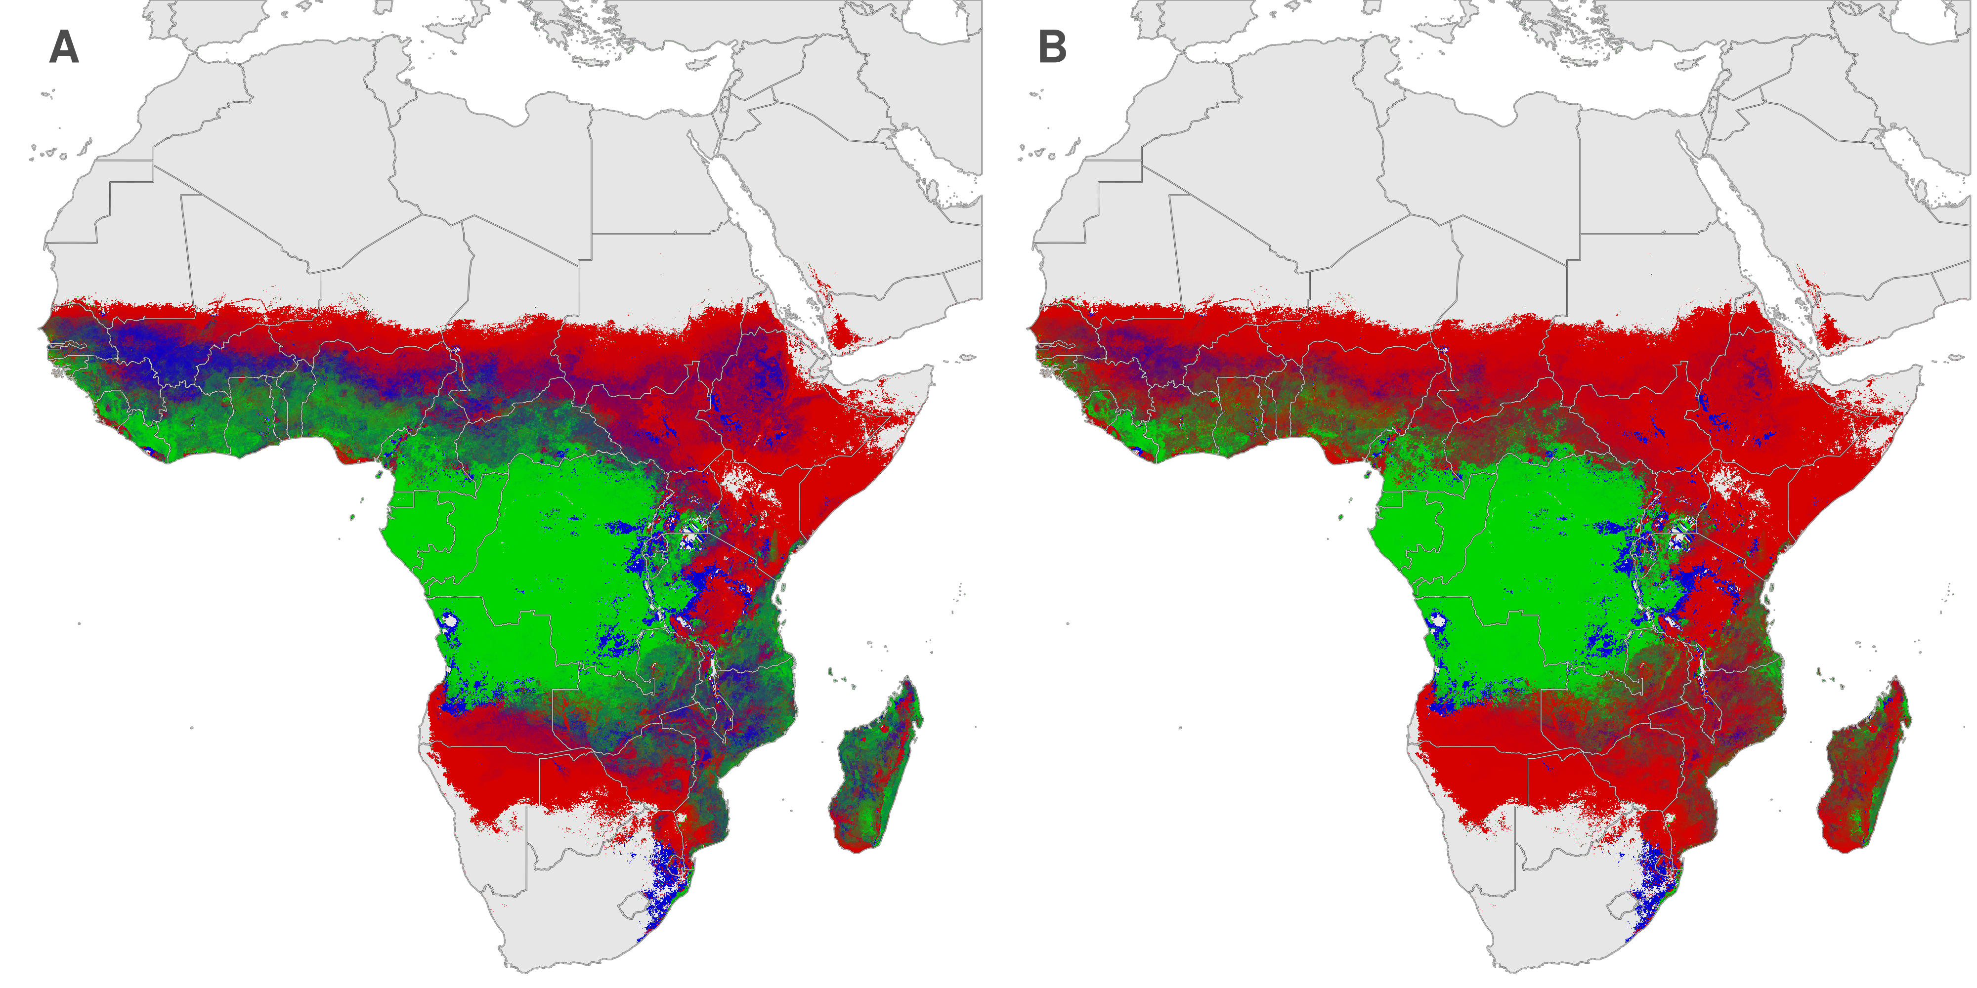
Figure A2: Red-green-blue plots for pre- (A), and post- (B) intervention (Long lasting insecticidal nets) relative abundance. Red = An. arabiensis, blue = An. funestus and green = An. gambiae with intervening colours indicating the transitioning increasing or decreasing relative abundance between species.
Table A1: The top five environmental/climatic variables selected by the BRT for predicting the habitat suitability of An. arabiensis, An funestus and An. gambiae/An. coluzzii. Numbers in parenthesis after the species name indicate the number of occurrence points used in the model.
Species | Environmental variables
An. arabiensis (1196)
  1 | NDVI (phase of the annual cycle)
An. arabiensis (1196)
  2 | Prec (amplitude of the bi-annual cycle)
An. arabiensis (1196)
  3 | LST (phase of the annual cycle)
An. arabiensis (1196)
  4 | Prec (max.)
An. arabiensis (1196)
  5 | MIR (phase of the annual cycle)
An. funestus (919)
  1 | Prec (max.)
An. funestus (919)
  2 | NDVI (mean)
An. funestus (919)
  3 | Prec (amplitude of the bi-annual cycle)
An. funestus (919)
  4 | MIR (mean)
An. funestus (919)
  5 | NDVI (amplitude of the annual cycle)
An. gambiae/An. coluzzii (1443)
  1 | Prec (mean)
An. gambiae/An. coluzzii (1443)
  2 | Prec (max.)
An. gambiae/An. coluzzii (1443)
  3 | DEM
An. gambiae/An. coluzzii (1443)
  4 | Prec (amplitude of the bi-annual cycle)
An. gambiae/An. coluzzii (1443)
  5 | LST (min.)
NB: NDVI: Normalized Difference Vegetation Index; Prec: Precipitation; LST: Land Surface Temperature; MIR: Middle Infrared; DEM: Digital Elevation Model

