HOUSEHOLD QUESTIONNAIRE: ENGLISH VERSION
KNOWLEDGE AND AWARENESS ON MALARIA, MALARIA VECTOR CONTROLS AND MOSQUITO BITING BEHAVIOR IN SELECTED SITES WITHIN MOROGORO AND DODOMA REGIONS TANZANIA
S/N |  | Variables | Response
 |  | Region …………………………
 |  | Questionnaire #
SOCIODEMOGRAPHIC CHARACTERISTICS
 | Age |  | …….
 | Sex |  | - Male | - Female
 | Ward and street |  | - Ward……………. | - Street………………….
 | Level of education |  | - No formal education  - Primary education  - Secondary education | - College /university  - Others (specify)……
 | Marital status |  | - Single  - Married  - Cohabited | - Divorced  - Widowed  - Others(specify)
 | Occupation status |  | - Self employed  - Employed | - Studying  - Others (specify}……
MALARIA, MALARIA VECTOR CONTROLS AND MOSQUITOES-(KNOWLEDGE) Choose appropriate answer(s)
 | What causes malaria? |  | 1.Mosquito  2. Bacteria  3. Worms | - Plasmodium  - Others, explain…..……
 | What is a risk mode of malaria transmission? |  | ………………………………………………..
 | What is the name of the mosquito which transmits malaria? |  | - Anopheles  2. Culex | 3. Aedes  4. Don’t know
 | What are common breeding sites for mosquitoes? |  | - Garbage/trash  - Running water | - Stagnant water  - Long grasses
 | What is the most important health problem affecting your household |  | …………………………………………………………………………….
 | Have you suffered from malaria? |  | - Yes | - No
 | What are symptoms and signs of malaria? |  | - High fever  - Headache  - Vomiting | - Joint pain  - Shivering/Rigors  - Other (specify)……….
 | When you get these symptoms above what do you do? |  | - Go to hospital for check up and treatment  - Use antimalarial without check up | - Go to traditional healer  - Use pain killer  - Other (specify)…..
 | What is your preferred source of information for Malaria and its vector |  | - Health Centre  - Radio | - Television  - At school
MALARIA, MALARIA VECTOR CONTROLS AND MOSQUITOES -(Awareness) Choose one correct answer
 | What time can malaria vector start biting? |  | - Midnight  - Early evening | - Anytime
 | Is midnight mosquito only responsible for malaria transmission? |  | - Yes | - No
 | Can early Anopheles bite transmit malaria? |  | - Yes | - No
 | Can outdoor mosquito bite transmit malaria? |  | 1. Yes | 2.No
 | What convenient protection methods against mosquito bite do use in your household? |  | - LLINs  - IRS  - Mosquito spray | - Mosquito coils  - Others (specify)…..
 | In your household do you own mosquito nets? |  | - Yes | - No
 | Who sleeps under mosquito nets? |  | - Pregnant mother  - Mothers and under-five children | - Father only  - All people in the house  - Others (specify)
 | Where did you get this net? |  | - Mass campaign  - Retail shop | - Health facility  - Others(specify)…….
UELEWA JUU YA MBU ANAYEENEZA MALARIA.
Put tick (√) to the pictures of mosquito which transmit malaria, (X ) to pictures of mosquito which do not transmit malaria and (0) if you don’t know
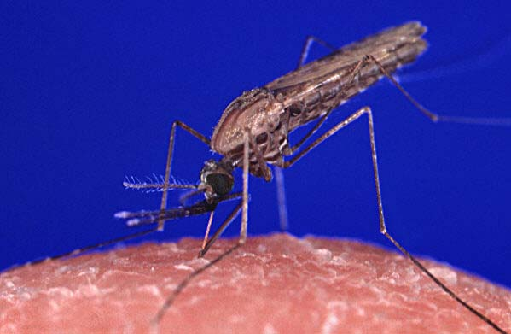  i)………………………………… |  |  | 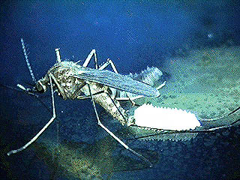  ii)………………………………..
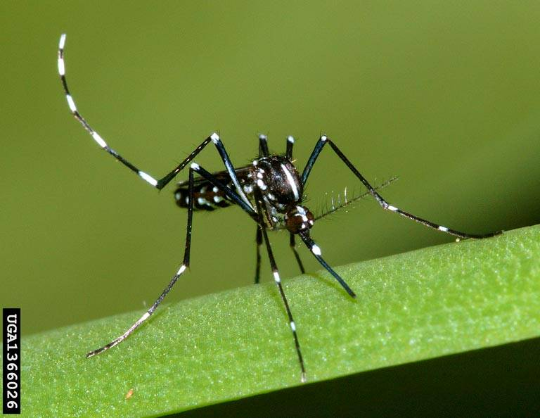  iii)………………………………… |  |  | 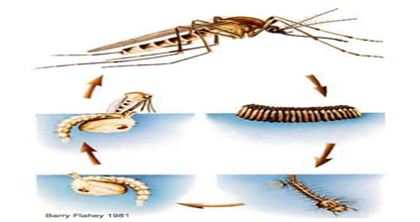  iv) …………………………
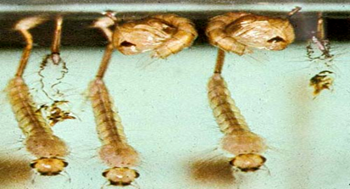  v)…………………………………… |  |  | 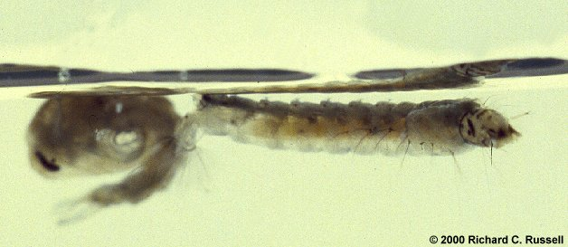  vi)……………………………………
FOR PUPILS ONLY
 | What health information do you get more frequent at school |  | - HIV ` | - Malaria

Thank you for your participation!
SWAHILI VERSION
DODOSO LA KUPIMA UELEWA JUU YA MALARIA, MBU WANGATAO MAPEMA/JION NA NJIA ZA KUJIKINGA NA MBU HAO
S/N |  | Maelezo |  | Majibu
1. |  | Mkoa……………………………………………..
2. |  | Namba ya dodoso
Taarifa ya mshiriki
 |  | Umri (Miaka)
 |  | Jinsia |  | 1.Me |  | 2.Ke
 |  | Kata na Mtaa unamoishi |  | Kata …………………………….. |  | Mtaa ……………………………
 |  | Kiwango cha elimu |  | 1.Sijasoma  2.Elimu ya msingi |  | 3.Elimu ya sekondari  4.Chuo/ Chuo kikuu  5.Majibu mengine……………
 |  | Hali ya ndoa |  | 1.Sijaowa /Sijaolewa  2.Nimeowa /Nimeolewa  3.Tunaishi bila ndoa |  | - Tumeachana  - Nimefiwa mke/mme  - Mengineyo...
 |  | Ajira |  | 1.Nimeajiajiri  - Nimeajiriwa |  | - Nasoma  - Menyineyo...
Elimu juu ya malaria, mbu na njia za kujikinga dhidi ya malaria (Chagua jibu au majibu sahihi)
 |  | Ugonjwa wa malaria unasababishwa na nini? |  | - Mbu  - Bakteria  - Minyoo | 4.Plasmodiam  5. Fangasi  6.Nyingine (elezea)……………
 |  | Ni njia gani hatarishi inayoweza kusambaza malaria? |  | …………………………………………..
 |  | Taja jina la mbu anayesambaza ugonjwa wa malaria |  | - Anofelesi  - Kiuleksi | - Aidesi  - Sijui
 |  | Ni mazingira gani yanasababisha mbu kuzaliana? |  | - Sehemu ya kutunza takataka  - Maji yanayotiririka | - Maji yaliyotuama  - Majani marefu
 |  | Je ni magonjwa gani yanasumbua sana familia yako? |  | …………………………………………………………………………
 |  | Umeshawahi kuugua malaria |  | 1.Ndio |  | 2.Hapana
 |  | Taja dalili za malaria |  | 1.Homa kali  2. Kichwa kuuma  3.Kutapika |  | 4.Kutetemeka  5.Maumivu ya viungo  6.Nyingine (elezea) ……………..
 |  | Ukiona dalili hizi za malaria anafanya nini? |  | 1.Ninaenda hospitali  2.Nakunywa dawa za malaria bila kupima  3.Ananipeleke kwa mganga wa jadi |  | 4.Ananipa dawa za kupunguza maumivu  5. Majibu mengine……………
 |  | Chagua sehemu ungependa ikupatie taarifa kuhusu malaria na mbu |  | - Kituo cha afya  - Radio |  | - Kwenye Runinga  - Shuleni
Mtazamo juu ya malaria, mbu na njia za kujikinga dhidi ya malaria (Chagua jibu au majibu sahihi)
 | Muda gani ambao mbu wanaoambukiza malaria wanaanza kungata watu |  | 1.Usiku wa manane  2. Mapema jioni |  |  | 3.Muda wowote
 | Mbu wanaonang’ata usiku wa manane ndio mbu pekee wanaoasambaza malaria? |  | - Ndio |  |  | - Hapana
 | Mbu wanaong’ata mapema jioni wanaweza kusambaza malaria |  | - Ndio |  |  | - Hapana
 | Mbu wanaong’ata nje ya nyumba wanaweza kuambukiza malaria? |  | 1.Ndio |  |  | 2.Hapana
 | Njia zipi rahis unazotumia nyumban kujikinga na mbu wanaoasambaza malaria? |  | - Chandarua kilichowekewa dawa ya muda mrefu  - Dawa za kunyunyiza kwenye ukuta  - Dawa za kupuliza |  |  | - Dawa za mbu za kuchoma  - Majibu mengine, (elezea)………………………
 |  | Je kwenye familia yako mnamiliki chandarua? | - Ndio |  |  | - Hapana
 |  | Je vyandarua hivyo mnavitoa wapi ? | - Kwenye kampeni za kugawa vyandarua  - Tunanunua dukani |  |  | - Tunapewa hospitali  - Majibu mengine, (elezea)………………………
 |  | Nani analala kwenye chandarua? | - Mama mjamzito  - Mama na watoto chini ya miaka mitano |  |  | - Baba  - Watu wote  - Majibu mengine, (elezea)………………………
UELEWA JUU YA MBU ANAYEENEZA MALARIA.
Weka alama ya tiki (√) kwenye picha za mbu wanaoeneza malaria, alama (X)atika picha ya mbu wasioeneza malaria na alama (0 ) kama haujuiako
i)………………………………… | ii)………………………………..
iii)………………………………… | iv) …………………………
v)…………………………………… | vi)……………………………………
WANAFUNZI TU
 |  | Ni habari zipi mnaazofundishwa zaidi pewa shuleni | - Virusi vya ukimwi na ukimwi. |  |  | - Malaria

Asante kwa ushiriki !

