Supplementary Information
Article title
Antimalarial effect of (E)-4-((7-chloroquinolin-4-yl)amino)-N-(2-(dimethylamino)ethyl)-5-phenylpent-2-enamide and novel chloroquine derivatives as agents for the treatment of malaria

Article author

Seon-Ju Yeo¹‡, Dong-Xu Liu¹‡, Hak Sung Kim^{2*}, Hyun Park^{1*}
¹Zoonosis Research Center, Department of Infection Biology, School of Medicine, Wonkwang University, Iksan, Jeolabuk-do, 54538, Republic of Korea
²College of Pharmacy, Institute of Pharmaceutical Research and Development, Wonkwang University, Iksan, Jeolabuk-do, 54538, Republic of Korea

Supplementary Figures
Fig. S1. FACS analysis for IC₅₀ of CQ in P.falciparum (3D7)
Fig. S2. FACS analysis for IC₅₀ of SKM13 in P.falciparum (3D7)
Fig. S3. FACS analysis for IC₅₀ of SKM14 in P.falciparum (3D7)
Fig. S4. FACS analysis for IC₅₀ of CQ in P.falciparum (FCR3)
Fig. S5. FACS analysis for IC₅₀ of SKM13 in P.falciparum (FCR3)
Fig. S6. FACS analysis for IC₅₀ of SKM14 in P.falciparum (FCR3)

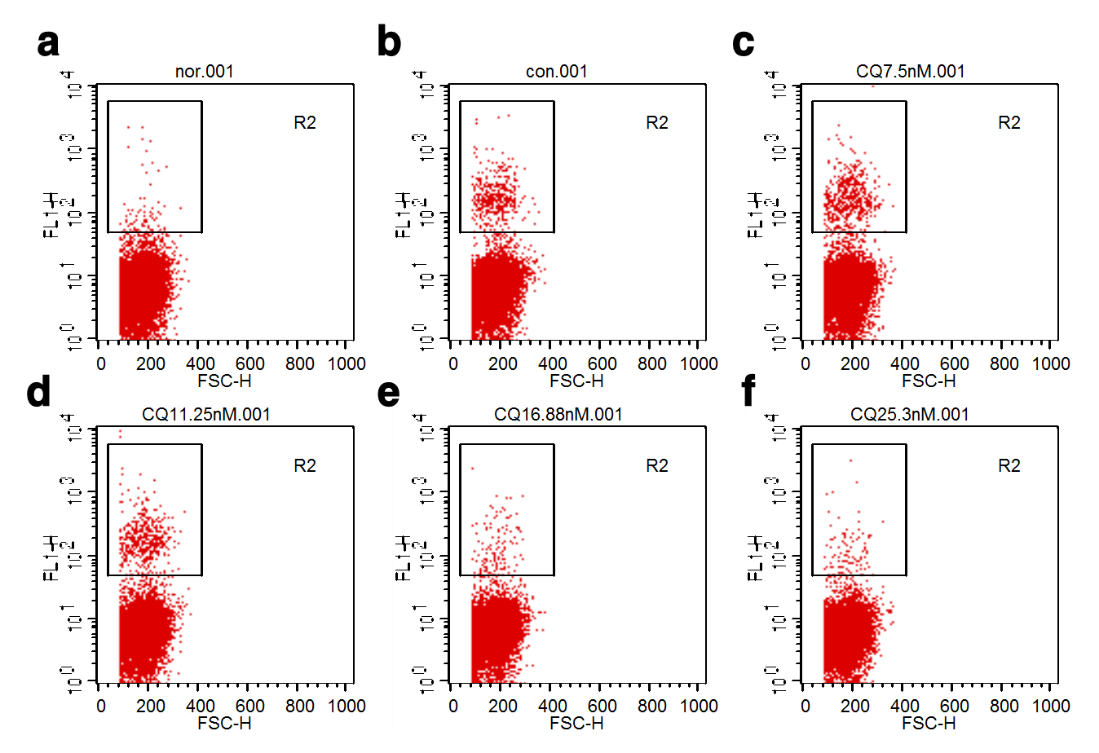
Fig. S1. FACS analysis for IC₅₀ of CQ in P.falciparum (3D7). Each small rectangular square indicates the positive fluorescence labeling. a, uninfected RBC; b, P.falciparum (3D7)-infected RBC+DMSO; c, infected RBC+ 7.5 nM of CQ; d, infected RBC+ 11.25 nM of CQ; e, infected RBC+ 16.88 nM of CQ; f, infected RBC+ 25.3 nM of CQ.

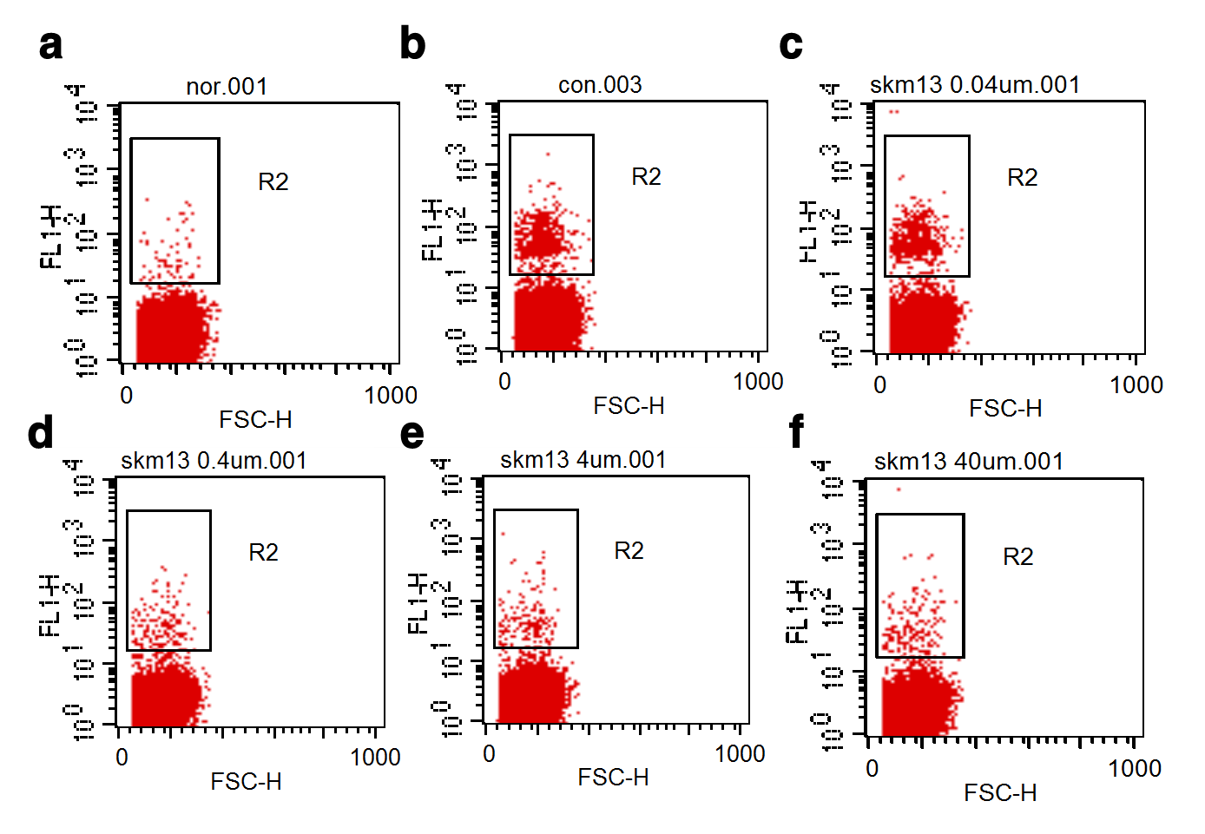
Fig. S2. FACS analysis for IC₅₀ of SKM13 in P.falciparum (3D7). Each small rectangular square indicates the positive fluorescence labeling. a, uninfected RBC; b, infected RBC+DMSO; c, infected RBC+ 0.04 μM of SKM13; d, infected RBC+ 0.4 μM of SKM13; e, infected RBC+ 4 μM of SKM13; f, infected RBC+ 40 μM of SKM13.
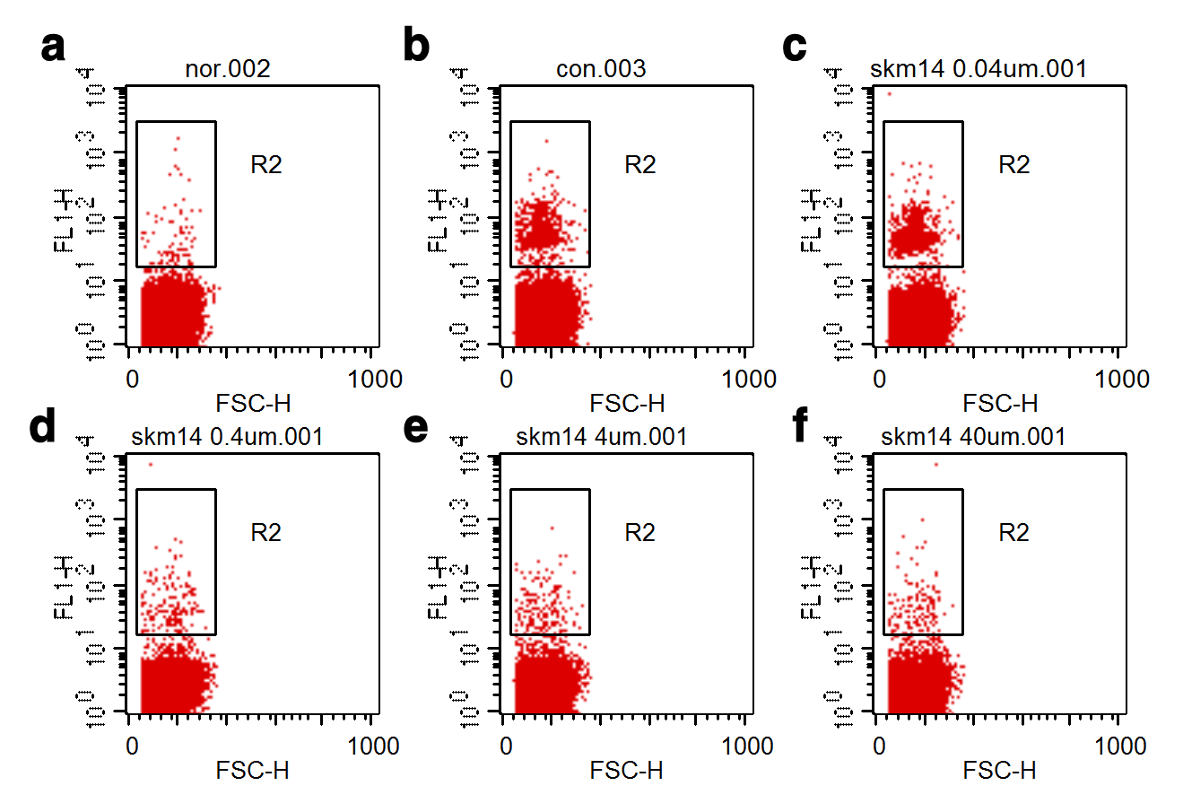
Fig. S3. FACS analysis for IC₅₀ of SKM14 in P.falciparum (3D7). Each small rectangular square indicates the positive fluorescence labeling. a, uninfected RBC; b, infected RBC+DMSO; c, infected RBC+ 0.04 μM of SKM14; d, infected RBC+ 0.4 μM of SKM14; e, infected RBC+ 4 μM of SKM14; f, infected RBC+ 40 μM of SKM14.

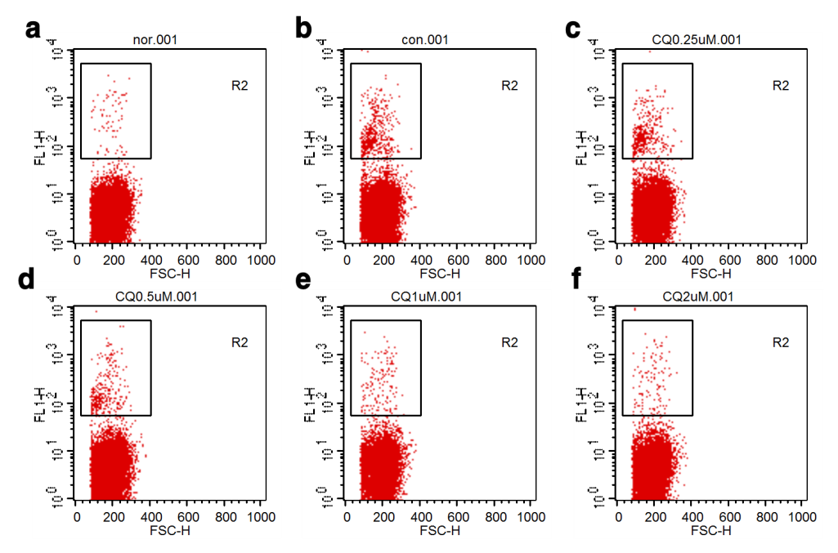
Fig. S4. FACS analysis for IC₅₀ of CQ in P.falciparum (FCR3). Each small rectangular square indicates the positive fluorescence labeling. a, uninfected RBC; b, infected RBC+DMSO; c, infected RBC+ 0.25 μM of CQ; d, infected RBC+ 0.5 μM of CQ; e, infected RBC+ 1 μM of CQ; f, infected RBC+ 2 μM of CQ.
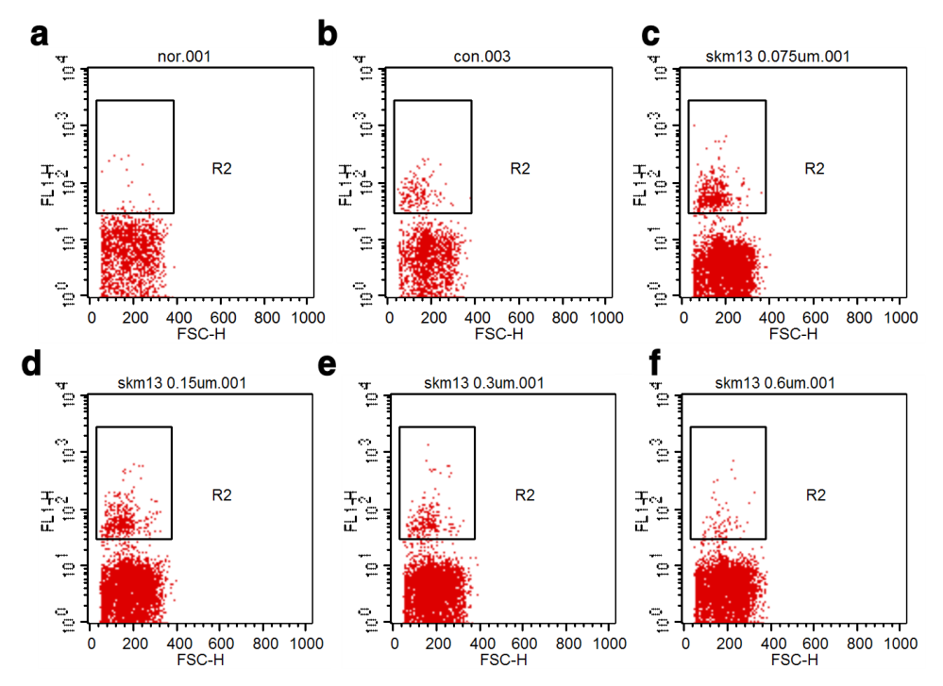
Fig. S5. FACS analysis for IC₅₀ of SKM13 in P.falciparum (FCR3). Each small rectangular square indicates the positive fluorescence labeling. a, uninfected RBC; b, infected RBC+DMSO; c, infected RBC+ 0.075 μM of SKM13; d, infected RBC+ 0.15 μM of SKM13; e, infected RBC+0.3 μM of SKM13; f, infected RBC+ 0.6 μM of SKM13.

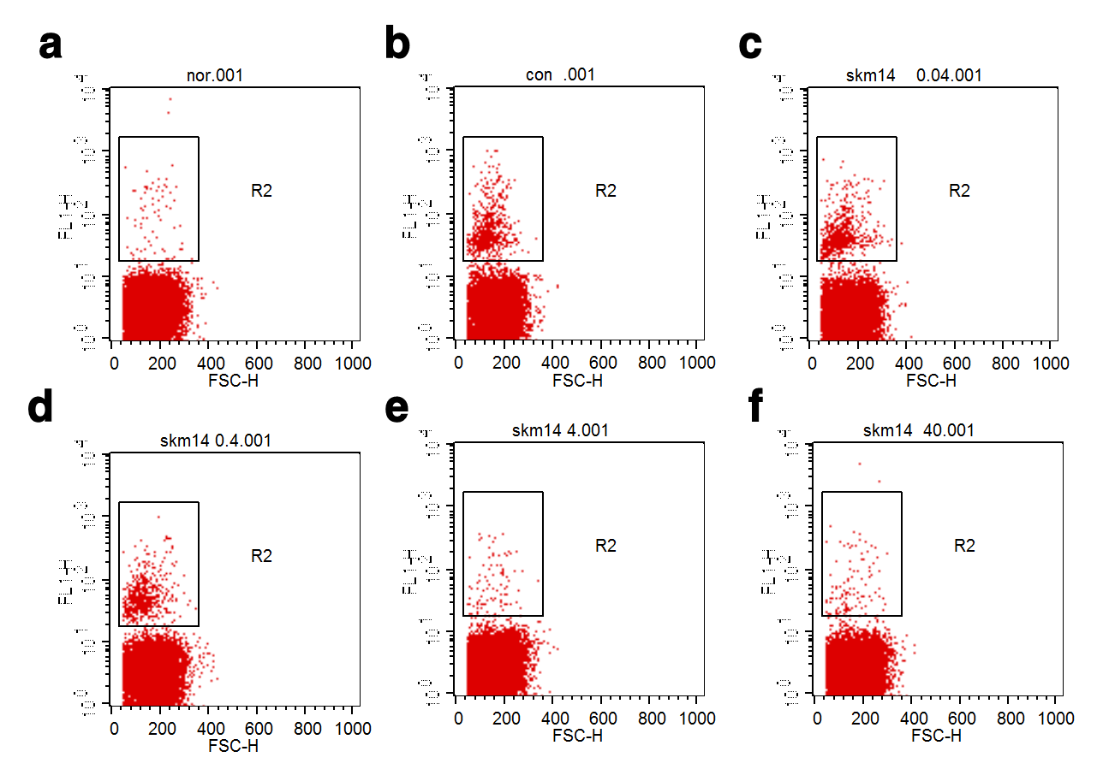
Fig. S6. FACS analysis for IC₅₀ of SKM14 in P.falciparum (FCR3). Each small rectangular square indicates the positive fluorescence labeling. a, uninfected RBC; b, infected RBC+DMSO; c, infected RBC+ 0.04 μM of SKM14; d, infected RBC+ 0.4 μM of SKM14; e, infected RBC+ 4 μM of SKM14; f, infected RBC+ 40 μM of SKM14.

