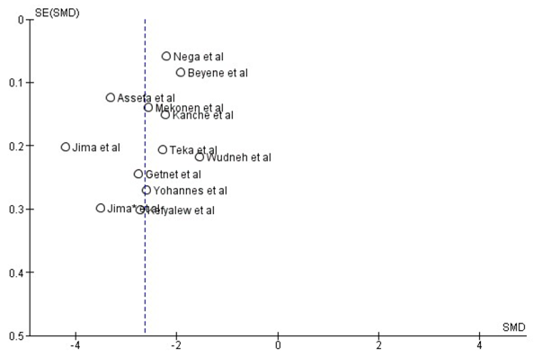
SE: Standard Error; SMD: Standard Mean Difference
Additional file 4: Funnel plot: Assessment of publication bias

