Additional file 1

1.1 Model formulation
Let Y_{it} denote the number of positive microscopy tests for Plasmodium falciparum out of n_{it} in a community at location x_{i} and year t_{i}. We assume that conditionally on a Gaussian random effect, W(x_{i},t_{i}), the Y_{it} are mutually independent Binomial variables with number of trials n_{it} and probability of a positive microscopy test p(x_{i},t_{i}) such that

$$\log\left\{\frac{p(x_{i}, t_{i})}{1- p(x_{i}, t_{i})}\right\}= α+f\left(a_{it}\right)+g(A_{it})+W\left(x_{i}, t_{i}\right)$$

where: a_{it} and A_{it} are the minimum and maximum age among the sampled individuals at location x_{i} and year t_{i}, respectively; f and g are linear splines, with knots at 3 and 10 years for f and at 80 years for g. We model the random effects as

$$W\left(x,t\right)=S\left(x,t\right)+Z\left(x,t\right)$$

where S(x,t) is a zero-mean stationary and isotropic spatio-temporal Gaussian process with variance σ² and Z(x,t) is Gaussian noise with variance τ². We interpret S(x,t) as the cumulative effect of unmeasured spatio-temporal risk factors for P. falciparum that accounts for extra-binomial variation between the sampled communities; Z(x,t), instead, is an unstructured component that accounts for unexplained extra-binomial variation within communities (e.g. genetic variation).

We use a spatio-temporal correlation function of the Gneiting family [2], given by the following expression

$$cov\left\{S\left(x,t\right),S\left(x^{'},t^{'}\right)\right\}=\frac{σ^{2}}{1+\frac{\left|t-t^{'}\right|}{δ}} e^{-\left\|x-x^{'}\right\|/φ}$$

where δ and φ are scale parameters that regulates how fast the temporal and spatial correlations decay to 0, respectively.

Estimation of the model parameters is carried out using Monte Carlo maximum likelihood [1].

1.2 The empirical spatio-temporal variogram

Let $N(u,v)$ denote the set of observations such that $\left\|x_{i}-x_{j}\right\|=u$ and $\left|t_{i}-t_{j}\right|=v$. The empirical spatio-temporal variogram (ESTV) is defined as

$$γ\left(u,v\right)= \frac{1}{2\left|N(u,v)\right|}\sum_{\left(i,j\right)∈N(u,v)}{{\left\{\tilde{W}\left(x_{i},t_{i}\right)-\tilde{W}(x_{j},t_{j})\right\}}^{2}}$$

where$|N\left(u,v\right)|$ is the number of observations within $N(u,v)$ and $\tilde{W}\left(x,t\right)$ is a point estimate of$W(x,t)$ from a model that assume the absence of any extra-binomial spatio-temporal variation, i.e. S(x,t)=0 for all x and t.

1.3 Testing the presence of residual spatio-temporal correlation
To justify the need of modelling the data using a geostatistical approach, we test the hypothesis on the presence of residual spatio-temporal correlation in the data. To pursue this objective, we then use the following iterative algorithm.

- Obtain a point estimate of$W(x_{i},t_{i})$, say$\tilde{W}(x_{i},t_{i})$, at each of the observed locations x_{i} and years t_{i}, from a model that assume the absence of any residual spatio-temporal correlation, i.e. S(x,t)=0 for all x and t.
- Permute the order of the data, including$\tilde{ W}(x_{i},t_{i})$, while holding $(x_{i},t_{i})$ fixed.
- Compute the ESVM, as defined in the previous section.
- Repeat 2 and 3 a large enough number of times, say B.
- Use the resulting B empirical variograms to generate 95% tolerance intervals at each of the pre-defined distance bins.

If the ESVM obtained from the original, unpermuted data, lies outside these intervals, then the data show evidence of residual spatio-temporal correlation.

Figure SI-1 shows that the ESVM from the original data lies out the 95% tolerance intervals for time separations up to 2 years. However, the ESVM lies inside these intervals for time bins above 2 years, indicating a weak correlation between data points that are sampled more than 2 years apart.

1.4 Model validation

In order to check the validity of the chosen spatio-temporal covariance function, we modify the Monte Carlo algorithm introduced in the previous section by replacing step 2 with following.

2*. Simulate$W(x_{i},t_{i})$, at each of the observed locations x_{i} and years t, from its marginal multivariate Gaussian distribution under the assumed model. Conditionally on the simulated values of$W(x_{i},t_{i})$, simulate binomial data y_{it}, corresponding to the counts positive of positive microscopy tests. Finally, compute the point estimates $\tilde{ W}(x_{i},t)$ using the simulated data.

In this case, the resulting 95% tolerance band of the ESTV is generated under the assumption that the true covariance function for$W(x_{i},t_{i})$ exactly corresponds to the one adopted in the analysis. If the ESVM obtained from the original data lies outside these intervals, then the data show evidence that the adopted spatio-temporal covariance function is not appropriate. If, instead, the ESVM from the data lies within the 95% tolerance band, we then conclude that the adopted covariance function is compatible with the data.

Figure SI-2 shows that the ESTV lies well within the 95% tolerance interval generated by the algorithm. This indicates that the data do not show evidence against the fitted spatio-temporal correlation function.

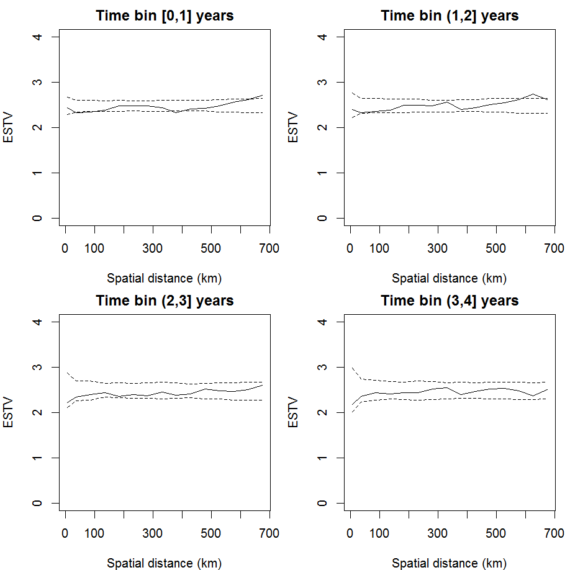

Figure SI-1. The solid line in each panel show the empirical spatio-temporal variogram (ESTV), defined in SI1, at four different time lags. The dashed lines represent the 95% confidence intervals generated under the hypothesis of spatio-temporal independence. At time lags of [0,1] and (1,2] years, the ESTV lies partly outside the 95% bandwidth, which is evidence of residual spatio-temporal correlation at the those time separations.

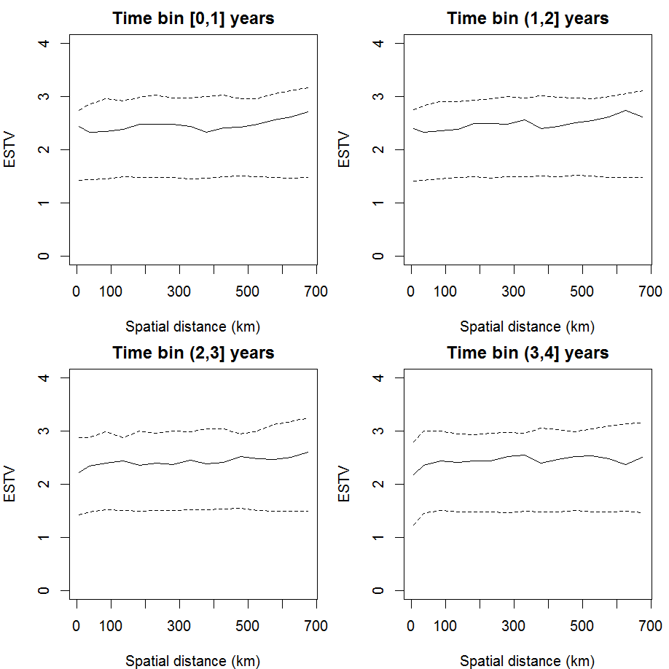

Figure SI-2. The solid line in each panel show the empirical spatial spatio-temporal variogram (ESTV), defined in SI1, at four different time lags. The dashed lines represent the 95% confidence intervals generated under the hypothesis that the fitted spatio-temporal covariance function correspond to the true covariance function that generated the data. At any of the four time lags, the ESTV falls within the 95% bandwidth, which is evidence that the adopted covariance function is compatible with the data.

References
- Christensen OF (2004). Monte Carlo maximum likelihood in model-based geostatistics. Journal of Computational and Graphical Statistics, 13: 702-718

- Gneiting T (2002). Nonseparable, Stationary Covariance Functions for Space-Time Data. Journal of the American Statistical Association, 97: 590-600

