Supplementary Data
Additional file 2

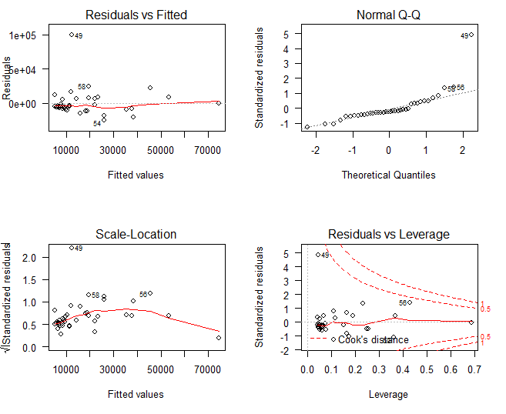
Additional file 2: Diagnostic plots for the regression analysis described in the legend of Additional file 1. The plots reveal data points from one of the subjects (subject #49) to be outliers. This subject was excluded from the regression analysis.

