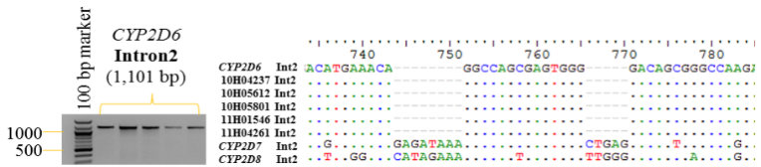
Additional file 1: Figure S1. Discrimination of functional and non-functional genes using intron 2 sequencing. The multiple sequence alignment of Intron 2 region (1.1kb) of each CYP2D gene compared among individual’s intron 2 sequence.

