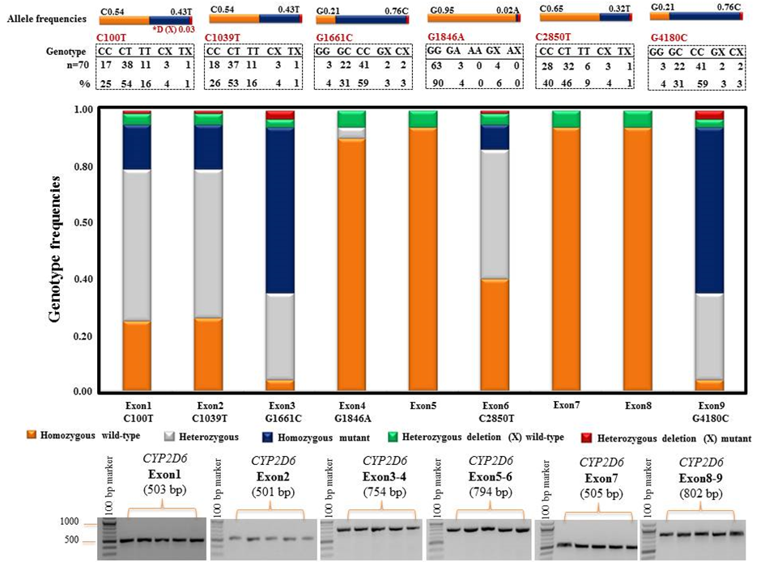
Additional file 3: Figure S3. The allele and genotype frequencies from different CYP2D6 coding regions. The bottom panel illustrates the successful amplification of exonic CYP2D6-specific PCR fragments uniquely generated by the DSP assay. Five colored bars are shown for each exon, representing the genotype frequency of homozygous wild-type (orange), heterozygous (gray), homozygous mutant (blue), heterozygous deletion (X, green) wild-type, and heterozygous deletion (X, red) mutant. The allele frequencies are presented on top; deletion alleles were carried in each variant with a frequency of 0.03 (*D (X), red). Analysis used STATA/SE12.1 to calculate frequencies.

