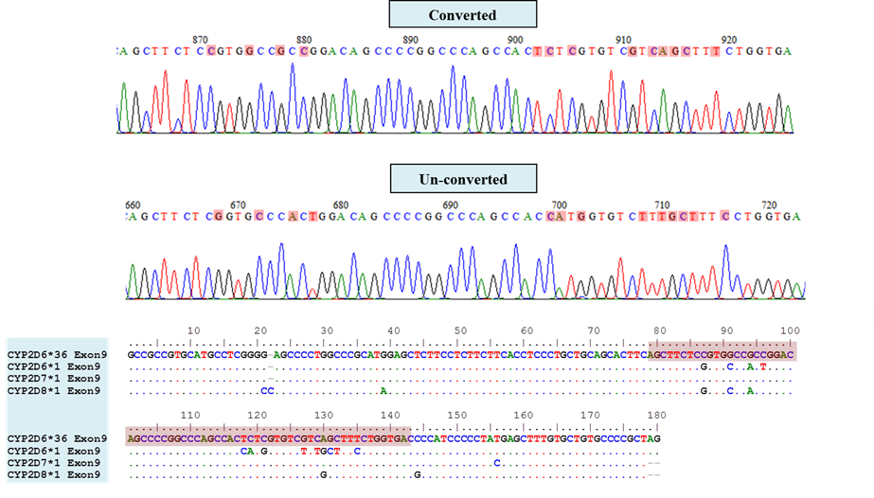
Additional file 4: Figure S4. Evidence of gene conversion to CYP2D7 in the exon 9 of the CYP2D6 gene. Red boxes denote the converted region, the 5′ end of the CYP2D6 gene fused with the 3′ end of CYP2D7 gene as a result of partial gene recombination, located at the downstream position of the exon 9.

