Additional file 1
A long-term follow-up study on otoacoustic emissions testing in pediatric patients with severe malaria in Gabon
Elisa Reiterer¹, Simon Reider², Peter Lackner³, Natalie Fischer¹, Daniel Dejaco¹, Herbert Riechelmann¹, Patrick Zorowka⁴, Peter Kremsner^{5,6}, Ayola Akim Adegnika⁵, Erich Schmutzhard³, Joachim Schmutzhard^{1*}

Additional Figures

Figure S1. The results of the questionnaire regarding hearing and understanding in absolute numbers (n=31)

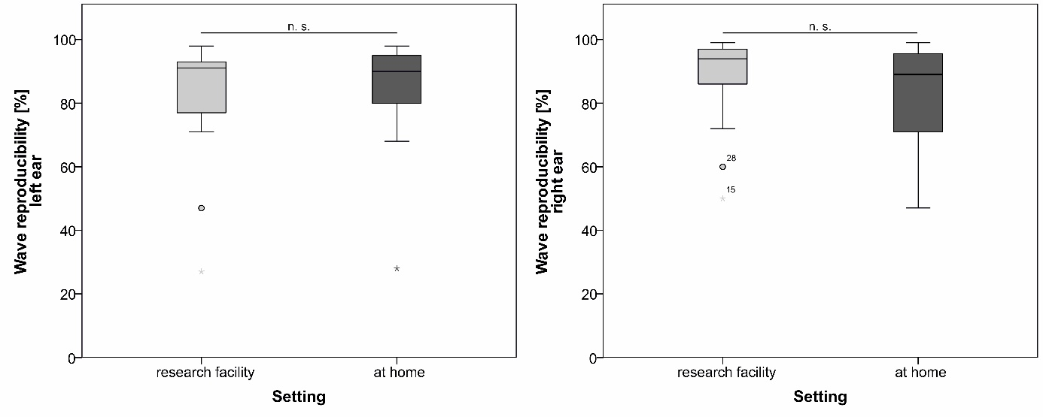Figure S2. The wave reproducibility rates of each ear (left and right) are compared according to the setting in which the measurement was taken: at the research facility (CERMEL, Centre des Rechèrches Médicales Lambaréné, n=15) or at home (n=16). Statistical significance is assessed using independent samples t-test.

Additional Table
Table S1. Of the 31 patients that could be included in the follow-up study, 15 were assessed in the research facility and 16 at home.

 | TEOAE pass rates |  |  | best wave reproducibility rate
 | facility | home | p | facility | home | p
left ear | 13/15  (86.7 %) | 15/16  (93.8 %) | 0.6 | 81.60  (+/- 20.2) | 84.13  (+/- 17.7) | 0.71
right ear | 14/15  (93.3 %) | 14/16  (87.5 %) | 1 | 87.33  (+/- 15.0) | 82.70  (+/- 16.5) | 0.42

