Additional file 1. Seroprevalence for each antigen studied
Antigen | N | Number  positive | % (95% CI)
PfAMA-1 | 1615 | 85 | 5.3 (4.3-6.5)
PfMSP-1₁₉ | 1624 | 58 | 3.6 (2.8-4.6)
PvAMA-1 | 1624 | 19 | 1.2 (0.8-1.8)
PvMSP-1₁₉ | 1624 | 17 | 1.2 (0.7-1.7)

Additional file 2. Demographic characteristics and factors associated with P. vivax transmission in Sabang, Indonesia, 2013

Variable (n = 1624) | Total | P. vivax seropositive |  | Bivariate | p
Variable (n = 1624) | N (%) | n | % (95% CI) | OR (95% CI) | p
Age (years)  <15 years old  - years old  25-40 years old  >40 years old | 656 (40.39)  270 (16.63)  347 (21.37)  351 (21.61) | 3  11  8  10 | 0.5 (0.1-1.4)  4.1 (2.3-7.2)  2.3 (1.2-4.5)  2.8 (1.5-5.2) | 1  9.24 (2.56-33.41)  5.14 (1.35-19.49)  6.38 2 (1.75-23.35) | 0.001  0.016  0.005
Gender  Female  Male | 984 (60.55)  641 (39.45) | 23  9 | 2.3 (1.6-3.5)  1.4 (0.7-2.7) | 1  0.59 (0.27-1.29) | 0.190
Residence  Sukakarya  Sukajaya | 603 (37.13)  1021 (62.87) | 11  21 | 1.8 (1.0-3.3)  2.1 (1.3-3.1) | 1  1.13 (0.54-2.36) | 0.745
Education  None  Primary education  Higher education | 3 (0.34)  764 (86.33)  118 (13.33) | 1  27  3 | 0.4 (0.1-2.6)  2.2 (1.5-3.2)  2.5 (0.8-7.5) | 1  6.14 (0.83-45.38)  6.97 (0.72-67.75) | 0.075  0.094
Employment  Unemployed  Non-office-based job  Office-based job  Student | 516 (57.33)  215 (23.89)  105 (11.67)  64 (7.11) | 20  4  2  6 | 2.5 (1.6-3.8)  1.8 (0.7-4.8)  1.9 (0.5-7.1)  1.2 (0.6-2.7) | 1  0.73 (0.25-2.16)  0.73 (0.17-3.19)  0.48 (0.19-1.22) | 0.572  0.681  0.123
LLIN use  No  Yes | 1098 (68.28)  510 (31.72) | 19  13 | 1.7 (1.1-2.7)  2.5 (1.5-4.3) | 1  1.48 (0.73-3.03) | 0.278
IRS last 12 months  No  Yes | 1376 (84.83)  246 (15.17) | 25  7 | 1.8 (1.2-2.7)  2.8 (1.4-5.9) | 1  1.58 (0.68-3.70) | 0.290
Fever  No  Yes | 1483 (91.26)  142 (8.74) | 31  1 | 2.1 (1.5-3.0)  0.7 (0.1-4.8) | 1  0.33 (0.45-2.45) | 0.280
Altitude (meter)  < 120  > 120 | 716 (50.46)  703 (49.54) | 13  10 | 1.8 (1.1-3.1)  1.4 (0.8-2.6) | 1  0.78 (0.34-1.79) | 0.559

Individual level data: age, gender, education status, employment status and fever. Household level data: LLIN use, IRS in last 12 months and altitude
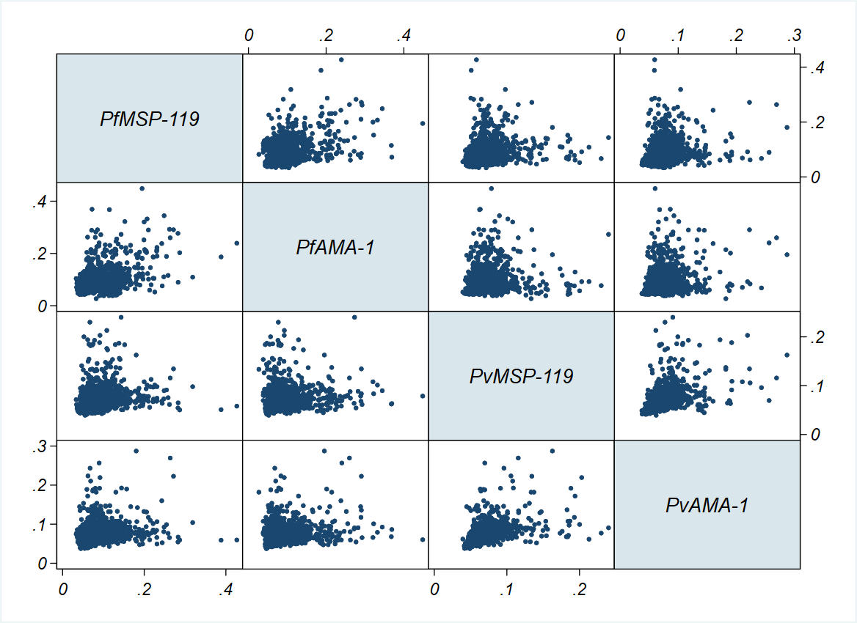Additional file 3. Scatter plots matrix of antibody responses (optical density) to P. falciparum and to P. vivax antigens tested in the study describing the absence of cross-reactivity between the P. falciparum and P. vivax antigens

