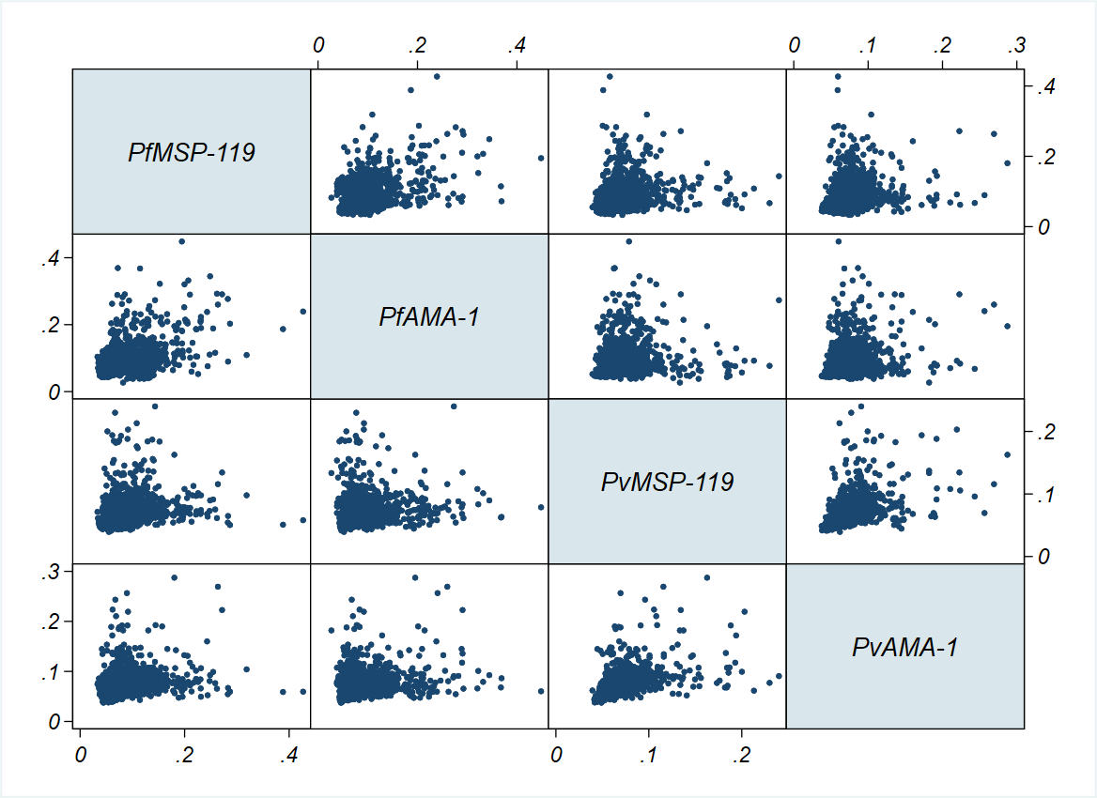Additional file 3. Scatter plots matrix of antibody responses (optical density) to P. falciparum and to P. vivax antigens tested in the study describing the absence of cross-reactivity between the P. falciparum and P. vivax antigens

