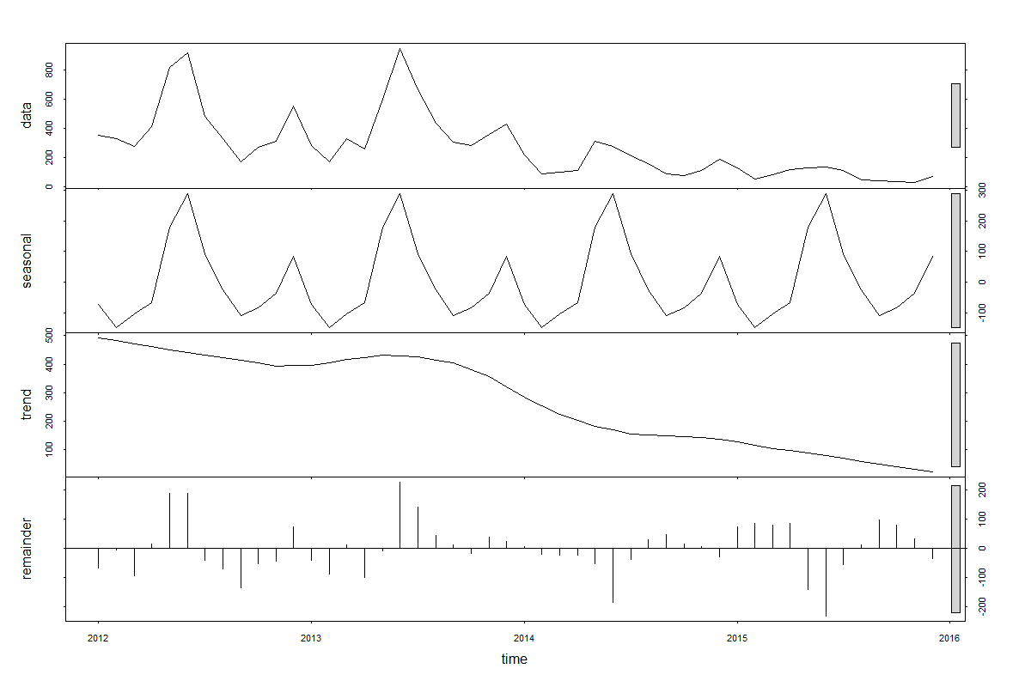Fig. S1 Time series decomposition of total confirmed P. falciparum malaria cases in Tak Province, 2012-2015. Top plot is decomposed into seasonal, trend and irregular components. The grey bar on the right indicates the relative magnitude of each of the decomposed components (length of bar = relative magnitude).

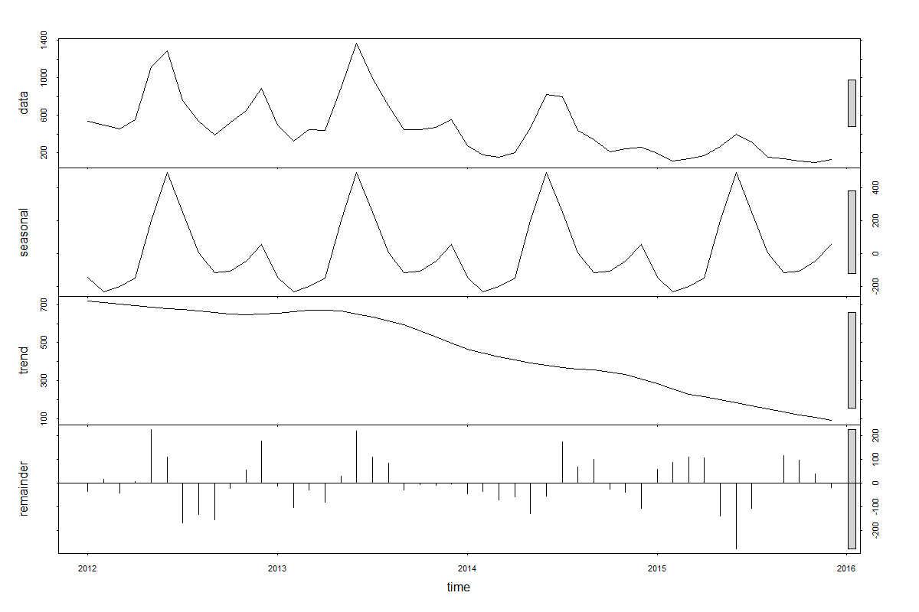
Fig. S2 Time series decomposition of total confirmed P. vivax malaria cases in Tak Province, 2012-2015. Top plot is decomposed into seasonal, trend and irregular components. The grey bar on the right indicates the relative magnitude of each of the decomposed components (length of bar = relative magnitude).

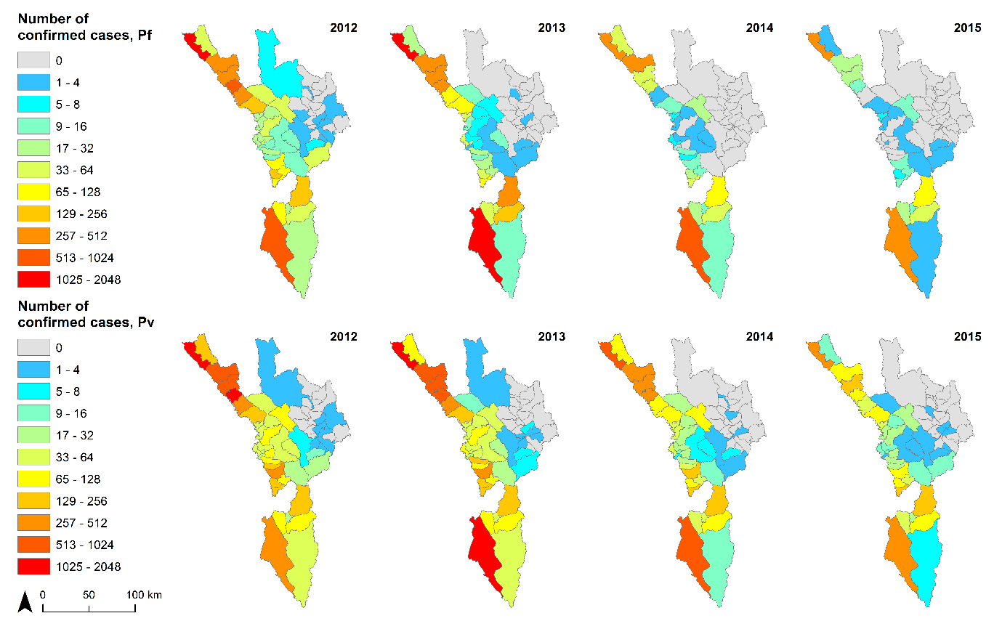
Fig. S3 Number of confirmed malaria cases (top panel: P. falciparum plus mixed infections, lower panel: P. vivax plus mixed infections) at subdistrict (tambon) level in Tak Province, 2012-2015.

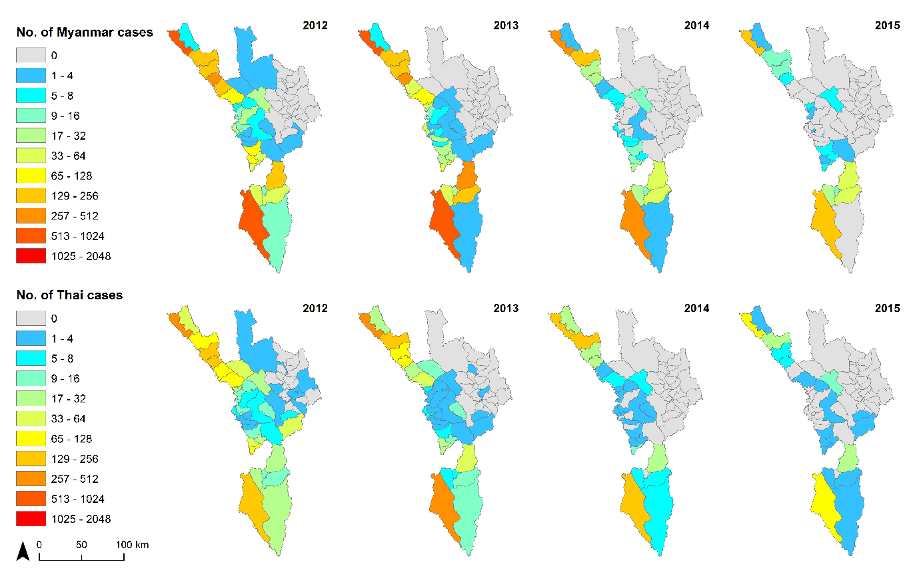
Fig. S4 Number of confirmed malaria cases (P. falciparum plus mixed infections) by nationality at subdistrict (tambon) level in Tak Province, 2012-2015. Top panel maps show Myanmar cases, while bottom panel maps depict Thai cases.
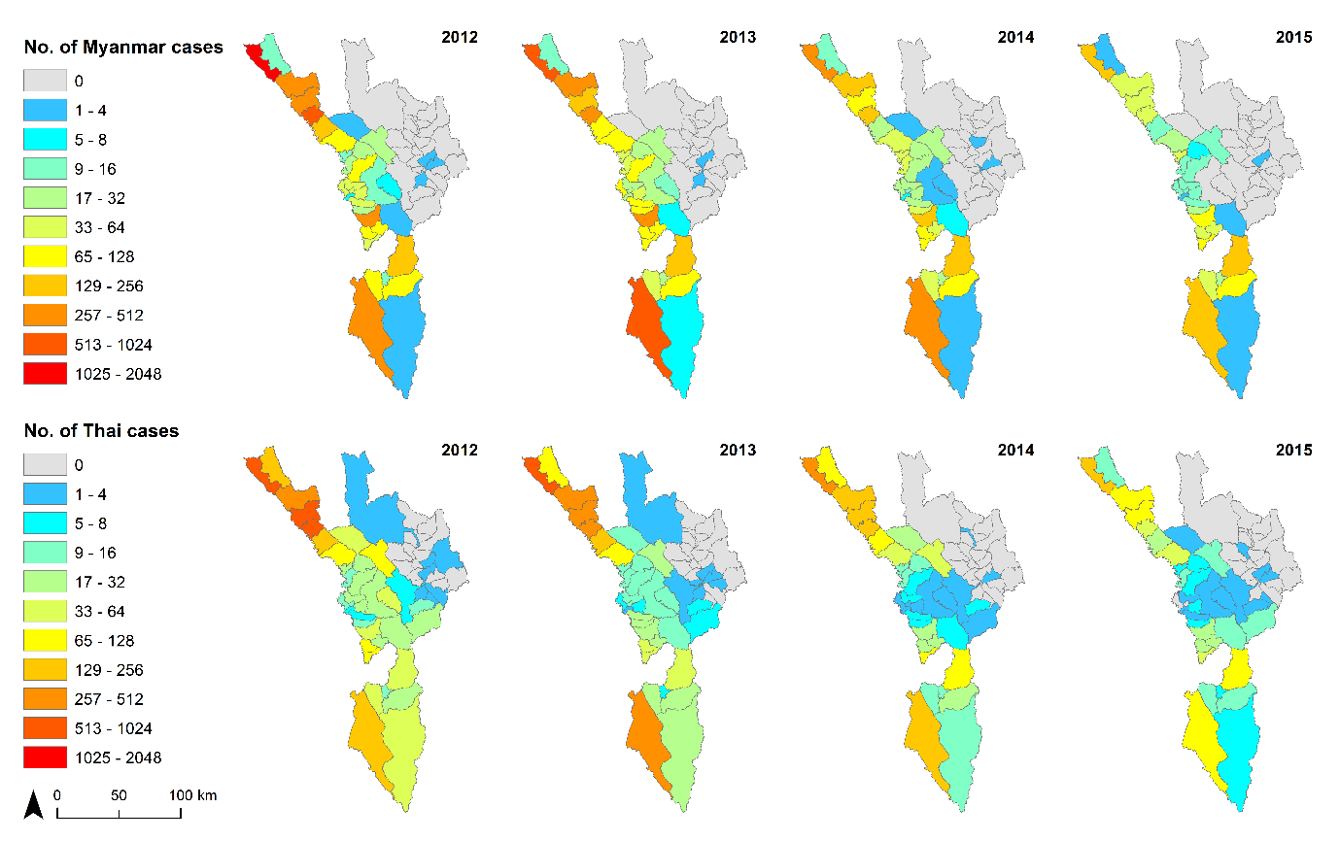
Fig. S5 Number of confirmed malaria cases (P. vivax plus mixed infections) by nationality at subdistrict (tambon) level in Tak Province, 2012-2015. Top panel maps show Myanmar cases, while bottom panel maps depict Thai cases.

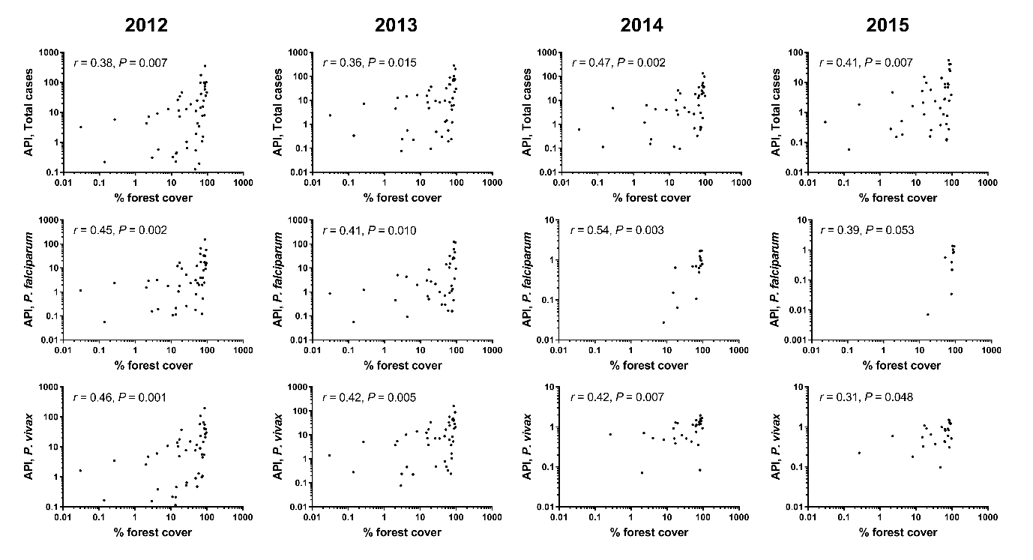
Fig. S6 Scatterplots (logarithmic scale) of percent forest cover and API at subdistrict (tambon) level in Tak Province, 2012-2015. Rows represent species of malaria (mixed infections were added to both P. falciparum and P. vivax cases), while columns represent years of surveillance. Each plot shows the results of Pearson’s correlation test.

Table S1 Number of confirmed malaria cases in SMRU for Tak Province, 2012-2015.
Year | P. falciparum | P. vivax | P. malariae | P. ovale | Total
2012 | 3,820 | 4,768 | 234 | 1 | 8,823
2013 | 1,762 | 3,558 | 11 | 0 | 5,331
2014 | 245 | 1,770 | 9 | 1 | 2,025
2015 | 94 | 1,169 | 4 | 0 | 1,267
Total | 5,921 | 11,265 | 258 | 2 | 17,446

Table S2 Summary of missing information in the malaria dataset for Tak Province, 2012-2015.
Year | Age |  | Nationality |  | Species |  | Subdistrict code
Year | N | % | N | % | N | % | N | %
2012 | 2,038 | 14.70 | 606 | 4.37 | 353 | 2.55 | 98 | 0.71
2013 | 1,727 | 13.38 | 470 | 3.64 | 253 | 1.96 | 197 | 1.53
2014 | 712 | 11.10 | 233 | 3.63 | 101 | 1.58 | 176 | 2.74
2015 | 595 | 17.72 | 180 | 5.36 | 171 | 5.09 | 4 | 0.12
Overall | 5,072 | 13.88 | 1,489 | 4.08 | 878 | 2.40 | 475 | 1.30
Average | 1,268 | 14.23 | 372.25 | 4.25 | 219.50 | 2.79 | 118.75 | 1.27

Table S3 Malaria cases by detection method in Tak Province, 2012-2015.
Year | Passive case  detection |  | Active case detection |  | Follow-up |  | Total
Year | N | % | N | % | N | % | N | %
2012 | 13,074 | 94.31 | 543 | 3.92 | 246 | 1.77 | 13,863 | 100.00
2013 | 12,139 | 94.08 | 539 | 4.18 | 225 | 1.74 | 12,903 | 100.00
2014 | 5,918 | 92.30 | 349 | 5.44 | 145 | 2.26 | 6,412 | 100.00
2015 | 3,075 | 91.57 | 213 | 6.34 | 70 | 2.08 | 3,358 | 100.00
Total | 34,206 | 93.62 | 1,644 | 4.50 | 686 | 1.88 | 36,536 | 100.00
Note: Row percentages are presented. “Follow-up” refers to cases on follow-up visits after treatment, which are likely to be duplicated from passive and active case detection methods.

