Supplementary Information to:

Theory of reactive interventions in the elimination and control of malaria

Nakul Chitnis, Peter Pemberton-Ross, Josh Yukich, Busiku Hamainza, John Miller, Theresa Reiker, Thomas P. Eisele, Thomas A Smith

Additional File 1. Parameterisation of the models using Zambian field data

Each individual in the field survey for whom a positive RDT was reported, was used to define the household of residence of an index case in a simulated RCD program, Hypothetical index cases were sampled from the infections detected in the surveys. A set of concentric circles was defined around each index case, and for each radius r, the number of people residing within that radius, the total numbers tested in the survey, and the numbers positive for P. falciparum, were computed. The data were grouped into 10 categories defined by different values of r, and aggregated over all possible index cases. Corresponding to each of these radii, values of ν were computed as the mean, for all the index cases, of the number of individuals registered in the census within that radius (Table S1).

Table S1. Numbers of individuals registered by distance from index case
Radius (km) | Mean*
0.01 | 13.7
0.02 | 17.1
0.04 | 23.1
0.08 | 32.4
0.16 | 54.0
0.32 | 106.0
0.64 | 208.0
1.28 | 416.6
2.56 | 892.5
5.12 | 2002.2
The values refer to 1117 index cases including both surveys and all three trial arms.
For each index case, the corresponding prevalence for the largest value of $ν$ provided an estimate of the local prevalence, p. The values of p thus obtained were binned into a series of categories, and the numbers of RDTs ($n_{i}$) and of positive RDTs ($r_{i})$were summed over all index cases for each range of p and of $ν$. Estimates, $\hat{τ}(ν,p)$, of τ for each for each range of p and of $ν$ were obtained as ratio of the local prevalence around any index case, to p i.e.:
$\hat{τ}\left(ν,p\right)={\left(\frac{\sum{r_{i}}}{{\sum{n}}_{i}}\right)}/p{ }$.
Equivalently, taking logarithms:
$$log\left(\frac{\sum{r_{i}}}{{\sum{n}}_{i}}\right)=log\left(p\right)+{ log\left(\hat{τ}(ν,p)\right)}$$

Figure S1. Empirical Relationship of $\hat{τ}(ν,p)$with p and $ν$. 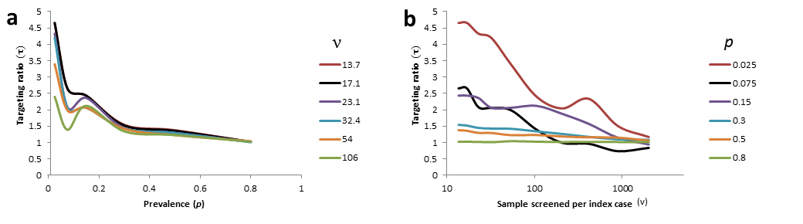
Empirically, $\hat{τ}(ν,p)$ was seen to decline steeply with p (Figure S1a) and also with $ν$. The strong relationship with $ν,$ applied only to low p values. At high prevalence even very focal screening is associated with a targeting ratio close to one.
For parameterisation of the models a smooth function of p and of $ν$ was required as an estimator of $τ\left(ν,p\right)$. Several different functional relationships were fitted to the observed relationships between the numbers of infections found, and the numbers of individuals tested (using a Bayesian approach in WinBUGS(Spiegelhalter et al. 2003)). An excellent fit was observed with the function:
$$τ\left(ν,p\right)=\exp\left(\left(-α_{1}\ln\left(p\right)+\frac{α_{2}}{ν}-\frac{α_{3}}{ν}\ln\left(p\right)\right)\frac{N-ν}{N}\right) | τ\left(ν,p\right)≥1$$
This function satisfies the important constraints that $τ\left(N,p\right)=1,$since there can be no targeting if the whole population is tested. The estimates of the three parameters were: $α_{1}$ = 0.23 (95% credible interval (CI): 0.16, 0.29); $α_{2}$ = -1.40 (CI : -2.77, -0.02) and $α_{3}$ = 2.87 (CI: 1.13, 4.59). Figure S2 is a heatmap, showing how $τ\left(ν,p\right)$ varies jointly with $ν$ and $p$. Consistent with Figure S1, $τ\left(ν,p\right)$ is close to unity over most of the surface, but increases sharply when $ν$ and $p$ are small.

Figure S2. Fitted relationship of $τ\left(ν,p\right)$ with $p$ and $ν$.
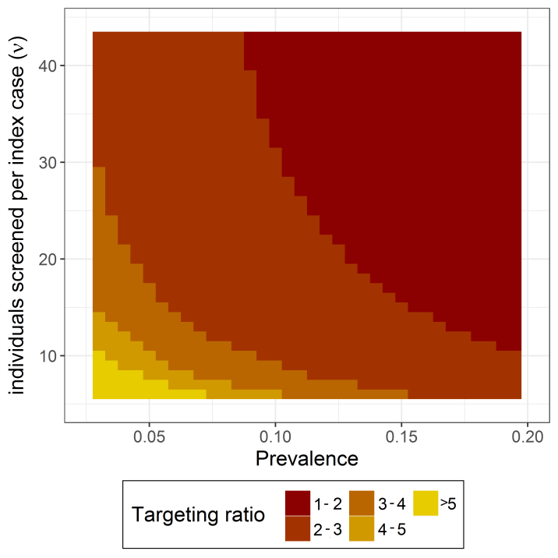

References

Spiegelhalter, D. J., Thomas, A., Best, N., & Lunn, D. Winbugs Version 1.4. 2003. Cambridge, England, MRC-BSU.

