Additional data
1 CACGTGGATG ACATCAAGAA CACCAGCCAA AAGAAAATTA CTTACGACAA GTACAACAAA
61 AACAAGGAGA ACATGAACAA CGAAAAGAAC GACAACAAAG ATAACAAGGA CAACATCTAC
121 AACGATAACA TTAACAACGA CAACATCAAC AACGACAACA TTAACAACGA GGACGAATAC
181 AAGTTCCTCT CAATGAAACA CTACAAGGAC TCCCTCTCTA ACAAGTTGAA CAACGAGAAC
241 GATCATATGA ACTACTTGAT CAGGAAAAGA AAGGACAACA CCCAGGGCAG TCAACACTTC
301 AACGAGAACA TCGAAAACAA CGAGAACGTC GAAAACAACG AGAACATTGA AAACAACGAG
361 AACAACGAAA ACATTGAAAA CATCGAGAAC AACGAAAACA ATGAGAACAA CGAGAACATC
421 GAGAACAACG AGAATAATGA GAATAATGAG AACTCCAGCA TCATGAACTC TGAGTCATAC
481 AACAACATCA TTAACTCCAA CGAACACAAC GAGGAACAAA TCAAGAAAAA GGAGGAAGAC
541 CTCATCGAGG CCTTCTTCCC ATTCATTTTG AAAAAGCTGG ACAACGAAAG TCTGTCGCTC
601 GATAACAAGT ACGACGATTA CTACAACCTG CCTAACGATC ACAACGACAC CCATAAGGAG
661 AACTCTTCAG ATCATAACCT GCTCGGATAC AAGCTGGGTA ACAACCTCAA ATCATACTTG
721 ATCGAGGAAA ACGACGTCAG TCAGAAAAAG ACTGACGATA TTAACGAGTC GGCTAGTTCG
781 GATTCCGAGA ACATCCAAGA AATTTTGTCC ACAGACAGCA ACACGTCTCA CCTGAAAGAA
841 AGGAAGAACC AGAAAGCTCC TCCCGGAGAG CATAAGCCTG AAGTCAAAAA CGCATTGCTG
901 AACTCACAGG TTGCGAGTCC CAAGGGAGAG GACGAGAAGA AGTCCCAGCC ACAACACCCG
961 CTGGTGAACT CCGGCGACCA GCTCCAACAT CCCAAGGAAA TCGATGAGAA CGCAGAAAAG
1021 ATTCGCCGTA CACTCTTGAA GGAGTCCCGC GACATCAAAA ACACCACTGC CATCATTGAT
1081 GAGACAGTCT ACAAGTTCGA ACAACTGATC ATGAAAGGAA GGTACTACGC TACGGCCGTG
1141 AGAAACTTCG TCATCTTCAA GGTTAACTAC ATTTGCGAGT ACAGCAAGTG TGGTCCAAAC
1201 TCTCGTTGCT ACATCGTTGA GAAAGATAAG GAACAGTGCC GCTGTCGTCC AAACTACATC
1261 GTGGACATGA GCGTCAACTA CTTCAAGTGC ATTCCGATGA AAGATATGAA CTGTTCTAAG
1321 AACAACGGTG GCTGCGACGT GAACGCTGAG TGTACGATCG TTGAAGGCGC CGTGAAGTGC
1381 CAGTGTTCCC ACCTGTACTT CGGAGACGGT GTCTTCTGTG TCAAAAACTC TCAAACCAAG
1441 CATCATCATC ATCATCATCA TCAC
Figure S1. Codon–optimized pfmsp10 gene (79 – 1518 nu). Letter underline shows the 8-his tag at carboxyl side protein. The all sequence was synthetized into pUC57 vector.

pFastBacTM dual vector
PfMSP10 optimized-pUC57 vector

F1
pfmsp10 optimized
R1
EcoRI
BamHI

F1

Gene cloning by PCR
EcoRI
BamHI

Polh
SV40
8-His
pfmsp10 “Optimized” (1440 pb)

~ 6750 pb
pFastBac-pfmsp10 vector vector

Figure S2. Construction of the pFastBac-pfmsp10 vector with insertions of codon-optimized pfmsp10 gene (from pUC57 vector). 8-His: histidine tag; SV40: SV40 polyadenylation terminator. BamHI and EcoRI are the restriction sites where the genes were inserted into pFastBacTM dual.

Figure S3. Standard-curve of P. falciparum serum pool using either: a) rMSP10, b) PfMSP10-1 or b) PfMSP10-2 as antigen in ELISA assays. The black arrow shows the optimal serum dilution (1/100) for all ELISA procedures. This point was considered as two down dilutions from the signal saturating (1/10). The dotted horizontal line indicates the calculated cut-off. Mean and standard deviation are showed for each dilution point.

Signal Peptide (1-26aa)

PfMSP10 MMFFKCNQVFTLVFLLLLYFNNIVYTHVDDIKNTSQKKIT--------YDKYNKNKENMN
PvMSP10 MKRAKCNKSLTFTIFLLLYVNGAVHVSANELNGTDGGDVPNQKDITKDYSIFERITSEG-
* ***: :*:.::****.* *:. .:::: *. .: *. ::: ..:

PfMSP10 NEKNDNKDNKDNIYNDN-----------INNDNINNDNINNEDEYKFLSMKHYKDSLSNK
PvMSP10 -QSASGKDD-SPISQSNTPQGEEASDGKQGNTPLDEKNSAKDVEAHFIREGHDKVTHSDV
:. . **: . * :.* * :::.* :: * :*: * * : *:

Tandem Repetas

PfMSP10 LNNENDHMNYLIRKRKDNTQGSQHFNENIENNENVENNENIENNENNENIENIENNENNE
PvMSP10 -GTE-----------EGKATGH------------VQKNAN--------------------
.* : :: * *::* *

PfMSP10 NNENIENNENNENNENSSIMNSESYNNIINSNEHNEEQIKKKEEDLIEAFFPFILK---K
PvMSP10 -------------------LRSTSYFSTQ---------------GAVSQAYNFVQENHPQ
:.* ** . :. : *: : :

PfMSP10 LDNESLSLDNKYDDYYNLPNDHNDTHKE--NSSDHNLLGYKLGNNLKSYLIEEN------
PvMSP10 LDNNGANVEQ-------VARGQDDVGSTENGEGNSGGEGNPLGSDKPGGKPEDASKDTPG
***:. .::: : . ::*. . ..: * **.: . *:

PfMSP10 -------DVSQKKT-DDINESASSDSENIQEILSTDSNTSHLKERKNQKAPP-----GEH
PvMSP10 NNPEESPNRNQEKGEKEKKERGDTDNPNR-------GKTSEKADQQGGNHPNGLSPDEKN
: .*:* .: :* ..:*. * .:**. ::: : * :.

PfMSP10 KPEVKN-----ALLNSQVASPKGEDEKKSQPQHPLVNSGDQLQHPKEIDENAEKIRRTLL
PvMSP10 NPKTHNNHSESITNPGDVGALDGEENGEGDDQTGISPTEEHPTGDAPPSDHAEKIKNTLL
:*:.:* .:*.: .**:: :.: * : : :: .:.****:.***

EGF-Like Domain 1
PfMSP10 KESRDIKNTTAIIDETVYKFEQLIMKGRYYATAVRNFVIFKVNYICEYSKCGPNSRCYIV
PvMSP10 KEGIDLKETTSMIDNAVYNMEQFILKTKFYTTAIRNFVHFKVNHICEYSKCGANARCYIV
**. *:*:**::**::**::**:*:* ::*:**:**** ****:******** *:*****

EGF-Like Domain 1 EGF-Like Domain 2
PfMSP10 EKDKEQCRCRPNYIVDMSVNYFKCIPMKDMNCSKNNGGCDVNAECTIVE-GAVKCQCSHL
PvMSP10 EKDKEECRCRANYMPDDSVDYFKCIPMVEKDCSKENGNCDVNAECSIDKNKDIKCQCKFN
*****:**** **: * **:******* : :***:** *******:* : :****..

GPI
PfMSP10 YFGDGVFCVKNSQTKQTLYILFIVILLVFQNFFI
PvMSP10 YIGDGIFCVMGSQAKQSLCLLLLLLICLLHKFLF
*:***:*** **:**:* :*::::: ::::*::

Figure S4. Amino acid sequence alignment between PfMSP10 and PvMSP10 proteins. PfMSP10 regions are shown based in Black et al and Pacheco et al. The figure shows, the signal peptide, Tandem Repeats, EGF-like domains and glycosylphosphatidylinositol (GPI). Letters in italic and underlined show selected peptides (PfMSP10-1, PfMSP10-2 and PfMSP10-3). In bold, the area predicted by Black et al for the cleavage of the PfMSP10 protein that gives rise to a 36kDa protein.
Figure S5. rMSP10 cross-reaction against healthy donor sera. Total IgG levels from Symptomatic (Pfal Sym) and Asymptomatic (Pfal Asym) individuals infected with P. falciparum. HDend: Healthy donor from endemic area for Malaria and HDn: Healthy donor from non-endemic area. The dotted horizontal line indicates the calculated cut-off. The horizontal bar at the center of each group indicates the median of the group.

Figure S6. rMSP10 cross-reaction against other non-Plasmodium spp infection sera and healthy donor sera. Total IgG levels from Symptomatic (Pfal Sym) and Asymptomatic (Pfal Asym) individuals infected with P. falciparum. HDend: Healthy donor from endemic area for Malaria; Tx: Toxoplasmosis; Ls: Leishmaniasis; Lp: Leptospirosis; Nc: Neurocysticercocys and Dn: Dengue. The dotted horizontal line indicates the calculated cut-off. The horizontal bar at the center of each group indicates the median of the group.

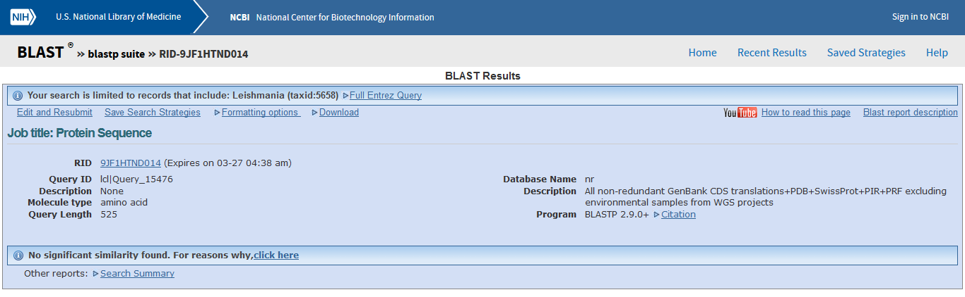
Leishmania (taxid:5658)

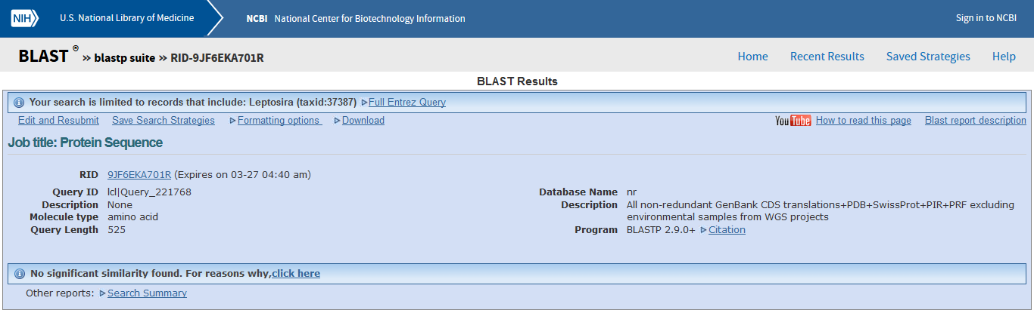
Leptosira (taxid:37387)

Figure S7. BLASTp results using PfMSP10 aminoacide sequence against to Leishmania (taxid:5658) or Leptosira (taxid:37387) protein data base. The program selection/algorithm was Blastp (protein-protein BLAST). Evaluated in March,2019.

References:
Black CG, Wang L, Wu T, Coppel RL. Apical location of a novel EGF-like domain-containing protein of Plasmodium falciparum. Molecular and biochemical parasitology. 2003;127(1):59-68.
Pacheco MA, Elango AP, Rahman AA, Fisher D, Collins WE, Barnwell JW, et al. Evidence of purifying selection on merozoite surface protein 8 (MSP8) and 10 (MSP10) in Plasmodium spp. Infection, genetics and evolution : journal of molecular epidemiology and evolutionary genetics in infectious diseases. 2012;12(5):978-86.
Stephen F. Altschul, Thomas L. Madden, Alejandro A. Schäffer, Jinghui Zhang, Zheng Zhang, Webb Miller, and David J. Lipman (1997), "Gapped BLAST and PSI-BLAST: a new generation of protein database search programs", Nucleic Acids Res. 25:3389-3402.

No | Antigenic Determinant | Length | Antigenicity/Surface/Hydrophilicity | Disordered Score | Mus_musculus/ Oryctolagus_cuniculus blast | In our study
1* | NMNNEKNDNKDNKD | 14 | 3.27/1.00/1.46 | 0.1597 | 64%/56% | PfMSP10-1
2* | ERKNQKAPPGEHKP | 14 | 3.16/0.93/1.14 | 0.1376 | 49%/57% | PfMSP10-2
3* | RRTLLKESRDIKNT | 14 | 2.85/0.79/0.92 | 0.1538 | 50%/49% | PfMSP10-3
4 | VASPKGEDEKKSQP | 14 | 2.55/0.93/1.26 | 0.0930 | 56%/49% | -
5 | IRKRKDNTQGSQHF | 14 | 2.38/0.86/0.78 | NONE | 56%/49% | -
6 | SGDQLQHPKEIDEN | 14 | 2.00/0.79/0.74 | 0.1314 | 56%/49% | -
7 | NNLKSYLIEENDVS | 14 | 1.84/0.71/0.38 | NONE | 49%/56% | -
8 | IINSNEHNEEQIKK | 14 | 1.65/0.79/0.85 | NONE | 56%/56% | -
9 | SLSNKLNNENDHMN | 14 | 1.65/0.79/0.43 | NONE | 70%/56% | -
10 | INNDNINNDNINNE | 14 | 1.55/0.86/0.52 | 0.1126 | 56%/64% | -
Table S1. List of antigenic peptides selected by Optimum Antigen using the amino acid sequence of PfMSP10 (GenBank:XP_966190.1).

* indicated the peptides with higher

