Additional file 1
Table S1: Administrative regions of Tanzania stratified by geographic zone and malaria transmission.
Region | Geographic zone* | Malaria transmission**
Dodoma | Central | Seasonal
Manyara | Central | Seasonal
Singida | Central | Seasonal
Arusha | Northern | Seasonal
Kilimanjaro | Northern | Seasonal
Tanga | Northern | Seasonal
Iringa | Southern Highlands | Seasonal
Njombe | Southern Highlands | Seasonal
Ruvuma | Southern Highlands | Seasonal
Katavi | Southwest Highlands | Seasonal
Mbeya | Southwest Highlands | Seasonal
Rukwa | Southwest Highlands | Seasonal
Dar Es Salaam | Eastern | Perennial
Morogoro | Eastern | Perennial
Pwani | Eastern | Perennial
Geita | Lake | Perennial
Kagera | Lake | Perennial
Mara | Lake | Perennial
Mwanza | Lake | Perennial
Shinyanga | Lake | Perennial
Simiyu | Lake | Perennial
Kigoma | Western | Perennial
Tabora | Western | Perennial
Lindi | Southern | Perennial
Mtwara | Southern | Perennial
*Tanzania Demographic and Health Survey and Malaria Indicator Survey 2015/16
** Progress and Impact Series – Focus on Mainland Tanzania, WHO 2012

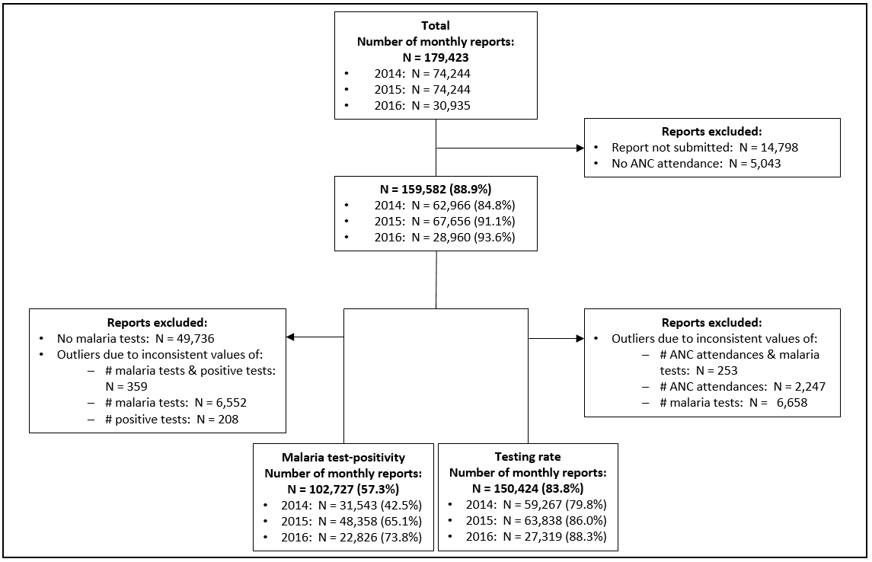Figure S1: Flow chart for the number of observations of the ANC dataset included in the analysis.

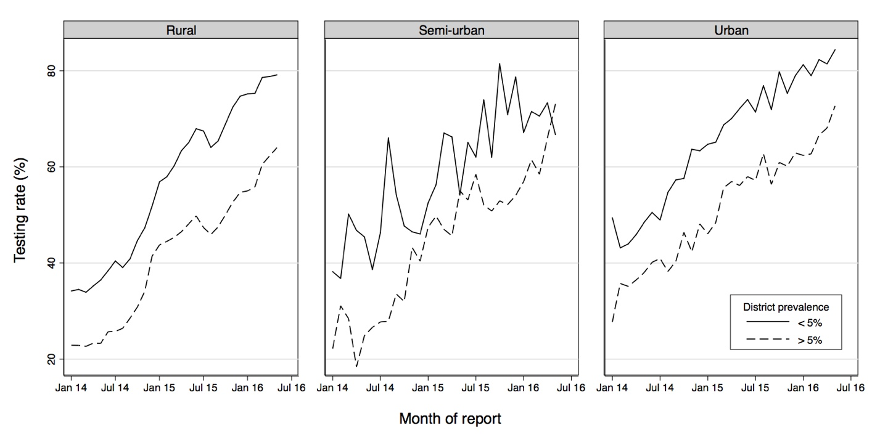
Figure S2: Average malaria testing rate at ANC health facilities in districts with more and less than 5% ANC test-positivity, over time, by district type (rural, semi-urban, urban).

